## GIFTGIFT University Gujranwala

Project Final Report

For

**Stay Ease**

**Submitted By:**

**Maryam Fazal FA24-BCS-211400155**

**Sumaira Ramzan FA24-BCS-211400100**

**Sitara Bibi FA24-BCS-211400125**

**Sehar Mazhar FA24-BCS-211400033**

**SupervisorMa’am Rahima Tanveer**

Original Version 1.0

Bachelor of Science in Software Engineering (2021-2025)



**GIFT University Gujranwala**

**Stay Ease**

**A project presented to**

**GIFT University, Gujranwala**

**In partial fulfillment**

**of the requirement for the degree of**

***Bachelors of Science in Software Engineering (2021-2025)***

**By**

**Maryam Fazal SP09-BCS-211400155**

**Sumaira Ramzan SP09-BCS-211400100**

**Sitara Bibi SP09-BCS-211400125**

**Sehar Mazhar SP09-BCS-211400033**

**DECLARATION**

We hereby declare that this software, neither in whole nor as a part has been copied from any source. It is further declared that we have developed this software and accompanied report entirely on the basis of our personal efforts. If any part of this project is proved to be copied from any source or found to be reproduction of someone else's work, we will stand by the consequences. No portion of the work presented has been submitted of any application for any other degree or qualification at this or any other university or institute of learning.

**Student Name 1 Student Name 2**

Sumaira Ramzan Sitara Bibi

**Student Name 3 Student Name 4**

Sehar MazharMaryam Fazal

**Executive Summary**

Manual and time-consuming management of rentals in Pakistan has always been the case. Generally, landlords have traditionally used old-fashioned methods such as paper work and direct face-to-face contact to manage the property and the tenants. All these cause a lot of problems, including inefficient management, lack of transparency in communication, trust issues, and no centralized system to follow for tracking rent and tenant details. Misunderstandings and even disputes occur due to the lack of transparency and documented evidence.

Stay Ease provides a modern, user-friendly digital rental management platform that streamlines the entire process for landlords, renters, and admins. For landlords, Stay Ease simplifies property management by allowing them to list properties, manage renters details, monitor rent payments, and handle property-related tasks in one place. The platform eliminates the need for manual record-keeping, making the process more efficient and stress-free. Renters can simply search for available rentals, make secure payments directly from the platform, and easily communicate with their landlords through a simple in-app chatbot. Admins help the platform to run smoothly by verifying properties and Renters, resolving disputes, and generally overseeing the performance of the system.

The platform's key features include a secure payment gateway that enables renters to make rent payments directly through the app while landlords can track transactions effortlessly. Stay Ease also provides centralized communication by documenting all interactions between landlords and renters within the platform, enhancing transparency and minimizing disputes. In addition, Stay Ease uses Firebase, a secure and scalable cloud storage solution, to store property listings, renters records, and payment histories, ensuring that all data is safe and easily accessible at any time.

It helps in automating manual tasks, ensuring transparency, and offering a centralized system; hence, it makes rental management easier and hassle-free. It eliminates inefficiencies, reduces misunderstandings, and increases the reliability and seamlessness of landlords and renters. Be it a landlord looking to simplify property operations or a renters seeking to have a stress-free rental journey, Stay Ease is conceptualized to make rental management modern, efficient, and trustworthy.

**Acknowledgement**

All praise is to Almighty Allah who bestowed upon us a minute portion of His boundless knowledge by virtue of which we were able to accomplish this challenging task.

We are greatly indebted to our project supervisor “**Ma’am Rahima Tanveer”**. Without his personal supervision, advice and valuable guidance, completion of this project would have been doubtful. We are deeply indebted to them for their encouragement and continual help during this work.

We are also thankful to our parents and family who have been a constant source of encouragement for us and brought us the values of honesty & hard work.

**Student Name 1 Student Name 2**

Sumaira Ramzan Sitara Bibi

**Student Name 3 Student Name 4**

Sehar MazharMaryam Fazal

**Abbreviations**

|  |  |
| --- | --- |
| **SRS** | Software Require Specification |
| **PC** | Personal Computer |
| **PCC** | Police Character Certificate |
| **UM** | User Management |
| **PM** | Property Management |
| **PCM** | Police Character Management |
| **SPM** | Shared Property Management |
| **RNM** | Reporting Notification Management |
| **CM** | Communication Management |
| **FMM** | Feedback Management Module |
| **PCM** | Payment Commission Management |
| **LI** | Limitations |
| **BO** | Business Objectives |
| **SCA** | Scalability |
| **AVA** | Availability |
| **INT** | Data Integrity |
| **COM** | Compliance |
| **LOC** | Localization |
| **MAIN** | Maintainability |
| **INT** | Interoperability |

**Table of Contents**

1 Introduction 11

1.1 Project Background 11

1.2 Comparative Analysis 11

1.3 Advantages/Benefits of Proposed System 12

1.4 Project Scope 13

1.5 Module 14

1.5.1 User Management Module 14

1.5.2 Property Management Module 14

1.5.3 Police Character Certificate Management Module 14

1.5.4 Shared Property Management Module 15

1.5.5 Reporting and Notification Management Module 15

1.5.6 Communication Management Module 15

1.5.7 Agreement Management Module 15

1.5.8 Feedback Management Module 15

1.5.9 Payment and Commission Management Module 15

1.6 System Limitations/Constraints 17

1.7 Tools and Technologies 17

1.8 Team Members Individual Tasks/Work Division 18

1.9 WBS and Gantt Chart 19

1.9.1 Gantt Chart 20

1.10 Cost of Project 21

2 Problem Definition 22

2.1 Problem Statement 22

2.2 Problem Statement 22

2.3 Proposed Solution 23

2.4 Current System (if applicable to your project) 23

3 Requirement Analysis 25

3.1 Requirement Elicitation Techniques 25

3.1.1 Document Analysis 25

3.1.2 Brainstorming 25

3.2 Business Requirements 25

3.3 Use Cases Diagram(s) 25

3.4 Detailed Use Case (Tabular- Module Wise) 29

3.4.1 Use Case Names 29

3.4.2 Use Case Description 31

3.5 Functional Requirements (Tabular FR- Module Wise) 97

3.5.1 User Management Module 97

3.5.2 Property Management Module 113

3.5.3 Police Character Certificate Management Module 136

3.5.4 Shared Property Management Module 139

3.5.5 Reporting and Notification Management Module 141

3.5.6 Communication Management Module 143

3.5.7 Agreement Management Modul 144

3.5.8 Feedback Management Module 145

3.5.9 Payment and Commission Management Module 148

3.6 Non-Functional Requirements 151

3.6.1 Scalability 151

3.6.2 Availability 151

3.6.3 Data Integrity 151

3.6.4 Compliance 152

3.6.5 Localization 152

3.6.6 Auditability 152

3.6.7 Maintainability 152

3.6.8 Interoperability 152

3.7 External Interface Requirements 152

3.7.1 User Interface Requirements 152

3.7.2 Software Interface 153

3.7.3 Hardware Interfaces 153

3.7.4 Communication Interfaces 154

4 Architecture and Design 154

4.1 System Architecture 154

4.2 Design Methodology 154

4.3 Data Representation [Diagram + Description] (ERD, JSON SCHEMA) 155

4.4 Design Models [along with descriptions] 160

4.4.1 Class Diagram 160

4.4.2 Activity Diagram 162

4.4.3 Sequence Diagram 176

4.4.4 State Diagram 186

4.4.5 Layered Architecture 187

5 Human Interface Design 188

5.1.1 Screen Images 188

6 . Implementation Screens 256

7 Testing and Evaluation ...... 21

7.1 Test Plan ...... 21  
7.2 Product Scope ...... 21  
7.3 Intended Audience ...... 22  
7.4 Definitions, Acronyms and Abbreviations ...... 22  
7.5 Test Pass/Fail Criteria ...... 22  
7.6 Verification ...... 23  
7.7 Validation ...... 23  
7.8 Usability Testing ...... 23  
7.9 Module/Unit Testing ...... 23  
7.10 Integration Testing ...... 23  
7.11 System Testing ...... 23  
7.12 Acceptance Testing ...... 23  
7.13 Manual Testing ...... 24  
7.14 Test Cases ...... 24  
    7.14.1 Unit Testing (Test Cases) ...... 25  
    7.14.2 Functional Testing ...... 25  
    7.14.3 Integration Testing ...... 26  
    7.14.4 Automated Testing ...... 27  
7.15 Environmental Needs ...... 27  
7.16 Responsibilities ...... 27

**List of Figures**

Figure 1:Context Diagram Of The System 13

Figure 2: WBS with Gantt Chart 20

Figure 3:Current System 23

Figure 4: Renter Use Case Diagram 25

Figure 5:LandLord Use Case Diagram 26

Figure 6:Admin Use Case Diagram 27

**List of Tables**

Table 1 :Related System Analysis 12

Table 2:Tools &Technologies 17

Table 3:Team Members Work Divion 17

Table 4:Admin Use Case Description 30

Table 5:LandLord Use Case Description 45

Table 6:Renter Use Case Description 69

**Project Category: (**Select all the major domains of proposed project**)**

□ **A-**Desktop Application/Information System □ **B-**Web Application/Web Application based Information System □ **C-**Problem Solving and Artificial Intelligence □ **D-**Simulation and Modeling □ **E-**Smartphone Application

□ **F-**Smartphone Game □ **G-**Networks □ **H-**Image Processing□ Other (specify category) ________________

# Introduction

The purpose of developing the **Stay Ease** application is to make it easier for students and job seekers to find short-term rentals tailored to their needs. Presently, finding the right rental option is difficult due to the absence of centralized systems, dependence on outdated manual processes, and limited access to verified listings. This often leads to inefficiencies, wasted time, and potential security risks. Stay Ease seeks to bridge this gap by offering a digital solution that simplifies the process of finding, comparing, and securing temporary rentals. The project is therefore seeking to bridge the gap in the market for a dedicated rental platform focused on short-term accommodations for those with unique needs and constraints. The main aims are a well-protected, user-friendly interface, an intelligent search and filtering mechanism, and an online review system that helps enhance transparency and trust. Such objectives will bring the Stay Ease application to save users' precious time and serve them accurate information without additional stress concerning temporary accommodation searches. This project is of importance because it simplifies and modernizes the process of finding accommodation, making it convenient and reliable for its target audience.

## Project Background

The concept of Stay Ease is based on the problems in Pakistan's rental property market, where manual processes and fragmented systems often make renting inefficient and unreliable. Existing platforms cater to general users but fail to address the specific needs of students and job seekers seeking temporary housing. Issues such as unverified listings, lack of trust, and limited affordability highlight the need for a tailored solution. Stay Ease is developed to bridge the gap by offering a central platform that incorporates landlord verification, secure online payments, installment plans, and rental agreements. Featuring property recommendations based on user choices, scheduling of visits to properties and sentiment analysis for feedback, Stay Ease offers a transparent and efficient, user-friendly rental experience that meets the unique requirements of short-term Renters, simplifying the property management processes for the landlords involved.

## Comparative Analysis

**Granna.com:** Mainly focused on property listings and rental agreements, Granna doesn't have sophisticated features such as AI-powered chatbots, renters-landlord communication tools, or integrated maintenance request handling, which

**Feeta:** Feeta offers property search and financial tools but does not include features such as digital contract management or renters feedback systems.

**Property.hamariweb.com:** This website is dedicated to real estate listings with basic search and filter options but lacks comprehensive role-based features for Landlords and Renters.

Table 1 :Related System Analysis

|  |  |  |
| --- | --- | --- |
| **Application Name** | **Weakness** | **Proposed Project Solution** |
| **Graana.com** | Mainly focuses on long-term rentals and property sales, lacks features for short-term rentals ,no proper verification process for landlords and Renters, no secure online payments or rental agreements | *Stay Ease* addresses the need for temporary housing by providing a platform with secure online payments, verified listings, rental agreements, and features that are tailored to short-term rentals. |
| **Feeta** | Landlord and Renter verification is very minimal; there is no safe method of payment, and the rental agreement cannot be automatically generated; mainly buys/sells properties instead of short-term rentals. | *Stay Ease*completes this gap with a safe online transaction, landlord, and Renter verification and automatically generates rental agreements for short-term stays, which particularly focuses on students and job seekers. |
| **Property.hamari.web** | It doesn't provide an easily navigable interface for short-term rentals, offers no secure payment or Renter/landlord verification and does not personalize property suggestions. | *Stay Ease* enhances the rental process with an intuitive interface, secure payments, landlord and Renter verification, and a personalized recommendation system based on user preferences. |

## Advantages/Benefits of Proposed System

* **Safe Transaction:** Stay Ease offers safety and reliability in online transactions, thus saving Renters from scams while landlords are also saved.
* **Verified User:** Both the landlord and the Renter will pass a vetting process to ensure they are trustworthy and genuine before entering into any rental.
* **Focusing on Short-Term Rental:** Unlike other websites, the specific specialty of StayEase is for short-term rentals, catering to students and job seekers.
* **Installment Payments:** Renters can pay in installments, thus making it easier to handle rental costs.
* **Automated Rental Agreements:** The system makes the process of renting easier with automated agreements, thus eliminating paperwork and speeding up transactions.
* **Personalized Recommendations:** It suggests properties based on the preferences of Renters and their previous searches, saving time and effort.
* **Convenient Property Visits:** The Renter can easily book visits so that the visit goes as smooth as possible.

## Project Scope

The Stay Ease project is an advanced platform designed to streamline the rental process for short-term accommodations across Pakistan. It serves three primary user types: Admin, Landlord, and Renter, each with distinct functionalities to ensure a smooth and transparent experience for all parties involved. The **Admin module** allows administrators to manage the entire platform, including verifying landlord profiles, approving or rejecting rental requests, and tracking payments. Admins will also be able to generate detailed reports on transactions, commissions, and landlord activities. They are responsible for monitoring feedback from both landlords and renters and taking action when necessary, such as disabling accounts based on negative feedback. The **Landlord module** enables landlords to create accounts, submit property details for approval, and upload property information, including images, videos, and descriptions, once their properties are approved. Landlords can set rules, visiting hours, and payment plans for their properties. The system also allows landlords to interact with renters, schedule property visits, and finalize rental agreements and fill feedback on the renter. The **Renter module** provides renters with an easy-to-use interface to search for properties based on their preferences, including budget, location, and property type (flat, Appointment Room) shared or unshared. Renters can shortlist properties, view detailed information, and contact landlords. Once a property is selected, renters can review and accept rental agreements, make secure payments, and leave feedback on the property.

Figure 1:Context Diagram Of The System

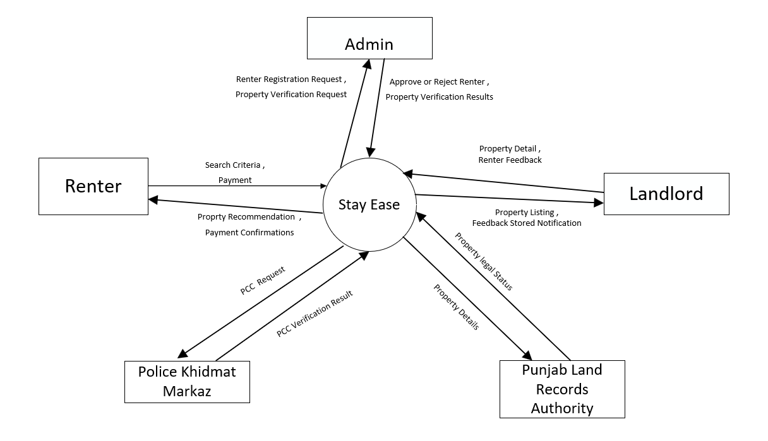

## Module

### User Management Module

It offers role-based account management for administrators, landlords, and renters, involving registration, log in, password reset, updates of their profile, and accounts deletion. Every role has control and is granted permission to view and manage their profile with proper access control mechanisms.

### Property Management Module

This module deals with property verification, approval, and listing by landlords. Admins verify property requests through third-party integrations, while renters search, view, and filter properties based on their preferences like location, budget, and type.

### Police Character Certificate Management Module

This module authenticates the police character certificates for renters through third-party platforms. The admins will approve or reject certificates, and the result is communicated to the renters. Only verified renters will proceed with the rental agreement.

### Shared Property Management Module

This module deals with the shared property listing management; this is where landlords can set up capacity and monitor tenants. Tenants are given the ability to choose shared properties and guided through form submissions in order to facilitate shared space management.

### Reporting and Notification Management Module

This module automatically generates reports for admins and landlords, such as transaction and property reports. It also manages notifications for agreements, payments, and feedback, keeping all users updated.

### Communication Management Module

This module facilitates interaction between landlords and renters through a chatbot and direct calls, ensuring smooth communication for queries, agreements, and issue resolution.

### Agreement Management Module

It automatically generates a rental agreement for each property and renter. The agreement can be seen and finalized after the police character certificate is approved by the authorities.

### Feedback Management Module

This module collects feedbacks from tenants and landlords and helps generate property and renter ratings using sentiment analysis. The feedback improves service quality and property management.

### Payment and Commission Management Module

All financial transactions are managed through this module, including one-time commission payments by landlords, rent payments from tenants, and penalties for late payments. Admins oversee and enforce financial compliance.

**Special Features**

* **Integration with Third-Party Services**: Verification of property and police character certificates through Punjab Land Records Authority and Police Khidmat Markaz, ensuring authenticity.
* **Advanced Search and Filtering**: Renters can search properties by location, budget, type, and shared/unshared status.
* **AI-Powered Feedback Analysis**: Sentiment analysis to evaluate feedback and generate property and user ratings automatically.
* **Automated Agreement Generation**: Rental agreements are auto-generated based on property rules and renter details.
* **Penalties and Notifications**: Automatic penalties for late payments and real-time notifications for renters and landlords.
* **Shared Property Management**: Special handling for shared properties with capacity limits and dynamic forms.
* **Secure Payment Gateways**: Robust mechanisms for seamless transactions with penalty tracking

**Module 1: User Management Module**

*UM-1: Manage role-based accounts for Admins, Landlords, and Renters, including registration, login, profile updates, and deletion.  
UM-2: Provide secure password reset and access control mechanisms for all roles.  
UM-3: Allow users to view and manage their profiles with appropriate permissions.*

**Module 2: Property Management Module**

*PM-1: Handle property verification, approval, and listing by landlords.  
PM-2: Allow renters to search, view, and filter properties based on location, budget, and type.  
PM-3: Enable admins to verify property details using third-party integrations.*

**Module 3: Police Character Certificate Management Module**

*PCM-1: Authenticate renters' police character certificates through third-party platforms.  
PCM-2: Allow admins to approve or reject certificates and notify renters of the results.  
PCM-3: Restrict renters with rejected certificates from proceeding with agreements*

**Module 4: Shared Property Management Module**

*SPM-1: Enable landlords to define capacity limits and monitor tenants in shared properties.  
SPM-2: Allow renters to choose shared properties and manage form submissions.  
SPM-3: Facilitate efficient management of shared spaces by landlords.*

**Module 5: Reporting and Notification Management Module**

*RNM-1: Generate reports for admins and landlords, such as transaction and property reports.  
RNM-2: Notify users about agreements, payments, feedback, and system updates.  
RNM-3: Ensure timely delivery of reminders and alerts to keep users informed.*

**Module 6: Communication Management Module**

*CM-1: Facilitate communication between landlords and renters through chatbots.  
CM-2: Support direct calls for queries, agreements, and issue resolution.  
CM-3: Provide 24/7 chatbot assistance for smooth interaction.*

**Module 7: Agreement Management Module**

*AGM-1: Automatically generate rental agreements based on property and renter details.  
AGM-2: Allow renters to review and finalize agreements post certificate approval.  
AGM-3: Ensure all agreements adhere to the system's rules and regulations..*

**Module 8: Feedback Management Module**

*FMM-1: Collect and analyze feedback from tenants and landlords using sentiment analysis.  
FMM-2: Generate property and renter ratings based on feedback.  
FMM-3: Improve service quality through actionable insights from feedback.*

**Module 9:  Payment and Commission Management Module**

*PCM-1: Manage financial transactions, including one-time commissions and rent payments.  
PCM-2: Enforce penalties for late payments and notify users accordingly.  
PCM-3: Allow admins to oversee and ensure financial compliance.*

## System Limitations/Constraints

*LI-1: Stay Ease is only operational within Pakistan and therefore cannot hold properties or users outside of the country*

*LI-2: The platform relies on external verification systems for police clearance certificates and landlord registration numbers, which may lead to delays if these systems are unavailable or slow to respond.*

*LI-3: The system requires reliable internet connectivity, as all operations, including property searches, payments, and communication, are online-based.*

*LI-4 : Sentiment analysis for review feedback is subject to user-provided review quality that may lead to rating errors if users give very biased or low-quality reviews*

## Tools and Technologies

Table 2:Tools &Technologies

|  |  |  |  |  |
| --- | --- | --- | --- | --- |
| **Tools and Technologies** | **Tools** | **Version** | **Rationale** | **Paid/Free** |
| Visual Studio Code | 1.59 | IDE | Free |
| Firebase | 9.12.1 | DBMS | Free |
| MS Project | 2016 | Project Management | Free |
| MS Word | 365 | Documentation | Free |
| MS Power Point | 365 | Presentation | Free |
| MS Visio | 2013 | Diagram Creation | Free |
| Figma | 1.7 | Mockups Creation | Free |
| Strip | 2.23.1 | Payment Method | Free |
| **Technology** | **Version** | **Rationale** | **Paid/Free** |
| Python | 3.9.0 | Programming language | Free |
| React Native | React 17 | Programming language | Free |
| LambdaMART | 4.1.0 | Programming language | Free |
| Node JS | 14.17.4 | Runtime Environment | Free |

## Team Members Individual Tasks/Work Division

Table 3:Team Members Work Divion

|  |  |  |
| --- | --- | --- |
| **Student Name** | **Student Registration Number** | **Responsibility/ Modules** |
| * **Sehar Mazhar** | **211400033** | **Module 1-Module 6** |
| * **Sitara Bibi** | **211400125** | **Module 4-Module 5-Module 9** |
| * **Sumaira Ramzan** | **211400100** | **Module 2-Module 8** |
| * **Maryam Fazal** | **211400155** | **Module 7-Module 3** |

## WBS and Gantt Chart

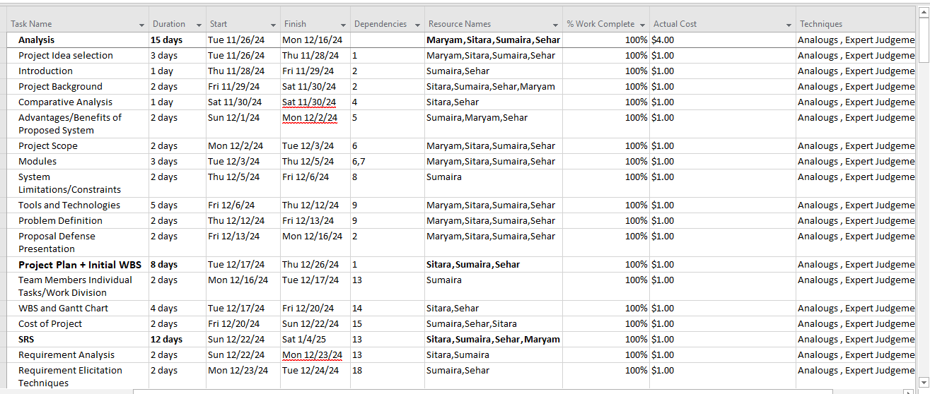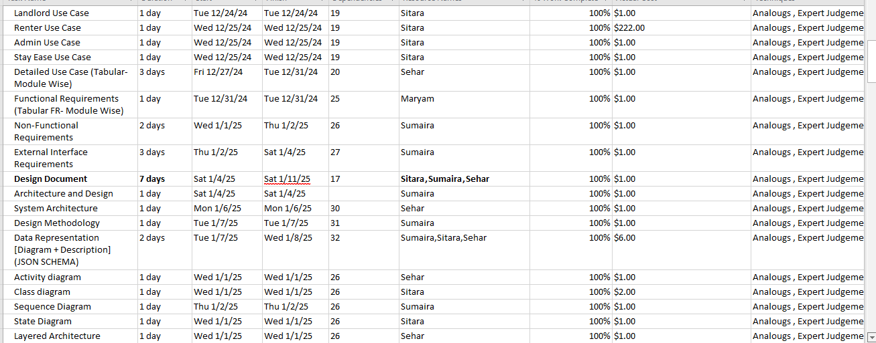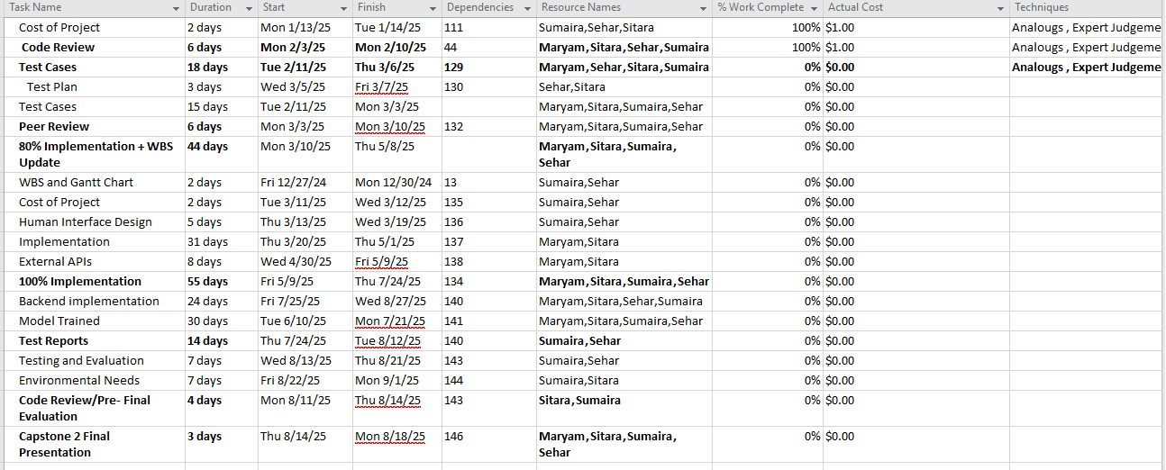

### Gantt Chart

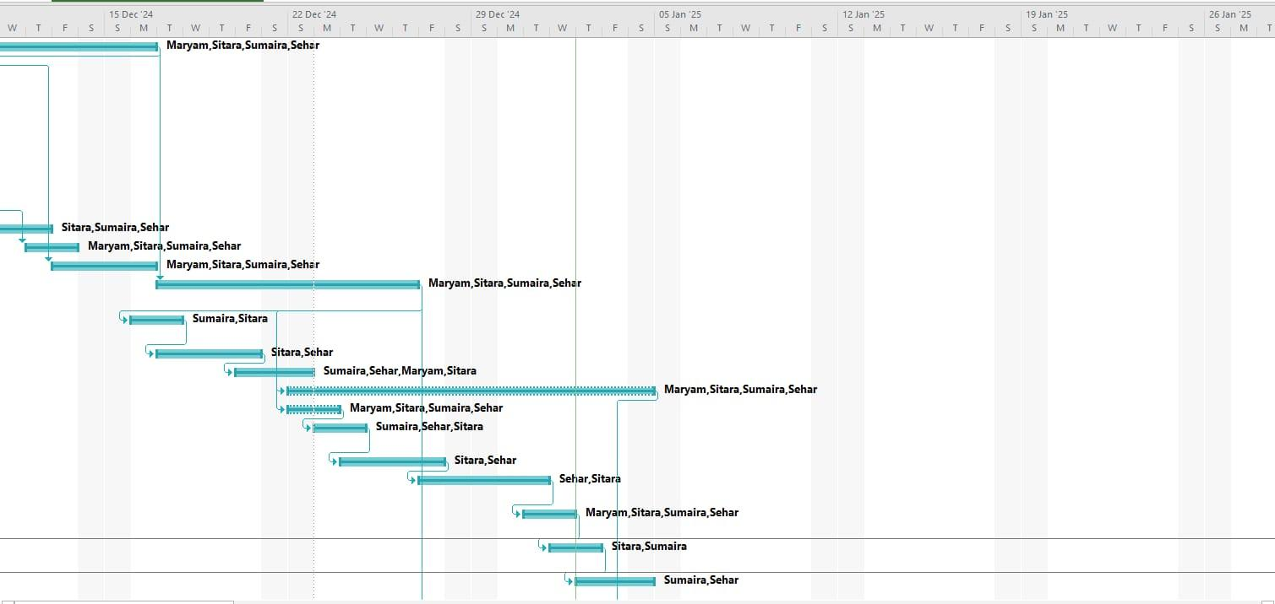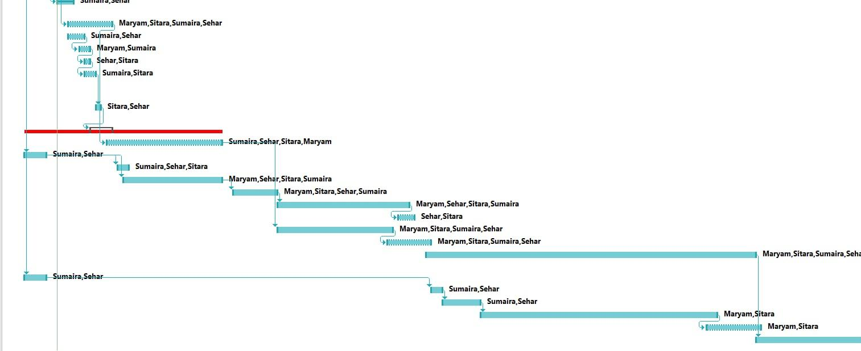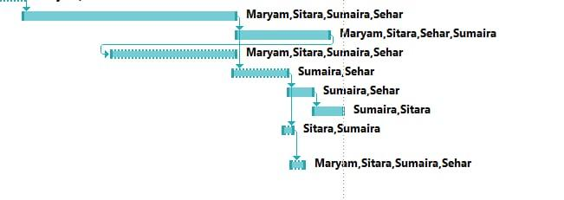

Figure 2: WBS with Gantt Chart

## Cost of Project

**Effort Calculation (COCOMO Semi-Detached Model)**

Formula:

E=3.0×(KLOC)^1.12

Substituting **KLOC = 40**

E=3.0×(40)^1.12

E=3.0×49.64=148.92 Person-Months

**Required Effort :** 148.92 Person-Months

**Development Time Calculation**

Formula:

T=2.5×(E)0.35

T=2.5×(148.92)0.35

T=2.5×5.61=14.03 Months

**Cost Estimation**

Each developer’s salary = **PKR 200,000/month**

Total Cost=4×200,000×8

PKR6,400,000 (PKR 64 Lakh)

# Problem Definition

This chapter discusses the specific problem to be solved and should also elaborate on the expected outcome.



## Problem Statement

This chapter discusses the specific problem to be solved and should also elaborate on the expected outcome.



## Problem Statement

The rental management process in Pakistan currently faces several inefficiencies, as landlords and renters are finding it difficult to manage property details, communication, and transactions. Most landlords lack a comprehensive platform to manage their properties, set rules, track payments, and approve rental requests efficiently. Renters face problems in finding the right properties according to their preferences and budget, which creates frustration and delays in securing a rental. Moreover, the lack of a single platform for communication and feedback between landlords and renters leads to more misunderstandings and dissatisfaction.

The proposed **StayEase** system is going to overcome these challenges by providing an integrated platform that streamlines property management, rental requests, bookings, payments, and communication. The system will enable landlords to create and manage property listings, approve or reject rental requests, set payment plans, and track their rental income. Renters will be able to intuitively search for properties, read in-depth information, and make safe bookings. In addition, the platform will offer a communication tool to facilitate live conversations about issues raised between the renter and landlord. There will be feedback and review mechanisms to provide transparency and accountability.

Although there are some rental platforms, they usually specialize in only one aspect, such as property listings or payment processing, and lack the integration of all features necessary for seamless management. The re-implementation of such a system will not only allow me to gain hands-on experience in full-stack development but also give me an opportunity to improve user experience through real-time communication and automated processes. Furthermore, building this platform will help me understand the depth of database management, payment systems integration, and the importance of user-centered design in developing practical solutions for real-world problems.

This project will enable me to acquire valuable technical skills, including web development, database management, payment gateway integration, and UI/UX design.

## Proposed Solution

StayEase will solve the inefficiency and challenges in the Pakistan rental property market. Through the system, a centrally managed rental property market provides a transparent platform for various stakeholders. Landlords can freely upload and manage listings from the property with description images, and schedules for more accessible renters search processes based on their needs

It has implemented renters and landlord verification where the risk of frauds is reduced by verifying the CNICs and the PCC through third-party verification mechanisms. It secures the payment, thereby having an in-built system for managing rental advances as well as refundable security deposits to ensure safe transaction processes for all users involved.

Unique features like chatbots facilitate seamless communication between renterss and landlords, while sentiment analysis ensures actionable feedback for improving property and user experiences. Automated generation of rental agreements further simplifies the legal formalities, making the process more efficient.

Unlike existing systems, StayEase offers end-to-end functionality such as user management, reporting, analytics, and compliance monitoring. It is also scalable to accommodate a growing number of users and increasing property listings without a decrease in performance

By automating and integrating these processes, StayEase saves time and effort while building trust and reliability in the rental market. It is a comprehensive, cost-effective solution that improves the rental experience for both landlords and renters.

**Objectives**

* BO-1: Reduce the time taken by renterss to find and finalize a property by 50%.
* BO-2: Ensure 100% verification of all users to eliminate fraud in the rental process.
* BO-3: Increase user satisfaction by 50% by improving feedback and sentiment analysis.
* BO-4: Reduce manual intervention for the creation of rental agreements by 70% in order to increase efficiency.

## Current System (if applicable to your project)

A brief description of an existing system, along with pictures of existing system and modules.

The following figure is a sample figure of existing system, Figure 3



Figure 3:Current System

Table 4:Current System Modules

|  |  |  |
| --- | --- | --- |
| **Name of Modules** | **Sub Module** | **Sub Module** |
| **User Management** | Admin Registration/Login | Landlord Registration/Login |
|  |  |  |
| **Property Listings** | Residential,Commercial, Agricultural, | New Listings, Featured Properties, Price Drop Listings |
| **Search and Filters** | Location, Type, Price, Size, Amenities | Nearby Landmarks, Property Status |
| **Seller and Buyer Portal** | Listing Management, Transaction Tracking | Profile Management, Communication with Agents, Price Alerts |

# Requirement Analysis

## Requirement Elicitation Techniques

### Document Analysis

**Reason:** This will be used to review existing documentation on the rental management system and i1ndustry standards to identify best practices and regulatory requirements for the rental management system. Document analysis ensures that the system design aligns with legal, technical, and business standards.

### Brainstorming

**Reason:** Since the project will have an AI chatbot feature, brainstorming will help generate ideas on innovative functionalities, user interface designs, and ways to improve renters-landlord interactions. It can be done with the project team or with stakeholders to ensure creative and useful solutions are considered.

## Business Requirements

This project provides significant business benefits by creating a secure, efficient, and profitable rental platform.

For admins, the system generates revenue through one-time commission fees from landlords when they list their first property and ensures streamlined financial handling through automated payment notifications and transaction summaries. The platform enhances trust by implementing thorough verification processes for landlords and renters, reducing fraudulent activities and fostering credibility.

Landlords benefit from features like detailed property management tools, timely rent notifications, and renter feedback visibility, allowing them to make informed decisions and maximize their earnings.

Renters enjoy a seamless experience with personalized property recommendations, secure payment options, and transparent transaction histories, ensuring satisfaction and repeat usage.

Overall, the platform not only generates revenue but also establishes itself as a trusted intermediary by promoting high-quality interactions, efficient operations, and a secure environment for all stakeholders.

## Use Cases Diagram(s)

1. 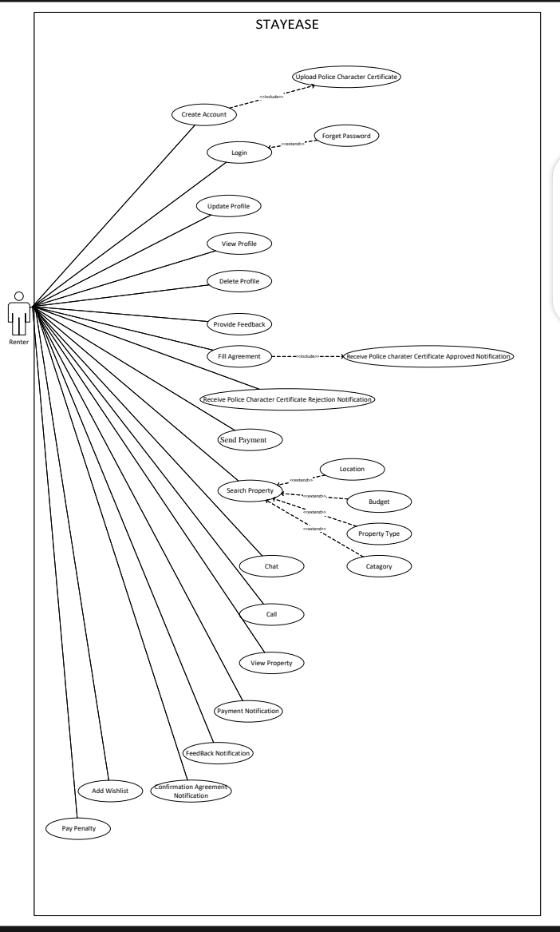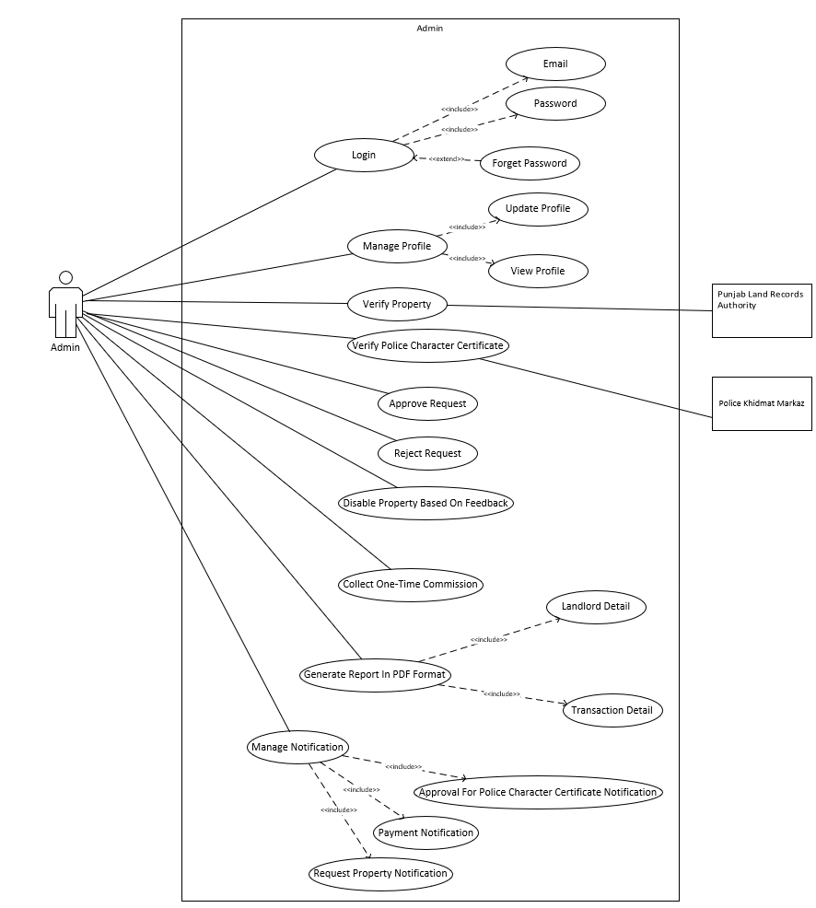

Figure 4: Renter Use Case Diagram

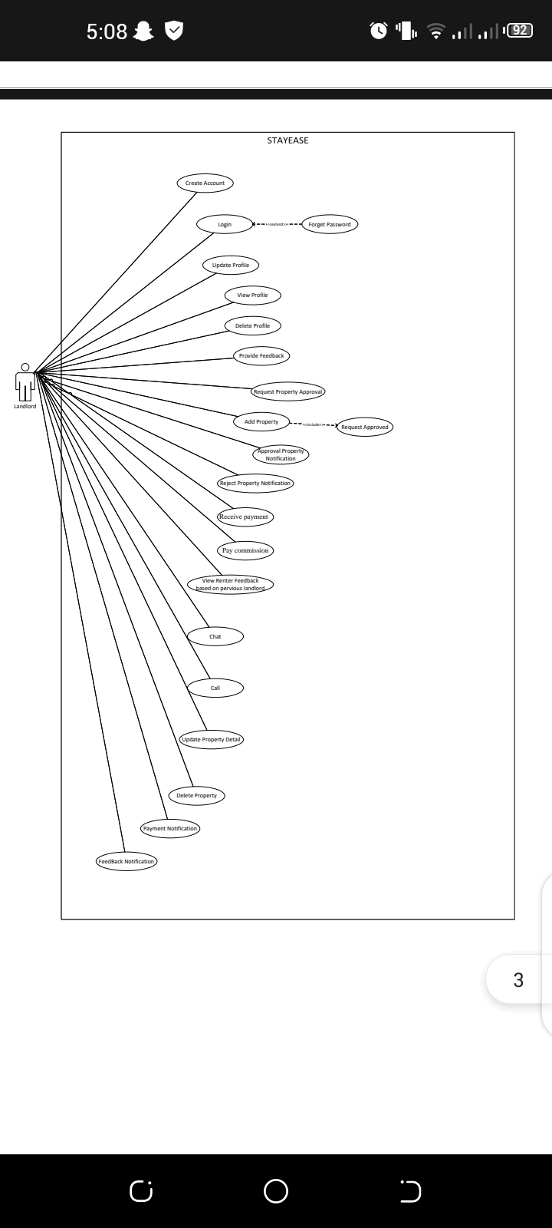

Figure 5:LandLord Use Case Diagram

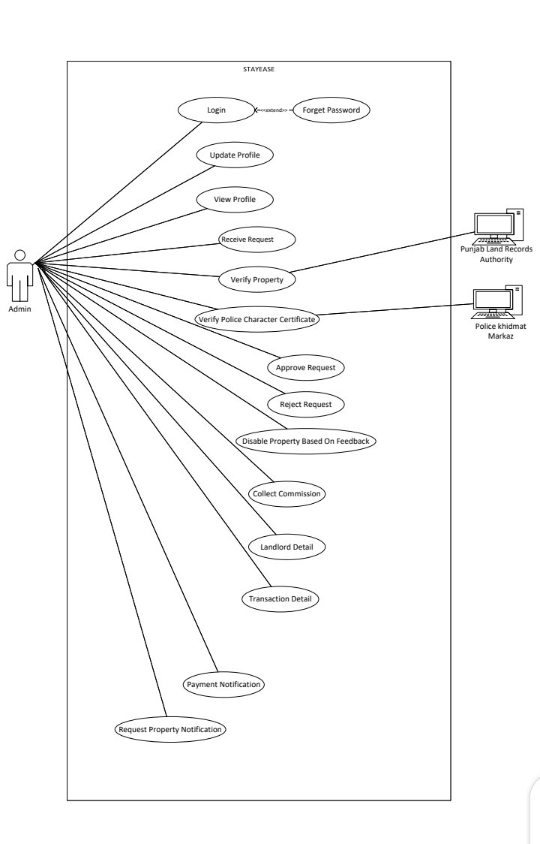

Figure 6:Admin Use Case Diagram

## Detailed Use Case (Tabular- Module Wise)

This section of the SRS should contain all the details that the software developer needs to create a design. This is typically the largest and most important part of the SRS. This section contains an overview of the use-case model or the subset of the use-case model that is applicable for this subsystem or feature.  This includes a list of names and brief descriptions of all use cases and actors, along with their applicable relationships.

### Use Case Names

**Admin Use Case**

* Login
* Update profile
* View profile
* Receive Request
* Verify Property
* Verify PCC
* Approve Request
* Reject Request
* Disable Property Based On Feedback
* Collect Commission
* Landlord Detail
* Transaction Detail
* Payment Notification
* Request Property Notification

**Landlord Use Case**

* Create Account
* Login
* Update Profile
* View Profile
* Update Profile
* View Profile
* Delete Profile
* Provide Feedback
* Request Property Approval
* Add Property
* Approval Property Notification
* Reject Property Notification
* Receive Payment
* Pay Commission
* Request Rejected
* View Renter Feedback Based on Previous Landlord
* Chat
* Call
* Update Property Detail
* Delete Property
* Payment Notification
* Feedback Notification

**Renter Use Case**

* Create Account
* Login
* Update Profile
* View Profile
* Delete Profile
* Provide Feedback
* Receive PCC Approved Notification
* Receive PCC Rejected Notification
* Search Property
* Send Payment
* View Property
* Chat
* Call
* Fill Agreement
* Payment Notification
* Feedback Notification
* Confirmation Agreement Notification
* Add Wishlist
* Pay Penalty

### Use Case Description

Table 4:Admin Use Case Description

|  |  |
| --- | --- |
| **Use Case ID:** | UC-1 |
| **Use Case Name:** | Login |
| **Actors:** | **Primary Actor:** Admin  **Secondary Actor**: None |
| **Description:** | This use case describes how the Admin logs into the system to access their dashboard and functionalities. |
| **Trigger:** | The Admin opens the system login page. |
| **Level:** | High |
| **Preconditions:** | PRE-1: The Admin must have valid login credentials (email and password).  PRE-2: The system must be online and accessible. |
| **Post conditions:** | POST-1: The Admin is authenticated and redirected to their dashboard.  POST-2: The system logs the login activity for auditing purposes. |
| **Include** | None |
| **Extend** | UC-1.1 Forget Password |
| **Normal Flow:** | 1. The Admin opens the login page. 2. The Admin enters their email and password. 3. The Admin clicks the "Login" button. 4. The system validates the credentials. 5. Upon successful authentication, the Admin is redirected to their dashboard. |
| **Alternative Flows:** | **Incorrect email or Password:**  The system notifies the Admin: "Invalid email or password. Please try again." |
| **Exceptions:** | 1: Invalid Credentials:   * The system displays an error message: "Invalid email or password. Please try again."   2: System Unavailable:   * The system notifies the Admin: "The system is currently unavailable. Please try again later." |
| **Business Rules** | None. |
| **Assumptions:** | 1. Assume the Admin has a valid account in the system. 2. Assume the login page is accessible through a web browser or application. |

|  |  |
| --- | --- |
| **Use Case ID:** | UC-1.1 |
| **Use Case Name:** | Forget Password |
| **Actors:** | **Primary Actor:** Admin  **Secondary Actor**: None |
| **Description:** | This use case describes how the Admin resets their password in case of forgetting it. |
| **Trigger:** | The Admin selects the "Forget Password" option on the login page. |
| **Level:** | High |
| **Preconditions:** | PRE-1: The Admin's email must be registered in the system.  PRE-2: The system must be able to send emails. |
| **Post conditions:** | POST-1: The Admin successfully resets their password.  POST-2: The system logs the password reset activity for auditing purposes. |
| **Include** | None |
| **Extend** | None |
| **Normal Flow:** | 1. The Admin clicks the "Forget Password" link on the login page. 2. The system prompts the Admin to enter their registered email address. 3. The Admin provides their email address and submits the form. 4. The system sends a password reset link to the Admin's email. 5. The Admin clicks the link and resets their password. |
| **Alternative Flows:** | **Invalid Email Address:**  The system notifies the Admin: "The entered email address is not associated with any account. Please try again."  **Expired Reset Link:**  The system notifies the Admin: "This password reset link has expired. Please request a new one. |
| **Exceptions:** | **Unregistered Email:**   * The system notifies the Admin: "The provided email address is not registered."   **Expired Link:**   * The system displays an error message: "The reset link has expired. Please request a new one." |
| **Business Rules** | None |
| **Assumptions:** | 1. Assume the Admin has access to their registered email. 2. Assume the system is configured to send password reset emails. |

|  |  |
| --- | --- |
| **Use Case ID:** | UC-2 |
| **Use Case Name:** | Update Profile |
| **Actors:** | **Primary Actor:** Admin  **Secondary Actor:** None |
| **Description:** | This use case describes how the Admin updates their profile information in the system. |
| **Trigger:** | The Admin selects the "Update Profile" option from their dashboard. |
| **Level:** | High |
| **Preconditions:** | PRE-1: The Admin is logged into the system. |
| **Post conditions:** | POST-1: The Admin's profile is updated successfully.  POST-2: The system logs the update activity for auditing purposes. |
| **Include** | None |
| **Extend** | None |
| **Normal Flow:** | 1. The Admin navigates to the "Update Profile" section. 2. The Admin updates their details (e.g., email, password,contact number). 3. The Admin clicks the "Save Changes" button. 4. The system validates the changes and updates the profile. |
| **Alternative Flows:** | **Incomplete Fields:**  The Admin attempts to save changes but leaves required fields empty.  **Invalid Data:**  The Admin enters data in an invalid format (e.g., incorrect email format or phone number). |
| **Exceptions:** | **Invalid Data:**   * The system notifies the Admin: "Invalid input. Please check your details and try again." |
| **Business Rules** | . None |
| **Assumptions:** | 1. Assume the Admin has permissions to update their profile. |

|  |  |
| --- | --- |
| **Use Case ID:** | UC-3 |
| **Use Case Name:** | View Profile |
| **Actors:** | **Primary Actor:** Admin  **Secondary Actor**: None |
| **Description:** | This use case describes how the Admin views their profile details stored in the system. |
| **Trigger:** | The Admin selects the "View Profile" option from their dashboard. |
| **Level:** | High |
| **Preconditions:** | PRE-1: The Admin is logged into the system. |
| **Post conditions:** | POST-1: The Admin’s profile details are displayed.  POST-2: The system logs the profile viewing activity for auditing purposes. |
| **Include** | None |
| **Extend** | None |
| **Normal Flow:** | 1. The Admin navigates to the "View Profile" section. 2. The system retrieves and displays the Admin’s profile details. |
| **Alternative Flows:** | **Profile Not Found:**   * + The system notifies the Admin: "Profile details not found. Please contact support."   **Session Timeout:**   * The system logs the Admin out due to inactivity, requiring re-login before viewing the profile. |
| **Exceptions:** | **Profile Retrieval Failure:**   * The system notifies the Admin: "Unable to retrieve profile details at the moment. Please try again later." |
| **Business Rules** | None |
| **Assumptions:** | 1.Assume the system can retrieve and display profile data in real-time. |

|  |  |
| --- | --- |
| **Use Case ID:** | UC-4 |
| **Use Case Name:** | Receive Request |
| **Actors:** | **Primary Actor:** Admin  **Secondary Actor**: None |
| **Description:** | This use case describes how the Admin receives a property rental request submitted by a Landlord. |
| **Trigger:** | The Landlord sends a request for property listing approval. |
| **Level:** | High |
| **Preconditions:** | PRE-1: The Landlord has submitted a request for listing their property. |
| **Post conditions:** | POST-1: The Admin receives the property request. |
| **Include** | None |
| **Extend** | None |
| **Normal Flow:** | 1. The Landlord submits a property request for approval. 2. The system validates the request and forwards it to the Admin. 3. The Admin navigates to the "Property Requests" section. 4. The system displays the list of pending property requests. 5. The Admin reviews the details of a selected request. |
| **Alternative Flows:** | **Invalid Request:**  If required details are missing, the system notifies the Landlord: "Property request incomplete. Please provide all required details." |
| **Exceptions:** | **Invalid Property Request Data**   * The system displays a validation error message: "Invalid property request. Please ensure all required fields are filled correctly." * The system highlights the missing or incorrect fields. |
| **Business Rules** | BR-2: Uploaded videos must meet format (MP4) and size limitations (1080p, 5 Mbps) with proper compression for efficient storage and streaming.  BR-3: Uploaded images must meet size (KB) and format requirements (PNG) and be stored securely in the system. |
| **Assumptions:** | 1. The system ensures that only verified Landlords can send property requests. 2. The Admin can review, approve, or reject property requests. |

|  |  |
| --- | --- |
| **Use Case ID:** | UC-5 |
| **Use Case Name:** | Verify Property |
| **Actors:** | **Primary Actor:** Admin  **Secondary Actor:** Punjab Land Records Authority |
| **Description:** | This use case describes how the Admin verifies property details submitted by landlords through integration with the Punjab Land Records Authority. |
| **Trigger:** | The Admin selects the "Verify Property" option from the property request details page. |
| **Level:** | High |
| **Preconditions:** | PRE-1: The Admin is logged into the system.  PRE-2: The landlord has submitted property details for verification. |
| **Post conditions:** | POST-1: The property is verified successfully.  POST-2: Verification activity is logged in the system. |
| **Include** | None |
| **Extend** | None |
| **Normal Flow:** | 1. The Admin selects a property request to verify. 2. The system retrieves property details and sends them to the Punjab Land Records Authority for validation. 3. The Authority responds with the verification status. 4. The system displays the verification result to the Admin. |
| **Alternative Flows:** | 1. **Invalid Property Details:**    * The system notifies the Admin: "The property details provided are invalid or incomplete. Please review and try again." 2. **Verification Service Down:**    * The system notifies the Admin: "The Punjab Land Records Authority service is currently unavailable. Please try again later." |
| **Exceptions:** | **Verification Failure:**   * The system notifies the Admin: "Unable to verify property details. Please try again later." |
| **Business Rules** | None |
| **Assumptions:** | 1. Assume the Punjab Land Records Authority’s API is operational and reliable. |

|  |  |
| --- | --- |
| **Use Case ID:** | UC-6 |
| **Use Case Name:** | Verify Police Character Certificate |
| **Actors:** | **Primary Actor:** Admin  **Secondary Actor:** Police Khidmat Markaz |
| **Description:** | This use case describes how the Admin verifies the Police Character Certificate submitted by landlords through integration with Police Khidmat Markaz. |
| **Trigger:** | The Admin selects the "Verify Police Character Certificate" option from the landlord’s profile. |
| **Level:** | High |
| **Preconditions:** | PRE-1: The Admin is logged into the system.  PRE-2: The landlord has uploaded a Police Character Certificate. |
| **Post conditions:** | POST-1: The certificate is verified successfully.  POST-2: Verification activity is logged in the system. |
| **Include** | None |
| **Extend** | None |
| **Normal Flow:** | 1. The Admin selects a landlord’s profile to verify the certificate. 2. The system retrieves certificate details and sends them to Police Khidmat Markaz for validation. 3. The Markaz responds with the verification status. 4. The system displays the verification result to the Admin. |
| **Alternative Flows:** | 1. **Invalid Certificate Details:**    * The system notifies the Admin: "The certificate details provided are invalid or incomplete. Please review and try again."   2.**Verification Service Down:**   * + The system notifies the Admin: "The Police Khidmat Markaz service is currently unavailable. Please try again later." |
| **Exceptions:** | Verification Failure:   * The system notifies the Admin: "Unable to verify the certificate. Please try again later." |
| **Business Rules** | None |
| **Assumptions:** | 1. Assume the Police Khidmat Markaz’s API is operational and reliable. |

|  |  |
| --- | --- |
| **Use Case ID:** | UC-7 |
| **Use Case Name:** | Approve Request |
| **Actors:** | **Primary Actor:** Admin |
| **Description:** | This use case describes how the Admin approves a property request after reviewing the details. |
| **Trigger:** | The Admin selects the "Approve" option for a specific property request. |
| **Level:** | High |
| **Preconditions:** | PRE-1: The Admin is logged into the system.  PRE-2: The property request has been verified. |
| **Post conditions:** | POST-1: The request is approved, and the landlord is notified.  POST-2: Approval activity is logged in the system. |
| **Include** | None |
| **Extend** | None |
| **Normal Flow:** | 1. The Admin selects a pending property request. 2. The Admin clicks the "Approve" button. 3. The system updates the request status to "Approved" and notifies the landlord. |
| **Alternative Flows:** | 1. **Approval Confirmation:**    * The system prompts the Admin to confirm approval before proceeding. 2. **Notification Failure:**    * The system updates the status but notifies the Admin: "Unable to notify the landlord. Please contact support." |
| **Exceptions:** | **System Error:**   * The system notifies the Admin: "Unable to approve the request. Please try again later." |
| **Business Rules** | BR-1: Only authorized admins can manage property status.  **BR**-4: Notifications should be sent via email, including a confirmation of approval and rejection. |
| **Assumptions:** | 1. Assume the Admin has permissions to approve requests. |

|  |  |
| --- | --- |
| **Use Case ID:** | UC-8 |
| **Use Case Name:** | Reject Request |
| **Actors:** | **Primary Actor:** Admin |
| **Description:** | This use case describes how the Admin rejects a property request after reviewing the details. |
| **Trigger:** | The Admin selects the "Reject" option for a specific property request. |
| **Level:** | High |
| **Preconditions:** | PRE-1: The Admin is logged into the system.  PRE-2: The property request has been reviewed. |
| **Post conditions:** | POST-1: The request is rejected, and the landlord is notified.  POST-2: Rejection activity is logged in the system. |
| **Include** | None |
| **Extend** | None |
| **Normal Flow:** | 1. The Admin selects a pending property request. 2. The Admin clicks the "Reject" button. 3. The system updates the request status to "Rejected" and notifies the landlord. |
| **Alternative Flows:** | 1. **Rejection Confirmation:**    * The system prompts the Admin to confirm rejection before proceeding. 2. **Notification Failure:**    * The system updates the status but notifies the Admin: "Unable to notify the landlord. Please contact support." |
| **Exceptions:** | **System Error:**   * The system notifies the Admin: "Unable to reject the request. Please try again later." |
| **Business Rules** | BR-1: Only authorized admins can manage property status. |
| **Assumptions:** | 1. Assume the Admin has permissions to reject requests |

|  |  |
| --- | --- |
| **Use Case ID:** | UC-9 |
| **Use Case Name:** | Disable Property Based on Feedback |
| **Actors:** | **Primary Actor:** Admin |
| **Description:** | This use case describes how the Admin disables a property reported for violations or poor feedback from renters. |
| **Trigger:** | The Admin selects the "Disable Property Based on Feedback" option for a specific property. |
| **Level:** | High |
| **Preconditions:** | PRE-1: The Admin is logged into the system.  PRE-2: The property exists in the system. |
| **Post conditions:** | POST-1: The property is disabled successfully.  POST-2:**:** The landlord is notified about the action and provided with the feedback details. |
| **Include** | None |
| **Extend** | None |
| **Normal Flow:** | 1. The Admin navigates to the property management section and selects a reported property. 2. The Admin reviews the feedback linked to the property. 3. The Admin clicks the "Disable Property" button and and disable the property according to renter’s feedback. 4. The system updates the property status to "Disabled." 5. The system notifies the landlord about the property's status change, including the feedback summary. |
| **Alternative Flows:** | **1.Feedback Review Error:** The system notifies the Admin: "Unable to retrieve feedback details. Please try again later."  **2.Notification Failure:** The system disables the property but notifies the Admin: "Unable to notify the landlord. Please contact support." |
| **Exceptions:** | **System Error:**   * The system notifies the Admin: "Unable to disable the property. Please try again later." |
| **Business Rules** | BR-1: Only authorized admins can manage property status.  BR-5: The system must verify feedback and complaints, and properties with low ratings or multiple complaints must trigger an automatic notification to the admin before blocking. |
| **Assumptions:** | 1. Assume the Admin has permissions to disable properties. |

|  |  |
| --- | --- |
| **Use Case ID:** | UC-10 |
| **Use Case Name:** | Collect Commission |
| **Actors:** | **Primary Actor:** Admin  **Secondary Actor**:None |
| **Description:** | This use case describes how the Admin collects a commission from landlords for completed property transactions. |
| **Trigger:** | The system identifies a completed property transaction, and the Admin initiates the commission collection process. |
| **Level:** | High |
| **Preconditions:** | PRE-1: The Admin is logged into the system.  PRE-2: The property transaction is marked as completed. |
| **Post conditions:** | POST-1: The commission is collected successfully.  POST-2: The system logs the transaction for auditing purposes. |
| **Include** | None |
| **Extend** | None |
| **Normal Flow:** | 1. The Admin navigates to the commission collection section. 2. The system displays a list of completed property transactions eligible for commission. 3. The system calculates the commission and updates the payment status. 4. The system deducts the commission amount from the landlord’s account or adds it to the Admin’s account. 5. The system notifies the landlord about the commission collection. |
| **Alternative Flows:** | 1. Insufficient Funds:    * The system notifies the Admin: "Unable to collect commission due to insufficient funds in the landlord’s account." 2. Payment Failure:    * The system notifies the Admin: "Commission collection failed. Please try again later." |
| **Exceptions:** | **System Error:**   * The system notifies the Admin: "Unable to process the commission collection. Please try again later." |
| **Business Rules** | None |
| **Assumptions:** | 1. Assume the Admin has permissions to collect commissions. |

|  |  |
| --- | --- |
| **Use Case ID:** | UC-11 |
| **Use Case Name:** | Landlord Details |
| **Actors:** | **Primary Actor:** Admin  **Secondary Actor**:None |
| **Description:** | This use case describes how the Admin views detailed information about a landlord, including contact details, property ownership, and transaction history |
| **Trigger:** | The Admin selects a landlord's profile from the dashboard or search results. |
| **Level:** | High |
| **Preconditions:** | PRE-1: The Admin is logged into the system.  PRE-2: The landlord's information exists in the system database. |
| **Post conditions:** | POST-1: The landlord's details are displayed successfully.  POST-2: The system logs the viewing activity for auditing purposes. |
| **Include** | None |
| **Extend** | None |
| **Normal Flow:** | 1. The Admin navigates to the landlord management section. 2. The Admin searches for a specific landlord using filters (e.g., name, email, phone, or property ID). 3. The Admin selects a landlord to view details. |
| **Alternative Flows:** | 1. **Landlord Not Found:**    * The system notifies the Admin: "No landlord found matching the search criteria." 2. **Incomplete Profile Data:**    * The system notifies the Admin: "Some details are missing in the landlord’s profile. Please contact support." |
| **Exceptions:** | **Data Retrieval Failure:**   * The system notifies the Admin: "Unable to retrieve landlord details at the moment. Please try again later." |
| **Business Rules** | None |
| **Assumptions:** | 1. Assume the system has a robust search and retrieval mechanism. 2. Assume the Admin has appropriate permissions to access landlord details. |

|  |  |
| --- | --- |
| **Use Case ID:** | UC-12 |
| **Use Case Name:** | Transaction Details |
| **Actors:** | **Primary Actor:** Admin  **Secondary Actor**:None |
| **Description:** | This use case describes how the Admin views the transaction details associated with a specific landlord or property. |
| **Trigger:** | The Admin selects the "View Transaction Details" option from the dashboard |
| **Level:** | High |
| **Preconditions:** | PRE-1: The Admin is logged into the system.  PRE-2: Transaction data exists in the system database. |
| **Post conditions:** | POST-1: The transaction details are displayed successfully.  POST-2: The system logs the viewing activity for auditing purposes. |
| **Include** | None |
| **Extend** | None |
| **Normal Flow:** | 1. The Admin navigates to the transactions section or selects a specific landlord/property profile. 2. The Admin clicks on the "View Transaction Details" option. 3. The system retrieves and displays the transaction details, including:    * Transaction ID    * Date and time of transaction    * Amount involved    * Payment method    * Status (e.g., completed, pending, failed)    * Commission deducted (if applicable) |
| **Alternative Flows:** | **No Transactions Found:**  The system notifies the Admin: "No transactions found for the selected criteria."  **Incomplete Transaction Data:**  The system notifies the Admin: "Some transaction details are missing. Please contact support." |
| **Exceptions:** | **Data Retrieval Failure:**  The system notifies the Admin: "Unable to retrieve transaction details at the moment. Please try again later." |
| **Business Rules** | None |
| **Assumptions:** | 1. Assume the system has a robust database to store and retrieve transaction data. 2. Assume the Admin has appropriate permissions to view transaction details. |

|  |  |
| --- | --- |
| **Use Case ID:** | UC-13 |
| **Use Case Name:** | Payment Notification. |
| **Actors:** | **Primary Actor:** Admin  **Secondary Actor**:None |
| **Description:** | This use case describes how the system notifies the admin about a successful payment transaction, such as a one-time commission or fee payment. |
| **Trigger:** | The payment is processed successfully by the system. |
| **Level:** | High |
| **Preconditions:** | **PRE-1:** The payment transaction is completed successfully. |
| **Post conditions:** | **POST-1:** The admin receives a payment confirmation notification. |
| **Include** | None |
| **Extend** | None |
| **Normal Flow:** | 1. The system processes the admin payment and confirms it was successful. 2. The system generates a payment confirmation notification, including:  * Transaction ID * Payment amount * Date and time of the payment * Payment method   3.The landlord receives the notification and reviews the payment details. |
| **Alternative Flows:** | **Invalid Contact Information:**  The system logs the issue and notifies the Admin: "Unable to send payment confirmation notification. Please verify landlord’s contact details."  **Notification Delivery Failure:**  The system retries delivery. If retries fail, the system notifies the Admin: "Notification delivery failed. Please contact support." |
| **Exceptions:** | * The system logs the error and notifies the Admin: "An error occurred while processing the notification. Please try again." |
| **Business Rules** | BR-4: Notifications should be sent via email, including a confirmation of approval and rejection. |
| **Assumptions:** | 1.Assume the system retries notification delivery in case of temporary failures. |

|  |  |
| --- | --- |
| **Use Case ID:** | UC-14 |
| **Use Case Name:** | Request Property Notification |
| **Actors:** | **Primary Actor:** Admin  **Secondary Actor**:None |
| **Description:** | This use case describes how the system notifies the Admin when a landlord submits a property request. |
| **Trigger:** | A landlord submits a property request through the system. |
| **Level:** | High |
| **Preconditions:** | **PRE-1:** The landlord has successfully submitted the property request.  **PRE-2:** The system has validated the request details. |
| **Post conditions:** | **POST-1:** The Admin receives a notification about the submitted property request.  **POST-2:** The system logs the notification activity for auditing purposes. |
| **Include** | None |
| **Extend** | None |
| **Normal Flow:** | 1. The landlord submits a property request via the system. 2. The system validates the request details and ensures they are complete. 3. The system generates a notification for the Admin. 4. The system sends the notification to the Admin 5. The Admin acknowledges receipt of the notification and views the property request in detail. |
| **Alternative Flows:** | **Invalid Request Details:**   * The system identifies incomplete or invalid details in the property request.   **Duplicate Request Detection:**   * The system identifies that a similar property request has already been submitted. |
| **Exceptions:** | **System Error During Notification:**  The system logs the error and alerts the Admin: "An error occurred while generating the notification. Please review property requests manually." |
| **Business Rules** | BR-4: Notifications should be sent via email, including a confirmation of approval and rejection. |
| **Assumptions:** | 1. Assume the landlord submits complete and accurate property request details. 2. Assume the Admin monitors notifications regularly for updates. |

Table 5:LandLord Use Case Description

|  |  |
| --- | --- |
| **Use Case ID:** | UC-1 |
| **Use Case Name:** | Create Account |
| **Actors:** | **Primary Actor:** Landlord  **Secondary Actor**:None |
| **Description:** | This use case describes how a landlord creates an account on the system to access its features. |
| **Trigger:** | The landlord selects the "Sign Up" option on the system's interface. |
| **Level:** | High |
| **Preconditions:** | **PRE-1:** The landlord has access to the internet and the system.  **PRE-2:** The landlord provides valid details (e.g., email, contact number, CNIC, address, and full name). |
| **Post conditions:** | **POST-1:** A new landlord account is created in the system.  **POST-2:** The system sends a confirmation email to the landlord. |
| **Include** | None |
| **Extend** | None |
| **Normal Flow:** | 1. The landlord selects the "Sign Up" button. 2. The system displays a registration form. 3. The landlord fills in the required fields:    * Full Name    * Email    * Contact Number    * CNIC    * Address    * Password    * Confirm Password 4. The landlord submits the form. 5. The system validates the provided details. |
| **Alternative Flows:** | 1. **Duplicate Email Address:**    * The landlord provides an email address already associated with an account.    * The system notifies the landlord: "This email address is already in use. Please use a different email." |
| **Exceptions:** | 1. **Server Error:**   .The system notifies the landlord: "An error occurred while creating your account. Please try again later."   1. **Network Failure:**   The system notifies the landlord: "Unable to connect to the server. Please check your connection and try again." |
| **Business Rules** | None |
| **Assumptions:** | 1. Assume the landlord has access to all required details during registration. |

|  |  |
| --- | --- |
| **Use Case ID:** | UC-2 |
| **Use Case Name:** | Login |
| **Actors:** | **Primary Actor:** Landlord  **Secondary Actor**:None |
| **Description:** | This use case describes how a landlord logs into the system. |
| **Trigger:** | The landlord selects the "Login" option on the system's interface. |
| **Level:** | High |
| **Preconditions:** | **PRE-1:** The landlord has an active account.  **PRE-2:** The landlord provides valid login credentials. |
| **Post conditions:** | **POST-1:** The landlord gains access to their account dashboard. |
| **Include** | None |
| **Extend** | UC-2.1 Forget Password |
| **Normal Flow:** | 1. The landlord selects the "Login" button. 2. The system displays the login form. 3. The landlord enters their email and password. 4. The system verifies the credentials. 5. If valid, the system redirects the landlord to their dashboard. |
| **Alternative Flows:** | 1. **Invalid Credentials:**    * The landlord enters incorrect email or password.    * The system notifies the landlord: "Invalid email or password. Please try again."   **Account Not Verified:**   * + The landlord attempts to log in without confirming their email.   + The system notifies the landlord: "Please verify your email address before logging in." |
| **Exceptions:** | **Server Error:**   * The system encounters an error while verifying credentials. * The system notifies the landlord: "An error occurred. Please try again later." |
| **Business Rules** | None |
| **Assumptions:** | 1.Assume the landlord remembers their login credentials. |

|  |  |
| --- | --- |
| **Use Case ID:** | UC-2.1 |
| **Use Case Name:** | Forget Password |
| **Actors:** | **Primary Actor:** Landlord  **Secondary Actor**:None |
| **Description:** | This use case describes how a landlord recovers their account when they forget their password. |
| **Trigger:** | The landlord selects the "Forgot Password" option. |
| **Level:** | Medium |
| **Preconditions:** | **PRE-1:** The landlord has an active account. |
| **Post conditions:** | **POST-1:** The landlord resets their password and regains account access. |
| **Include** | None |
| **Extend** | None |
| **Normal Flow:** | 1. The landlord selects the "Forgot Password" option. 2. The system prompts for the landlord's email address. 3. The landlord provides their email address. 4. The system verifies the email. 5. The system sends a password recovery link to the provided email address. 6. The landlord clicks the link and is redirected to the password reset page. 7. The landlord enters a new password and confirms it. |
| **Alternative Flows:** | **Link Expired:**   * + The landlord attempts to use an expired recovery link.   + The system notifies the landlord: "This link has expired. Please request a new password reset." |
| **Exceptions:** | **Email Not Sent:**   * + The system fails to send the password recovery email.   + The system notifies the landlord: "Unable to send the recovery email. Please try again later." |
| **Business Rules** | None |
| **Assumptions:** | 1.Assume the landlord has access to their registered email address. |

|  |  |
| --- | --- |
| **Use Case ID:** | UC-3 |
| **Use Case Name:** | Update Profile |
| **Actors:** | **Primary Actor:** Landlord  **Secondary Actor**:None |
| **Description:** | This use case describes how the landlord updates their profile details such as name, email, contact number, CNIC, and address. |
| **Trigger:** | The landlord selects the "Update Profile" option under the “Profile Settings” section to modify their details |
| **Level:** | Medium |
| **Preconditions:** | **PRE-1:** The landlord is logged into their account.  **PRE-2:** The system displays the landlord’s current profile information. |
| **Post conditions:** | **POST-1:** The updated profile details are saved in the database. |
| **Include** | None |
| **Extend** | None |
| **Normal Flow:** | 1. The landlord selects the "Update Profile" option. 2. The system displays editable fields with existing information. 3. The landlord edits one or more fields. 4. The landlord submits the changes. 5. The system validates the updated information. 6. The system saves the changes. 7. The system notifies the landlord: "Profile updated successfully." |
| **Alternative Flows:** | **Incomplete Fields:**   * The landlord submits the form with missing mandatory fields. * The system notifies: "Please complete all required fields before submitting." |
| **Exceptions:** | **Update Failure:**  The system encounters an error while saving the updated information and notifies: "An error occurred while updating your profile. Please try again later." |
| **Business Rules** | None |
| **Assumptions:** | 1.The landlord has valid and editable data available in the system. |

|  |  |
| --- | --- |
| **Use Case ID:** | UC-4 |
| **Use Case Name:** | View Profile |
| **Actors:** | **Primary Actor:** Landlord  **Secondary Actor**:None |
| **Description:** | This use case allows the landlord to view their profile details without making any changes. |
| **Trigger:** | The landlord selects the "View Profile" option under “Profile Setting" sections to review their details. |
| **Level:** | High |
| **Preconditions:** | **PRE-1:** The landlord is logged into their account. |
| **Post conditions:** | **POST-1:** The landlord successfully views their profile details. |
| **Include** | None |
| **Extend** | None |
| **Normal Flow:** | 1. The landlord selects the "View Profile" option under "Manage Profile." 2. The system retrieves the landlord's profile information from the database. 3. The system checks if the profile data is complete and accurate. 4. The system displays the landlord's profile details in a read-only format such as Full Name, Email,Contact Number , CNIC and Address. 5. The landlord reviews the displayed profile details. |
| **Alternative Flows:** | **Session Timeout:**   * The landlord’s session expires while viewing the profile. * The system redirects to the login page with a message: "Your session has expired. Please log in again." |
| **Exceptions:** | **Data Retrieval Error:** The system encounters an issue fetching profile data and notifies: "Unable to retrieve profile details. Please try again later." |
| **Business Rules** | None |
| **Assumptions:** | The landlord’s profile data exists and is accessible in the system. |

|  |  |
| --- | --- |
| **Use Case ID:** | UC-5 |
| **Use Case Name:** | Delete Profile |
| **Actors:** | **Primary Actor:** Landlord  **Secondary Actor**:None |
| **Description:** | This use case describes the process for a landlord to delete their profile from the system permanently. |
| **Trigger:** | The Renter selects the "Delete Profile" option under the "Profile Settings" section to permanently remove their account. |
| **Level:** | Low |
| **Preconditions:** | **PRE-1**:The landlord is logged into their account. |
| **Post conditions:** | **POST-1:** The landlord’s profile is deleted from the database.  **POST-2:** Any associated data is removed if no dependencies exist. |
| **Include** | None |
| **Extend** | None |
| **Normal Flow:** | 1. The landlord selects the "Delete Profile" option. 2. The system asks for confirmation with the message: "Are you sure you want to delete your profile? This action cannot be undone." 3. The landlord confirms the action. 4. The system deletes the profile and associated data from the database. 5. The system notifies the landlord: "Your profile has been successfully deleted." |
| **Alternative Flows:** | **Associated Data Exists:**   * + The landlord has pending property requests linked to the profile.   + The system notifies: "Profile cannot be deleted until all property requests are resolved." |
| **Exceptions:** | **Data Deletion Error:**   * The system fails to delete the profile due to a backend error. * The system notifies the landlord: "An error occurred while deleting your profile. Please contact support." |
| **Business Rules** | None |
| **Assumptions:** | 1. The landlord has no active dependencies (e.g., pending property requests) blocking the deletion process. 2. The system can securely delete all associated data. |

|  |  |
| --- | --- |
| **Use Case ID:** | UC-6 |
| **Use Case Name:** | Provide Feedback |
| **Actors:** | **Primary Actor:** Landlord  **Secondary Actor**:None |
| **Description:** | This use case describes how a landlord provides feedback regarding their experience, system issues, or suggestions for improvements. |
| **Trigger:** | The landlord selects the "Provide Feedback" option from the dashboard. |
| **Level:** | High |
| **Preconditions:** | **PRE-1:** The landlord is logged into their account.  **PRE-2:** The feedback form is accessible in the system. |
| **Post conditions:** | **POST-1:** The feedback is saved in the system and sent to the Admin for review.  **POST-2:** The system notifies the landlord of successful feedback submission. |
| **Include** | None |
| **Extend** | None |
| **Normal Flow:** | 1. The landlord selects the "Provide Feedback" option from the dashboard. 2. The system displays a feedback related to suggestions and complaint. 3. The landlord fills out the form and submits it. 4. The system validates the input to ensure all required fields are completed. 5. The system saves the feedback in the database. 6. The system sends a notification to the Admin for review. |
| **Alternative Flows:** | **Incomplete Fields:**   * The landlord submits the form without completing all required fields. * **System Response:** "Please complete all required fields before submitting your feedback." |
| **Exceptions:** | **Duplicate Feedback:**   * + The landlord submits feedback that closely resembles previously submitted feedback.   + **System Response:** "It seems you’ve already submitted similar feedback. Do you still want to proceed?" |
| **Business Rules** | BR-5: The system must verify feedback and complaints, and properties with low ratings or multiple complaints must trigger an automatic notification to the admin before blocking. |
| **Assumptions:** | 1. The landlord is motivated to provide constructive feedback. 2. The Admin reviews submitted feedback regularly. |

|  |  |
| --- | --- |
| **Use Case ID:** | UC-7 |
| **Use Case Name:** | Request Property Approval |
| **Actors:** | **Primary Actor:** Landlord  **Secondary Actor**:None |
| **Description:** | This use case describes how a landlord submits a property for approval to make it available for listing on the platform. |
| **Trigger:** | The landlord selects the "Request Property Approval" option from their dashboard. |
| **Level:** | High |
| **Preconditions:** | **PRE-1:** The landlord is logged into their account.  **PRE-2:** The landlord has added the property details to the system. |
| **Post conditions:** | **POST-1**:The property request is submitted to the Admin for approval.  **POST-2:** The system notifies the landlord about the status of their request |
| **Include** | None |
| **Extend** | None |
| **Normal Flow:** | 1. The landlord selects the "Request Property Approval" option from their dashboard. 2. The system displays a list of properties the landlord has added but not yet submitted for approval. 3. The landlord selects a property to submit for approval. 4. The system prompts the landlord to confirm submission and review the property details. 5. The landlord confirms the submission. |
| **Alternative Flows:** | 1. **Incomplete Property Details:**    * The landlord attempts to submit a property with incomplete or missing details.    * **System Response:** "Please complete all required fields before submitting your property for approval." 2. **Duplicate Property Submission:**    * The landlord tries to submit the same property for approval multiple times.    * **System Response:** "This property is already under review. Please wait for approval or rejection before resubmitting. |
| **Exceptions:** | **System Error During Submission:**   * + The system encounters an error while submitting the property request.   + **System Response:** "An error occurred while submitting your property for approval. Please try again later." |
| **Business Rules** | BR-1: Only authorized admins can manage property status. |
| **Assumptions:** | 1. The landlord has valid property details ready for submission. 2. The Admin reviews property approval requests within a reasonable time. |

|  |  |
| --- | --- |
| **Use Case ID:** | UC-8 |
| **Use Case Name:** | Add Property |
| **Actors:** | **Primary Actor:** Landlord  **Secondary Actor**:None |
| **Description:** | This use case describes how a landlord adds a property for approval. |
| **Trigger:** | The landlord selects the "Add Property" option from their dashboard. |
| **Level:** | High |
| **Preconditions:** | **PRE-1:** The landlord is logged into the system.  **PRE-2:** The landlord’s profile is verified. |
| **Post conditions:** | **POST-1:** The property is submitted successfully and awaits admin approval.  **POST-2:** The system logs the property submission for tracking purposes. |
| **Include** | UC-8.1 Request Approved |
| **Extend** | None |
| **Normal Flow:** | 1. The landlord navigates to the property management section and selects "Add Property." 2. The system prompts the landlord to enter property details, including:    * Property title, description, location, and rules.    * Images and videos .    * Payment plans and visiting hours and duration. 3. The landlord submits the property for approval. 4. The system validates the entered details and saves the property with a "Request Approval" status. |
| **Alternative Flows:** | **1. Incomplete Property Details:**   * The system notifies the landlord: "Property details are incomplete. Please fill in all required fields."   **2. Upload Failure:**   * The system notifies the landlord: "Failed to upload property images/videos. Please try again." |
| **Exceptions:** | **System Error:**  The system notifies the landlord: "Unable to submit the property. Please try again later." |
| **Business Rules** | BR-2: Uploaded videos must meet format (MP4) and size limitations (1080p, 5 Mbps) with proper compression for efficient storage and streaming.  BR-3: Uploaded images must meet size (KB) and format requirements (PNG) and be stored securely in the system. |
| **Assumptions:** | 1. The landlord has an active and verified account. |

|  |  |
| --- | --- |
| **Use Case ID:** | UC-8.1 |
| **Use Case Name:** | Request Approved |
| **Actors:** | **Primary Actor:** Landlord  **Secondary Actor**:None |
| **Description:** | This use case describes the process through which a landlord receives approval for their submitted property, enabling the property to be listed on the platform. |
| **Trigger:** | The Admin reviews and approves the property submitted by the landlord. |
| **Level:** | High |
| **Preconditions:** | **PRE-1**: The landlord has submitted a property for approval.  **PRE-2**: The property details, including complete and verified specific information, have been uploaded to the system. |
| **Post conditions:** | **POST-1**: The property is approved and visible to renters in the system.  **POST-2**: The landlord is notified of the property's approved status.  **POST-3**: The landlord can now manage the property. |
| **Include** | None |
| **Extend** | None |
| **Normal Flow:** | 1. The Landlord selects the **"Property Approval Requests"** option on their dashboard. 2. The system displays a list of submitted properties pending approval. 3. The landlord selects a property to review its details, including region-specific criteria. 4. The landlord validates the property details (e.g., registration number, region, CNIC copy). 5. If the property meets all the requirements, the landlord marks it as **approved**. 6. The system updates the property status to "Approved." |
| **Alternative Flows:** | **Rejected Request:**   * **Condition**: The Landlord finds issues with the property details. * **System Response**: The landlord marks the request as **rejected** and provides feedback. |
| **Exceptions:** | **System Error During Approval**:   * The system fails while updating the property status. * **System Response**: "An error occurred while processing the property request. Please try again later." |
| **Business Rules** | BR-1: Only authorized admins can manage property status. |
| **Assumptions:** | 1.The system supports notifications for landlords, including detailed feedback on approval or rejection. |

|  |  |
| --- | --- |
| **Use Case ID:** | UC-9 |
| **Use Case Name:** | Approval Property Notification |
| **Actors:** | **Primary Actor:** Landlord  **Secondary Actor**:None |
| **Description:** | This use case describes how a landlord receives and responds to a notification when their property listing is approved by the Admin. The notification informs the landlord that their property is now live and visible to renters. |
| **Trigger:** | The system generates an approval property notification to the landlord when the Admin approves the property listing. |
| **Level:** | Low |
| **Preconditions:** | **PRE-1:** The landlord has submitted a property listing for approval.  **PRE-2:** The Admin has reviewed and approved the property.  **PRE-3:** The system has generated a notification for the approval. |
| **Post conditions:** | **POST-1:** The landlord successfully reviews the approval notification.  **POST-2:** The system marks the property as active and visible to renters. |
| **Include** | None |
| **Extend** | None |
| **Normal Flow:** | 1. The system displays a list of notifications, including the approval property notification. 2. The landlord selects the notification related to the property approval. 3. The system displays the property details, including listing status, approval date, and visibility settings. 4. The landlord reviews the approval details. |
| **Alternative Flows:** | **Property Approved with Conditions:**  The Admin approves the property but with required changes or conditions.  **System Response:** "Your property has been approved, but some details need updates. Please review the required changes." |
| **Exceptions:** | **Property Approval Delayed:**  The landlord does not receive the approval notification on time due to system processing delays.  **System Response:** "Your property approval is in progress. You will be notified once the process is complete." |
| **Business Rules** | BR-4: Notifications should be sent via email, including a confirmation of approval and rejection. |
| **Assumptions:** | 1. Landlords are promptly notified when their property is approved. 2. The platform provides all necessary property approval details in a clear and organized manner. |

|  |  |
| --- | --- |
| **Use Case ID:** | UC-10 |
| **Use Case Name:** | Reject Property Notification |
| **Actors:** | **Primary Actor:** Landlord  **Secondary Actor**:None |
| **Description:** | This use case describes how a landlord receives a notification when the Admin rejects their property listing. The notification informs the landlord of the rejection reason and any required changes for resubmission. |
| **Trigger:** | The system generates a reject property notification when the Admin rejects the landlord’s property listing. |
| **Level:** | Low |
| **Preconditions:** | **PRE-1:** The landlord has submitted a property listing for approval.  **PRE-2:** The Admin has reviewed the property and rejected it.  **PRE-3:** The system has generated a rejection notification with reasons. |
| **Post conditions:** | **POST-1:** The landlord successfully reviews the rejection notification.  **POST-2:** The system marks the property as **rejected** and provides guidelines for resubmission. |
| **Include** | None |
| **Extend** | None |
| **Normal Flow:** | 1. The system displays a list of notifications, including the **reject property notification**. 2. The landlord selects the notification related to the property rejection. 3. The system displays the rejection details, including reasons and necessary modifications. 4. The landlord reviews the rejection reasons. |
| **Alternative Flows:** | **Property Rejected with Modification Request:**  The Admin rejects the property but provides a modification request.  **System Response:** "Your property listing has been rejected due to missing/inaccurate details. Please update and resubmit for approval." |
| **Exceptions:** | **Landlord Cannot Access Rejection Details:**   * The landlord tries to view the rejection details, but the system fails to load them. * **System Response:** "There was an issue loading your rejection details. Please try again later." |
| **Business Rules** | BR-4: Notifications should be sent via email, including a confirmation of approval and rejection. |
| **Assumptions:** | 1. Landlords are promptly notified when their property is rejected. 2. The platform provides clear reasons and guidelines for resubmission. |

|  |  |
| --- | --- |
| **Use Case ID:** | UC-11 |
| **Use Case Name:** | Receive Payment |
| **Actors:** | **Primary Actor:** Landlord  **Secondary Actor**:None |
| **Description:** | This use case describes how a landlord receives payments from renters for property rentals via the platform. |
| **Trigger:** | The system notifies the landlord of a recieve payment from a renters. |
| **Level:** | Low |
| **Preconditions:** | **PRE-1:** The renter has initiated a payment for the property rental.  **PRE-2:** The landlord has a valid payment method set up in the system. |
| **Post conditions:** | **POST-1:** The landlord successfully receives the payment in their account.  **POST-2:** The payment transaction is recorded in the system. |
| **Include** | None |
| **Extend** | None |
| **Normal Flow:** | 1. The landlord logs into their account and navigates to the "Payments" section. 2. The system displays a list of receive payments from renters. 3. The landlord selects a payment to review the details (e.g., amount, reneter name, payment date). 4. The landlord confirms receipt of the payment. 5. The system processes the payment and transfers the amount to the landlord's account.   6. The system notifies the landlord: "Payment of amount has been successfully received." |
| **Alternative Flows:** | **Payment Not Confirmed:**   * The landlord delays confirming the receipt of a payment. * **System Response:** "This payment is still pending. Please confirm receipt to complete the process." |
| **Exceptions:** | **Renters Cancellation:**   * The renter cancels the payment before it is processed. * **System Response:** "The payment has been canceled by the renters." |
| **Business Rules** | None |
| **Assumptions:** | 1. The landlord has provided a valid and verified payment method in their profile settings. 2. The system can notify landlords promptly about receiving payments from renters. |

|  |  |
| --- | --- |
| **Use Case ID:** | UC-12 |
| **Use Case Name:** | Pay Commission |
| **Actors:** | **Primary Actor:** Landlord  **Secondary Actor**:None |
| **Description:** | This use case describes how a landlord pays a commission fee to the platform for listing their property. |
| **Trigger:** | The landlord is notified of a pending commission fee. |
| **Level:** | Low |
| **Preconditions:** | **PRE-1:** The landlord has listed a property that requires a commission payment.  **PRE-2:** The landlord has a valid payment method added to their account. |
| **Post conditions:** | **POST-1:** The commission payment is successfully processed and recorded.  **POST-2:** The property status is updated to "Active" after payment. |
| **Include** | None |
| **Extend** | None |
| **Normal Flow:** | 1. The landlord logs into their account and navigates to the "Payments" section. 2. The system displays a notification about the pending commission fee. 3. The landlord reviews the commission details (e.g., amount, property name). 4. The landlord selects a payment method and confirms the payment. 5. The system processes the commission payment and updates the property status to "Active." 6. The system notifies the landlord: "Your commission fee for Property has been successfully paid." |
| **Alternative Flows:** | **Insufficient Funds:**   * The landlord's payment method has insufficient funds. * **System Response:** "Payment failed due to insufficient funds. Please try again with a different payment method." |
| **Exceptions:** | **System Error During Payment:**   * The system encounters an error while processing the commission payment. * **System Response:** "An error occurred while processing your payment. Please try again later." |
| **Business Rules** | None |
| **Assumptions:** | 1. The system enforces the payment of the commission before the property listing becomes "Active." |

|  |  |
| --- | --- |
| **Use Case ID:** | UC-13 |
| **Use Case Name:** | View Renter Feedback based on Pervious landlord |
| **Actors:** | **Primary Actor:** Landlord  **Secondary Actor**:None |
| **Description:** | This use case describes how a landlord views renter feedback submitted for a property by a previous landlord. |
| **Trigger:** | The landlord selects the "View Previous Feedback" option for a property from their dashboard. |
| **Level:** | Low |
| **Preconditions:** | **PRE-1**: The property was previously managed by another landlord.  **PRE-2**: Renters had submitted feedback for the property under the previous landlord. |
| **Post conditions:** | **POST-1**: The landlord successfully views previous renter feedback for the property.  **POST-2:** The landlord can analyze past feedback to assess renter experiences and improve services. |
| **Include** | None |
| **Extend** | None |
| **Normal Flow:** | 1. The landlord logs into their account and navigates to the dashboard. 2. The landlord selects a specific property from the list of their properties. 3. The landlord clicks on the "View Previous Feedback" option. 4. The system retrieves and displays feedback submitted by renters during the previous landlord’s ownership. 5. The landlord reads the feedback and notes any patterns, concerns, or positive aspects. |
| **Alternative Flows:** | **No Previous Feedback Available:**   * The landlord selects a property that has no renter feedback from the previous landlord. * **System Response:** *"No previous feedback is available for this property."* |
| **Exceptions:** | **Feedback Retrieval Failure:**   * The system displays an error message: *"*Unable to retrieve previous feedback at the moment. Please try again later." |
| **Business Rules** | None |
| **Assumptions:** | 1. Previous renter feedback remains accessible to the new landlord for reference. 2. Landlords cannot modify or delete previous feedback; they can only view it. |

|  |  |
| --- | --- |
| **Use Case ID:** | UC-14 |
| **Use Case Name:** | Chat |
| **Actors:** | **Primary Actor:** Landlord  **Secondary Actor**:None |
| **Description:** | This use case describes how a landlord communicates with renters through the platform’s chat feature to discuss property details, address queries, or respond to feedback. |
| **Trigger:** | The landlord initiates a chat from the communication dashboard or responds to a renter's message. |
| **Level:** | Low |
| **Preconditions:** | **PRE-1:** The landlord has at least one active property listed on the platform.  **PRE-2:** The renter has initiated or is open to receiving messages. |
| **Post conditions:** | **POST-1:** The landlord successfully exchanges messages with the renter via the platform’s chat system.  **POST-2:** The conversation is logged and accessible for future reference. |
| **Include** | None |
| **Extend** | None |
| **Normal Flow:** | 1. The landlord logs into their account and navigates to the "Chat" section. 2. The system displays a list of existing chat threads organized by renters or properties. 3. The landlord selects a chat thread or initiates a new conversation by selecting a renter. 4. The landlord types a message into the chat interface and sends it. 5. The system delivers the message to the renter in real time. 6. The landlord receives the renter’s response in the chat thread and continues the conversation as needed. |
| **Alternative Flows:** | **No Active Threads:**   * The landlord opens the chat section but has no active conversations. * **System Response:** "No active chats found. Start a new conversation from the property details page." |
| **Exceptions:** | **Blocked Communication:**   * The landlord has blocked communication with the renters. * **System Response:** "You cannot message this landlord. Communication is restricted by the landlord's settings." |
| **Business Rules** | None |
| **Assumptions:** | 1. The platform provides a user-friendly and real-time chat interface. 2. Renters and landlords are responsible for adhering to communication guidelines set by the platform. |

|  |  |
| --- | --- |
| **Use Case ID:** | UC-15 |
| **Use Case Name:** | Call |
| **Actors:** | **Primary Actor:** Landlord  **Secondary Actor**:None |
| **Description:** | This use case describes how a landlord uses the platform to initiate or receive calls with renters to discuss property details or address rental-related queries. |
| **Trigger:** | The landlord selects the "Call" option from the platform's communication dashboard. |
| **Level:** | Low |
| **Preconditions:** | **PRE-1:** The renter's contact information is accessible via the platform, and they have allowed communication through calls. |
| **Post conditions:** | **POST-1:** The landlord successfully communicates with the renter via a call. |
| **Include** | None |
| **Extend** | None |
| **Normal Flow:** | 1. The landlord logs into their account and navigates to the communication dashboard. 2. The system displays a list of renters or properties linked to the landlord. 3. The landlord selects a specific renter or property and clicks the "Call" option. 4. The system initiates the call either via an in-app calling feature or by securely sharing the renter's contact details. 5. The landlord communicates with the renter. |
| **Alternative Flows:** | **Renter Unavailable:**   * The landlord initiates a call, but the renter does not answer or is unavailable. * **System Response:** "The renter is currently unavailable. Please try calling later or send a message." |
| **Exceptions:** | **Insufficient Permissions:**   * + The landlord attempts to call a renter without the required permissions.   + **System Response:** "You do not have permission to call this renter”. |
| **Business Rules** | None |
| **Assumptions:** | 1. Both parties have access to reliable internet or phone networks for seamless communication. 2. The landlord adheres to platform communication policies during calls. |

|  |  |
| --- | --- |
| **Use Case ID:** | UC-16 |
| **Use Case Name:** | Update Property Detail |
| **Actors:** | **Primary Actor:** Landlord  **Secondary Actor**:None |
| **Description:** | This use case describes how a landlord updates the details of a property already listed on the platform. The updates could include changes to pricing, description, photos, or other property-related information. |
| **Trigger:** | The landlord selects the Update Property Detail option from their dashboard. |
| **Level:** | Low |
| **Preconditions:** | **PRE-1:** The property to be updated is already listed on the platform.  **PRE-2:** The landlord has permission to update the detail of selected property. |
| **Post conditions:** | **POST-1:** The property details are successfully updated and saved in the system. |
| **Include** | None |
| **Extend** | None |
| **Normal Flow:** | 1. The landlord selects a property and clicks the “Update Property" button. 2. The system displays the editable fields of the property details (e.g., title, description, price, photos, location). 3. The landlord makes the necessary updates to the property details. 4. The landlord clicks "Save" to confirm the changes. 5. The system validates the updated details (e.g., required fields, correct formats) and saves the changes. 6. The system notifies the landlord: "Property details have been updated successfully." |
| **Alternative Flows:** | **Invalid Input:**   * The landlord enters incorrect or incomplete information while updating the property. * **System Response:** Please provide valid inputs for the following fields |
| **Exceptions:** | **Restricted Updates During Approval Process:**   * + The property is undergoing an approval process or already rented, and some fields are locked for updates.   + **System Response:** "Updates to certain fields are restricted during the approval process or when the property is rented." |
| **Business Rules** | BR-3: Uploaded images must meet size (KB) and format requirements (PNG) and be stored securely in the system. |
| **Assumptions:** | 1. The landlord is responsible for maintaining accurate and truthful property details.   2.The platform provides a user-friendly interface for updating property details. |

|  |  |
| --- | --- |
| **Use Case ID:** | UC-17 |
| **Use Case Name:** | Delete Property |
| **Actors:** | **Primary Actor:** Landlord  **Secondary Actor**:None |
| **Description:** | This use case describes how a landlord removes a property from the platform. Deleting a property might be necessary when it is no longer available for rent or the landlord decides to delist it permanently. |
| **Trigger:** | The landlord selects the "Delete Property" option from the property management dashboard. |
| **Level:** | Low |
| **Preconditions:** | **PRE-1:** The property is currently listed on the platform under the landlord’s management. |
| **Post conditions:** | **POST-1:** The property is successfully removed from the platform. |
| **Include** | None |
| **Extend** | None |
| **Normal Flow:** | 1. The landlord selects the property to delete and clicks the "Delete Property" button. 2. The system displays a confirmation prompt: "Are you sure you want to delete this property? This action cannot be undone." 3. The landlord confirms the deletion. 4. The system validates that the property can be deleted (e.g., no active rentals or pending approvals). 5. The system removes the property from the platform and updates the landlord's property list. 6. The system notifies the landlord: "The property has been deleted successfully." |
| **Alternative Flows:** | **Active Rental Agreements Exist:**   * The landlord attempts to delete a property that has active rental agreements. * **System Response:** "This property cannot be deleted because there are active rental agreements associated with it." |
| **Exceptions:** | **System Error During Deletion:**   * The system encounters an error while deleting the property. * **System Response:** "An error occurred while deleting the property. Please try again later." |
| **Business Rules** | BR-1: Only authorized admins can manage property status. |
| **Assumptions:** | 1.The landlord has the right and responsibility to manage their listed properties, including deletion. |

|  |  |
| --- | --- |
| **Use Case ID:** | UC-18 |
| **Use Case Name:** | Payment Notification |
| **Actors:** | **Primary Actor:** Landlord  **Secondary Actor**:None |
| **Description:** | This use case describes how a landlord receives and manages notifications related to payments, such as receiving rental payments, pending payments, or updates about completed payments. |
| **Trigger:** | The system generates a payment notification when a renter pays the payment. |
| **Level:** | Low |
| **Preconditions:** | **PRE-1:** Payment events (e.g., successful payment, overdue payment) are linked to properties managed by the landlord.  **PRE-2:** The system has generated the payment notification for the landlord. |
| **Post conditions:** | **POST-1:** The landlord reviews the payment notification and acknowledges it.  **POST-2:** The system updates the payment status as "viewed" or "acknowledged." |
| **Include** | None |
| **Extend** | None |
| **Normal Flow:** | 1. The system displays a list of notifications, including payment-related notifications. 2. The landlord selects a payment notification to view its details. 3. The system displays the payment details, such as amount received or pending and date and time of payment. 4. The landlord acknowledges the notification or takes a related action . |
| **Alternative Flows:** | **Payment Discrepancy:**   * The landlord notices a discrepancy in the payment amount or details.   **Notification Already Acknowledged:**   * The landlord tries to acknowledge a notification that has already been marked as read. |
| **Exceptions:** | **System Error Fetching Payment Details:**   * The system encounters an error while loading the payment details. |
| **Business Rules** | BR-4: Notifications should be sent via email, including a confirmation of approval and rejection. |
| **Assumptions:** | 1. The platform supports real-time notifications for payment-related events. 2. Payment details are accurate and up-to-date when displayed to the landlord. |

|  |  |
| --- | --- |
| **Use Case ID:** | UC-19 |
| **Use Case Name:** | Feedback Notification |
| **Actors:** | **Primary Actor:** Landlord  **Secondary Actor**:None |
| **Description:** | This use case describes how a landlord receives and manages notifications about renter feedback, such as reviews or ratings for properties. The landlord is able to view, acknowledge, or respond to feedback received for their properties. |
| **Trigger:** | The system generates a feedback notification when a renter submits a review or rating for a property managed by the landlord. |
| **Level:** | Low |
| **Preconditions:** | **PRE-1:** A renter has submitted feedback ( rating, or comment) for a property managed by the landlord.  **PRE-2:** The system has generated the feedback notification for the landlord. |
| **Post conditions:** | **POST-1:** The landlord successfully views or acknowledges the feedback notification. |
| **Include** | None |
| **Extend** | None |
| **Normal Flow:** | 1. The landlord logs into their account and navigates to the "Notifications" section. 2. The system displays a list of notifications, including feedback notifications. 3. The landlord selects the feedback notification to view the details. 4. The system displays the feedback details, such as renter’s review and rating and the date of feedback submission 5. The landlord reviews the feedback. 6. The landlord may take action based on the feedback. |
| **Alternative Flows:** | **Feedback Contains Inappropriate Content:**  The landlord finds that the feedback contains inappropriate content or violates platform rules.  **No Feedback for Property:**  The landlord accesses the feedback notifications section but finds no new feedback for their properties. |
| **Exceptions:** | * **Invalid Feedback Notification:**   + The landlord opens a feedback notification that is no longer relevant or valid. |
| **Business Rules** | BR-4: Notifications should be sent via email, including a confirmation of approval and rejection.  BR-5: The system must verify feedback and complaints, and properties with low ratings or multiple complaints must trigger an automatic notification to the admin before blocking. |
| **Assumptions:** | 1. Landlords are notified in real time when new feedback is submitted for their properties. 2. Feedback notifications are categorized based on the property or renter. |

Table 6:Renter Use Case Description

|  |  |
| --- | --- |
| **Use Case ID:** | UC-1 |
| **Use Case Name:** | Create Account |
| **Actors:** | **Primary Actor:** Renter  **Secondary Actor**:None |
| **Description:** | This use case describes how a renter creates an account on the system to access its features. |
| **Trigger:** | The renter selects the "Sign Up" option on the system's interface. |
| **Level:** | High |
| **Preconditions:** | **PRE-1:** The renter has access to the internet and the system.  **PRE-2:** The renter provides valid details (e.g., upload police character certificate,Full Name,Email, contact number and CNIC) |
| **Post conditions:** | **POST-1:** A new renter account is created in the system.  **POST-2:** The system sends a confirmation email to the renter. |
| **Include** | UC-1.1 Upload Police Character Certificate |
| **Extend** | None |
| **Normal Flow:** | 1. The renter selects the "Sign Up" button. 2. The system displays a registration form. 3. The renter fills in the required fields:    * Full Name    * Email    * Contact Number    * CNIC    * Address    * Upload Police Character Certificate 4. The renter submits the form. 5. The system validates the provided details. |
| **Alternative Flows:** | 1. **Duplicate Email Address:**    * The renter provides an email address already associated with an account.    * The system notifies the renter: "This email address is already in use. Please use a different email." |
| **Exceptions:** | 1. **Server Error:**   .The system notifies the renter: "An error occurred while creating your account. Please try again later."   1. **Network Failure:**   The system notifies the renter: "Unable to connect to the server. Please check your connection and try again." |
| **Business Rules** | None |
| **Assumptions:** | 1. Assume the renter has a valid email address. 2. Assume the renter has access to all required details during registration. |

|  |  |
| --- | --- |
| **Use Case ID:** | UC-1.1 |
| **Use Case Name:** | Upload Police Character Certificate |
| **Actors:** | **Primary Actor:** Renter  **Secondary Actor**:None |
| **Description:** | This use case describes how a renter uploads their Police Character Certificate (PCC) as part of the account creation process to comply with platform requirements and ensure verification. |
| **Trigger:** | The system prompts the renter to upload their Police Character Certificate. |
| **Level:** | Low |
| **Preconditions:** | **PRE-1:** The renter has successfully created an account on the platform.  **PRE-2:** The renter has access to a valid Police Character Certificate in the required format. |
| **Post conditions:** | **POST-1:** The Police Character Certificate is successfully uploaded to the system. |
| **Include** | None |
| **Extend** | None |
| **Normal Flow:** | 1. After logging into the platform for the first time, the system prompts the renter to upload their Police Character Certificate. 2. The system displays instructions and requirements for the PCC upload, including acceptable file formats and size limits. 3. The renter clicks on the "Upload PCC" button and selects the certificate file from their device. 4. The system validates the uploaded file: 5. If the file is valid, the system successfully uploads the PCC to the renter’s profile. |
| **Alternative Flows:** | **Invalid File Format:**   * The renter attempts to upload a file in an unsupported format .   **No Internet Connection:**   * The renter attempts to upload the file but loses internet connectivity during the process. |
| **Exceptions:** | **Duplicate Uploads:**   * The renter tries to upload the PCC multiple times.   **System Error During Upload:**   * The system encounters an error while processing the file upload. |
| **Business Rules** | None |
| **Assumptions:** | 1. Renters are informed of the requirement to upload the PCC during the account creation process. |

|  |  |
| --- | --- |
| **Use Case ID:** | UC-2 |
| **Use Case Name:** | Login |
| **Actors:** | **Primary Actor:** Renter  **Secondary Actor**:None |
| **Description:** | This use case describes how a renter logs into the system. |
| **Trigger:** | The renter selects the "Login" option on the system's interface. |
| **Level:** | High |
| **Preconditions:** | **PRE-1:** The renter has an active account.  **PRE-2:** The renter provides valid login credentials. |
| **Post conditions:** | **POST-1:** The renter gains access to their account dashboard. |
| **Include** | None |
| **Extend** | UC-2.1 Forget Password |
| **Normal Flow:** | 1. The renter selects the "Login" button. 2. The system displays the login form. 3. The renter enters their email and password. 4. The system verifies the credentials. 5. If valid, the system redirects the renter to their dashboard. |
| **Alternative Flows:** | 1. **Invalid Credentials:**    * The renter enters incorrect email or password.    * The system notifies the renter: "Invalid email or password. Please try again."   **Account Not Verified:**   * + The renter attempts to log in without confirming their email.   + The system notifies the renter: "Please verify your email address before logging in." |
| **Exceptions:** | **Server Error:**   * The system encounters an error while verifying credentials. * The system notifies the renter: "An error occurred. Please try again later." |
| **Business Rules** | None |
| **Assumptions:** | 1.Assume the renter remembers their login credentials. |

|  |  |
| --- | --- |
| **Use Case ID:** | UC-2.1 |
| **Use Case Name:** | Forget Password |
| **Actors:** | **Primary Actor:** Renter  **Secondary Actor**:None |
| **Description:** | This use case describes how a renter recovers their account when they forget their password. |
| **Trigger:** | The renter selects the "Forgot Password" option. |
| **Level:** | Medium |
| **Preconditions:** | **PRE-1:** The renter has an active account. |
| **Post conditions:** | **POST-1:** The landlord resets their password and regains account access. |
| **Include** | None |
| **Extend** | None |
| **Normal Flow:** | 1. The renter selects the "Forgot Password" option. 2. The system prompts for the renter's email address. 3. The renter provides their email address. 4. The system verifies the email. 5. The system sends a password recovery link to the provided email address. 6. The renter clicks the link and is redirected to the password reset page. 7. The renter enters a new password and confirms it. |
| **Alternative Flows:** | **Link Expired:**   * + The renter attempts to use an expired recovery link.   + The system notifies the renter: "This link has expired. Please request a new password reset." |
| **Exceptions:** | **Email Not Sent:**   * + The system fails to send the password recovery email.   + The system notifies the renter: "Unable to send the recovery email. Please try again later." |
| **Business Rules** | None |
| **Assumptions:** | 1.Assume the renter has access to their registered email address. |

|  |  |
| --- | --- |
| **Use Case ID:** | UC-3 |
| **Use Case Name:** | Update Profile |
| **Actors:** | **Primary Actor:** Renter  **Secondary Actor**:None |
| **Description:** | This use case describes how the renter updates their profile details such as name, email, contact number and CNIC. |
| **Trigger:** | The Renter selects the "Update Profile" option under the "Profile Settings" section to modify their details. |
| **Level:** | Medium |
| **Preconditions:** | **PRE-1:** The renter is logged into their account.  **PRE-2:** The system displays the renter’s current profile information. |
| **Post conditions:** | **POST-1:** The updated profile details are saved in the database. |
| **Include** | None |
| **Extend** | None |
| **Normal Flow:** | 1. The renter selects the "Update Profile" option. 2. The system displays editable fields with existing information. 3. The renter edits one or more fields. 4. The renter submits the changes. 5. The system validates the updated information. 6. The system saves the changes. 7. The system notifies the renter: "Profile updated successfully." |
| **Alternative Flows:** | **Incomplete Fields:**   * The renter submits the form with missing mandatory fields. * The system notifies: "Please complete all required fields before submitting." |
| **Exceptions:** | **Update Failure:**  The system encounters an error while saving the updated information and notifies: "An error occurred while updating your profile. Please try again later." |
| **Business Rules** | None |
| **Assumptions:** | 1.The renter has valid and editable data available in the system. |

|  |  |
| --- | --- |
| **Use Case ID:** | UC-4 |
| **Use Case Name:** | View Profile |
| **Actors:** | **Primary Actor:** Renter  **Secondary Actor**:None |
| **Description:** | This use case allows the renter to view their profile details without making any changes. |
| **Trigger:** | The Renter selects the "View Profile" option under the "Profile Settings" section to review their details. |
| **Level:** | High |
| **Preconditions:** | **PRE-1:** The renter is logged into their account. |
| **Post conditions:** | **POST-1:** The renter successfully views their profile details. |
| **Include** | None |
| **Extend** | None |
| **Normal Flow:** | 1. The renter selects the "View Profile" option under "Manage Profile." 2. The system retrieves the renter's profile information from the database. 3. The system checks if the profile data is complete and accurate. 4. The system displays the renter's profile details in a read-only format such as Full Name, Email, Contact Number , CNIC and Upload Police Character Certificate. 5. The renter reviews the displayed profile details. |
| **Alternative Flows:** | **Session Timeout:**   * The renter’s session expires while viewing the profile. * The system redirects to the login page with a message: "Your session has expired. Please log in again." |
| **Exceptions:** | **Data Retrieval Error:** The system encounters an issue fetching profile data and notifies: "Unable to retrieve profile details. Please try again later." |
| **Business Rules** | None |
| **Assumptions:** | The renter’s profile data exists and is accessible in the system. |

|  |  |
| --- | --- |
| **Use Case ID:** | UC-5 |
| **Use Case Name:** | Delete Profile |
| **Actors:** | **Primary Actor:** Renter  **Secondary Actor**:None |
| **Description:** | This use case describes the process for a renter to delete their profile from the system permanently. |
| **Trigger:** | The Renter selects the "Delete Profile" option under the "Profile Settings" section to permanently remove their account. |
| **Level:** | Low |
| **Preconditions:** | **PRE-1**:The renter is logged into their account. |
| **Post conditions:** | **POST-1:** The renter’s profile is deleted from the database.  **POST-2:** Any associated data is removed if no dependencies exist. |
| **Include** | None |
| **Extend** | None |
| **Normal Flow:** | 1. The renter selects the "Delete Profile" option. 2. The system asks for confirmation with the message: "Are you sure you want to delete your profile? This action cannot be undone." 3. The renter confirms the action. 4. The system deletes the profile and associated data from the database. 5. The system notifies the renter: "Your profile has been successfully deleted." |
| **Alternative Flows:** | **Associated Data Exists:**   * + The renter has pending property requests linked to the profile.   + The system notifies: "Profile cannot be deleted until all property requests are resolved." |
| **Exceptions:** | **Data Deletion Error:**   * The system fails to delete the profile due to a backend error. * The system notifies the renter: "An error occurred while deleting your profile. Please contact support." |
| **Business Rules** | None |
| **Assumptions:** | 1.The system can securely delete all associated data |

|  |  |
| --- | --- |
| **Use Case ID:** | UC-6 |
| **Use Case Name:** | Provide Feedback |
| **Actors:** | **Primary Actor: Renter**  **Secondary Actor**:None |
| **Description:** | This use case describes how a renter provides feedback on their experience with a property or interaction with a landlord on the platform. |
| **Trigger:** | The renter selects the "Provide Feedback" option from the dashboard. |
| **Level:** | High |
| **Preconditions:** | **PRE-1:** The renter is logged into their account.  **PRE-2:** The feedback form is accessible in the system. |
| **Post conditions:** | **POST-1:** The feedback is successfully submitted and stored in the system.  **POST-2:** The landlord is notified about the feedback received. |
| **Include** | None |
| **Extend** | None |
| **Normal Flow:** | 1. The renter selects the "Provide Feedback" option from the dashboard. 2. The system displays a feedback related to suggestions and complaint. 3. The renter fills out the form and submits it. 4. The system validates the input to ensure all required fields are completed. 5. The system saves the feedback in the database. 6. The system sends a notification to the landlord for review. |
| **Alternative Flows:** | **Incomplete Feedback Submission:**   * The renter submits feedback without filling mandatory fields (e.g., rating).   **Invalid Feedback Submission:**   * The renter enters inappropriate or prohibited content in the feedback form. |
| **Exceptions:** | **No Eligible Transactions:**   * The renter accesses the feedback section but has no completed transactions eligible for feedback. |
| **Business Rules** | BR-5: The system must verify feedback and complaints, and properties with low ratings or multiple complaints must trigger an automatic notification to the admin before blocking. |
| **Assumptions:** | 1. The renter has access to the "Provide Feedback" feature within their account. 2. Feedback impacts the landlord's rating and reputation on the platform. |

|  |  |
| --- | --- |
| **Use Case ID:** | UC-7 |
| **Use Case Name:** | Fill Agreement |
| **Actors:** | **Primary Actor:** Renter  **Secondary Actor**:None |
| **Description:** | This use case describes how a renter fills out a rental agreement before their Police Character Certificate has been approved and the system allows them to proceed. |
| **Trigger:** | The renter initiates the process of filling out the agreement before receiving the notification that their Police Character Certificate has been approved. |
| **Level:** | Medium |
| **Preconditions:** | **PRE-1:** The renter’s Police Character Certificate has been approved..  **PRE-2:** The system has generated the rental agreement template for the renter. |
| **Post conditions:** | **POST-1:** The rental agreement is successfully filled and submitted.  **POST-2:** The agreement is sent to the landlord for review and approval. |
| **Include** | UC-7.1 Receive Police Character Certificate Approved Notification |
| **Extend** | None |
| **Normal Flow:** | 1. The renter logs into their account and navigates to the "Fill Agreement" section. 2. The renter reviews the agreement details and fills in any additional required fields (e.g., rental duration, agreement start date). 3. The renter uploads any supporting documents (if required). 4. The renter submits the filled agreement. 5. The system validates the provided information and saves the agreement. |
| **Alternative Flows:** | **Incomplete Agreement Submission:**   * The renter tries to submit the agreement without filling all required fields. |
| **Exceptions:** | **System Error During Submission:**   * The system encounters an error while saving the agreement.   **Session Timeout:**   * The renter's session expires during the agreement process. |
| **Business Rules** | None |
| **Assumptions:** | 1. The system provides a pre-filled agreement template based on renter and landlord details. 2. The renter has access to the "Fill Agreement" section only before completing the Police Character Certificate verification process. |

|  |  |
| --- | --- |
| **Use Case ID:** | UC-7.1 |
| **Use Case Name:** | Receive Police Character Certificate Approved Notification |
| **Actors:** | **Primary Actor:** Renter  **Secondary Actor**:None |
| **Description:** | This use case describes how a renter receives a notification after their uploaded Police Character Certificate (PCC). |
| **Trigger:** | The system triggers the notification once the renter's PCC is reviewed and marked as approved. |
| **Level:** | Low |
| **Preconditions:** | **PRE-1:** The renter has uploaded their Police Character Certificate to the platform.  **PRE-2:** The PCC is successfully reviewed and approved by the admin or landlord. |
| **Post conditions:** | **POST-1:** The renter is notified of the approval status of their Police Character Certificate.  **POST-2:** The renter’s account is updated to reflect a "Verified" status. |
| **Include** | UC-5.1 Fill Agreement |
| **Extend** | None |
| **Normal Flow:** | 1. The admin reviews the Police Character Certificate uploaded by the renter. 2. Upon approval, the system marks the PCC as "Approved." 3. The system generates a notification for the renter about the approval. 4. The renter receives the notification through one or more channels (e.g., in-app notification, email). 5. The system displays a success message: "Your Police Character Certificate has been approved. Your account is now verified." |
| **Alternative Flows:** | **Notification Settings Disabled:**   * The renter has disabled notifications in their account settings. |
| **Exceptions:** | **Notification Delivery Failure:**   * The notification fails to deliver due to a system error or incorrect email/contact information. |
| **Business Rules** | None |
| **Assumptions:** | 1. The renter has provided valid contact information for receiving notifications. 2. Approval of the PCC automatically updates the renter’s account to "Verified" status. |

|  |  |
| --- | --- |
| **Use Case ID:** | UC-8 |
| **Use Case Name:** | Receive Police Character Certificate Rejection Notification |
| **Actors:** | **Primary Actor:** Renter  **Secondary Actor**:None |
| **Description:** | This use case describes how a renter is notified when their submitted Police Character Certificate (PCC) is reviewed and rejected by the landlord or admin. |
| **Trigger:** | The system triggers the rejection notification after the renter's Police Character Certificate fails verification. |
| **Level:** | Low |
| **Preconditions:** | **PRE-1:** The renter has uploaded their Police Character Certificate to the platform.  **PRE-2:** The admin or system has reviewed the PCC and marked it as rejected. |
| **Post conditions:** | **POST-1:** The renter is notified about the rejection of their PCC.  **POST-2:** The renter can review the reason for rejection and resubmit their PCC. |
| **Include** | None |
| **Extend** | None |
| **Normal Flow:** | 1. The admin or system reviews the renter's Police Character Certificate and identifies an issue (e.g., missing details, invalid document). 2. The system marks the PCC as "Rejected." 3. The system generates a notification for the renter, detailing the rejection reason. 4. The renter receives the notification via the chosen communication channel (e.g., in-app, email). 5. The system displays the rejection message: |
| **Alternative Flows:** | **Notification Settings Disabled:**   * The renter has disabled notifications in their account settings. |
| **Exceptions:** | **Notification Delivery Failure:**   * The notification fails to deliver due to system error or invalid contact information. |
| **Business Rules** | None |
| **Assumptions:** | 1. The platform supports detailed notifications, including reasons for PCC rejection. |

|  |  |
| --- | --- |
| **Use Case ID:** | UC-9 |
| **Use Case Name:** | Send Payment |
| **Actors:** | **Primary Actor:** Renter  **Secondary Actor**:None |
| **Description:** | This use case describes how a renter sends payment for their rental obligations, such as rent or other associated charges. |
| **Trigger:** | The renter selects an outstanding payment and chooses to proceed with sending the payment. |
| **Level:** | High |
| **Preconditions:** | **PRE-1:** The renter is logged into their account.  **PRE-2:** The renter has navigated to the “ Payment" section and selected a payment to process. |
| **Post conditions:** | **POST-1:** The renter and landlord are notified of the successful send payment.  **POST-2:** The payment status is updated to "Paid" in the system. |
| **Include** | None |
| **Extend** | None |
| **Normal Flow:** | 1. The renter selects a payment to send from the "Payment" section. 2. The system displays the payment details, including the amount, due date, and purpose of the payment. 3. The renter selects their preferred payment method. 4. The renter enters the required payment details (e.g., card information) and confirms the payment. 5. The system processes the payment and validates the transaction. |
| **Alternative Flows:** | **Payment Cancellation:**   * The renter cancels the payment before confirming.   **Insufficient Funds:**   * The renter's selected payment method has insufficient funds. |
| **Exceptions:** | **Invalid Payment Details:**   * + The renter provides incorrect payment details.   + **System Response:** "Invalid payment details. Please verify and try again." |
| **Business Rules** | None |
| **Assumptions:** | 1. The system supports secure and reliable payment processing. |

|  |  |
| --- | --- |
| **Use Case ID:** | UC-10 |
| **Use Case Name:** | Search Property |
| **Actors:** | **Primary Actor:** Renter  **Secondary Actor**:None |
| **Description:** | This use case describes how a renter searches for properties on the platform by specifying various criteria such as location, budget, property type, and category. |
| **Trigger:** | The renter initiates the search by selecting the "Search Property" option on the platform. |
| **Level:** | High |
| **Preconditions:** | **PRE-1:** The renter has access to the platform.  **PRE-2:** The platform has a database of available properties. |
| **Post conditions:** | **POST-1:** The system displays a list of properties matching the search criteria.  **POST-2:** The renter can further refine their search or select a property to view details. |
| **Include** | None |
| **Extend** | UC-10.1 Location,UC-10.2 Budget ,UC-10.3 Property type,UC-10.4 Category |
| **Normal Flow:** | 1. The renter navigates to the "Search Property" section. 2. The system displays options for specifying search criteria including location ,Budget,Property type and Category 3. The renter selects and fills in the desired criteria. 4. The renter confirms the search. 5. The system processes the search request and retrieves matching properties. 6. The system displays the search results, including brief details of each property. |
| **Alternative Flows:** | **No Results Found:**   * The system finds no properties matching the renter's criteria. * **System Response:** "No properties found. Please modify your search criteria." |
| **Exceptions:** | **System Error During Search:**   * + A technical issue occurs during the search process.   + **System Response:** "An error occurred while processing your request. Please try again later." |
| **Business Rules** | BR-1: Only authorized admins can manage property status. |
| **Assumptions:** | 1. The system can handle complex search queries with multiple filters. |
|  |  |
| **Use Case ID:** | UC-10.1 |
| **Use Case Name:** | Location |
| **Actors:** | **Primary Actor:** Renter  **Secondary Actor**:None |
| **Description:** | This use case describes how a renter selects or specifies the location while searching for a property on the platform. |
| **Trigger:** | The renter navigates to the "Search Property" section and selects the option to filter by location. |
| **Level:** | Low |
| **Preconditions:** | **PRE-1:** The renter has access to the "Search Property" functionality.  **PRE-2:** The system has a database of properties tagged with location details. |
| **Post conditions:** | **POST-1:** The selected location is applied as a filter to the property search results. |
| **Include** | None |
| **Extend** | None |
| **Normal Flow:** | 1. The renter selects the "Location" filter in the "Search Property" section. 2. The system displays a search bar or dropdown list of available locations (e.g., cities, neighborhoods, areas). 3. The renter selects a location or types in the desired location. 4. The renter confirms the location selection. 5. The system applies the selected location as a filter to the property search query. |
| **Alternative Flows:** | **Location Not Found:**   * + The renter searches for a location not present in the system's database.   + **System Response:** "The specified location is not available. Please try a different location." |
| **Exceptions:** | **System Error:**   * + A technical issue occurs while loading location data.   + **System Response:** "Unable to load locations. Please try again later." |
| **Business Rules** | None |
| **Assumptions:** | 1. Renters can select multiple locations simultaneously if supported by the system. |

|  |  |
| --- | --- |
| **Use Case ID:** | UC-10.2 |
| **Use Case Name:** | Budget |
| **Actors:** | **Primary Actor:** Renter  **Secondary Actor**:None |
| **Description:** | This use case describes how a renter sets their budget for property searches, allowing them to filter properties within their specified price range on the platform. |
| **Trigger:** | The renter navigates to the "Search Property" section and selects the option to filter by budget. |
| **Level:** | Low |
| **Preconditions:** | **PRE-1:** The renter is logged into their account (if required).  **PRE-2:** The system has property listings with prices tagged. |
| **Post conditions:** | **POST-1:** The system filters and displays properties that match the renter's budget criteria. |
| **Include** | None |
| **Extend** | None |
| **Normal Flow:** | 1. The renter navigates to the "Search Property" section and selects the "Budget" filter. 2. The system prompts the renter to enter a minimum and maximum budget range. 3. The renter enters their desired budget range. 4. The renter confirms the budget selection. 5. The system applies the budget filter and updates the search results with properties falling within the specified price range. |
| **Alternative Flows:** | **Invalid Budget Range:**   * + The renter enters a maximum budget lower than the minimum budget.   + **System Response:** "Invalid budget range. Please ensure your maximum budget is greater than the minimum budget." |
| **Exceptions:** | * **System Error:**   + A technical issue occurs while applying the budget filter.   + **System Response:** "An error occurred while applying your budget filter. “ |
| **Business Rules** | None |
| **Assumptions:** | 1. Renters can modify their budget filter at any time during the search process. 2. The system can handle various currencies and price formats if the platform supports |

|  |  |
| --- | --- |
| **Use Case ID:** | UC-10.3 |
| **Use Case Name:** | Property Type |
| **Actors:** | **Primary Actor:** Renter  **Secondary Actor**:None |
| **Description:** | This use case describes how a renter selects the property type they are interested in when searching for properties on the platform. The renter can filter properties based on various types such as flats or rooms. |
| **Trigger:** | The renter navigates to the "Search Property" section and selects the "Property Type" filter. |
| **Level:** | Low |
| **Preconditions:** | **PRE-1:** The renter is logged into the platform (if required).  **PRE-2:** The system has a list of available property types for filtering. |
| **Post conditions:** | **POST-1:** The system displays only properties matching the selected property type. |
| **Include** | None |
| **Extend** | None |
| **Normal Flow:** | 1. The renter navigates to the "Search Property" section and selects the "Property Type" filter. 2. The system displays available property types such as apartment, house, commercial, etc. 3. The renter selects one or more property types from the options. 4. The renter confirms their selection. 5. The system applies the selected property type filter and updates the search results to only show properties that match the specified type. |
| **Alternative Flows:** | **No Property Type Selected:**   * The renter does not select a property type and proceeds with the search. |
| **Exceptions:** | **System Error:**   * A technical issue occurs while applying the property type filter. * **System Response:** "An error occurred while applying the property type filter. |
| **Business Rules** | None |
| **Assumptions:** | 1. The platform supports various property types such as apartments, houses, and commercial spaces. 2. The renter can modify their property type filter anytime during the search process. |

|  |  |
| --- | --- |
| **Use Case ID:** | UC-10.4 |
| **Use Case Name:** | Category |
| **Actors:** | **Primary Actor:** Renter  **Secondary Actor**:None |
| **Description:** | This use case describes how a renter filters properties based on the category they are interested in during a property search. |
| **Trigger:** | The renter navigates to the "Search Property" section and selects the "Category" filter to refine their search. |
| **Level:** | Low |
| **Preconditions:** | **PRE-1:** The renter has access to the property search functionality.  **PRE-2:** The system has properties listed under different categories such as shared and unshared . |
| **Post conditions:** | **POST-1:** The system filters the search results to show only properties within the selected category. |
| **Include** | None |
| **Extend** | None |
| **Normal Flow:** | 1. The renter accesses the "Search Property" section. 2. The system displays an option to filter properties by category (e.g. shared or unshared.). 3. The renter selects the desired category filter. 4. The renter confirms their selection. 5. The system applies the category filter and updates the search results to show only properties within the selected category. |
| **Alternative Flows:** | **No Category Selected:**   * The renter does not select a category and proceeds with the search. |
| **Exceptions:** | **System Error:**   * A technical issue occurs while applying the category filter. |
| **Business Rules** | None |
| **Assumptions:** | 1. Renters can modify or clear their category filter at any time during the search process. 2. The system should allow renters to select multiple categories if needed |

|  |  |
| --- | --- |
| **Use Case ID:** | UC-11 |
| **Use Case Name:** | Chat |
| **Actors:** | **Primary Actor:** Renter  **Secondary Actor**:None |
| **Description:** | This use case describes how a renters communicates with landlord through the platform’s chat feature to discuss property details, address queries, or respond to feedback. |
| **Trigger:** | The renters initiates a chat from the communication dashboard or responds to a landlord's message. |
| **Level:** | Low |
| **Preconditions:** | **PRE-1:** The renter has at least one active property listed on the platform.  **PRE-2:** The renter has initiated or is open to receiving messages. |
| **Post conditions:** | **POST-1:** The renter successfully exchanges messages with the landlord via the platform’s chat system.  **POST-2:** The conversation is logged and accessible for future reference. |
| **Include** | None |
| **Extend** | None |
| **Normal Flow:** | 1. The renter logs into their account and navigates to the "Chat" section. 2. The system displays a list of existing chat threads organized by landlords or properties. 3. The renter selects a chat thread or initiates a new conversation by selecting a renter. 4. The renter types a message into the chat interface and sends it. 5. The system delivers the message to the renter in real time. 6. The renter receives the renter’s response in the chat thread and continues the conversation as needed. |
| **Alternative Flows:** | **No Active Threads:**   * The renters opens the chat section but has no active conversations. * **System Response:** "No active chats found. Start a new conversation from the property details page." |
| **Exceptions:** | **Blocked Communication:**   * The renters has blocked communication with landlords. * **System Response:** "You cannot message this renters. Communication is restricted by the renter’s settings." |
| **Business Rules** | None |
| **Assumptions:** | 1. The platform provides a user-friendly and real-time chat interface. 2. Renters and landlords are responsible for adhering to communication guidelines set by the platform. |

|  |  |
| --- | --- |
| **Use Case ID:** | UC-12 |
| **Use Case Name:** | Call |
| **Actors:** | **Primary Actor:** Renter  **Secondary Actor**:None |
| **Description:** | This use case describes how a renter uses the platform to initiate or receive calls with landlords to discuss property details. |
| **Trigger:** | The renters selects the "Call" option from the platform's communication dashboard. |
| **Level:** | Low |
| **Preconditions:** | **PRE-1:** The renter's contact information is accessible via the platform, and they have allowed communication through calls. |
| **Post conditions:** | **POST-1:** The renters successfully communicates with the landlord via a call. |
| **Include** | None |
| **Extend** | None |
| **Normal Flow:** | 1. The renter logs into their account and navigates to the communication dashboard. 2. The system displays a list of renters or properties linked to the landlord. 3. The renters selects a specific renter or property and clicks the "Call" option. 4. The system initiates the call either via an in-app calling feature or by securely sharing the renter's contact details. 5. The landlord communicates with the renter. |
| **Alternative Flows:** | **Renter Unavailable:**   * The renter initiates a call, but the renter does not answer or is unavailable. * **System Response:** "The landlord is currently unavailable. Please try calling later or send a message." |
| **Exceptions:** | **Insufficient Permissions:**   * + The renters attempts to call a renter without the required permissions.   + **System Response:** "You do not have permission to call this landlord”. |
| **Business Rules** | None |
| **Assumptions:** | 1. Both parties have access to reliable internet or phone networks for seamless communication. 2. The renter adheres to platform communication policies during calls. |

|  |  |
| --- | --- |
| **Use Case ID:** | UC-13 |
| **Use Case Name:** | View Property |
| **Actors:** | **Primary Actor:** Renter  **Secondary Actor**:None |
| **Description:** | This use case describes how a renter views the details of a property listed on the platform. It includes the ability to view property features, images, and detailed descriptions to decide whether they are interested in renting or inquiring further about the property. |
| **Trigger:** | The renter selects a property from the search results to view more detailed information. |
| **Level:** | Low |
| **Preconditions:** | **PRE-1:** The renter has accessed the platform and completed a property search or browsed available listings.  **PRE-2:** The system has available property listings that are properly categorized and accessible. |
| **Post conditions:** | **POST-1:** The renter views detailed information about the selected property, including features, images, rent price, and availability. |
| **Include** | None |
| **Extend** | None |
| **Normal Flow:** | 1. The renter performs a property search or navigates through available listings. 2. The system displays a list of properties that match the renter's search criteria. 3. The renter selects a specific property from the list. 4. The renter reviews the property details. 5. The renter can either proceed to request more information or save the property for future reference. |
| **Alternative Flows:** | **No Property Found:**   * The renter selects a property, but it no longer exists or has been removed from the platform. |
| **Exceptions:** | **System Error During Property View:**  A technical issue occurs while loading the property details.  **Property Details Not Loaded Correctly:**  Incomplete or incorrect property details are displayed. |
| **Business Rules** | BR-1: Only authorized admins can manage property status.  BR-2: Uploaded videos must meet format (MP4) and size limitations (1080p, 5 Mbps) with proper compression for efficient storage and streaming.  BR-3: Uploaded images must meet size (KB) and format requirements (PNG) and be stored securely in the system. |
| **Assumptions:** | 1. The renter can view detailed property information as needed. |

|  |  |
| --- | --- |
| **Use Case ID:** | UC-14 |
| **Use Case Name:** | Payment Notifications |
| **Actors:** | **Primary Actor:** Renter  **Secondary Actor**:None |
| **Description:** | This use case describes how a renter receives a payment notification after completing a payment for a property. The notification informs the renter that the payment has been successfully processed, and includes details like payment amount, date, and property information. |
| **Trigger:** | The renter successfully completes a payment transaction for a property. |
| **Level:** | Low |
| **Preconditions:** | **PRE-1:** The renter has initiated and completed a payment for a property rental. |
| **Post conditions:** | **POST-1:** The renter receives a notification confirming that the payment has been successfully processed. |
| **Include** | None |
| **Extend** | None |
| **Normal Flow:** | 1. The renter completes the payment for the selected property. 2. The system processes the payment and verifies its success. 3. Once the payment is successfully processed, the system generates a payment notification. 4. The renter receives the payment notification and reviews the information. |
| **Alternative Flows:** | **Payment Failed:**   * If the payment does not go through (e.g., due to insufficient funds or a network issue), no payment notification is sent. |
| **Exceptions:** | **Notification Delivery Failure:**  The system encounters an issue while delivering the payment notification to the renter |
| **Business Rules** | BR-4: Notifications should be sent via email, including a confirmation of approval and rejection. |
| **Assumptions:** | 1. The renter will receive the payment notification in a timely manner after completing the payment. |

|  |  |
| --- | --- |
| **Use Case ID:** | UC-15 |
| **Use Case Name:** | Feedback Notifications |
| **Actors:** | **Primary Actor:** Renter  **Secondary Actor**:None |
| **Description:** | This use case describes how a renter receives a feedback notification after submitting feedback on a property. |
| **Trigger:** | The renter submits feedback for a property they have rented. |
| **Level:** | Low |
| **Preconditions:** | **PRE-1:** The renter has rented a property and completed the feedback submission process. |
| **Post conditions:** | **POST-1:** The renter receives a feedback submission confirmation notification. |
| **Include** | None |
| **Extend** | None |
| **Normal Flow:** | 1. The renter submits their feedback about the property they have rented, including their experience and rating. 2. The system processes the feedback and confirms successful submission. 3. After processing the feedback, the system generates a feedback notification. 4. The feedback notification is sent to the renter, confirming that their feedback has been received successfully. 5. The renter receives the notification and is informed that their feedback has been logged. |
| **Alternative Flows:** | **Feedback Submission Failed:**   * If the feedback submission fails (e.g., due to a system error or missing required fields), no notification is sent. |
| **Exceptions:** | **System Error During Feedback Notification:**  A technical issue occurs while generating or sending the feedback notification.  **Notification Delivery Failure:**  The notification could not be delivered due to a network or email issue. |
| **Business Rules** | BR-4: Notifications should be sent via email, including a confirmation of approval and rejection.  BR-5: The system must verify feedback and complaints, and properties with low ratings or multiple complaints must trigger an automatic notification to the admin before blocking. |
| **Assumptions:** | 1. The renter will receive the feedback notification in a timely manner after submitting their feedback.   2. The renter has valid contact details on the platform for receiving notifications. |

|  |  |
| --- | --- |
| **Use Case ID:** | UC-16 |
| **Use Case Name:** | Confirmation Agreement Notification |
| **Actors:** | **Primary Actor:** Renter  **Secondary Actor**:None |
| **Description:** | This use case describes how a renter receives and responds to notifications related to the confirmation of rental agreements. These notifications inform the renter whether the landlord has accepted or rejected the agreement request. |
| **Trigger:** | The system generates a **confirmation agreement notification** to the renter when the landlord responds to the rental agreement request (either accepts or rejects). |
| **Level:** | Low |
| **Preconditions:** | **PRE-1:** The renter has submitted a rental agreement request for a property.  **PRE-2:** The system has generated a notification for the agreement status update. |
| **Post conditions:** | **POST-1:** The renter successfully reviews the agreement status and acknowledges it.  **POST-2:** The system updates the agreement process based on the landlord's response. |
| **Include** | None |
| **Extend** | None |
| **Normal Flow:** | 1. The system displays a list of notifications, including the **confirmation agreement notification**. 2. The renter selects the notification related to the rental agreement. 3. The system displays the agreement status (Accepted/Rejected) along with property details, landlord information, and terms. 4. The renter reviews the agreement status. |
| **Alternative Flows:** | **Agreement Rejected by Landlord:**   * The renter receives a notification that the agreement request was rejected. * **System Response:** "Your rental agreement request has been rejected by the landlord. You may submit a new request or explore other listings." |
| **Exceptions:** | **System Error Fetching Agreement Status:**   * The system encounters an error while loading the agreement details. |
| **Business Rules** | BR-4: Notifications should be sent via email, including a confirmation of approval and rejection. |
| **Assumptions:** | 1. Renters are promptly notified of the landlord's decision. 2. The platform provides all necessary agreement details in a clear and organized manner. |

|  |  |
| --- | --- |
| **Use Case ID:** | UC-17 |
| **Use Case Name:** | Add Wishlist |
| **Actors:** | **Primary Actor:** Renter  **Secondary Actor**:None |
| **Description:** | This use case describes how the renter adds properties to their wishlist for easy access later and receives recommendations for similar properties from the system. |
| **Trigger:** | The renter selects the "Add to Wishlist" option for a property on the property details page. |
| **Level:** | High |
| **Preconditions:** | **PRE-1:** The renter is logged into the system. **PRE-2:** The property is visible and available in the system. |
| **Post conditions:** | **POST-1:** The property is successfully added to the renter's wishlist. **POST-2:** The system updates the renter's wishlist with the new property. **POST-3:** Recommendations for similar properties are generated by the system. |
| **Include** | None |
| **Extend** | None |
| **Normal Flow:** | 1. The renter clicks the "Add to Wishlist" button. 2. The system validates the renter's session and property availability. 3. The property is added to the renter's wishlist. 4. Recommendations for similar properties are generated and shown to the renter. |
| **Alternative Flows:** | **Property Already in Wishlist:** The system notifies the renter: "This property is already in your wishlist."  **Renter Not Logged In:** The system prompts the renter to log in to use the wishlist feature. |
| **Exceptions:** | **System Error:**  The system notifies the renter: "Unable to add property to wishlist. Please try again later." |
| **Business Rules** | None |
| **Assumptions:** | 1.The renter has sufficient permissions to access and use the wishlist feature. |

|  |  |
| --- | --- |
| **Use Case ID:** | UC-18 |
| **Use Case Name:** | Pay Penality |
| **Actors:** | **Primary Actor:** Renter  **Secondary Actor**:None |
| **Description:** | This use case describes how a renter pays a penalty for failing to make a payment on or before the due date. The penalty is calculated based on the number of days the payment is overdue. |
| **Trigger:** | The system detects that the renter’s payment due date has passed. |
| **Level:** | High |
| **Preconditions:** | **PRE-1:** The renter has a pending payment that is overdue. **PRE-2:** The system has calculated the penalty based on the overdue days. |
| **Post conditions:** | **POST-1:** The renter’s payment is successfully processed, including the penalty amount. **POST-2:** The system updates the renter's payment history to include the penalty. |
| **Include** | None |
| **Extend** | None |
| **Normal Flow:** | 1. The system identifies that the renter's payment due date has passed. 2. The system calculates the penalty amount based on the number of overdue days. 3. The renter receives a notification about the overdue payment and the penalty. 4. The renter logs into the system and navigates to the payment section. 5. The renter views the total payment amount, including the penalty. |
| **Alternative Flows:** | **Payment Failure:**The system notifies the renter: "Payment failed. Please try again or use a different payment method." |
| **Exceptions:** | **Penalty Calculation Error:**  The system notifies the renter: "Unable to calculate the penalty amount. Please contact support." |
| **Business Rules** | None |
| **Assumptions:** | 1. The system has an accurate record of due dates for all renters. 2. The penalty calculation mechanism is correctly implemented. |

## Functional Requirements (Tabular FR- Module Wise)

### User Management Module

|  |  |
| --- | --- |
| **Identifier** | FR-01 |
| **Title** | Admin Login account |
| **Requirement** | The system shall allow the admin to log in using email |
| **Source** | Admin |
| **Rationale** | To ensure secure access for the admin to manage the system's functionalities. |
| **Business Rule (if required)** | None |
| **Dependencies** | None |
| **Priority** | low |

|  |  |
| --- | --- |
| **Identifier** | FR-02 |
| **Title** | Admin Login account |
| **Requirement** | The system shall allow the admin to log in using password. |
| **Source** | Admin |
| **Rationale** | To ensure secure access for the admin to manage the system's functionalities, |
| **Business Rule (if required)** | None |
| **Dependencies** | None |
| **Priority** | Low |

|  |  |
| --- | --- |
| **Identifier** | FR-03 |
| **Title** | |  | | --- | |  |  |  | | --- | | Admin Reset Password | |
| **Requirement** | The system shall allow the admin to reset their password using a "Forget Password" feature. |
| **Source** | Admin |
| **Rationale** | To allow the admin to recover or change their password in case of forgetfulness. |
| **Business Rule (if required)** | BR-01: Notifications for password reset must be sent immediately upon request |
| **Dependencies** | FR-01 |
| **Priority** | Medium |

|  |  |
| --- | --- |
| **Identifier** | FR-04 |
| **Title** | |  | | --- | |  |  |  | | --- | | Admin Update Account Password | |
| **Requirement** | The system shall allow the admin to update account details using password |
| **Source** | Admin |
| **Rationale** | To allow the admin to keep their account information up to date. |
| **Business Rule (if required)** | None |
| **Dependencies** | FR-01 |
| **Priority** | High |

|  |  |
| --- | --- |
| **Identifier** | FR-05 |
| **Title** | Landlord Account Creation |
| **Requirement** | The system shall allow the landlord to create an account using full Name |
| **Source** | Landlord |
| **Rationale** | To enable landlords to create an account and manage their properties. |
| **Business Rule (if required)** | None |
| **Dependencies** | None |
| **Priority** | High |

|  |  |
| --- | --- |
| **Identifier** | FR-06 |
| **Title** | Landlord Account Creation |
| **Requirement** | The system shall allow the landlord to create an account using Email |
| **Source** | Landlord |
| **Rationale** | To enable landlords to create an account and manage their properties. |
| **Business Rule (if required)** | None |
| **Dependencies** | None |
| **Priority** | High |

|  |  |
| --- | --- |
| **Identifier** | FR-07 |
| **Title** | Landlord Account Creation |
| **Requirement** | The system shall allow the landlord to create an account using Contact Number |
| **Source** | Landlord |
| **Rationale** | To enable landlords to create an account and manage their properties. |
| **Business Rule (if required)** | None |
| **Dependencies** | None |
| **Priority** | High |

|  |  |
| --- | --- |
| **Identifier** | FR-08 |
| **Title** | Landlord Account Creation |
| **Requirement** | The system shall allow the landlord to create an account using CNIC Number |
| **Source** | Landlord |
| **Rationale** | To enable landlords to create an account and manage their properties. |
| **Business Rule (if required)** | None |
| **Dependencies** | None |
| **Priority** | High |

|  |  |
| --- | --- |
| **Identifier** | FR-09 |
| **Title** | Landlord Account Creation |
| **Requirement** | The system shall allow the landlord to create an account using password |
| **Source** | Landlord |
| **Rationale** | To enable landlords to create an account and manage their properties. |
| **Business Rule (if required)** | None |
| **Dependencies** | None |
| **Priority** | High |

|  |  |
| --- | --- |
| **Identifier** | FR-10 |
| **Title** | Landlord Account Creation |
| **Requirement** | The system shall allow the landlord to create an account using confirm password |
| **Source** | Landlord |
| **Rationale** | To enable landlords to create an account and manage their properties. |
| **Business Rule (if required)** | None |
| **Dependencies** | None |
| **Priority** | High |

|  |  |
| --- | --- |
| **Identifier** | FR-11 |
| **Title** | Landlord Login |
| **Requirement** | The system shall allow the landlord to log in using E-mail |
| **Source** | Landlord |
| **Rationale** | To allow landlords to securely access their accounts. |
| **Business Rule (if required)** | None |
| **Dependencies** | FR-06 |
| **Priority** | High |

|  |  |
| --- | --- |
| **Identifier** | FR-12 |
| **Title** | Landlord Login |
| **Requirement** | The system shall allow the landlord to log in using Password |
| **Source** | Landlord |
| **Rationale** | To allow landlords to securely access their accounts. |
| **Business Rule (if required)** | None |
| **Dependencies** | FR-06 |
| **Priority** | High |

|  |  |
| --- | --- |
| **Identifier** | FR-13 |
| **Title** | Landlord Reset Password |
| **Requirement** | The system shall allow the landlord to reset their password via a "Forget Password" feature. |
| **Source** | Landlord |
| **Rationale** | To enable landlords to recover access to their accounts if they forget their password. |
| **Business Rule (if required)** | BR-01: Notifications for password reset must be sent immediately upon request |
| **Dependencies** | FR-11 |
| **Priority** | Medium |

|  |  |
| --- | --- |
| **Identifier** | FR-14 |
| **Title** | Landlord Update Account |
| **Requirement** | The system shall allow the landlord to update account details using Full Name |
| **Source** | Landlord |
| **Rationale** | To allow landlords to keep their account information up to date. |
| **Business Rule (if required)** | None |
| **Dependencies** | FR-05 to FR-10 |
| **Priority** | High |

|  |  |
| --- | --- |
| **Identifier** | FR-15 |
| **Title** | Landlord Update Account |
| **Requirement** | The system shall allow the landlord to update account details using Contact Number |
| **Source** | Landlord |
| **Rationale** | To allow landlords to keep their account information up to date. |
| **Business Rule (if required)** | None |
| **Dependencies** | FR-05 to FR-10 |
| **Priority** | High |

|  |  |
| --- | --- |
| **Identifier** | FR-16 |
| **Title** | Landlord Update Account |
| **Requirement** | The system shall allow the landlord to update account details using Address |
| **Source** | Landlord |
| **Rationale** | To allow landlords to keep their account information up to date. |
| **Business Rule (if required)** | None |
| **Dependencies** | FR-05 to FR-10 |
| **Priority** | High |

|  |  |
| --- | --- |
| **Identifier** | FR-17 |
| **Title** | Landlord Update Account |
| **Requirement** | The system shall allow the landlord to update account details using password |
| **Source** | Landlord |
| **Rationale** | To allow landlords to keep their account information up to date. |
| **Business Rule (if required)** | None |
| **Dependencies** | FR-05 to FR-10 |
| **Priority** | High |

|  |  |
| --- | --- |
| **Identifier** | FR-18 |
| **Title** | Landlord View Account |
| **Requirement** | The system shall allow the landlord to view account details using Email. |
| **Source** | Landlord |
| **Rationale** | To enable landlords to view their account details. |
| **Business Rule (if required)** | None |
| **Dependencies** | FR-05 to FR-10 |
| **Priority** | High |

|  |  |
| --- | --- |
| **Identifier** | FR-19 |
| **Title** | Landlord View Account |
| **Requirement** | The system shall allow the landlord to view account details using CNIC |
| **Source** | Landlord |
| **Rationale** | To enable landlords to view their account details. |
| **Business Rule (if required)** | None |
| **Dependencies** | FR-05 to FR-10 |
| **Priority** | High |

|  |  |
| --- | --- |
| **Identifier** | FR-20 |
| **Title** | Landlord View Account |
| **Requirement** | The system shall allow the landlord to view account details using Address |
| **Source** | Landlord |
| **Rationale** | To enable landlords to view their account details. |
| **Business Rule (if required)** | None |
| **Dependencies** | FR-05 to FR-10 |
| **Priority** | High |

|  |  |
| --- | --- |
| **Identifier** | FR-21 |
| **Title** | Landlord View Account |
| **Requirement** | The system shall allow the landlord to view account details using Full Name |
| **Source** | Landlord |
| **Rationale** | To enable landlords to view their account details. |
| **Business Rule (if required)** | None |
| **Dependencies** | FR-05 to FR-10 |
| **Priority** | High |

|  |  |
| --- | --- |
| **Identifier** | FR-22 |
| **Title** | Landlord View Account |
| **Requirement** | The system shall allow the landlord to view account details using password |
| **Source** | Landlord |
| **Rationale** | To enable landlords to view their account details. |
| **Business Rule (if required)** | None |
| **Dependencies** | FR-05 to FR-10 |
| **Priority** | High |

|  |  |
| --- | --- |
| **Identifier** | FR-23 |
| **Title** | Landlord Delete Account |
| **Requirement** | The system shall allow the landlord to delete their account. |
| **Source** | Landlord |
| **Rationale** | To allow landlords to delete their account from the system. |
| **Business Rule (if required)** | None |
| **Dependencies** | FR-05 to FR-12 |
| **Priority** | Low |

|  |  |
| --- | --- |
| **Identifier** | FR-24 |
| **Title** | Renter Account Creation |
| **Requirement** | The system shall allow the renter to create an account using Full Name |
| **Source** | Renter |
| **Rationale** | To enable renters to create an account for property management. |
| **Business Rule (if required)** | None |
| **Dependencies** | None |
| **Priority** | High |

|  |  |
| --- | --- |
| **Identifier** | FR-25 |
| **Title** | Renter Account Creation |
| **Requirement** | The system shall allow the renter to create an account using Email. |
| **Source** | Renter |
| **Rationale** | To enable renters to create an account for property management. |
| **Business Rule (if required)** | None |
| **Dependencies** | None |
| **Priority** | High |

|  |  |
| --- | --- |
| **Identifier** | FR-26 |
| **Title** | Renter Account Creation |
| **Requirement** | The system shall allow the renter to create an account using Contact Number |
| **Source** | Renter |
| **Rationale** | To enable renters to create an account for property management. |
| **Business Rule (if required)** | None |
| **Dependencies** | None |
| **Priority** | High |

|  |  |
| --- | --- |
| **Identifier** | FR-27 |
| **Title** | Renter Account Creation |
| **Requirement** | The system shall allow the renter to create an account using Police Character Certificate. |
| **Source** | Renter |
| **Rationale** | To enable renters to create an account for property management. |
| **Business Rule (if required)** | None |
| **Dependencies** | None |
| **Priority** | High |

|  |  |
| --- | --- |
| **Identifier** | FR-28 |
| **Title** | Renter Account Creation |
| **Requirement** | The system shall allow the renter to create an account using CNIC |
| **Source** | Renter |
| **Rationale** | To enable renters to create an account for property management. |
| **Business Rule (if required)** | None |
| **Dependencies** | None |
| **Priority** | High |

|  |  |
| --- | --- |
| **Identifier** | FR-29 |
| **Title** | Renter Account Creation |
| **Requirement** | The system shall allow the renter to create an account using address |
| **Source** | Renter |
| **Rationale** | To enable renters to create an account for property management. |
| **Business Rule (if required)** | None |
| **Dependencies** | None |
| **Priority** | High |

|  |  |
| --- | --- |
| **Identifier** | FR-30 |
| **Title** | Renter Account Creation |
| **Requirement** | The system shall allow the renter to create an account using password |
| **Source** | Renter |
| **Rationale** | To enable renters to create an account for property management. |
| **Business Rule (if required)** | None |
| **Dependencies** | None |
| **Priority** | High |

|  |  |
| --- | --- |
| **Identifier** | FR-31 |
| **Title** | Renter Account Creation |
| **Requirement** | The system shall allow the renter to create an account using confirm Password |
| **Source** | Renter |
| **Rationale** | To enable renters to create an account for property management. |
| **Business Rule (if required)** | None |
| **Dependencies** | None |
| **Priority** | High |

|  |  |
| --- | --- |
| **Identifier** | FR-32 |
| **Title** | Renter Login Account |
| **Requirement** | |  | | --- | |  |  |  | | --- | | The system shall allow the renter to log in using email. | |
| **Source** | Renter |
| **Rationale** | To allow renters to securely access their accounts. |
| **Business Rule (if required)** | None |
| **Dependencies** | FR-24 to FR-31 |
| **Priority** | High |

|  |  |
| --- | --- |
| **Identifier** | FR-33 |
| **Title** | Renter Login Account |
| **Requirement** | |  | | --- | |  |  |  | | --- | | The system shall allow the renter to log in using password | |
| **Source** | Renter |
| **Rationale** | To allow renters to securely access their accounts. |
| **Business Rule (if required)** | None |
| **Dependencies** | FR-24 to FR-31 |
| **Priority** | High |

|  |  |
| --- | --- |
| **Identifier** | FR-34 |
| **Title** | Renter Reset Password |
| **Requirement** | |  | | --- | |  |  |  | | --- | | The system shall allow the renter to log in using email. | |
| **Source** | Renter |
| **Rationale** | To enable renters to recover their accounts if they forget their password. |
| **Business Rule (if required)** | BR-01: Notifications for password reset must be sent immediately upon request |
| **Dependencies** | FR-24 to FR-31 |
| **Priority** | Medium |

|  |  |
| --- | --- |
| **Identifier** | FR-35 |
| **Title** | |  | | --- | |  |  |  | | --- | | Renter View Account Details | |
| **Requirement** | |  | | --- | |  |  |  | | --- | | The system shall allow the renter to view account details using Full Name. | |
| **Source** | Renter |
| **Rationale** | To allow renters to view their account details. |
| **Business Rule (if required)** | None |
| **Dependencies** | FR-24 to FR-31 |
| **Priority** | High |

|  |  |
| --- | --- |
| **Identifier** | FR-36 |
| **Title** | |  | | --- | |  |  |  | | --- | | Renter View Account Details | |
| **Requirement** | |  | | --- | |  |  |  | | --- | | The system shall allow the renter to view account details using E-mail | |
| **Source** | Renter |
| **Rationale** | To allow renters to view their account details. |
| **Business Rule (if required)** | None |
| **Dependencies** | FR-24 to FR-31 |
| **Priority** | High |

|  |  |
| --- | --- |
| **Identifier** | FR-37 |
| **Title** | |  | | --- | |  |  |  | | --- | | Renter View Account Details | |
| **Requirement** | |  | | --- | |  |  |  | | --- | | The system shall allow the renter to view account details using CNIC | |
| **Source** | Renter |
| **Rationale** | To allow renters to view their account details. |
| **Business Rule (if required)** | None |
| **Dependencies** | FR-24 to FR-31 |
| **Priority** | High |

|  |  |
| --- | --- |
| **Identifier** | FR-38 |
| **Title** | |  | | --- | |  |  |  | | --- | | Renter View Account Details | |
| **Requirement** | |  | | --- | |  |  |  | | --- | | The system shall allow the renter to view account details using password | |
| **Source** | Renter |
| **Rationale** | To allow renters to view their account details. |
| **Business Rule (if required)** | None |
| **Dependencies** | FR-24 to FR-31 |
| **Priority** | High |

|  |  |
| --- | --- |
| **Identifier** | FR-39 |
| **Title** | |  | | --- | |  |  |  | | --- | | Renter View Account Details | |
| **Requirement** | |  | | --- | |  |  |  | | --- | | The system shall allow the renter to view account details using Contact Number | |
| **Source** | Renter |
| **Rationale** | To allow renters to view their account details. |
| **Business Rule (if required)** | None |
| **Dependencies** | FR-24 to FR-31 |
| **Priority** | High |

|  |  |
| --- | --- |
| **Identifier** | FR-40 |
| **Title** | |  | | --- | |  |  |  | | --- | | Renter View Account Details | |
| **Requirement** | |  | | --- | |  |  |  | | --- | | The system shall allow the renter to view account details using Address | |
| **Source** | Renter |
| **Rationale** | To allow renters to view their account details. |
| **Business Rule (if required)** | None |
| **Dependencies** | FR-24 to FR-31 |
| **Priority** | High |

|  |  |
| --- | --- |
| **Identifier** | FR-41 |
| **Title** | |  | | --- | |  |  |  | | --- | | Renter View Account Details | |
| **Requirement** | |  | | --- | |  |  |  | | --- | | The system shall allow the renter to view account details using police character certificate | |
| **Source** | Renter |
| **Rationale** | To allow renters to view their account details. |
| **Business Rule (if required)** | None |
| **Dependencies** | FR-24 to FR-31 |
| **Priority** | High |

|  |  |
| --- | --- |
| **Identifier** | FR-42 |
| **Title** | |  | | --- | |  |  |  | | --- | | Renter Update Account Details | |
| **Requirement** | |  | | --- | |  |  |  | | --- | | The system shall allow the renter to update account details using Full Name. | |
| **Source** | Renter |
| **Rationale** | |  | | --- | |  |  |  | | --- | | To allow renters to update their account information. | |
| **Business Rule (if required)** | None |
| **Dependencies** | FR-24 to FR-31 |
| **Priority** | High |

|  |  |
| --- | --- |
| **Identifier** | FR-43 |
| **Title** | |  | | --- | |  |  |  | | --- | | Renter Update Account Details | |
| **Requirement** | |  | | --- | |  |  |  | | --- | | The system shall allow the renter to update account details using Police Character Certificate | |
| **Source** | Renter |
| **Rationale** | |  | | --- | |  |  |  | | --- | | To allow renters to update their account information. | |
| **Business Rule (if required)** | None |
| **Dependencies** | FR-24 to FR-31 |
| **Priority** | High |

|  |  |
| --- | --- |
| **Identifier** | FR-44 |
| **Title** | |  | | --- | |  |  |  | | --- | | Renter Update Account Details | |
| **Requirement** | |  | | --- | |  |  |  | | --- | | The system shall allow the renter to update account details using password | |
| **Source** | Renter |
| **Rationale** | |  | | --- | |  |  |  | | --- | | To allow renters to update their account information. | |
| **Business Rule (if required)** | None |
| **Dependencies** | FR-24 to FR-31 |
| **Priority** | High |

|  |  |
| --- | --- |
| **Identifier** | FR-45 |
| **Title** | |  | | --- | |  |  |  | | --- | | Renter Update Account Details | |
| **Requirement** | |  | | --- | |  |  |  | | --- | | The system shall allow the renter to update account details using CNIC | |
| **Source** | Renter |
| **Rationale** | |  | | --- | |  |  |  | | --- | | To allow renters to update their account information. | |
| **Business Rule (if required)** | None |
| **Dependencies** | FR-24 to FR-31 |
| **Priority** | High |

|  |  |
| --- | --- |
| **Identifier** | FR-46 |
| **Title** | |  | | --- | |  |  |  | | --- | | Renter Update Account Details | |
| **Requirement** | |  | | --- | |  |  |  | | --- | | The system shall allow the renter to update account details using Address | |
| **Source** | Renter |
| **Rationale** | |  | | --- | |  |  |  | | --- | | To allow renters to update their account information. | |
| **Business Rule (if required)** | None |
| **Dependencies** | FR-24 to FR-31 |
| **Priority** | High |

|  |  |
| --- | --- |
| **Identifier** | FR-47 |
| **Title** | |  | | --- | |  |  |  | | --- | | Renter Delete Account | |
| **Requirement** | |  | | --- | |  |  |  |  |  | | --- | --- | --- | | |  | | --- | |  |  |  | | --- | | The system shall allow the renter to delete their account. | | |
| **Source** | Renter |
| **Rationale** | To allow renters to delete their account from the system. |
| **Business Rule (if required)** | None |
| **Dependencies** | FR-24 to FR-34 |
| **Priority** | Low |

### ****Property Management Module****

|  |  |
| --- | --- |
| **Identifier** | FR-48 |
| **Title** | Receive Property Verification Requests |
| **Requirement** | The system shall allow the admin to receive property verification requests using Property Owner Name. |
| **Source** | Admin |
| **Rationale** | To initiate the property verification process. |
| **Business Rule (if required)** | BR-02: Property details must be accurate, and landlords are responsible for submitting correct information. |
| **Dependencies** | FR-56 to FR-60 |
| **Priority** | High |

|  |  |
| --- | --- |
| **Identifier** | FR-49 |
| **Title** | Receive Property Verification Requests |
| **Requirement** | The system shall allow the admin to receive property verification requests using Property Owner CNIC. |
| **Source** | Admin |
| **Rationale** | To initiate the property verification process. |
| **Business Rule (if required)** | BR-02: Property details must be accurate, and landlords are responsible for submitting correct information. |
| **Dependencies** | FR-56 to FR-60 |
| **Priority** | High |

|  |  |
| --- | --- |
| **Identifier** | FR-50 |
| **Title** | Receive Property Verification Requests |
| **Requirement** | The system shall allow the admin to receive property verification requests using Property Registration number. |
| **Source** | Admin |
| **Rationale** | To initiate the property verification process. |
| **Business Rule (if required)** | BR-02: Property details must be accurate, and landlords are responsible for submitting correct information. |
| **Dependencies** | FR-56 to FR-60 |
| **Priority** | High |

|  |  |
| --- | --- |
| **Identifier** | FR-51 |
| **Title** | Receive Property Verification Requests |
| **Requirement** | The system shall allow the admin to receive property verification requests using region. |
| **Source** | Admin |
| **Rationale** | To initiate the property verification process. |
| **Business Rule (if required)** | BR-02: Property details must be accurate, and landlords are responsible for submitting correct information. |
| **Dependencies** | FR-56 to FR-60 |
| **Priority** | High |

|  |  |
| --- | --- |
| **Identifier** | FR-52 |
| **Title** | Receive Property Verification Requests |
| **Requirement** | The system shall allow the admin to receive property verification requests using district |
| **Source** | Admin |
| **Rationale** | To initiate the property verification process. |
| **Business Rule (if required)** | BR-02: Property details must be accurate, and landlords are responsible for submitting correct information. |
| **Dependencies** | FR-56 to FR-60 |
| **Priority** | High |

.

|  |  |
| --- | --- |
| **Identifier** | FR-53 |
| **Title** | Verify Property Details |
| **Requirement** | The system shall allow the admin to verify property details using the Punjab Land Records Authority Website (Third Party). |
| **Source** | Admin |
| **Rationale** | To ensure the authenticity of property details before approval. |
| **Business Rule (if required)** | BR-03: Verification must be done through the official third-party system to ensure authenticity. |
| **Dependencies** | FR-56 to FR-60 |
| **Priority** | High |

|  |  |
| --- | --- |
| **Identifier** | FR-54 |
| **Title** | Approve Property Verification Requests |
| **Requirement** | The system shall allow the admin to approve property verification requests. |
| **Source** | Admin |
| **Rationale** | To allow verified properties to be listed on the platform |
| **Business Rule (if required)** | None |
| **Dependencies** | FR-56 to FR-60 |
| **Priority** | High |

|  |  |
| --- | --- |
| **Identifier** | FR-55 |
| **Title** | Reject Property Verification Requests |
| **Requirement** | The system shall allow the admin to reject property verification requests. |
| **Source** | Admin |
| **Rationale** | |  | | --- | |  |  |  | | --- | | To prevent unverified or invalid properties from being listed. | |
| **Business Rule (if required)** | None |
| **Dependencies** | FR-56 to FR-60 |
| **Priority** | High |

|  |  |
| --- | --- |
| **Identifier** | FR-56 |
| **Title** | |  | | --- | |  |  |  | | --- | | Request Property Approval | |
| **Requirement** | The system shall allow the landlord to request property approval using Property Registration Number |
| **Source** | Landlord |
| **Rationale** | To initiate the property verification process with the admin. |
| **Business Rule (if required)** | None |
| **Dependencies** | None |
| **Priority** | High |

|  |  |
| --- | --- |
| **Identifier** | FR-57 |
| **Title** | |  | | --- | |  |  |  | | --- | | Request Property Approval | |
| **Requirement** | The system shall allow the landlord to request property approval using Property Owner Name |
| **Source** | Landlord |
| **Rationale** | To initiate the property verification process with the admin. |
| **Business Rule (if required)** | None |
| **Dependencies** | None |
| **Priority** | High |

|  |  |
| --- | --- |
| **Identifier** | FR-58 |
| **Title** | |  | | --- | |  |  |  | | --- | | Request Property Approval | |
| **Requirement** | The system shall allow the landlord to request property approval using Property Owner CNIC |
| **Source** | Landlord |
| **Rationale** | To initiate the property verification process with the admin. |
| **Business Rule (if required)** | None |
| **Dependencies** | None |
| **Priority** | High |

|  |  |
| --- | --- |
| **Identifier** | FR-59 |
| **Title** | |  | | --- | |  |  |  | | --- | | Request Property Approval | |
| **Requirement** | The system shall allow the landlord to request property approval using District. |
| **Source** | Landlord |
| **Rationale** | To initiate the property verification process with the admin. |
| **Business Rule (if required)** | None |
| **Dependencies** | None |
| **Priority** | High |

|  |  |
| --- | --- |
| **Identifier** | FR-60 |
| **Title** | |  | | --- | |  |  |  | | --- | | Request Property Approval | |
| **Requirement** | The system shall allow the landlord to request property approval using region |
| **Source** | Landlord |
| **Rationale** | To initiate the property verification process with the admin. |
| **Business Rule (if required)** | None |
| **Dependencies** | None |
| **Priority** | High |

|  |  |
| --- | --- |
| **Identifier** | FR-61 |
| **Title** | Receive Approval Notification |
| **Requirement** | The system shall allow the landlord to receive notifications of approved property requests. |
| **Source** | Landlord |
| **Rationale** | To inform landlords about the status of their property approval requests. |
| **Business Rule (if required)** | BR-04: Notifications should be sent via email, including a confirmation of approval and rejection. |
| **Dependencies** | FR-54 to FR-55 |
| **Priority** | Medium |

|  |  |
| --- | --- |
| **Identifier** | FR-62 |
| **Title** | |  | | --- | |  |  |  | | --- | | Receive Rejection Notification | |
| **Requirement** | The system shall allow the landlord to receive notifications of rejected property requests. |
| **Source** | Landlord |
| **Rationale** | To inform landlords about the status of their property approval requests. |
| **Business Rule (if required)** | BR-04: Notifications should be sent via email, including a confirmation of approval and rejection. |
| **Dependencies** | FR-54 to FR-55 |
| **Priority** | Medium |

|  |  |
| --- | --- |
| **Identifier** | FR-63 |
| **Title** | Update Property Verification Status |
| **Requirement** | The system shall allow the landlord to update the property verification status is approved |
| **Source** | Landlord |
| **Rationale** | To help landlord view the current status of properties verification |
| **Business Rule (if required)** | None |
| **Dependencies** | FR-61 |
| **Priority** | Medium |

|  |  |
| --- | --- |
| **Identifier** | FR-64 |
| **Title** | Update Property Verification Status |
| **Requirement** | The system shall allow the landlord to update the property verification status is Rejected |
| **Source** | Landlord |
| **Rationale** | To help landlord view the current status of properties verification |
| **Business Rule (if required)** | None |
| **Dependencies** | FR-62 |
| **Priority** | Medium |

|  |  |
| --- | --- |
| **Identifier** | FR-65 |
| **Title** | Update Property Availability Status |
| **Requirement** | The system shall allow the landlord to update the availability status of a property available. |
| **Source** | Landlord |
| **Rationale** | To help renters view the current status of listed properties. |
| **Business Rule (if required)** | BR-01: Only authorized admins can manage property status |
| **Dependencies** | None |
| **Priority** | Medium |

|  |  |
| --- | --- |
| **Identifier** | FR-66 |
| **Title** | Update Property Availability Status |
| **Requirement** | The system shall allow the landlord to update the availability status of a property is rented. |
| **Source** | Landlord |
| **Rationale** | To help renters view the current status of listed properties. |
| **Business Rule (if required)** | BR-01: Only authorized admins can manage property status |
| **Dependencies** | None |
| **Priority** | Medium |

|  |  |
| --- | --- |
| **Identifier** | FR-67 |
| **Title** | |  | | --- | |  |  |  | | --- | | Submit New Property Request After Rejection | |
| **Requirement** | The system shall allow the landlord to submit a new property request for verification after rejection. |
| **Source** | Landlord |
| **Rationale** | To allow landlords to correct issues with their property request and submit it for verification again. |
| **Business Rule (if required)** | None |
| **Dependencies** | FR-62 |
| **Priority** | Medium |

|  |  |
| --- | --- |
| **Identifier** | FR-68 |
| **Title** | Add Multiple Properties |
| **Requirement** | The system shall allow the landlord to add multiple properties. |
| **Source** | Landlord |
| **Rationale** | To facilitate landlords who own more than one property to list them all on the platform. |
| **Business Rule (if required)** | None |
| **Dependencies** | None |
| **Priority** | Medium |

|  |  |
| --- | --- |
| **Identifier** | FR-69 |
| **Title** | Add Property Details After Approval |
| **Requirement** | The system shall allow the landlord to add property Location. |
| **Source** | Landlord |
| **Rationale** | To enable landlords to provide further details and media for their approved properties to make them more appealing to renters. |
| **Business Rule (if required)** | None |
| **Dependencies** | FR-54 |
| **Priority** | High |

**­­**

|  |  |
| --- | --- |
| **Identifier** | FR-70 |
| **Title** | Add Property Details After Approval |
| **Requirement** | The system shall allow the landlord to add property price |
| **Source** | Landlord |
| **Rationale** | To enable landlords to provide further details and media for their approved properties to make them more appealing to renters. |
| **Business Rule (if required)** | None­ |
| **Dependencies** | FR-54 |
| **Priority** | High |

|  |  |
| --- | --- |
| **Identifier** | FR-71 |
| **Title** | Add Property Details After Approval |
| **Requirement** | The system shall allow the landlord to **upload videos maximum 2** |
| **Source** | Landlord |
| **Rationale** | To make the property visually appealing and provide renters with a better understanding of the property. |
| **Business Rule (if required)** | R-02: Uploaded videos must meet format (MP4) and size limitations 1080p (5 Mbps), with proper compression for efficient storage and streaming. |
| **Dependencies** | FR-54 |
| **Priority** | High |

|  |  |
| --- | --- |
| **Identifier** | FR-72 |
| **Title** | Add Property Details After Approval |
| **Requirement** | The system shall allow the landlord to **upload images maximum 5** |
| **Source** | Landlord |
| **Rationale** | To make the property visually appealing and provide renters with a better understanding of the property. |
| **Business Rule (if required)** | BR-03: Uploaded images must meet size KB and format requirements (PNG) and be stored securely in the system. |
| **Dependencies** | FR-54 |
| **Priority** | High |

|  |  |
| --- | --- |
| **Identifier** | FR-73 |
| **Title** | Add Property Details After Approval |
| **Requirement** | The system shall allow the landlord to specify **rules and regulations** for the property. |
| **Source** | Landlord |
| **Rationale** | To ensure that tenants are aware of the guidelines they must follow when renting the property. |
| **Business Rule (if required)** | None­ |
| **Dependencies** | FR-54 |
| **Priority** | High |

|  |  |
| --- | --- |
| **Identifier** | FR-74 |
| **Title** | Add Property Details After Approval |
| **Requirement** | The system shall allow the landlord to specify the property is **Shared** |
| **Source** | Landlord |
| **Rationale** | To clarify the type of rental arrangement available. |
| **Business Rule (if required)** | None |
| **Dependencies** | FR-54 |
| **Priority** | High |

|  |  |
| --- | --- |
| **Identifier** | FR-75 |
| **Title** | Add Property Details After Approval |
| **Requirement** | The system shall allow the landlord to specify the property is **unShared** |
| **Source** | Landlord |
| **Rationale** | To clarify the type of rental arrangement available. |
| **Business Rule (if required)** | None |
| **Dependencies** | FR-54 |
| **Priority** | High |

|  |  |
| --- | --- |
| **Identifier** | FR-76 |
| **Title** | Add Property Details After Approval |
| **Requirement** | The system shall allow the landlord to provide a **detailed description** of the property. |
| **Source** | Landlord |
| **Rationale** | To help renters understand key features and details about the property. |
| **Business Rule (if required)** | None |
| **Dependencies** | FR-54 |
| **Priority** | High |

|  |  |
| --- | --- |
| **Identifier** | FR-77 |
| **Title** | Add Property Details After Approval |
| **Requirement** | The system shall allow the landlord to specify **installment payment options** if available. |
| **Source** | Landlord |
| **Rationale** | To provide flexibility in payment options for renters. |
| **Business Rule (if required)** | None |
| **Dependencies** | FR-54 |
| **Priority** | High |

|  |  |
| --- | --- |
| **Identifier** | FR-78 |
| **Title** | Add Property Details After Approval |
| **Requirement** | The system shall allow the landlord to **add schedule slots** for property visits. |
| **Source** | Landlord |
| **Rationale** | To facilitate easy scheduling of property visits for potential renters. |
| **Business Rule (if required)** | None |
| **Dependencies** | FR-54 |
| **Priority** | High |

|  |  |
| --- | --- |
| **Identifier** | FR-79 |
| **Title** | Add Property Details After Approval |
| **Requirement** | The system shall allow the landlord to specify the **rental duration** |
| **Source** | Landlord |
| **Rationale** | To define the rental period for potential tenants clearly. |
| **Business Rule (if required)** | None |
| **Dependencies** | FR-54 |
| **Priority** | High |

|  |  |
| --- | --- |
| **Identifier** | FR-80 |
| **Title** | Add Property Details After Approval |
| **Requirement** | The system shall allow the landlord to specify the property title as **Room.** |
| **Source** | Landlord |
| **Rationale** | To classify the property as a **Room** for renters looking for single-room accommodations. |
| **Business Rule (if required)** | None |
| **Dependencies** | FR-54 |
| **Priority** | High |

|  |  |
| --- | --- |
| **Identifier** | FR-81 |
| **Title** | Add Property Details After Approval |
| **Requirement** | The system shall allow the landlord to specify the property title as **Flat.** |
| **Source** | Landlord |
| **Rationale** | To classify the property as a **Flat** for renters looking for apartment-style accommodations. |
| **Business Rule (if required)** | None |
| **Dependencies** | FR-54 |
| **Priority** | High |

|  |  |
| --- | --- |
| **Identifier** | FR-82 |
| **Title** | Add Property Details After Approval |
| **Requirement** | The system shall allow the landlord to specify the property title as **Apartment.** |
| **Source** | Landlord |
| **Rationale** | To classify the property as an **Apartment** for renters looking for full-fledged apartment living |
| **Business Rule (if required)** | None |
| **Dependencies** | FR-54 |
| **Priority** | High |

|  |  |
| --- | --- |
| **Identifier** | FR-83 |
| **Title** | Update Property Details |
| **Requirement** | The system shall allow the landlord to update property Price |
| **Source** | Landlord |
| **Rationale** | To allow landlords to keep their property details updated based on changes in the market or property condition. |
| **Business Rule (if required)** | None |
| **Dependencies** | FR-69 to FR-82 |
| **Priority** | High |

|  |  |
| --- | --- |
| **Identifier** | FR-84 |
| **Title** | Update Property Details |
| **Requirement** | The system shall allow the landlord to update the **property location.** |
| **Source** | Landlord |
| **Rationale** | To allow landlords to correct or update location details if needed. |
| **Business Rule (if required)** | None |
| **Dependencies** | FR-69 to FR-82 |
| **Priority** | High |

|  |  |
| --- | --- |
| **Identifier** | FR-85 |
| **Title** | Update Property Details |
| **Requirement** | The system shall allow the landlord to **update videos** of the property |
| **Source** | Landlord |
| **Rationale** | To keep the property listing visually appealing and up to date. |
| **Business Rule (if required)** | R-02: Uploaded videos must meet format (MP4) and size limitations 1080p (5 Mbps), with proper compression for efficient storage and streaming. |
| **Dependencies** | FR-69 to FR-82 |
| **Priority** | High |

|  |  |
| --- | --- |
| **Identifier** | FR-86 |
| **Title** | Update Property Details |
| **Requirement** | The system shall allow the landlord to **update images** of the property. |
| **Source** | Landlord |
| **Rationale** | To keep the property listing visually appealing and up to date. |
| **Business Rule (if required)** | BR-03: Uploaded images must meet size KB and format requirements (PNG) and be stored securely in the system. |
| **Dependencies** | FR-69 to FR-82 |
| **Priority** | High |

|  |  |
| --- | --- |
| **Identifier** | FR-87 |
| **Title** | Update Property Details |
| **Requirement** | The system shall allow the landlord to update **rules and regulations** for the property. |
| **Source** | Landlord |
| **Rationale** | To ensure that renters are aware of the latest property policies. |
| **Business Rule (if required)** | None |
| **Dependencies** | FR-69 to FR-82 |
| **Priority** | High |

|  |  |
| --- | --- |
| **Identifier** | FR-88 |
| **Title** | Update Property Details |
| **Requirement** | The system shall allow the landlord to change the property status **Shared** |
| **Source** | Landlord |
| **Rationale** | To reflect changes in property availability. |
| **Business Rule (if required)** | None |
| **Dependencies** | FR-69 to FR-82 |
| **Priority** | High |

|  |  |
| --- | --- |
| **Identifier** | FR-89 |
| **Title** | Update Property Details |
| **Requirement** | The system shall allow the landlord to change the property status **Unshared.** |
| **Source** | Landlord |
| **Rationale** | To reflect changes in property availability. |
| **Business Rule (if required)** | None |
| **Dependencies** | FR-69 to FR-82 |
| **Priority** | High |

|  |  |
| --- | --- |
| **Identifier** | FR-90 |
| **Title** | Update Property Details |
| **Requirement** | The system shall allow the landlord to update the **property title** Room |
| **Source** | Landlord |
| **Rationale** | |  | | --- | |  |  |  | | --- | | To allow modifications if the property type changes. | |
| **Business Rule (if required)** | None |
| **Dependencies** | FR-69 to FR-82 |
| **Priority** | High |

|  |  |
| --- | --- |
| **Identifier** | FR-91 |
| **Title** | Update Property Details |
| **Requirement** | The system shall allow the landlord to update the **property title** Flat |
| **Source** | Landlord |
| **Rationale** | |  | | --- | |  |  |  | | --- | | To allow modifications if the property type changes. | |
| **Business Rule (if required)** | None |
| **Dependencies** | FR-69 to FR-82 |
| **Priority** | High |

|  |  |
| --- | --- |
| **Identifier** | FR-92 |
| **Title** | Update Property Details |
| **Requirement** | The system shall allow the landlord to update the **property title** Apartment |
| **Source** | Landlord |
| **Rationale** | |  | | --- | |  |  |  | | --- | | To allow modifications if the property type changes. | |
| **Business Rule (if required)** | None |
| **Dependencies** | FR-69 to FR-82 |
| **Priority** | High |

|  |  |
| --- | --- |
| **Identifier** | FR-93 |
| **Title** | Update Property Details |
| **Requirement** | The system shall allow the landlord to update the **property description.** |
| **Source** | Landlord |
| **Rationale** | To ensure the property details remain accurate and informative. |
| **Business Rule (if required)** | None |
| **Dependencies** | FR-69 to FR-82 |
| **Priority** | High |

|  |  |
| --- | --- |
| **Identifier** | FR-94 |
| **Title** | Update Property Details |
| **Requirement** | The system shall allow the landlord to update the **installment payment options.** |
| **Source** | Landlord |
| **Rationale** | To provide flexibility for renters regarding payment methods. |
| **Business Rule (if required)** | None |
| **Dependencies** | FR-69 to FR-82 |
| **Priority** | High |

|  |  |
| --- | --- |
| **Identifier** | FR-95 |
| **Title** | Update Property Details |
| **Requirement** | The system shall allow the landlord to update **schedule slots for property visits**. |
| **Source** | Landlord |
| **Rationale** | |  | | --- | |  |  |  | | --- | | To allow landlords to adjust availability for potential renters. | |
| **Business Rule (if required)** | None |
| **Dependencies** | FR-69 to FR-82 |
| **Priority** | High |

|  |  |
| --- | --- |
| **Identifier** | FR-96 |
| **Title** | Update Property Details |
| **Requirement** | The system shall allow the landlord to update the **rental duration** |
| **Source** | Landlord |
| **Rationale** | To ensure accurate rental period details for potential tenants. |
| **Business Rule (if required)** | None |
| **Dependencies** | FR-69 to FR-82 |
| **Priority** | High |

|  |  |
| --- | --- |
| **Identifier** | FR-97 |
| **Title** | Search Properties |
| **Requirement** | The system shall allow the renter to search for properties using filters Location. |
| **Source** | Renter |
| **Rationale** | To help renters find properties that meet their criteria and preferences. |
| **Business Rule (if required)** | None |
| **Dependencies** | FR-69 to FR-82 |
| **Priority** | High |

|  |  |
| --- | --- |
| **Identifier** | FR-98 |
| **Title** | Search Properties |
| **Requirement** | The system shall allow the renter to search for properties using filters Budget. |
| **Source** | Renter |
| **Rationale** | To help renters find properties that meet their criteria and preferences. |
| **Business Rule (if required)** | None |
| **Dependencies** | FR-69 to FR-82 |
| **Priority** | High |

|  |  |
| --- | --- |
| **Identifier** | FR-99 |
| **Title** | Search Properties |
| **Requirement** | The system shall allow the renter to search apartment |
| **Source** | Renter |
| **Rationale** | To help renters find properties that meet their criteria and preferences. |
| **Business Rule (if required)** | None |
| **Dependencies** | FR-69 to FR-82 |
| **Priority** | High |

|  |  |
| --- | --- |
| **Identifier** | FR-100 |
| **Title** | Search Properties |
| **Requirement** | The system shall allow the renter to search flats |
| **Source** | Renter |
| **Rationale** | To help renters find properties that meet their criteria and preferences. |
| **Business Rule (if required)** | None |
| **Dependencies** | FR-69 to FR-82 |
| **Priority** | High |

|  |  |
| --- | --- |
| **Identifier** | FR-101 |
| **Title** | Search Properties |
| **Requirement** | The system shall allow the renter to search rooms |
| **Source** | Renter |
| **Rationale** | To help renters find properties that meet their criteria and preferences. |
| **Business Rule (if required)** | None |
| **Dependencies** | FR-69 to FR-82 |
| **Priority** | High |

|  |  |
| --- | --- |
| **Identifier** | FR-102 |
| **Title** | Search Properties |
| **Requirement** | The system shall allow the renter to search shared |
| **Source** | Renter |
| **Rationale** | To help renters find properties that meet their criteria and preferences. |
| **Business Rule (if required)** | None |
| **Dependencies** | FR-69 to FR-82 |
| **Priority** | High |

|  |  |
| --- | --- |
| **Identifier** | FR-103 |
| **Title** | Search Properties |
| **Requirement** | The system shall allow the renter to search unshared |
| **Source** | Renter |
| **Rationale** | To help renters find properties that meet their criteria and preferences. |
| **Business Rule (if required)** | None |
| **Dependencies** | FR-69 to FR-82 |
| **Priority** | High |

|  |  |
| --- | --- |
| **Identifier** | FR-104 |
| **Title** | View Detailed Property Information |
| **Requirement** | The system shall allow the renter to view property image |
| **Source** | Renter |
| **Rationale** | To help renters visually assess the property before making a decision. |
| **Business Rule (if required)** | None |
| **Dependencies** | FR-69 to FR-82 |
| **Priority** | High |

|  |  |
| --- | --- |
| **Identifier** | FR-105 |
| **Title** | View Detailed Property Information |
| **Requirement** | The system shall allow the renter to view property videos |
| **Source** | Renter |
| **Rationale** | To provide a better understanding of the property's layout and condition. |
| **Business Rule (if required)** | None |
| **Dependencies** | FR-69 to FR-82 |
| **Priority** | High |

|  |  |
| --- | --- |
| **Identifier** | FR-106 |
| **Title** | View Detailed Property Information |
| **Requirement** | |  | | --- | |  |  |  | | --- | | The system shall allow the renter to view the detailed description of the  property. | |
| **Source** | Renter |
| **Rationale** | To provide essential property information, including features |
| **Business Rule (if required)** | None |
| **Dependencies** | FR-69 to FR-82 |
| **Priority** | High |

|  |  |
| --- | --- |
| **Identifier** | FR-107 |
| **Title** | View Detailed Property Information |
| **Requirement** | The system shall allow the renter to view property Rules and Regulation |
| **Source** | Renter |
| **Rationale** | To provide renters with all the necessary details to make an informed decision. |
| **Business Rule (if required)** | None |
| **Dependencies** | FR-69 to FR-82 |
| **Priority** | High |

|  |  |
| --- | --- |
| **Identifier** | FR-108 |
| **Title** | View Detailed Property Information |
| **Requirement** | The system shall allow the renter to view property Rent Amount |
| **Source** | Renter |
| **Rationale** | To provide renters with all the necessary details to make an informed decision. |
| **Business Rule (if required)** | None |
| **Dependencies** | FR-69 to FR-82 |
| **Priority** | High |

|  |  |
| --- | --- |
| **Identifier** | FR-109 |
| **Title** | View Detailed Property Information |
| **Requirement** | The system shall allow the renter to **view installment payment options**, if available. |
| **Source** | Renter |
| **Rationale** | To provide renters with flexible payment choices. |
| **Business Rule (if required)** | None |
| **Dependencies** | FR-69 to FR-82 |
| **Priority** | High |

|  |  |
| --- | --- |
| **Identifier** | FR-110 |
| **Title** | View Detailed Property Information |
| **Requirement** | The system shall allow the renter to view property Visiting Hours |
| **Source** | Renter |
| **Rationale** | To provide renters with all the necessary details to make an informed decision. |
| **Business Rule (if required)** | None |
| **Dependencies** | FR-69 to FR-82 |
| **Priority** | High |

|  |  |
| --- | --- |
| **Identifier** | FR-111 |
| **Title** | View Detailed Property Information |
| **Requirement** | The system shall allow the renter to view property contact details |
| **Source** | Renter |
| **Rationale** | To enable direct communication between the renter and landlord. |
| **Business Rule (if required)** | None |
| **Dependencies** | FR-69 to FR-82 |
| **Priority** | High |

|  |  |
| --- | --- |
| **Identifier** | FR-112 |
| **Title** | View Detailed Property Information |
| **Requirement** | The system shall allow the renter to **view if the property is a Room.** |
| **Source** | Renter |
| **Rationale** | To help renters identify properties that fit their needs. |
| **Business Rule (if required)** | None |
| **Dependencies** | FR-69 to FR-82 |
| **Priority** | High |

|  |  |
| --- | --- |
| **Identifier** | FR-113 |
| **Title** | View Detailed Property Information |
| **Requirement** | The system shall allow the renter to **view if the property is a Flat.** |
| **Source** | Renter |
| **Rationale** | To help renters identify properties that fit their needs. |
| **Business Rule (if required)** | None |
| **Dependencies** | FR-69 to FR-82 |
| **Priority** | High |

|  |  |
| --- | --- |
| **Identifier** | FR-114 |
| **Title** | View Detailed Property Information |
| **Requirement** | The system shall allow the renter to **view if the property is an Apartment.** |
| **Source** | Renter |
| **Rationale** | To help renters identify properties that fit their needs. |
| **Business Rule (if required)** | None |
| **Dependencies** | FR-69 to FR-82 |
| **Priority** | High |

|  |  |
| --- | --- |
| **Identifier** | FR-115 |
| **Title** | View Detailed Property Information |
| **Requirement** | The system shall allow the renter to **view if the property is shared.** |
| **Source** | Renter |
| **Rationale** | To help renters decide if they are comfortable with a shared property. |
| **Business Rule (if required)** | None |
| **Dependencies** | FR-69 to FR-82 |
| **Priority** | High |

|  |  |
| --- | --- |
| **Identifier** | FR-116 |
| **Title** | View Detailed Property Information |
| **Requirement** | The system shall allow the renter to **view if the property is unshared.** |
| **Source** | Renter |
| **Rationale** | To help renters decide if they prefer a private rental. |
| **Business Rule (if required)** | None |
| **Dependencies** | FR-69 to FR-82 |
| **Priority** | High |

|  |  |
| --- | --- |
| **Identifier** | FR-117 |
| **Title** | View Detailed Property Information |
| **Requirement** | The system shall allow the renter to **view the rental duration** |
| **Source** | Renter |
| **Rationale** | To ensure renters are aware of the rental period before booking. |
| **Business Rule (if required)** | None |
| **Dependencies** | FR-69 to FR-82 |
| **Priority** | High |

|  |  |
| --- | --- |
| **Identifier** | FR-118 |
| **Title** | View Detailed Property Information |
| **Requirement** | The system shall allow the renter to **view ratings** given by previous renters for the property |
| **Source** | Renter |
| **Rationale** | The help renters assess the quality and reliability of the property based on other users’ experiences. |
| **Business Rule (if required)** | None |
| **Dependencies** | FR-69 to FR-82 |
| **Priority** | High |

### Police Character Certificate Management Module

|  |  |
| --- | --- |
| **Identifier** | FR-119 |
| **Title** | Receive Police Character Certificate Verification Notifications |
| **Requirement** | The system shall allow the admin to receive police character certificate verification notifications. |
| **Source** | Admin |
| **Rationale** | To inform the admin about new police character certificate verification requests that need attention. |
| **Business Rule (if required)** | BR-04: Notifications should be sent via email, including a confirmation of approval and rejection. |
| **Dependencies** | FR-24 to FR-31 |
| **Priority** | Medium |

|  |  |
| --- | --- |
| **Identifier** | FR-120 |
| **Title** | Verify Police Character Certificates |
| **Requirement** | The system shall allow the admin to verify police character certificates using the Police Khidmat Markaz Website (Third Party). |
| **Source** | Admin |
| **Rationale** | To validate the authenticity of the police character certificate using a third-party system. |
| **Business Rule (if required)** | BR-03: Verification must be done through the official third-party system to ensure authenticity. |
| **Dependencies** | FR-24 to FR-31 |
| **Priority** | High |

|  |  |
| --- | --- |
| **Identifier** | FR-121 |
| **Title** | Approve Police Character Certificate Requests |
| **Requirement** | The system shall allow the admin to approve police character certificate requests. |
| **Source** | Admin |
| **Rationale** | To approve verified police character certificates for renters to proceed with rental agreements. |
| **Business Rule (if required)** | None |
| **Dependencies** | FR-24 to FR-31 |
| **Priority** | High |

|  |  |
| --- | --- |
| **Identifier** | FR-122 |
| **Title** | Reject Police Character Certificate Requests |
| **Requirement** | The system shall allow the admin to reject police character certificate requests. |
| **Source** | Admin |
| **Rationale** | To reject police character certificates that do not meet verification standards. |
| **Business Rule (if required)** | None |
| **Dependencies** | FR-24 to FR-31 |
| **Priority** | Medium |

|  |  |
| --- | --- |
| **Identifier** | FR-123 |
| **Title** | Submit Police Character Certificate for Approval |
| **Requirement** | |  | | --- | |  |  |  | | --- | | The system shall allow the renter to submit a police character certificate for approval before finalizing an agreement. | |
| **Source** | Renter |
| **Rationale** | To ensure that renters submit a valid police character certificate for approval before proceeding with the agreement. |
| **Business Rule (if required)** | None |
| **Dependencies** | FR-24 to FR-31 |
| **Priority** | High |

|  |  |
| --- | --- |
| **Identifier** | FR-124 |
| **Title** | Notify Renter When Police Character Certificate is Approved |
| **Requirement** | The system shall notify the renter when their police character certificate is approved. |
| **Source** | Renter |
| **Rationale** | To inform the renter that their certificate has been successfully approved. |
| **Business Rule (if required)** | BR-04: Notifications should be sent via email, including a confirmation of approval and rejection. |
| **Dependencies** | FR-24 to FR-31 |
| **Priority** | High |

|  |  |
| --- | --- |
| **Identifier** | FR-125 |
| **Title** | Notify Renter When Police Character Certificate is Rejected |
| **Requirement** | The system shall notify the renter when their police character certificate is rejected. |
| **Source** | Renter |
| **Rationale** | To inform the renter that their certificate did not pass the verification process. |
| **Business Rule (if required)** | BR-04: Notifications should be sent via email, including a confirmation of approval and rejection. |
| **Dependencies** | FR-24 to FR-31 |
| **Priority** | Medium |

|  |  |
| --- | --- |
| **Identifier** | FR-126 |
| **Title** | Restrict Rental Agreement Process when Certificate is Rejected |
| **Requirement** | The system shall restrict the rental agreement process when the renter's police character certificate is rejected. |
| **Source** | Renter |
| **Rationale** | To ensure that only renters with an approved certificate can proceed with the rental agreement. |
| **Business Rule (if required)** | None |
| **Dependencies** | FR-24 to FR-31 |
| **Priority\** | High |

### 

### Shared Property Management Module

|  |  |
| --- | --- |
| **Identifier** | FR-127 |
| **Title** | Define Maximum Capacity for Shared Property |
| **Requirement** | The system shall allow the landlord to define the maximum capacity for the shared property. |
| **Source** | Landlord |
| **Rationale** | To manage the number of renters in a shared property to avoid overcrowding. |
| **Business Rule (if required)** | None |
| **Dependencies** | FR-69 to FR-75 |
| **Priority** | High |

|  |  |
| --- | --- |
| **Identifier** | FR-128 |
| **Title** | View Renters Occupying Shared Property |
| **Requirement** | The system shall allow the landlord to view the list of renters occupying the shared property. |
| **Source** | Landlord |
| **Rationale** | To enable landlords to monitor the occupancy status of their shared property. |
| **Business Rule (if required)** | None |
| **Dependencies** | FR-69 to FR-75 |
| **Priority** | Medium |

|  |  |
| --- | --- |
| **Identifier** | FR-129 |
| **Title** | Prompt Renter to Fill Form for Shared Property |
| **Requirement** | The system shall **prompt the renter to fill out the same form** that they have previously filled it. |
| **Source** | Landlord |
| **Rationale** | To maintain consistency and gather all necessary information from each renter in shared properties. |
| **Business Rule (if required)** | None |
| **Dependencies** | FR-69 to FR-75 |
| **Priority** | Low |

### Reporting and Notification Management Module

|  |  |
| --- | --- |
| **Identifier** | FR-130 |
| **Title** | Generate Transaction Report |
| **Requirement** | The system shall allow the admin to generate a transaction report in PDF format . |
| **Source** | Admin |
| **Rationale** | To allow the admin to track transactions and commissions for record-keeping and financial oversight. |
| **Business Rule (if required)** | BR-01: Only authorized admins can manage property status |
| **Dependencies** | FR-141 to FR-143 & FR-150 to FR-155 |
| **Priority** | High |

|  |  |
| --- | --- |
| **Identifier** | FR-131 |
| **Title** | Generate Landlord Details Report |
| **Requirement** | The system shall allow the admin to generate landlord details report in PDF format. |
| **Source** | Admin |
| **Rationale** | To enable landlords to receive rent payments for their properties. |
| **Business Rule (if required)** | None |
| **Dependencies** | FR-141 to FR-143 & FR-150 to FR-155 |
| **Priority** | Medium |

|  |  |
| --- | --- |
| **Identifier** | FR-132 |
| **Title** | Receive Agreement Fill Notifications |
| **Requirement** | |  | | --- | |  |  |  | | --- | | The system shall allow the landlord to receive agreement fill notifications. | |
| **Source** | landlord |
| **Rationale** | To inform landlords when a renter has filled out a rental agreement form. |
| **Business Rule (if required)** | None |
| **Dependencies** | FR-141 to FR-143 & FR-150 to FR-155 |
| **Priority** | High |

|  |  |
| --- | --- |
| **Identifier** | FR-133 |
| **Title** | |  | | --- | |  |  |  | | --- | | Receive Payment Notifications | |
| **Requirement** | The system shall allow the landlord to receive payment notifications. |
| **Source** | landlord |
| **Rationale** | To inform landlords when they have received payments from renters. |
| **Business Rule (if required)** | None |
| **Dependencies** | FR-141 to FR-143 & FR-150 to FR-155 |
| **Priority** | High |

|  |  |
| --- | --- |
| **Identifier** | FR-134 |
| **Title** | Receive Feedback Fill Notifications |
| **Requirement** | The system shall allow the landlord to receive feedback fill notifications. |
| **Source** | landlord |
| **Rationale** | |  | | --- | |  |  |  | | --- | | To notify landlords when renters have submitted feedback on their properties. | |
| **Business Rule (if required)** | None |
| **Dependencies** | FR-141 to FR-143 & FR-150 to FR-155 |
| **Priority** | Medium |

|  |  |
| --- | --- |
| **Identifier** | FR-135 |
| **Title** | Receive Payment Confirmations |
| **Requirement** | The system shall notify the renter about payment confirmations. |
| **Source** | Renter |
| **Rationale** | To ensure renters are notified when their payments have been successfully processed. |
| **Business Rule (if required)** | None |
| **Dependencies** | FR-141 to FR-143 & FR-150 to FR-155 |
| **Priority** | High |

|  |  |
| --- | --- |
| **Identifier** | FR-136 |
| **Title** | Receive Feedback Fill Reminders |
| **Requirement** | The system shall notify the renter about feedback fill reminders. |
| **Source** | Renter |
| **Rationale** | To remind renters to submit feedback after the rental period has ended. |
| **Business Rule (if required)** | None |
| **Dependencies** | FR-141 to FR-143 & FR-150 to FR-155 |
| **Priority** | Low |

### Communication Management Module

|  |  |
| --- | --- |
| **Identifier** | FR-137 |
| **Title** | Manage Communication with Renters via Chat |
| **Requirement** | The system shall allow the landlord to manage communication with renters through a chat |
| **Source** | Landlord |
| **Rationale** | To enable efficient, automated communication between landlords and renters through a chatbot interface. |
| **Business Rule (if required)** | None |
| **Dependencies** | FR-06 to FR-12 |
| **Priority** | High |

|  |  |
| --- | --- |
| **Identifier** | FR-138 |
| **Title** | Manage Communication with Renters via Calls |
| **Requirement** | The system shall allow the landlord to manage communication with renters through calls. |
| **Source** | Landlord |
| **Rationale** | To enable landlords to manage real-time verbal communication with renters. |
| **Business Rule (if required)** | None |
| **Dependencies** | FR-06 to FR-12 |
| **Priority** | Medium |

|  |  |
| --- | --- |
| **Identifier** | FR-139 |
| **Title** | Communicate with Landlords via Chat |
| **Requirement** | The system shall allow the renter to communicate with landlords through a chat |
| **Source** | Renter |
| **Rationale** | To allow renters to interact with landlords through an automated chatbot system for faster communication. |
| **Business Rule (if required)** | None |
| **Dependencies** | FR-06 to FR-12 |
| **Priority** | High |

|  |  |
| --- | --- |
| **Identifier** | FR-140 |
| **Title** | Communicate with Landlords via Calls |
| **Requirement** | The system shall allow the renter to communicate with landlords through calls. |
| **Source** | Renter |
| **Rationale** | To provide renters with the ability to communicate with landlords through voice calls for direct communication. |
| **Business Rule (if required)** | None |
| **Dependencies** | FR-06 to FR-12 |
| **Priority** | Medium |

### Agreement Management Modul

|  |  |
| --- | --- |
| **Identifier** | FR-141 |
| **Title** | Fill Agreement after Police Character Certificate Approval |
| **Requirement** | The system shall allow the renter to fill an agreement after their police character certificate is approved. |
| **Source** | Renter |
| **Rationale** | To ensure that only renters with an approved certificate can proceed to finalize the rental agreement. |
| **Business Rule (if required)** | None |
| **Dependencies** | FR-119 to FR-126 |
| **Priority** | High |

Actor: System

|  |  |
| --- | --- |
| **Identifier** | FR-142 |
| **Title** | Automatically Generate Rental Agreement |
| **Requirement** | The system shall automatically generate the rental agreement based on the property details |
| **Source** | System |
| **Rationale** | To reduce manual entry errors and ensure consistency in rental agreements by using existing property details. |
| **Business Rule (if required)** | None |
| **Dependencies** | FR-119 to FR-126 |
| **Priority** | High |

|  |  |
| --- | --- |
| **identifier** | FR-143 |
| **Title** | Display Agreement to Renter |
| **Requirement** | The system shall display the agreement to the renter. |
| **Source** | System |
| **Rationale** | To allow the renter to review the agreement before signing it. |
| **Business Rule (if required)** | None |
| **Dependencies** | FR-119 to FR-126 |
| **Priority** | Medium |

### Feedback Management Module

|  |  |
| --- | --- |
| **identifier** | FR-144 |
| **Title** | Provide Feedback on Renter |
| **Requirement** | The system shall allow the landlord to provide feedback on renter |
| **Source** | Landlord |
| **Rationale** | To enable landlords to rate or provide feedback on tenants after the rental period. |
| **Business Rule (if required)** | BR-05: The system must verify feedback and complaints, and properties with low ratings or multiple complaints must trigger an automatic notification to the admin before |
| **Dependencies** | FR-141 to FR-143 & FR-104 to FR-118 |
| **Priority** | Medium |

|  |  |
| --- | --- |
| **identifier** | FR-145 |
| **Title** | View Renter Feedback |
| **Requirement** | The system shall allow the landlord to view renter feedback received from Previous properties. |
| **Source** | Landlord |
| **Rationale** | To enable landlords to monitor feedback and improve their property management practices. |
| **Business Rule (if required)** | BR-05: The system must verify feedback and complaints, and properties with low ratings or multiple complaints must trigger an automatic notification to the admin before |
| **Dependencies** | FR-141 to FR-143 & FR-104 to FR-118 |
| **Priority** | Medium |

|  |  |
| --- | --- |
| **identifier** | FR-146 |
| **Title** | Provide Feedback for a Property |
| **Requirement** | The system shall allow the renter to provide feedback for a property. |
| **Source** | Renter |
| **Rationale** | To allow renters to provide feedback on the property they rented, helping future renters make informed decisions. |
| **Business Rule (if required)** | BR-05: The system must verify feedback and complaints, and properties with low ratings or multiple complaints must trigger an automatic notification to the admin before |
| **Dependencies** | FR-141 to FR-143 & FR-104 to FR-118 |
| **Priority** | Medium |

|  |  |
| --- | --- |
| **identifier** | FR-147 |
| **Title** | Analyze Feedback for Properties Using Sentiment Analysis |
| **Requirement** | The system shall analyze feedback for properties using sentiment analysis. |
| **Source** | System |
| **Rationale** | To automatically gauge the sentiment of feedback to help property owners understand tenant satisfaction. |
| **Business Rule (if required)** | None |
| **Dependencies** | FR-141 to FR-143 & FR-104 to FR-118 |
| **Priority** | High |

|  |  |
| --- | --- |
| **identifier** | FR-148 |
| **Title** | Analyze Feedback for Renters Using Sentiment Analysis |
| **Requirement** | The system shall analyze feedback for renters using sentiment analysis. |
| **Source** | System |
| **Rationale** | To automatically evaluate renter feedback and generate sentiment scores to inform landlord decisions. |
| **Business Rule (if required)** | None |
| **Dependencies** | FR-141 to FR-143 & FR-104 to FR-118 |
| **Priority** | High |

|  |  |
| --- | --- |
| **identifier** | FR-149 |
| **Title** | Convert Feedback into Rating |
| **Requirement** | The system shall convert feedback into a rating. |
| **Source** | System |
| **Rationale** | To standardize feedback into a quantifiable rating for easier comparison and decision-making. |
| **Business Rule (if required)** | BR-05: The system must verify feedback and complaints, and properties with low ratings or multiple complaints must trigger an automatic notification to the admin before |
| **Dependencies** | FR-141 to FR-143 & FR-104 to FR-118 |
| **Priority** | High |

### Payment and Commission Management Module

|  |  |
| --- | --- |
| **identifier** | FR-150 |
| **Title** | Receive One-Time Commission Payment from Landlords |
| **Requirement** | The system shall allow the admin to receive a one-time commission from landlords |
| **Source** | Admin |
| **Rationale** | To ensure the system tracks initial payments for registration. |
| **Business Rule (if required)** | None |
| **Dependencies** | FR-141 to FR-143 & FR-108 |
| **Priority** | High |

|  |  |
| --- | --- |
| **identifier** | FR-151 |
| **Title** | Disable Property Listing after Three Negative Feedbacks |
| **Requirement** | The system shall allow the admin to disable a property listing if it receives three negative feedbacks. |
| **Source** | Admin |
| **Rationale** | To protect renters from renting properties with consistent negative feedback and to maintain quality. |
| **Business Rule (if required)** | BR-05: The system must verify feedback and complaints, and properties with low ratings or multiple complaints must trigger an automatic notification to the admin before |
| **Dependencies** | FR-141 to FR-143 & FR-108 |
| **Priority** | Medium |

|  |  |
| --- | --- |
| **identifier** | FR-152 |
| **Title** | Landlord Pays One-Time Commission to Admin |
| **Requirement** | |  | | --- | |  |  |  | | --- | | The system shall **allow the landlord to pay a 2% one-time commission** to the admin based on the property rent price. | |
| **Source** | Landlord |
| **Rationale** | |  | | --- | |  |  |  | | --- | | To ensure landlords contribute financially during the registration process. | |
| **Business Rule (if required)** | None |
| **Dependencies** | FR-141 to FR-143 & FR-108 |
| **Priority** | High |

|  |  |
| --- | --- |
| **identifier** | FR-153 |
| **Title** | Landlord Receives Payments from Renters |
| **Requirement** | The system shall allow the landlord to receive payments from renters. |
| **Source** | Landlord |
| **Rationale** | To allow landlords to track payments made by renters for renting properties. |
| **Business Rule (if required)** | None |
| **Dependencies** | FR-141 to FR-143 & FR-108 |
| **Priority** | High |

|  |  |
| --- | --- |
| **identifier** | FR-154 |
| **Title** | Renter Sends Payments for Property Rent |
| **Requirement** | The system shall allow the renter to send payments for property rent. |
| **Source** | Renter |
| **Rationale** | To enable renters to pay rent for properties online. |
| **Business Rule (if required)** | None |
| **Dependencies** | FR-141 to FR-143 & FR-108 |
| **Priority** | High |

|  |  |
| --- | --- |
| **identifier** | FR-155 |
| **Title** | Apply Penalty on Late Payment |
| **Requirement** | The system shall **apply a penalty of 2% on the total rental amount** when the payment is delayed beyond **5 days after the submission date.** |
| **Source** | System |
| **Rationale** | To encourage timely rent payments and penalize renters for late payments. |
| **Business Rule (if required)** | None |
| **Dependencies** | FR-141 to FR-143 & FR-108 |
| **Priority** | Medium |

|  |  |
| --- | --- |
| **Identifier** | FR-156 |
| **Title** | Add Favorite Properties to Wishlist |
| **Requirement** | The system shall allow the renter to add properties to their Wishlist. |
| **Source** | Renter |
| **Rationale** | To enable renters to save preferred properties for easier access later. |
| **Business Rule (if required)** | None |
| **Dependencies** | FR-104 to FR-118 |
| **Priority** | High |

|  |  |
| --- | --- |
| **Identifier** | FR-157 |
| **Title** | View Favorite Properties in Wishlist |
| **Requirement** | The system shall allow the renter to view their Wishlist. |
| **Source** | Renter |
| **Rationale** | To provide renters with a convenient way to access their saved properties. |
| **Business Rule (if required)** | None |
| **Dependencies** | FR-104 to FR-118 |
| **Priority** | High |

|  |  |
| --- | --- |
| **Identifier** | FR-158 |
| **Title** | Recommend Properties Based on Wishlist |
| **Requirement** | The system shall recommend properties to renters based on their Wishlist when they revisit. |
| **Source** | System |
| **Rationale** | To offer personalized suggestions and enhance the user experience. |
| **Business Rule (if required)** | None |
| **Dependencies** | FR-104 to FR-118 |
| **Priority** | Medium |

|  |  |
| --- | --- |
| **Identifier** | FR-159 |
| **Title** | Recommend Top-Rated Properties |
| **Requirement** | The system shall **recommend the highest-rated properties** to renters based on user ratings and reviews. |
| **Source** | System |
| **Rationale** | To help renters quickly find high-quality properties based on feedback from previous tenants. |
| **Business Rule (if required)** | None |
| **Dependencies** | FR-104 to FR-118 |
| **Priority** | Medium |

## Non-Functional Requirements

### Scalability

* *SCA-1:* The system shall support 500 to 1000 concurrent users (Admin, Landlords, and Renterss) and scale to accommodate an increasing number of rental property listings (10,000 up to 15,000 properties) without significant performance degradation. As the platform grows, additional server capacity should be added to maintain optimal performance.

### Availability

* *AVA-1:* The system shall guarantee 89.9% uptime, ensuring that users (Admin, Landlords, Renterss) can access the platform at any time, with minimal disruption. Downtime for scheduled maintenance should not exceed 2 hour per month and must be communicated to users at least 24 hours in advance.

### Data Integrity

* *INT-1:* The system shall ensure the integrity and consistency of user data (Admin, Landlord, Renters profiles), property details, transactions, and feedback. Any data inconsistencies should trigger an alert for system administrators to resolve. Daily automated backups should be performed to ensure data recovery in case of failure.

### Compliance

* *COM-1:* The system shall comply with relevant national and international data protection laws, such as the Personal Data Protection Act in Pakistan, to ensure user data (e.g., CNIC, police clearance certificate) is securely stored and processed in accordance with privacy laws.

### Localization

* *LOC-1:* The system shall support English Language for the platform interface, including property listings, user feedback, and system notifications. This will ensure accessibility for a wide range of users across Pakistan.

### Auditability

* *AUD-1:* The system shall maintain an audit trail for all actions taken by the Admin, Landlords, and Renters. The audit log shall capture details such as login attempts, registration requests, property uploads, payment processing, and feedback. This log will be used for monitoring and ensuring accountability.

### Maintainability

* *MAIN-1:* The system shall be designed with modularity in mind. Different components, such as property management, payment processing, and user accounts, shall be isolated to facilitate easier maintenance, updates, and troubleshooting without affecting the entire system.

### Interoperability

* *INT-1:* The system shall integrate seamlessly with third-party services like payment gateways (e.g., Strip) for transaction processing, SMS and email services for notifications, and external verification services for police clearance certificates. All integrations must be secure, reliable, and ensure accurate data exchange.

## External Interface Requirements

This section provides information to ensure that the system will communicate properly with users and with external hardware or software elements. A complex system with multiple subcomponents should create a separate interface specification or system architecture specification. The interface documentation could incorporate material from other documents by reference. For instance, it could refer to a hardware device manual that lists the error codes the device could send to the software.

### User Interface Requirements

The Stay Ease system will have intuitive and user-friendly interfaces, ensuring consistency and accessibility:

**GUI Standards:**

Follow a modern, minimalistic design approach with adherence to Material Design Guidelines.

**Fonts, Icons, and Labels:**

Use a clean and readable sans-serif font (e.g., Roboto).

Consistent iconography with descriptive button labels like "Submit" or "Cancel."

**Color Schemes:**

A calming theme with primary colors like blue and white for trustworthiness.

**Screen Layout:**

The layout should be responsive and adaptable for mobile and desktop resolutions.

**Standard Buttons and Navigation:**

Consistent navigation bars including "Home," "Dashboard," "Profile," "Notifications," and "Help."

Standard functions including a "Back" button, a "Help" link, and a "Logout" button on every page.

**Message Display Conventions:**

Display error, success, and warning messages in consistent pop-ups or notification banners.

**Accessibility Accommodations:**

Offer high-contrast themes and screen reader support for visually impaired users.

**Mock-ups:**

Provide sample screen mock-ups for account creation, property management, and feedback submission in the user interface specification.

### Software Interface

The Stay Ease system will interact with external and internal software components through APIs and web services:

**Third-Party Integrations:**

Punjab Land Records Authority for property verification (API version 2.0).

Police Khidmat Markaz for verification of police character certificate (API version 1.3).

**Database Integration:**

Firebase Realtime Database for users, property postings, and alerts.

**Payment Gateways:**

Interface with payment processing services such as Stripe or PayPal to ensure secure payments.

**Admin Tools:**

Report generation and analytics with export options in PDF.

**Communication System:**

chatbot for communication between tenants and landlords.

### Hardware Interfaces

The Stay Ease system will communicate with different hardware devices for seamless execution:

**Supported Devices:**

Smartphones, tablets..

**Interact with Hardware:**

Device camera access for property images/videos, police character certificate upload.

Use GPS for location-based filters of searching properties.

### Communication Interfaces

The Stay Ease system relies on robust communication methods to ensure seamless operation:

**Email and SMS Notifications:**

Notifications for property approvals, payments, and feedback reminders.

**Network Protocols:**

RESTful APIs over HTTPS for secure communication between the app and servers.

**Chatbot Integration:**

Real-time chat functionality between landlords and tenants via Firebase messaging services.

# Architecture and Design

The following parts of Software Design Description (SDD) report should be included in this chapter.



## System Architecture

Develop a modular program structure and explain the relationships between the modules to achieve the complete functionality of the system. This is a high-level overview of how the system’s modules collaborate with each other to achieve the desired functionality.

## Design Methodology

The Stay Ease system adopts the Object-Oriented Programming (OOP) paradigm for its design and development. This methodology was chosen for its alignment with the system's complexity, modularity, and maintainability requirements.

**Justification for Using OOP**

* **Modularity and Reusability**

**Explanation:** OOP emphasizes encapsulating data and behavior within objects, which can be reused across modules like User Management, Property Management, and Feedback Management.

**Justification:** For instance, an extension of a User class to represent the Admin, Landlord, or Renter roles minimizes redundancy and makes it easy to add new roles in the future.

* **Scalability**

**Explanation:** OOP structures code into self-contained objects that can be modified independently. Scaling features, such as adding new filters in the Property Management Module, are easy to implement.

**Justification:** As the system expands to include features such as dynamic pricing models or advanced analytics, OOP's flexibility accommodates these additions without altering the previous codebase.

* **Ease of Maintenance**

**Explanation:** OOP enables developers to trace down bugs and fix or update particular classes without impacting any part of the system.

**Justification:** If a bug is identified in the Payment class, it can be debugged or replaced without affecting other unrelated components such as Property or Feedback.

* **Alignment with Real-World Entities**

**Explanation:** OOP represents the system entities as real-world objects, including Property, User, Agreement, and Payment. In this way, the design will be intuitive and easily mapped to the system requirements.

**Justification:** A Property object can have location and rent attributes, while its behavior (methods) can include verify() or updateDetails()

* **Code Readability and Collaboration**

**Explanation:** OOP code is structured into classes and objects, which makes it easier to read and understand in a team environment.

**Justification:** In the case of a group project of four members, OOP provides a clear structure in which each member can work on specific classes or modules without any conflicts.

* **Inheritance and Polymorphism**

**Explanation:** Inheritance allows for the reuse of existing code, while polymorphism provides flexibility because objects can be treated as instances of their parent class.

**Justification:** A Payment class can be subclassed to make RentPayment and CommissionPayment, so that their behavior can be different but interface remains the same.

* **Data Hiding for Security**

**Explanation**: OOP encapsulates sensitive data. The direct access to the data is restricted and ensures security.

**Justification:** The user's credentials and payment details can be kept hidden behind secure methods, thus preventing any data breach.

## Data Representation [Diagram + Description] (ERD, JSON SCHEMA)

{

  "PropertiesVerificationData": {

    "7EIqM644OcMPTX58h3Aags6EWxn1": {

      "-OIQW2bn_HRVrW2yHIRo": {

        "district": "Gujranwala",

        "isNew": true,

        "ownerCNIC": "2345678901234",

        "ownerName": "Sitara",

        "region": "Gujranwala",

        "registrationNumber": "89098",

        "status": "Pending",

        "submittedAt": "2025-02-06T13:47:42.426Z"

      }

    },

    "PSEbtxKdXGS9B04tNY4Hxg0j8vO2": {

      "-OIAm-dFZ0FfE8bUZJxg": {

        "district": "h",

        "isNew": true,

        "ownerCNIC": "0-9",

        "ownerName": "kf",

        "region": "hjg",

        "registrationNumber": "74",

        "status": "Pending",

        "submittedAt": "2025-02-03T12:29:16.227Z"

      },

      "-OIAshn0Rz9POe5WFlap": {

        "district": "gf",

        "isNew": true,

        "ownerCNIC": "756",

        "ownerName": "hg",

        "region": "hg",

        "registrationNumber": "856",

        "status": "Pending",

        "submittedAt": "2025-02-03T12:58:33.999Z"

      },

      "-OIAxcTkndfNDC0QTIxr": {

        "district": "jkhas",

        "isNew": true,

        "ownerCNIC": "0909876543212",

        "ownerName": "sitara",

        "region": "jh",

        "registrationNumber": "12",

        "status": "Pending",

        "submittedAt": "2025-02-03T13:20:02.150Z"

      },

      "-OIEoCuJww372obOpJHM": {

        "district": "Gujranwala ",

        "isNew": true,

        "ownerCNIC": "3410190561702",

        "ownerName": "Rahima",

        "region": "Gujranwala ",

        "registrationNumber": "12345",

        "status": "Pending",

        "submittedAt": "2025-02-04T07:15:59.502Z"

      },

      "-OIEoD7LlRR2SsSthULf": {

        "district": "Gujranwala ",

        "isNew": false,

        "ownerCNIC": "3410190561702",

        "ownerName": "Rahima",

        "region": "Gujranwala ",

        "registrationNumber": "12345",

        "status": "Approved",

        "submittedAt": "2025-02-04T07:16:08.273Z"

      },

      "-OIJSDRdeGpqaQ8z_Gwz": {

        "district": "hg",

        "isNew": true,

        "ownerCNIC": "9098765432112",

        "ownerName": "gh1",

        "region": "fy",

        "registrationNumber": "1",

        "status": "Pending",

        "submittedAt": "2025-02-05T04:53:38.486Z"

      }

    },

    "x68ts36KNMa4mJqd2RiuYzJf9I92": {

      "-OI9VTU5EFlKcG8BNRSU": {

        "district": "gij",

        "isNew": false,

        "ownerCNIC": "1234",

        "ownerName": "sitara",

        "region": "gij",

        "registrationNumber": "12",

        "status": "Rejected",

        "submittedAt": "2025-02-03T06:33:02.219Z"

      },

      "-OI9frs_rdVShDZlXAXg": {

        "district": "aaa",

        "isNew": false,

        "ownerCNIC": "1111",

        "ownerName": "aaa",

        "region": "aaa",

        "registrationNumber": "11111",

        "status": "Approved",

        "submittedAt": "2025-02-03T07:22:49.811Z"

      }

    }

  },

  "addProperty": {

    "PSEbtxKdXGS9B04tNY4Hxg0j8vO2": {

      "-OIEoD7LlRR2SsSthULf": {

        "description": "Ju",

        "images": [

          {

            "name": "1000089625.jpg",

            "type": "image",

            "uri": "file:///data/user/0/host.exp.exponent/cache/ExperienceData/%2540exponent%252Fsnack/ImagePicker/84c07780-9149-4b6d-904f-6016c9181a73.jpeg"

          },

          {

            "name": "1000089625.jpg",

            "type": "image",

            "uri": "file:///data/user/0/host.exp.exponent/cache/ExperienceData/%2540exponent%252Fsnack/ImagePicker/5b9e9ce5-7cb8-4911-a096-78224924adb4.jpeg"

          },

          {

            "name": "1000089625.jpg",

            "type": "image",

            "uri": "file:///data/user/0/host.exp.exponent/cache/ExperienceData/%2540exponent%252Fsnack/ImagePicker/b371b585-6618-48a1-9fd4-8384eefb4dfb.jpeg"

          },

          {

            "name": "1000089625.jpg",

            "type": "image",

            "uri": "file:///data/user/0/host.exp.exponent/cache/ExperienceData/%2540exponent%252Fsnack/ImagePicker/93562f76-4bd4-4729-aeef-71b672cb828e.jpeg"

          },

          {

            "name": "1000089622.jpg",

            "type": "image",

            "uri": "file:///data/user/0/host.exp.exponent/cache/ExperienceData/%2540exponent%252Fsnack/ImagePicker/422324bb-a5e2-477f-9971-3281ccea948f.jpeg"

          }

        ],

        "isNew": true,

        "price": "6",

        "propertyLocation": "54.24556,18.1099",

        "propertyShared": "D",

        "propertyTitle": "H",

        "submittedAt": "2025-02-05T09:22:48.075Z",

        "videos": [

          {

            "name": "1000089641.mp4",

            "type": "video",

            "uri": "file:///data/user/0/host.exp.exponent/cache/ExperienceData/%2540exponent%252Fsnack/ImagePicker/c2ee7864-d33a-4825-a940-2acbefe35c9f.mp4"

          },

          {

            "name": "1000089476.mp4",

            "type": "video",

            "uri": "file:///data/user/0/host.exp.exponent/cache/ExperienceData/%2540exponent%252Fsnack/ImagePicker/b01c1fce-0412-4cc3-ab78-601a6434491a.mp4"

          }

        ]

      }

    }

  },

  "landlordUserAccount": {

    "6Y3Qlwo5EvhrXL7WJ2TPQEj69k63": {

      "address": "Rahwali gujranwala",

      "cnic": "3410112123454",

      "contactNumber": "03028090100",

      "email": "211400100@gift.edu.pk",

      "name": "Sumaira Ramzan",

      "password": "Sumaira@11"

    }

  },

  "rulesOfProperty": {

    "PSEbtxKdXGS9B04tNY4Hxg0j8vO2": {

      "-OIEoD7LlRR2SsSthULf": {

        "electricityIncluded": true,

        "furnished": false,

        "guestAllowed": false,

        "hasBalcony": true,

        "hasLift": true,

        "hasSecurityCameras": true,

        "hasSharedBathroom": true,

        "hasSharedKitchen": true,

        "internetAvailable": false,

        "nearPublicTransport": true,

        "parkingAvailable": false,

        "petAllowed": false,

        "securityAvailable": false,

        "smokingAllowed": false,

        "submittedAt": "2025-02-05T09:22:57.406Z",

        "waterIncluded": true

      }

    }

  }

}

## Design Models [along with descriptions]

### Class Diagram

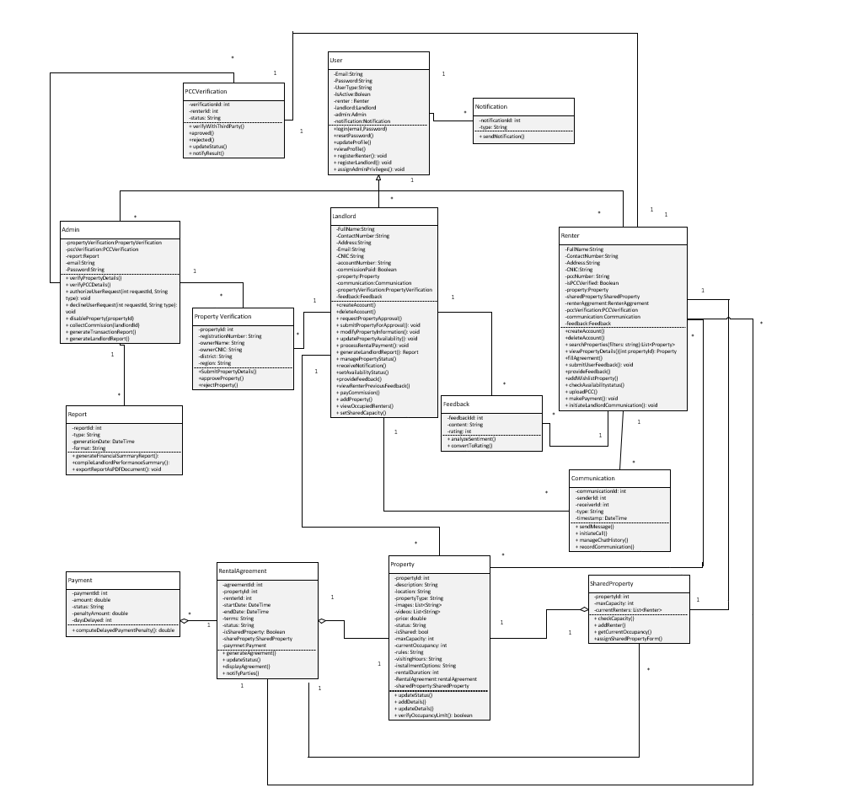

**Description**

This class diagram shows a rental management system with three major roles: Admin, Landlord, and Tenant, all derived from the User class. Admin verifies properties, users, and PCCs and produces reports. Landlord manages properties, rental agreements, and tenant feedback, while Tenant pays rent, signs agreements, and communicates with landlords. The Property class maintains rental details, and there are links to Property Verification for verifying the details of property and Shared Property Management for handling shared rentals. Payment is made for keeping a record of rent payments, and Rental Agreement maintains details about the lease. Other functionalities are Communication, Notification, and Report about system records and issues.

### Activity Diagram

1. **Login (Renter ,Landlord, Admin)**

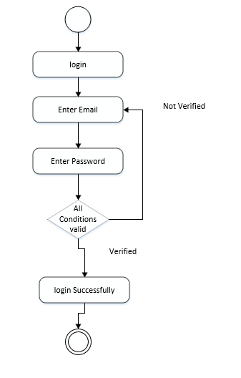

**Description:**

This diagram represents the user enters their email and password; if the email is verified, the login is successful; otherwise, verification is required.This system ensures user authentication, allowing only verified users to log in.

**2.Forget Password**

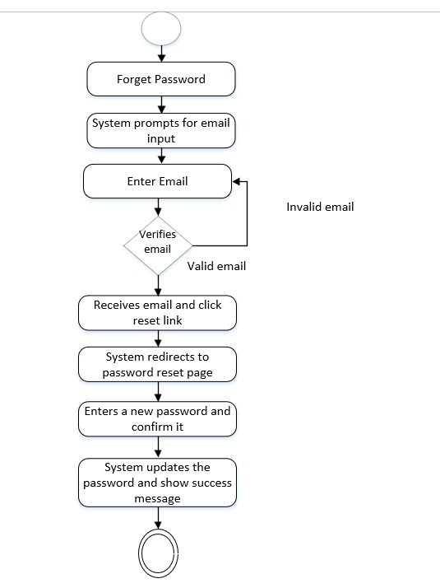

**Description:**

This diagram represents the user enters their email; if valid, they receive a reset link, which redirects them to the password reset page.After entering and confirming a new password, the system updates it and displays a success message.

**3.Account Creation (Renter)**

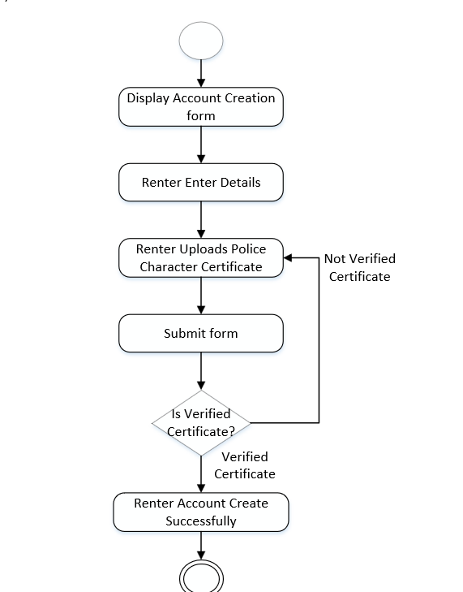

**Description:**

This diagram represent renter fills out the account creation form, uploads a police character certificate, and submits the form.If the certificate is verified, the account is successfully created; otherwise, verification is required.

**4. Account Creation (LandLord)**

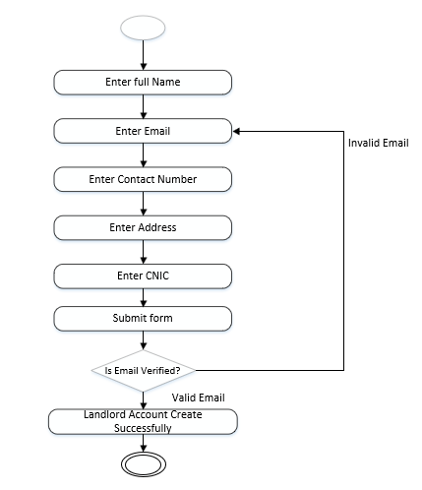

**Description:**

This diagram represents the account creation process for a landlord. It includes steps like entering full name, email, contact number, address, and CNIC, followed by form submission. If the email is invalid, the process loops back for correction. Upon valid email verification, the landlord account is created successfully.

**5.** **Update Profile (Renter, Admin and Landlord)**

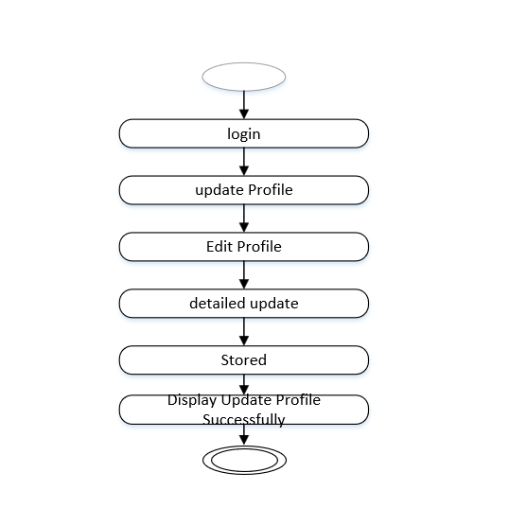

**Description:**

This diagram represents the process of updating a user profile. It starts with the user logging in, followed by updating and submitting profile changes. After submission, the system processes the update and displays the successfully updated profile. The final circle at the bottom indicates the completion of the process.

**6.View Profile(Renter, Landlord , Admin)**

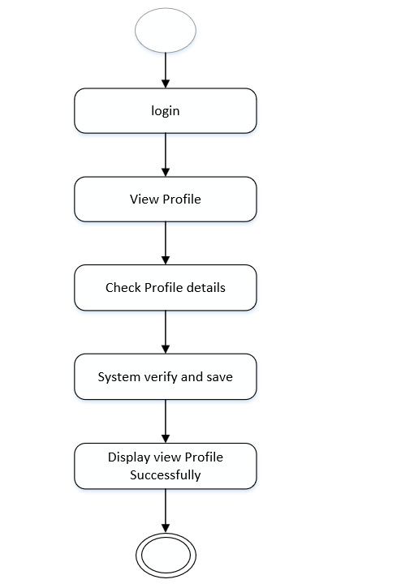

**Description:**

This diagram represents the process of viewing a user profile. It begins with the user logging in, followed by selecting the option to view the profile.The system then checks the profile details, verifies the information, and successfully displays the profile. The final circle at the bottom indicates the completion of the process.

**7. Delete Profile(Renter, Landlord , Admin)**

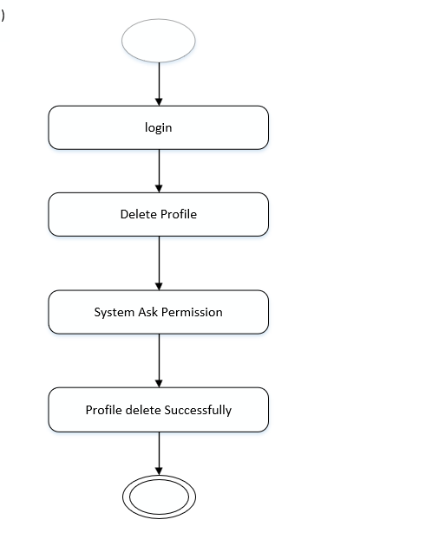

**Description:**

Users can search for properties by applying various filters, including location, budget, property type, and category. Once filters are selected, they are submitted, and the system validates the input. If the filters are valid, renters can view property details and save the property for further action, such as contacting the landlord.

**8.Verify Police Character Certificate**

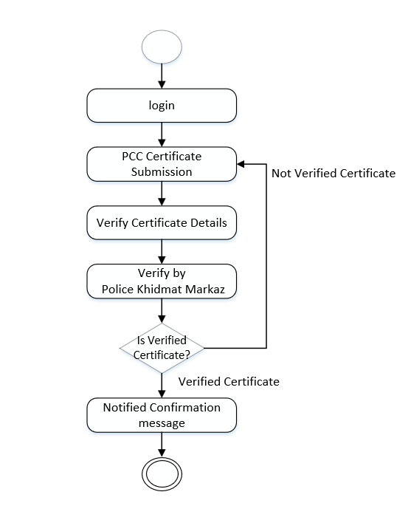

**Description:**

This diagram outlines the process of verifying a Police Character Certificate (PCC) for a renter. It begins with the renter logging in and submitting the PCC. The certificate details are then verified, followed by verification from the Police Khidmat Markaz. If the certificate is verified, a confirmation message is sent; otherwise, it remains unverified.

**9**.**Add To WishList**

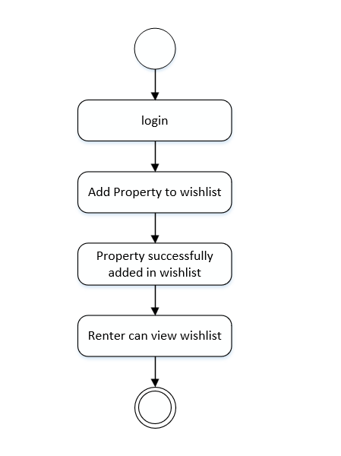

**Description:**

This diagram represents the process of adding a property to a wishlist for a renter. It starts with the renter logging into the system, then selecting a property to add to the wishlist. Once the property is successfully added, the renter can view the wishlist.

**10.Chat(LandLord With Renter)**

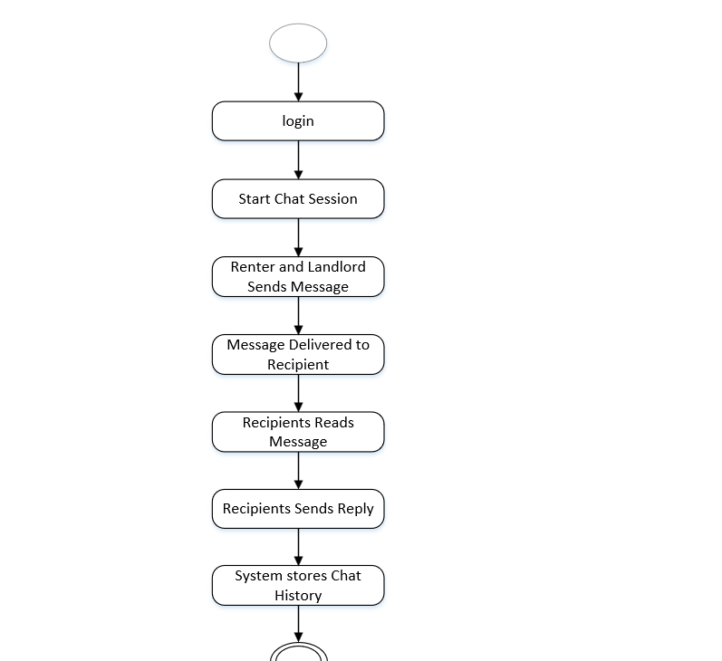

**Descripition:**

This diagram illustrates the chat session process between a renter and a landlord. The renter logs in and sends a message, which is delivered to the landlord. The landlord reads the message and sends a reply, while the system stores the chat history.

**11.Call(LandLord With Renter)**

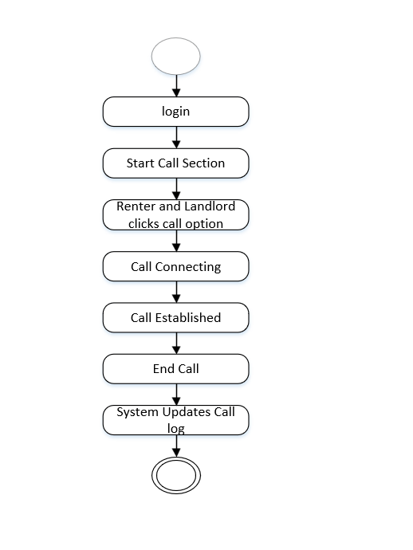

**Descripition:**

This diagram outlines the process for making a call between a tenant and a landlord. The tenant logs in and selects the call option. After the call is connected and established, either party can end the call, and the system updates the call log accordingly.

**12. Search Property**

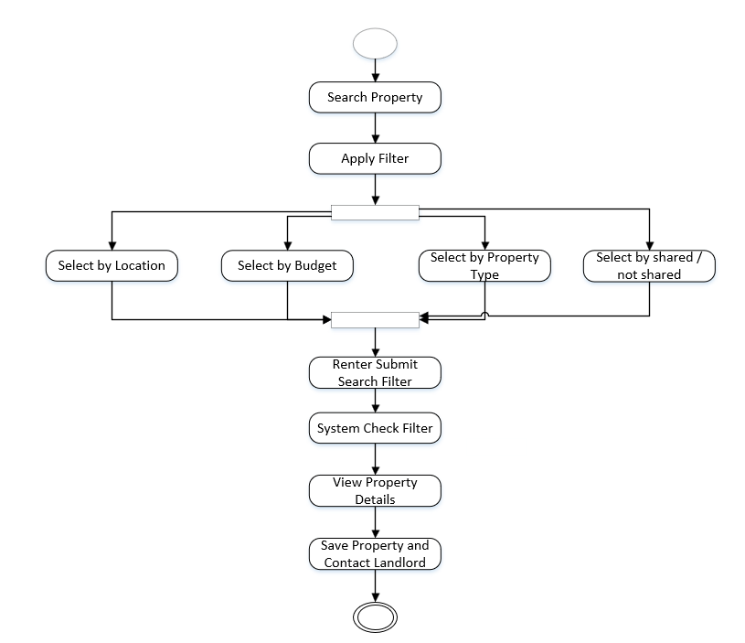

**Descripition:**

This diagram outlines the process for a tenant searching for a property. The tenant starts by searching for a property and applies filters such as location, budget, and property type. After refining the search, they review the property details and can either proceed to apply or continue refining the search criteria. Finally, the system saves the selected property for further action.

**13. Feedback Notification**

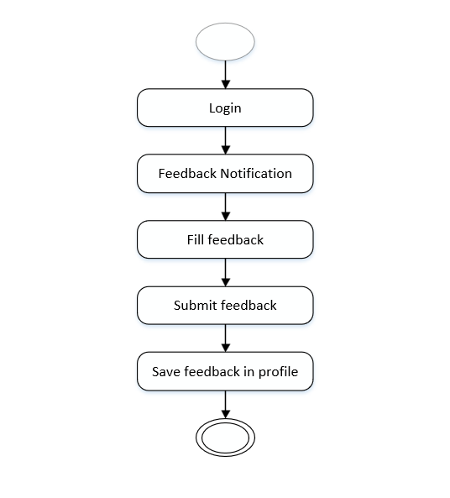

**Descripition:**

This diagram shows the process of providing feedback for a tenant or landlord. After logging in, the user receives a feedback notification and proceeds to fill out the feedback form. Once completed, the feedback is submitted and then saved in the user's profile for future reference.

**14.Send Payment**

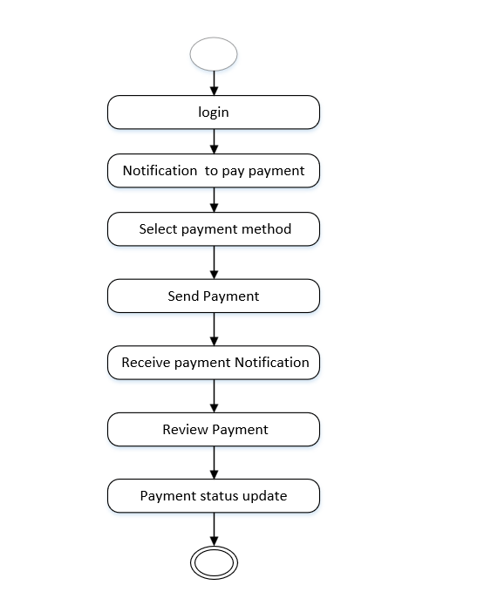

**Descripition:**

This diagram outlines the "Send Payment" process begins when the user logs into the system. Once logged in, the renter receives a notification prompting them to make a payment. After receiving the notification, the renter selects their preferred payment method and proceeds to send the payment. Once the payment is sent, the renter receives a notification confirming the transaction, and the paymenstatus is updated in the system accordingly.

### Sequence Diagram

1. **Admin Login**



**Description:**

This is the sequence diagram of the Admin Login process. The admin will be submitting his email and password, which will then be passed to the system for validation. The system checks with the database on whether the credentials are valid or not and fetches the validation result. In case the credentials match, it will redirect the admin to the dashboard else will show an error notification, ensuring safe access to the admin panel based on the verification of credentials

1. **Landlord Login**



**Description**

The sequence diagram depicts the process of account creation and login for the Landlord. In this, the Landlord will enter the account details, and the system validates and stores them in the database, thus proving that the account is created. The Landlord will then enter the email and password to log in, and the system validates these credentials with the database. If the credentials are valid, it redirects the Landlord to the dashboard; otherwise, an error notification will be displayed. This will ensure secure access and proper account creation for landlords.

1. **Renter Login and Account Creation**



**Description**

The sequence diagram depicts how a renter logs into the system and uploads his PCC. The renter enters his account details and uploads the PCC, which is sent to the system for validation. The system communicates with the database to verify the account details and PCC. If the credentials and PCC are valid, the renter is redirected to his dashboard. It promptly alerts the renter of an invalid identity and informs him that a PCC should be uploaded if he does not have one.

1. **Landlord Property Upload and Verified**



**Description**

This sequence diagram illustrates the process of property approval for landlords. When a landlord submits property details, the system checks their property count. If it's the first property, the landlord is prompted to pay a one-time commission. Upon successful payment, the system forwards the property for admin approval. The admin verifies details through PLRA and either approves or rejects the property, updating the status in the database.

1. **Renter Property Search**



**Description**

The sequence diagram illustrates the Renter login and property search process. The Renter logs in by providing credentials, which are validated by the system and database. Upon successful login, the Renter applies search filters like location, budget, or category. The system validates the filters, searches for matching properties in the database, and returns the results. If properties are available, they are displayed with an option to add them to the wishlist; otherwise, the Renter is notified that no matching properties were found.

1. **Communication Module**



**Description**

This sequence diagram illustrates the interaction between a renter and landlord through a property rental system. When a renter selects a property, the system fetches property and landlord details from the database. If the renter initiates a chat, the system retrieves the relevant chat history from the database and chat box, then provides it to the user. For calls, the renter initiates a request, and the system notifies the landlord of the incoming call. Once connected, both parties can communicate in real-time.

1. **Fill Agreement**



**Description**

This sequence diagram describes the process that a renter goes through to fill an agreement. The renter requests to fill an agreement, and the system checks the login status of the renter with the database. If the renter is logged in, the system displays agreement details, allows the renter to fill it, and finalizes the agreement. If the renter has no account, the user is asked to sign up for an account, which is then validated and created successfully before proceeding forward. In this way, the agreement can be processed by only the logged-in user.

1. **Renter Makes Payment**



**Description**

This sequence diagram shows the rent payment process from the renter to the landlord using Jazz Cash. When the renter initiates a rent payment, the system fetches the landlord’s account details from the database and validates them via Jazz Cash. If the account exists and validation is successful, the renter enters payment details, and the system processes the payment and records the transaction. A payment received notification is then sent to the landlord. If validation fails, the renter is notified that the payment cannot be processed.

1. **Payment Penality On Renters**



**Description**

This sequence diagram represents the process of applying a penalty for overdue rent payments. The system checks the status of the rent payment from the database and identifies if the payment is delayed by more than five days. It calculates a 2% penalty on the total rent and updates the payment record with the penalty in the database. The renter is notified of the overdue payment along with the penalty details. The landlord is also being informed of his updated payment status with the added penalty.

1. **Sentiment Analysis**



**Description**

This sequence diagram shows the process of feedback and rating updates between the landlord and the renter. The landlord provides feedback for the renter, which is stored in the database and analyzed by a sentiment analysis service to update the rating of the renter. In the same way, the renter provides feedback for the property, which is stored, analyzed, and used to update the rating of the property. The rating is stored to the relevant profiles after sentiment analysis converts the feedback into a rating. It means that there is transparent and accurate feedback-driven rating updates.

**11.Admin Generate Report**



**Description:**

This diagram is a sequence diagram that illustrates the process of an admin generating a report in a system. It begins with the admin logging in and navigating to the dashboard, after which the system validates the admin’s credentials via the database. Once logged in, the admin selects the "Generate Report" option and chooses a report type (e.g., Transaction). The system then fetches the relevant data from the database, compiles it, generates a PDF file, logs the activity, and finally provides a download or view option to the admin along with a confirmation message

### State Diagram

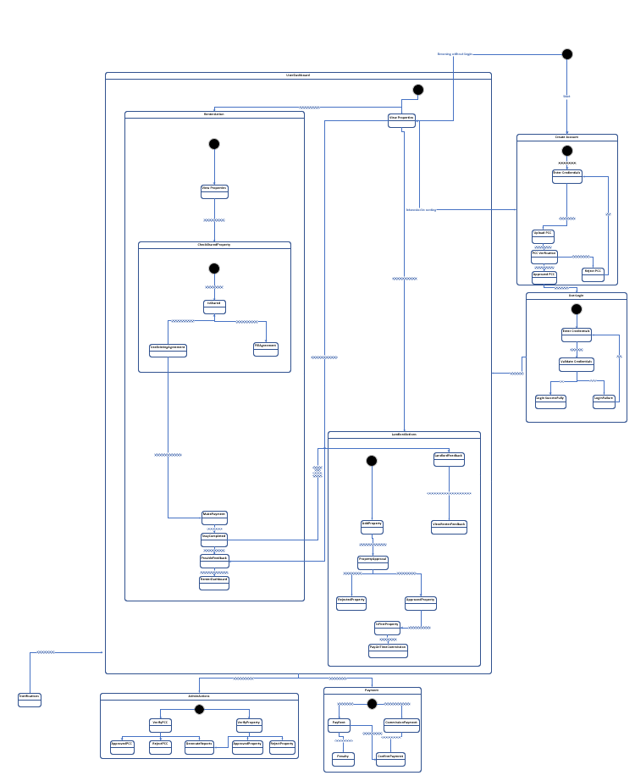

**Description**

This state diagram illustrates the workflow of a property rental system, starting with user account creation and credential validation. Users can browse properties without logging in but must log in to proceed with renting. Renters initiate the rental process by checking shared property status, uploading PCC, completing agreements, making payments, and providing feedback after their stay. Landlords can add properties for admin approval, view renter feedback given by previous landlords, and provide their own feedback after a stay is completed. Admins manage PCC and property verifications, approvals, and payment processes, including renters’ rent payments and landlords’ commission payments, ensuring smooth transactions.

### Layered Architecture



**Descripition**

This layered architecture diagram outlines the structure of a property management system. At the top, the Presentation Layer provides dashboards for the admin, landlord, and renter, serving as the user interface for each role. Below it, the Application Layer handles core modules like user authentication, property listings, payment processing, AI chatbot, and reporting. The Business Logic Layer is responsible for the system's essential APIs, including property management, renter verification, and third-party integrations. Finally, the Data Access Layer interfaces with Firebase to manage data storage and retrieval. This architecture ensures clear separation of concerns, making the system scalable, maintainable, and easier to manage.

# Human Interface Design

### Screen Images

### 

**Admin Screens**

**Welcome Screen**

* Purpose: Initial screen introducing the admin platform.
* Elements:
  + App logo and name.
* User Interaction: Admin selects the appropriate option to begin.

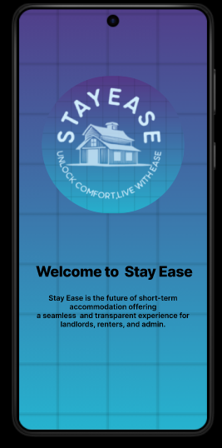

**Select User Type**

* Purpose: Identifies the role of the user.
* Elements:
  + User type options (e.g., Admin, Renter, landlord).
* User Interaction: Admin chooses the role to access relevant functionalities.

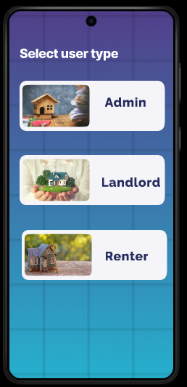

**Login**

* Purpose: Authenticates the admin to access the dashboard.
* Elements:
  + Input fields for Email and Password.
  + Button: Login.
* User Interaction: Admin enters credentials to log in.

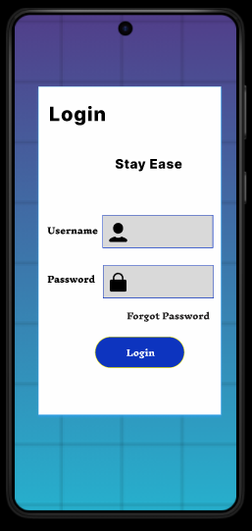

**Admin Dashboard:**

This Admin Dashboard manages property transactions, listings, reports, and PCS verifications. It features a navigation bar for quick access to Dashboard, Notifications, Search, and Reports, ensuring efficient property management.

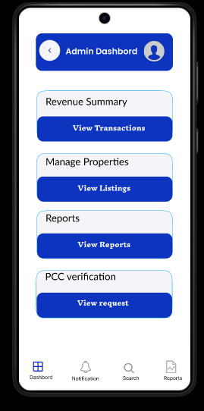

**Admin Profile:**

This Admin Profile screen in the mobile app allows administrators to update or delete their account credentials. It includes fields for email ID and password, along with Update and Delete buttons for managing profile settings efficiently.

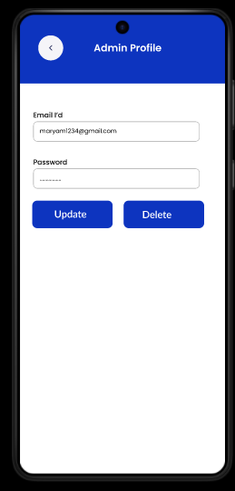

**Property Verification Requests**

* Purpose: Manage property verification requests from landlords.
* Elements:
  + List of requests with property details (e.g., Address, Landlord Name).
  + Action buttons: Approve or Reject.
* User Interaction: Admin reviews requests and decides.

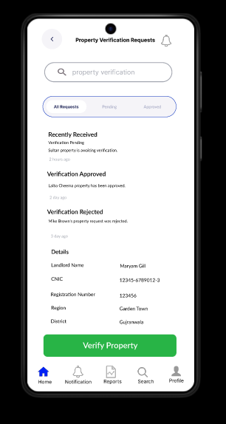

**Renter Agreement Verification**

* Purpose: Validate renter agreements submitted by landlords or renters.
* Elements:
  + Agreement details: Renter Name, Property Address, Terms.
  + Action buttons: Approve or Request Revision.
* User Interaction: Admin reviews and verifies agreements.

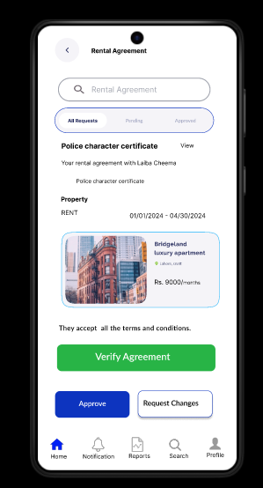

**Receive Commission Payments**

* Purpose: Record and process commission payments from landlords.
* Elements:
  + Payment details: Landlord Name, Property ID, Amount.
  + Status: Pending, Received, or Overdue.
* User Interaction: Admin marks payments as received and generates receipts if necessary.

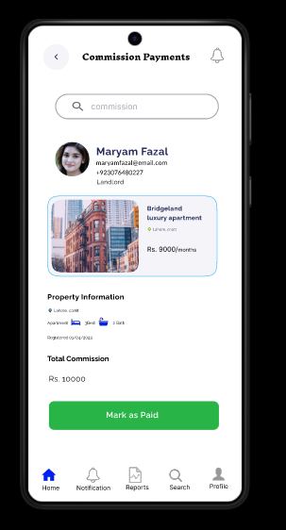

**Reports:**

This Reports screen in the Admin Dashboard provides access to Property Reports and Transaction Reports. It enables administrators to review key data related to properties and financial transactions. The navigation bar ensures quick access to Dashboard, Notifications, Search, and Reports.

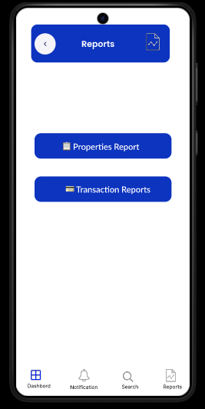

**Generate Property Listing Reports**

* Purpose: Provide insights into property listings.
* Elements:
  + Report filters: Date Range, Property Type, Location.
  + Button: Generate Report.
* User Interaction: Admin selects filters and views or downloads the report.

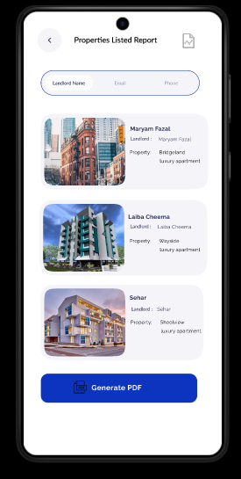

**Transaction Reports**

* Purpose: Generate detailed records of financial transactions.
* Elements:
  + Filters: Date Range, Landlord/Renter, Transaction Type.
  + Report Output: List of transactions with details like Amount, Date, Status.
* User Interaction: Admin applies filters to view or download transaction records.

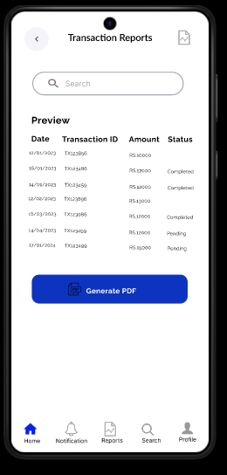

**LandLord Screens**

**Welcome Screen:**

Entry point of the app, directing users to proceed further.

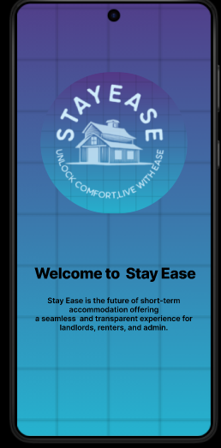

**Select User Type:**

Users select their role: renter and admin.

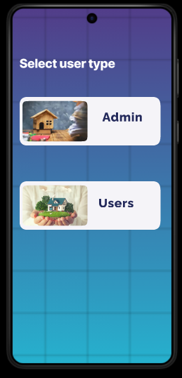

**Create Account Screen:**

Allows new users to register for an account.

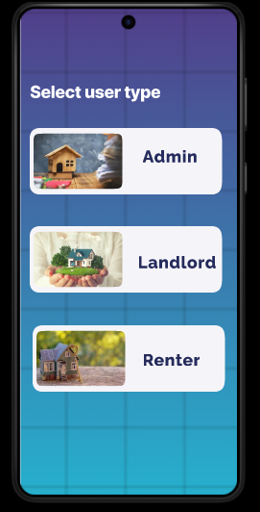

**Login Screen:**

Enables existing users to log in.

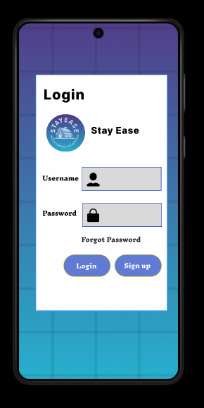

**Home Screen**

This **Home Screen** lets users , filter, and browse property listings, with options to add properties. The navigation bar provides quick access to **Home, Notifications, Payment, Search,** and **Profile**.

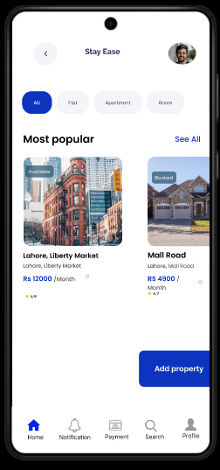

**Property Registration Request:**

**Property Request**:

Submits property details for admin review and verification.

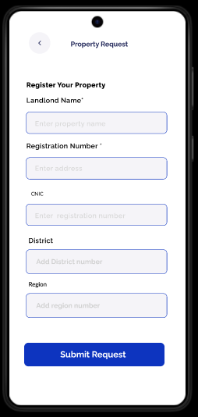

**Verification Approval Notification:**

Sends a notification confirming successful property verification.

Signals landlords that their property is now ready to list.

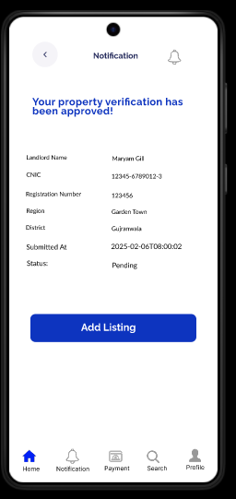

**Property Listing Screen:**

Add phone numbers, property category, and listing type.

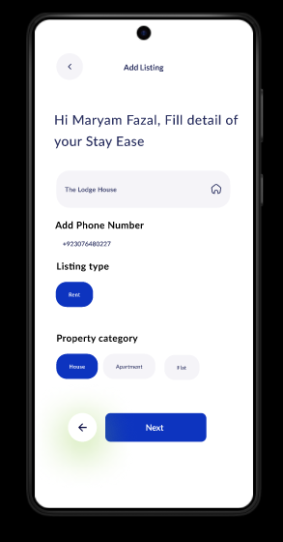

**Adding location:**

Input the exact property location using map.

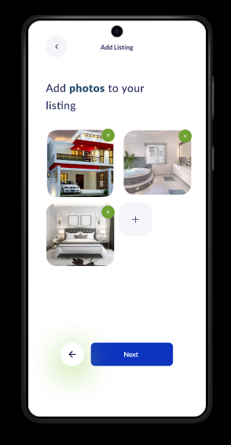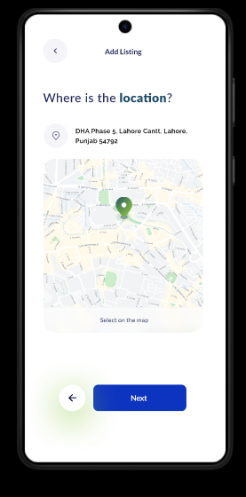

**Photos :**

Upload property images for listing.

**Video:**

Upload property Video for listing. **Rent and Features:**

Add rent price, number of bedrooms, bathrooms, and kitchens

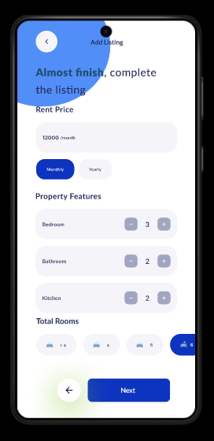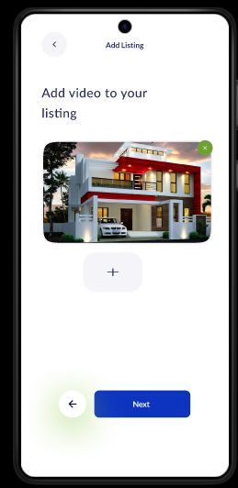

.

**Visiting Time Slots:**

Schedule available times for renters to visit.

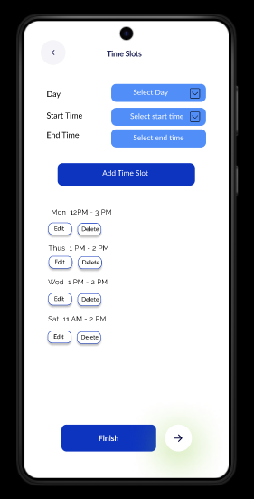

**Your listing is now published**

new

Add role and regulation

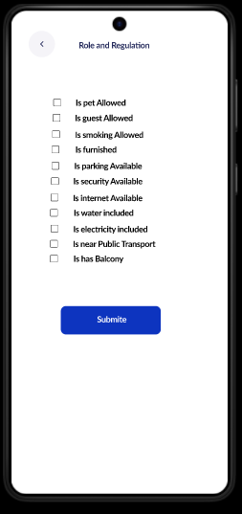

Provides feedback confirmation when the listing is published.

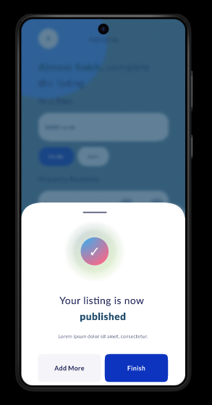

Provides feedback on errors when the listing is published

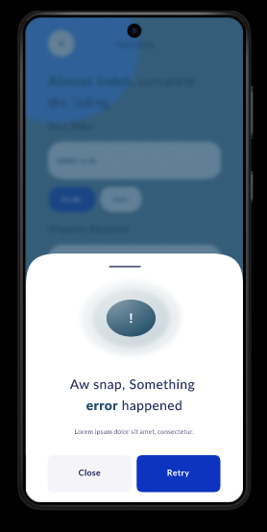

**Landlord Profile Screen:**

Displays a summary of the landlord’s transactions.

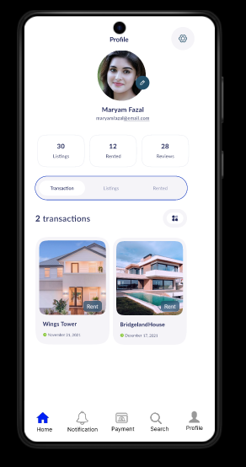

**Landlord Profile Screen:**

Displays a summary of the landlord’s property listings.

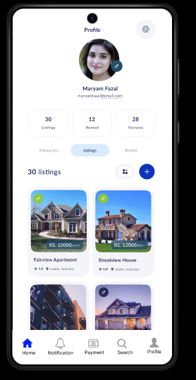

**Edit profile:**

Edit personal information

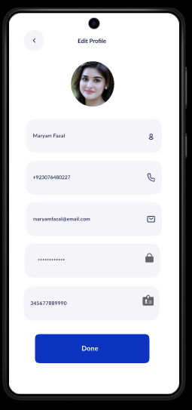

**Renter Review and Feedback Screens:**

Allows landlords to view reviews and feedback left by renters.

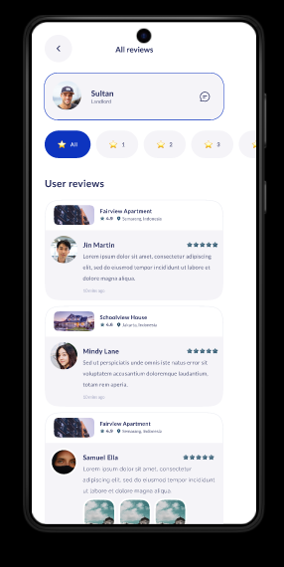

**All Notification:**

About payment received, incoming payment, Mark Residences, payment commission.

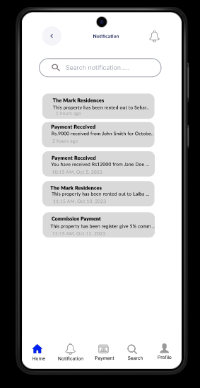

**Property Details Screen:**

Shows the specific property details chosen by renters.

Provides visibility into renter preferences.

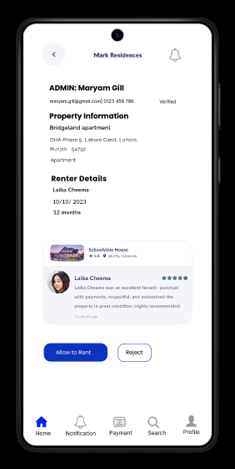

**Property Details the renter choices:­­­**

Provides visibility into renter preferences

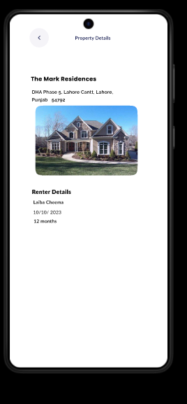

**Commission Payment Screen:**

Facilitates payment to the admin for using the platform.

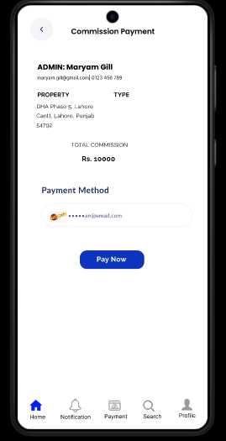

**Select Credit Card:**

Supports credit card selection and confirms successful transactions.

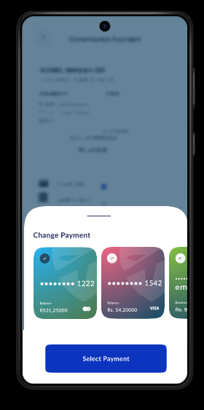

Your transaction is success transfer to Admin account:

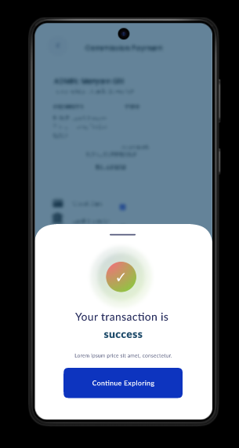

**Communication Screen:**

Renters to call landlord phone number directly.

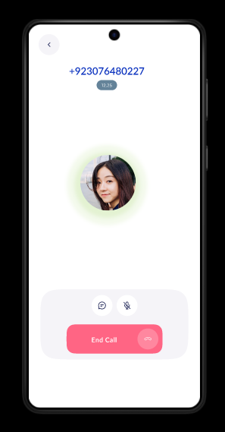

new

**Communication Screen:**

Provides features for renters chat with landlords within the app.

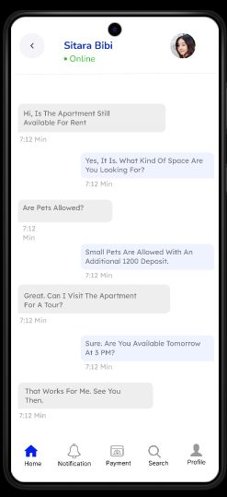

**Landlord Feedback Screen:**

Allows landlords to leave feedback about renters.

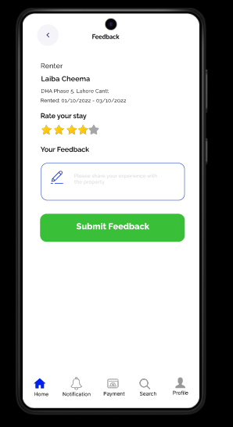

**Renter Screens**

**Welcome Screen:**

Displays a welcoming message or introduction.



**Home Screen:**

**Front Screen**

* **Purpose**: Acts as the home dashboard.
* **Elements**:
  + Search bar for properties.
  + Quick links for features like **Filters**, **Wishlist**, and **Notifications**.
  + Recent or recommended properties based on user preferences.
* **User Interaction**: Start a search or navigate to other sections (e.g., filters, wishlist).

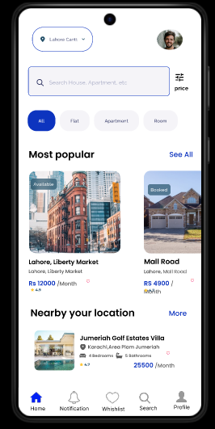

**Notification for Renter:**

• **Purpose**: Encourages users to log in or create an account to continue.

• **Elements**:

* Message box stating: “Please log in to access all features.”
* Login/Sign-Up buttons.

• **User Interaction**: Users are guided to log in or sign up before proceeding

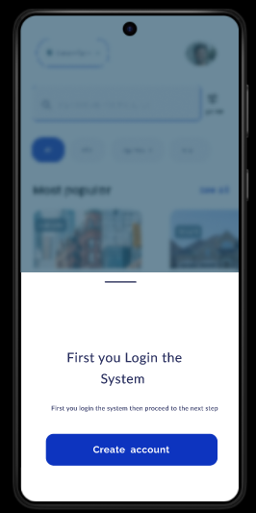

**Create Account:**

If new, the user can choose to Create Account.

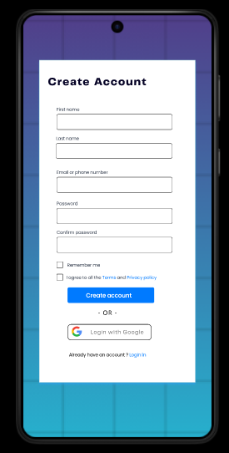

**Login:**

• **Purpose**: Authenticates users to access their profiles.

• **Elements**:

* Input fields: **Email** and **Password**.
* “Forgot Password?” link.
* **Sign-Up** button for new users.

• **User Interaction**: Users log in or create account if they don’t have an account.



**Apply location filter:**

• **Purpose**: Narrow down search results to a specific geographic area.

• **Elements**:

* Input box for entering a location or using GPS for current location.
* Dropdown or map view for selecting regions.

• **User Interaction**: Users input or select a location to apply a location filter.

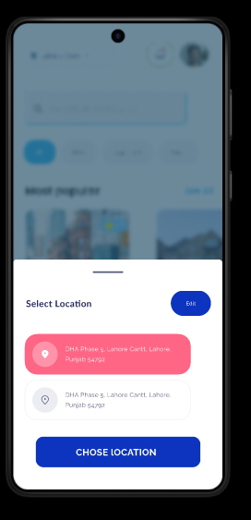

**Search Nearby Location**

* **Purpose**: Suggests properties close to the user’s location.
* **Elements**:
  + Button: **Search Nearby**.
  + List of nearby properties with distances shown.
* **User Interaction**: Users can tap on nearby results or refine further.

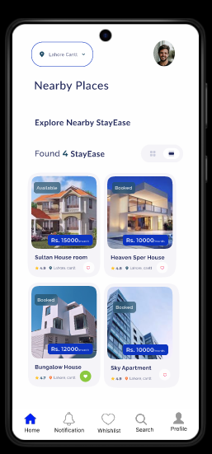

**Search Wrong Location**

* **Purpose**: Handles invalid location inputs.
* **Elements**:
  + Error message: “No properties found in this location. Try another area.”
* **User Interaction**: Users are prompted to adjust the search query.

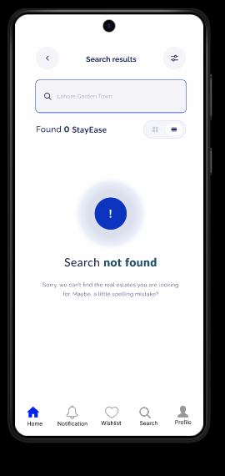

**Search Nearby Location**

* **Purpose**: Suggests properties close to the user’s location.
* **Elements**:
  + Button: **Search Nearby**.
  + List of nearby properties with distances shown.
* **User Interaction**: Users can tap on nearby results or refine further.

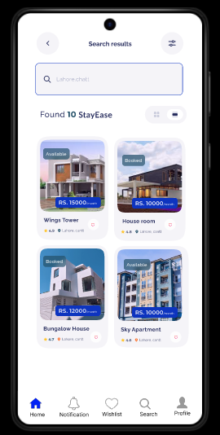

**Apply Property Type Filter**

* **Purpose**: Refine searches by property type (e.g., apartments, houses).
* **Elements**:
  + Dropdown or toggles for property types.
  + Example types: **Apartment**, **Flats**, **House**.
* **User Interaction**: Select a property type, and the results are filtered accordingly

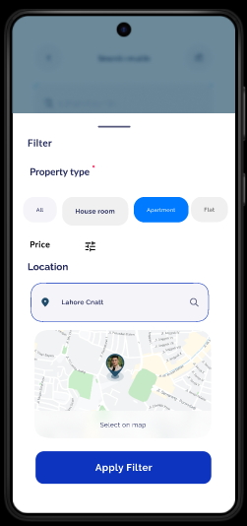

**Apartment Show on Screen**

* **Purpose**: Displays filtered results.
* **Elements**:
  + Property cards with:
    - Image.
    - Rent price.
    - Brief description (e.g., “2BHK near Downtown”).
  + Call-to-action buttons like **View Details**.
* **User Interaction**: Users browse the results and click on a property for more details.

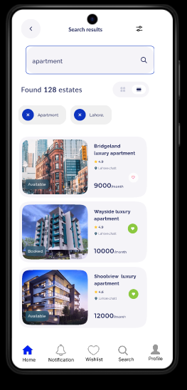

**Apply Price Filter**

* **Purpose**: Filter properties based on budget.
* **Elements**:
  + Slider or input fields for price range.
  + Example: “Rs.9000–Rs.12,000 per month.”
* **User Interaction**: Adjust price range and view updated results.

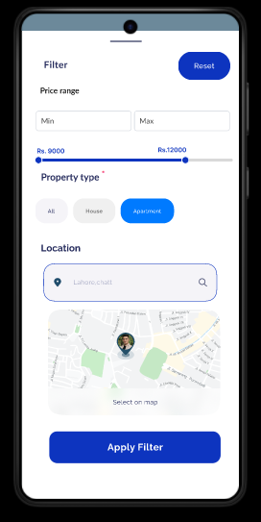

**Shown Results After All Filters**

* **Purpose**: Displays properties that meet all criteria (location, type, price).
* **Elements**:
  + Finalized list of properties.
  + Button: **Save to Wishlist** or **View Details**.
* **User Interaction**: Users browse, shortlist, or proceed to book.

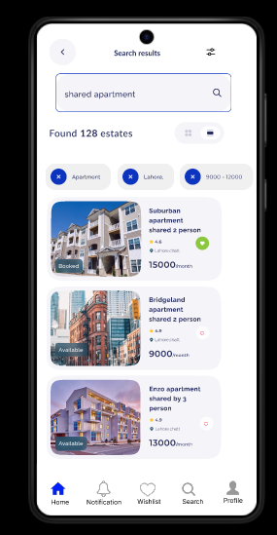

**Property Details Display**

* **Purpose**: Provides key property information.
* **Elements**:
  + Property Name.
  + Location.
  + Monthly Rent.
  + Features: Number of bedrooms and bathrooms.
  + Availability label (e.g., “Available” or “Not Available”).
  + Star rating (e.g., **4.9 stars**)
  + Landlord Name.
  + Contact options like direct call on landlord phone number or in-app chat
  + Book Now button to initiate rental requests.
  + Schedule Visit button to arrange a viewing.

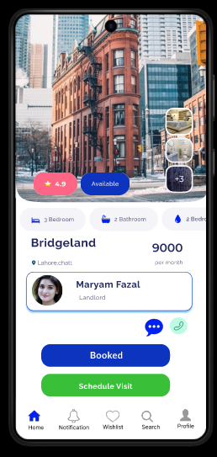

**View Reviews**

* **Purpose**: Help users make informed decisions.
* **Elements**:
  + User-submitted ratings and reviews.
  + Average rating displayed as stars.
* **User Interaction**: Read feedback on properties.

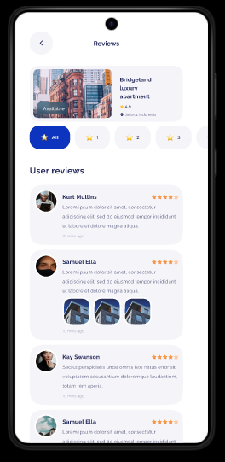

**Call to Landlord**

* **Purpose**: Directly contact landlords.
* **Elements**:
  + Button: **Call Landlord**.
  + Pop-up confirming the action before dialing.
* **User Interaction**: Users call landlords to inquire further.

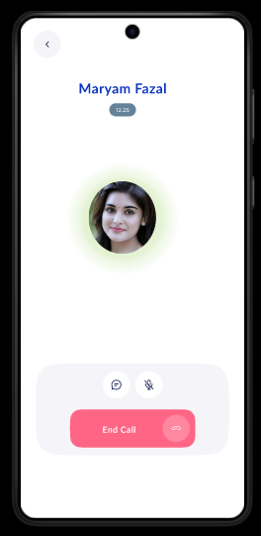

**Chat with Landlord within App**

* **Purpose**: Facilitates communication between renters and landlords.
* **Elements**:
  + In-app chat interface:
    - Message box.
    - Send button.
  + Chat history.
* **User Interaction**: Users type messages to discuss details or set up visits.

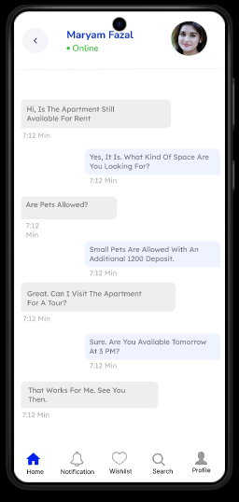

**Select Time Slot for Visiting**

* **Purpose**: Schedule property visits.
* **Elements**:
  + Calendar view for selecting dates.
  + Time slot options (e.g., “10:00 AM–12:00 PM”).
* **User Interaction**: Select a convenient slot and confirm.

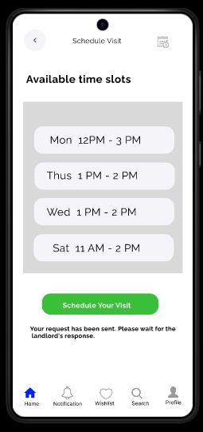

**View Wishlist**

* **Purpose**: Access saved properties.
* **Elements**:
  + List of bookmarked properties.
  + Actions like **Remove from Wishlist** or **View Details**.
* **User Interaction**: Browse and manage saved properties.

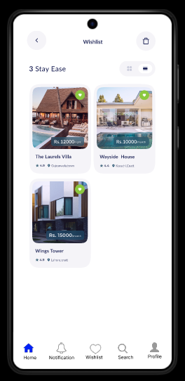

**First fill the agreement:**

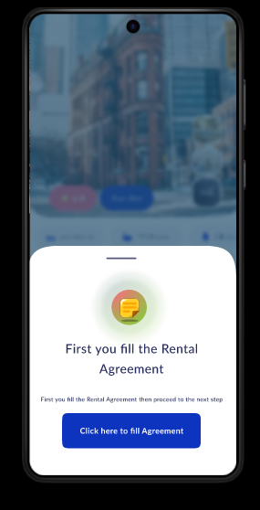

**Fill the Agreement**

* **Purpose**: Digitally sign rental agreements.
* **Elements**:
  + Digital form with:
    - Tenant details.
    - Property details.
    - Terms and conditions.
  + Signature field.
* **User Interaction**: Users review, complete, and sign the agreement.

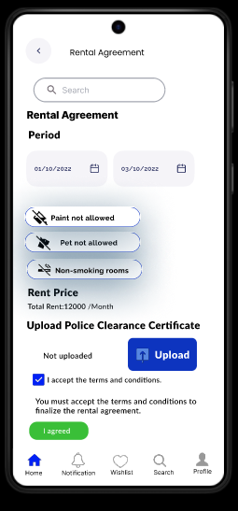

**Notification for Approved Request**

* **Purpose**: Notify renters when their request is approved.
* **Elements**:
  + Message: “Your rental request has been approved by the landlord.”
* **User Interaction**: Users can proceed to payments or other actions.

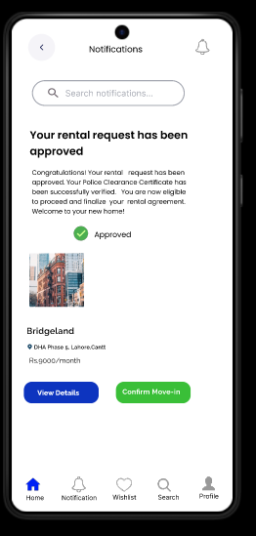

**Notification of Incoming Payment**

* **Purpose**: Alert about rent payments.
* **Elements**:
  + Reminder message for upcoming or overdue payments.
* **User Interaction**: Users are prompted to pay on time.

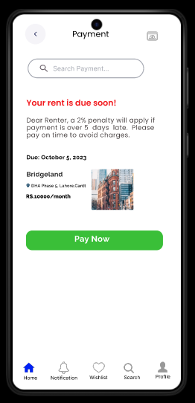

**Choose Payment Type**

This **Rent Payment** screen allows users to pay for properties. It displays property details, total amount due, payment breakdown (rent and utilities), and payment method. A **"Pay Now"** button finalizes the transaction. The navigation bar offers quick access to **Home, Notifications, Wishlist, Search,** and **Profile**.

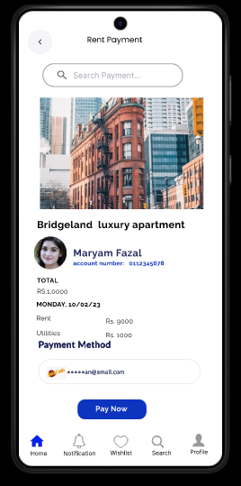

**Payment Choice**

* **Purpose**: Finalize payments.
* **Elements**:
  + Payment confirmation screen showing:
    - Amount.
    - Payment type.
    - Transaction ID (if applicable).
  + Button: **Confirm Payment**.
* **User Interaction**: Users confirm and complete the transaction.

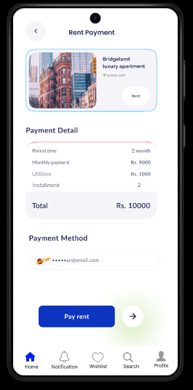

**Select Credit Card:**

Supports credit card selection and confirms successful transactions

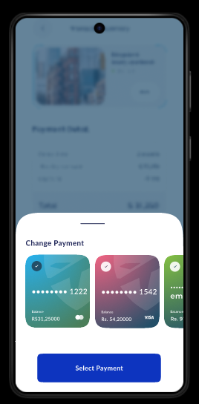

**Message:**

Your transaction is success transfer.

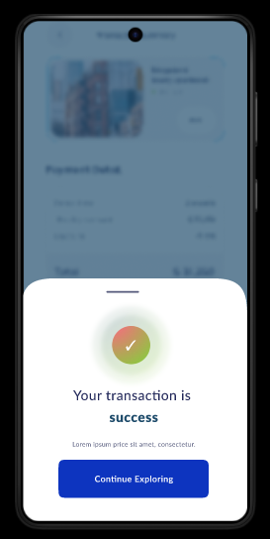

**Transaction Detail Page**

1. **Purpose**: This screen displays the details of a completed transaction, typically for a booking or purchase.
2. **Key Elements**:
   * **Header**: "Transaction Detail" indicates the purpose of the page.
   * **Image**: Displays the property or service associated with the transaction.
   * **Details Section**:
     + Shows key transaction information such as:
       - Order ID
       - Transaction Date
       - Property/Service details.
   * **Payment Details**:
     + Includes the total price, payment method, and other relevant payment information.
   * **Call-to-Action**:
     + A button at the bottom says, "Click here to add feedback," prompting the user to proceed to a feedback form.

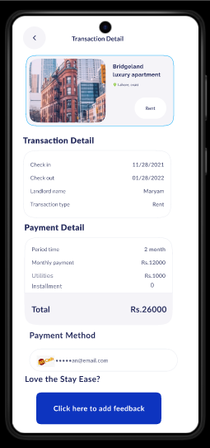

**Feedback Page**

1. **Purpose**: This screen allows the user to leave feedback about their experience with the transaction or service.
2. **Key Elements**:
   * **Header**: "Feedback" indicates the page's purpose.
   * **Image**: Shows the same property or service as in the transaction detail page, providing context for the feedback.
   * **Details Section**:
     + Displays the name of the property or service, alongside its rating and basic details.
   * **Feedback Form**:
     + A text input area for users to leave comments or suggestions.
     + A star rating system to give a numerical rating.
   * **Submit Button**:
     + Green button labeled "Submit Feedback" to finalize the feedback submission.

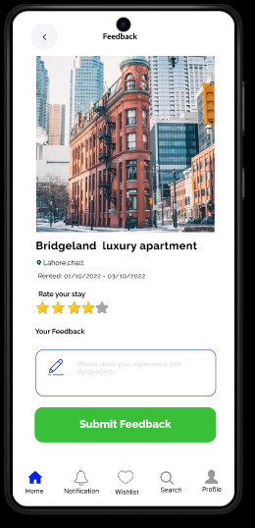

## 6 . Implementation Screens

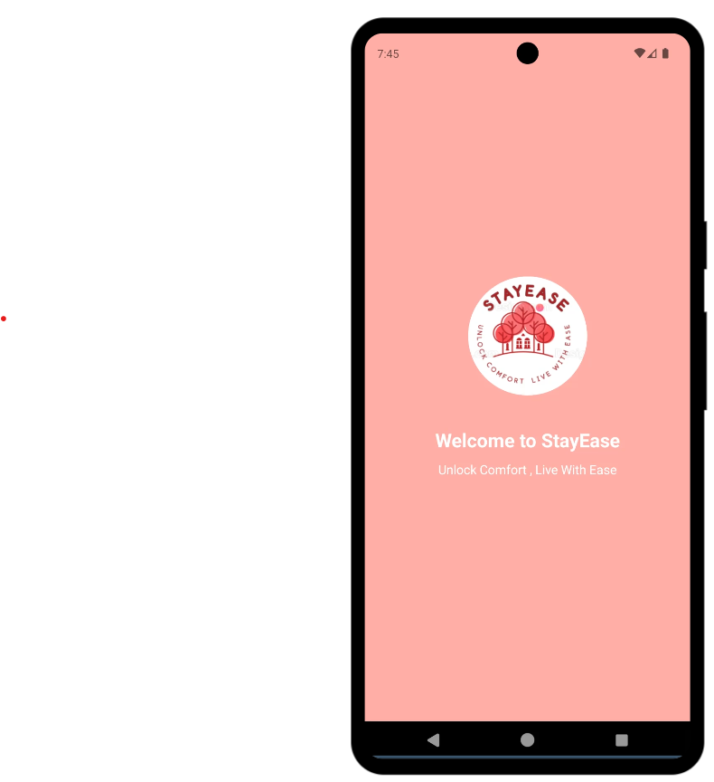

**Landlord**

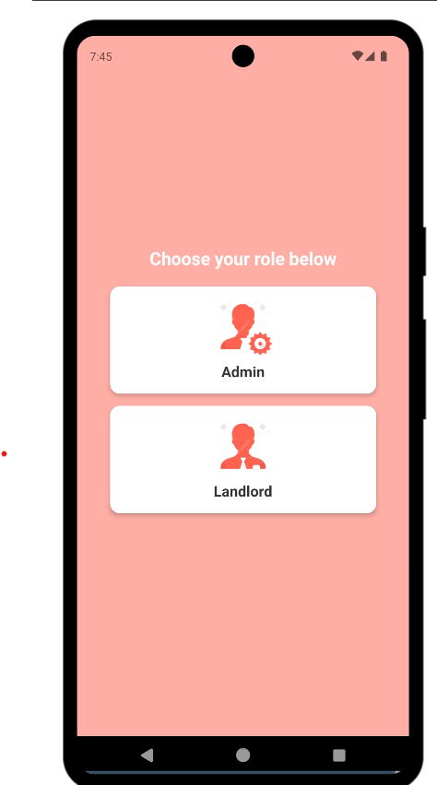

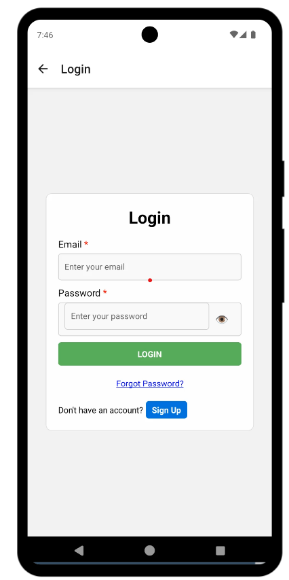

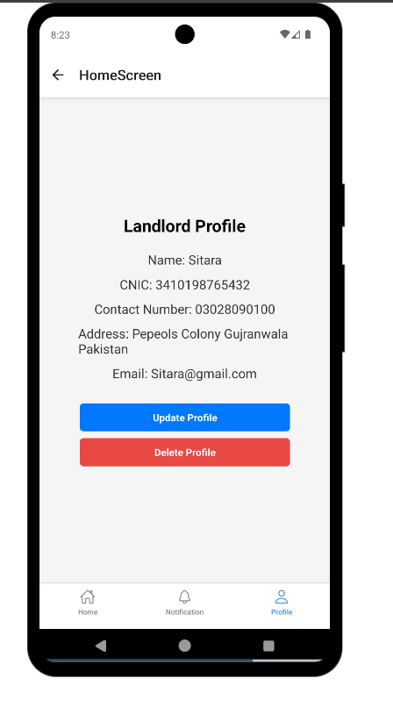

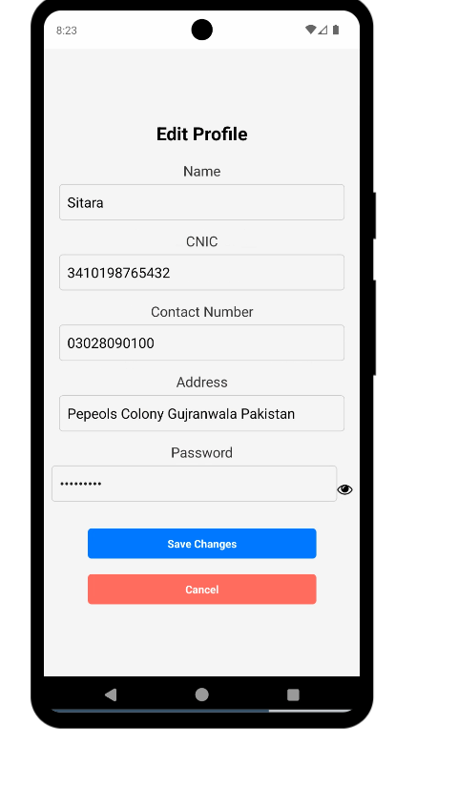

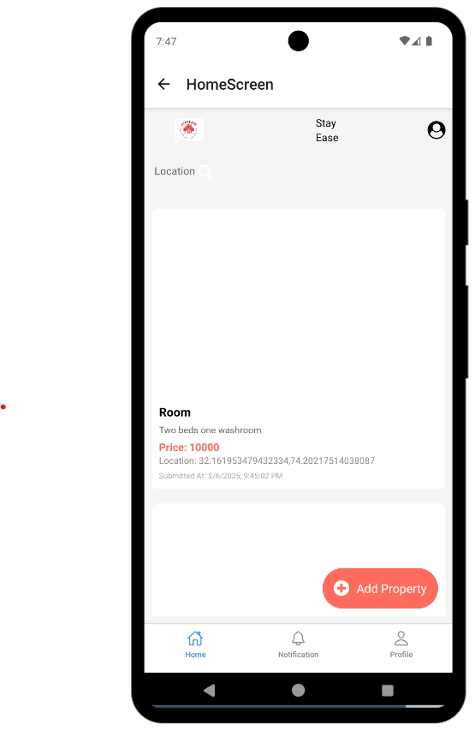

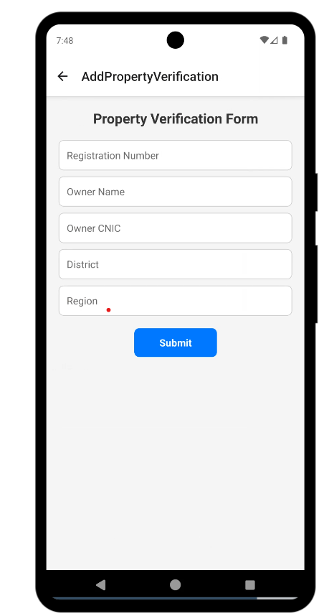

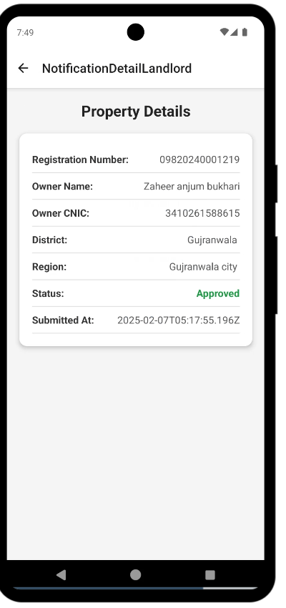

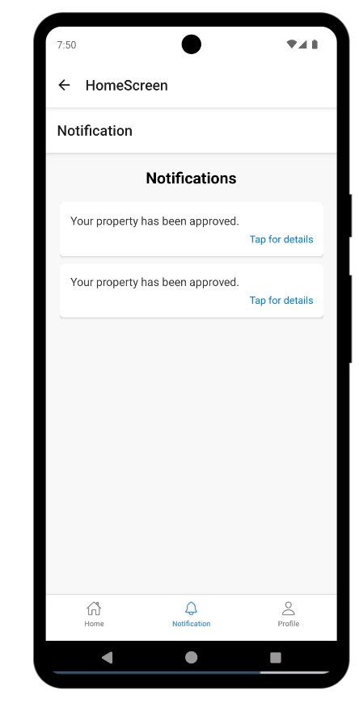

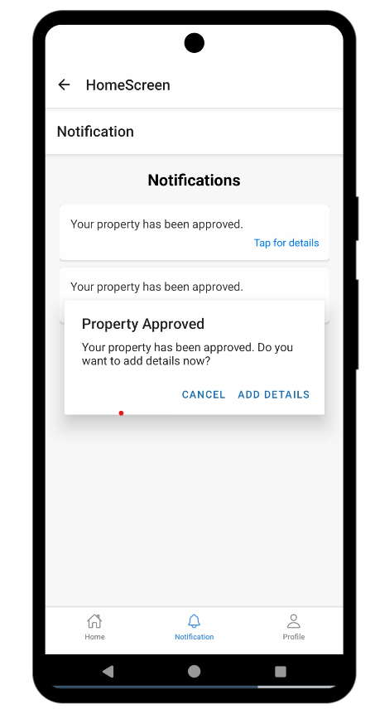

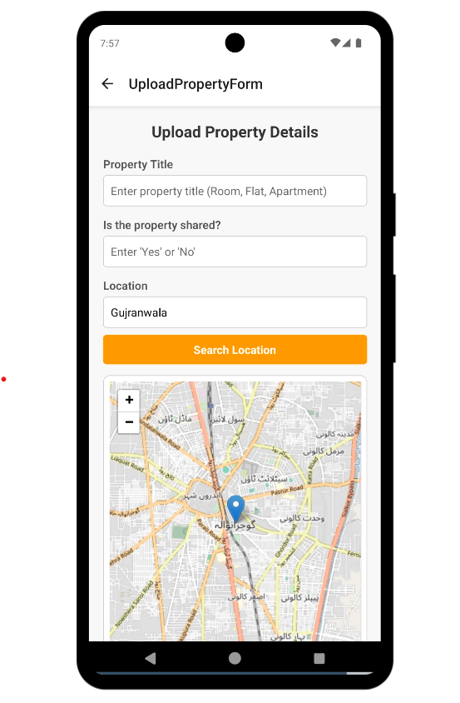

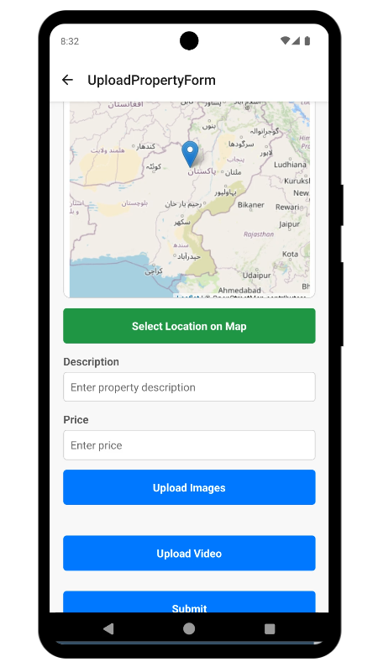

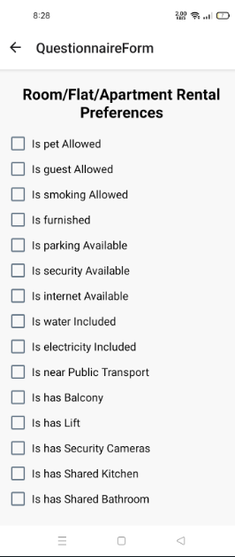

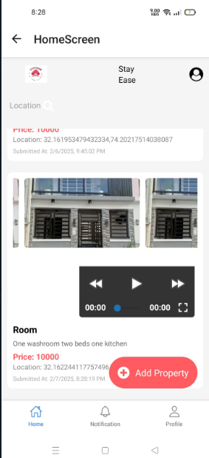

**Admin**





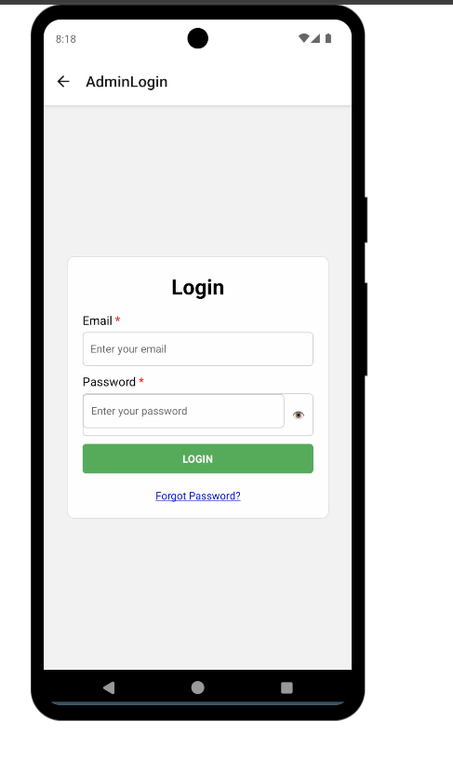

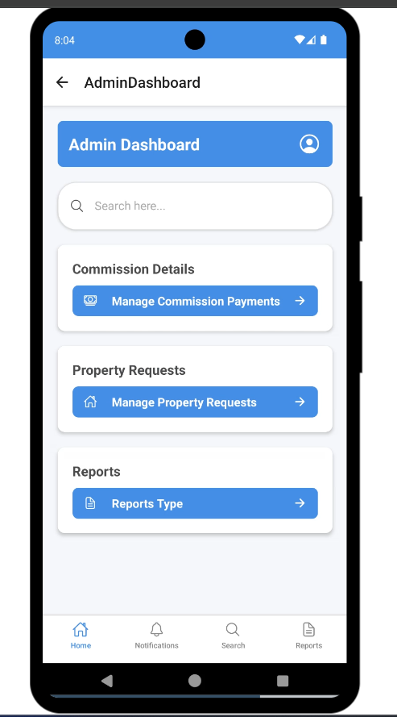

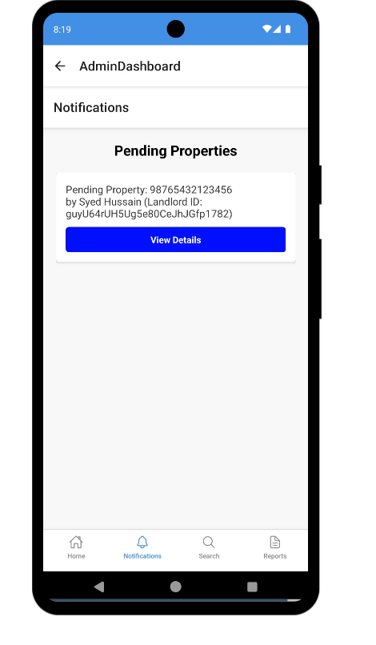

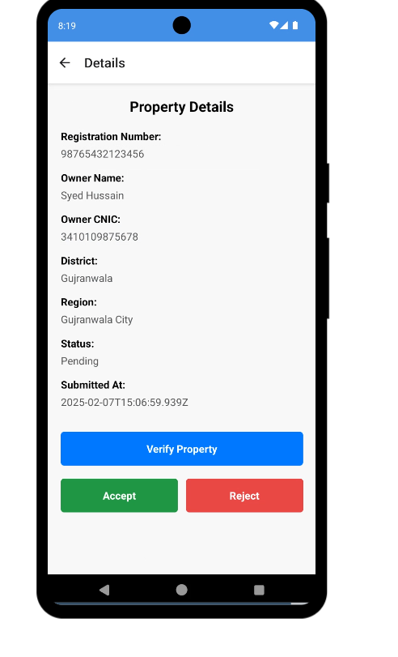

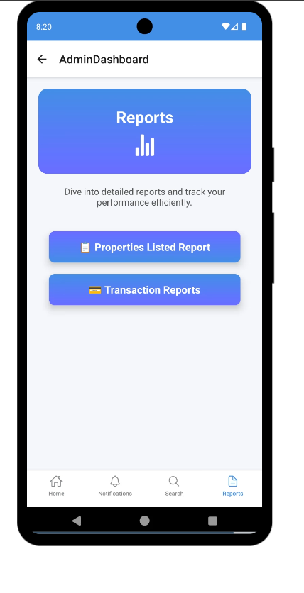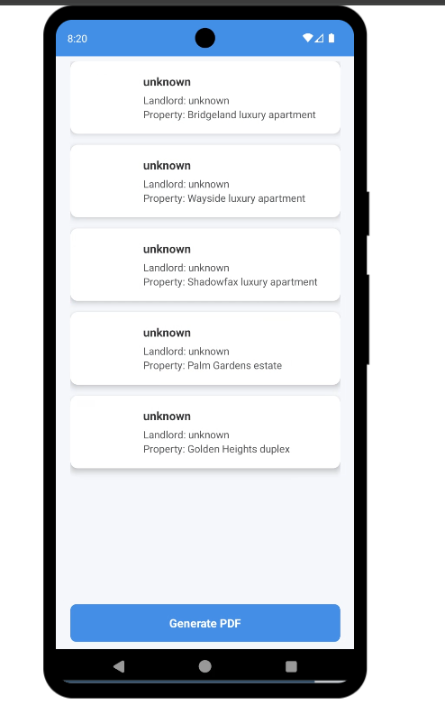

**7: Testing and Evaluation**

**7.1 Test Plan**

The purpose of this test plan is to define the strategy, approach, and resources required for testing the StayEase rental property management system. This plan covers all major functionalities of the system including the Admin, Landlord, and Tenant roles. It outlines the manual and automated testing efforts that ensure the platform is stable, reliable, and performs according to the specified requirements. The goal is to verify that each module functions correctly, integrations work smoothly, and the system delivers a seamless rental experience for users across Pakistan.

**7.2 Product Scope**

StayEase is a web-based rental management system that aims to streamline the renting process in Pakistan by connecting tenants and landlords through a centralized platform. The system enables tenants to search and rent verified properties, landlords to upload and manage their rentals, and admins to oversee the entire operation including user verification, payments, and feedback management. The software will offer key features such as property uploads, secure payment handling, rental agreements, feedback with sentiment analysis, and police clearance verification. It will not function as a general-purpose real estate marketplace or a property purchase portal. The core benefits of StayEase include enhanced transparency in property rentals, automation of agreements and payments, and a safer experience through user verifications and feedback-based controls.

**7.3 Intended Audience**

This document is intended for stakeholders involved in the StayEase project, including the project supervisor, evaluation committee, end clients (tenants, landlords), and the development team. It is designed to communicate the testing strategy and results to both technical and non-technical audiences.

**7.4 Definitions, Acronyms and Abbreviations**

|  |  |
| --- | --- |
| **SRS** | Software Require Specification |
| **PC** | Personal Computer |
| **PCC** | Police Character Certificate |
| **UM** | User Management |
| **PM** | Property Management |
| **PCM** | Police Character Management |
| **SPM** | Shared Property Management |
| **RNM** | Reporting Notification Management |
| **CM** | Communication Management |
| **FMM** | Feedback Management Module |
| **PCM** | Payment Commission Management |
| **LI** | Limitations |
| **BO** | Business Objectives |
| **SCA** | Scalability |
| **AVA** | Availability |
| **INT** | Data Integrity |
| **COM** | Compliance |
| **LOC** | Localization |
| **MAIN** | Maintainability |
| **INT** | Interoperability |

**7.5 Test Pass/Fail Criteria**

A test case will be considered passed when all steps execute successfully and the actual result matches the expected result. The test plan will be deemed complete when 100% of critical and major test cases are executed with no unresolved high-priority defects. Minor defects that do not affect core functionality may be accepted temporarily. Code coverage tools will be used to confirm that all logical paths have been tested. In UAT, the system must meet end-user expectations without causing failure or serious usability issues.

**7.6 Verification**

Verification ensures that StayEase is built according to its design and requirement documents. This includes checking all modules—admin controls, tenant search, landlord dashboards—against the system specification. It confirms the correctness of logic, security checks, user input validations, and integration points before moving to validation.

**7.7 Validation**

Validation ensures that StayEase meets the real-world needs of its users. This includes confirming that tenants can search properties, landlords can receive payments, and admins can manage feedback. If the system performs as expected in realistic scenarios and satisfies users, it is considered validated.

**7.8 Usability Testing**

Usability testing was conducted by observing several participants using the system. The goal was to assess ease of navigation, clarity of design, and the smoothness of user flow from login to rental agreement completion. A video demonstration or usability survey report link can be provided here to showcase user feedback.

**7.9 Module / Unit Testing**

Each module, such as property listing, registration, payment gateway, and feedback, was tested in isolation. Unit testing verified that forms validated correctly, calculations (like rent or security) were accurate, and proper messages displayed on success or failure. Manual input combinations were tested along with sample data.

**7.10 Integration Testing**

Integration testing focused on the data flow between modules—for example, a tenant booking a property should trigger notifications to the landlord and admin. We tested links, authentication flows, session control, and cross-module transactions to ensure they worked seamlessly.

**7.11 System Testing**

System testing covered the StayEase application as a whole, including all user roles and their interactions. We tested real scenarios such as property search, agreement generation, and feedback collection to ensure the entire system behaves as expected. This included interface design, responsiveness, and performance under different devices.

**7.12 Acceptance Testing**

Acceptance testing was conducted to verify if the application met the business goals. We involved users representing landlords and tenants to perform real tasks. The feedback indicated that the system effectively supports business requirements such as secure rentals, user verification, and digital contracts.

**7.13 Manual Testing**

Manual testing was extensively used for feature testing, UI testing, and edge case scenarios. Developers and testers interacted with the system just like end-users to identify hidden bugs and design flaws. Manual testing helped validate user flows and refine the overall experience.

**7.14 Test Cases**

Table 1: Test Case Template (Module)

### User Management Module

|  |  |  |  |
| --- | --- | --- | --- |
| **Test Id:** | TC-01 | **Test Case Designed by:** | Sumaira |
| **Test Case Title:** | Admin Login Functionality | **Test Case Executed by:** | Sumaira |
| **Module Name:** | User Management Module | **Test Case Execution Date:** | 21-04-2025 |
| **Test Data:** | Admin Email and Password | **Priority:** | High |
| **Precondition:** | | System has registered admin credentials in the database. | |
| **Steps /Action** | | **System Response** | |
| 1. Launch the Admin Login page  2. Enter valid email  3. Enter valid password  4. Click on "Login" button | | 1.System displays login form with fields for email and password  2. System accepts and validates the email format.  3. System accepts the password input.  4.System verifies the credentials against database.  5.System redirects to Admin Dashboard if credentials are correct. | |
| **Expected Result:** | | After execution, system should allow access to the admin dashboard upon entering valid email and password. | |
| **Actual Result:** | | After execution, system successfully allowed login and redirected to the admin dashboard. | |
| **Status:** | | Pass | |

|  |  |  |  |
| --- | --- | --- | --- |
| **Test Id:** | TC-02 | **Test Case Designed by:** | Sumaira |
| **Test Case Title:** | Admin Password Reset Functionality | **Test Case Executed by:** | Sumaira |
| **Module Name:** | User Management Module | **Test Case Execution Date:** | 21-04-2025 |
| **Test Data:** | Registered Admin Email Address | **Priority:** | High |
| **Precondition:** | | Admin email must be registered in the system. | |
| **Steps /Action** | | **System Response** | |
| 1. Launch the Admin Login page  2. Click on the "Forget Password" link  3. Enter registered admin email address  4. Click on "Submit"  5. Open the reset link from the email  6. Enter and confirm new password  7. Redirect to login page | | 1. System displays login form with "Forget Password" link  2. System navigates to the password reset page  3. System verifies if email exists in the database  4. System sends password reset link to the admin's email  5. System opens a new password entry form  6. System validates and updates the password  7. System redirects admin to login screen with success message | |
| **Expected Result:** | | System should send a password reset link to the registered email and allow the admin to set a new password. | |
| **Actual Result:** | | System successfully sent reset link, updated password, and redirected to login screen. | |
| **Status:** | | Pass | |

|  |  |  |  |
| --- | --- | --- | --- |
| **Test Id:** | TC-03 | **Test Case Designed by:** | Sumaira |
| **Test Case Title:** | View Admin Account Details | **Test Case Executed by:** | Sumaira |
| **Module Name:** | User Management Module | **Test Case Execution Date:** | 21-04-2025 |
| **Test Data:** | Admin Email and Password | **Priority:** | High |
| **Precondition:** | | Admin must be logged into the system and the account must exist in the database. | |
| **Steps /Action** | | **System Response** | |
| 1. Login as admin using valid email and password  2. Navigate to "Account Details" or "Profile" section  3. View account details  4. Verify displayed details | | 1. System authenticates and redirects to the admin dashboard  2. System displays a profile view page  3. System shows email and password field (password is masked for security)  4. System displays correct email and masked password matching stored records | |
| **Expected Result:** | | System should allow admin to view their account details, with email displayed and password masked. | |
| **Actual Result:** | | System successfully displayed admin account details, with email shown and password masked. | |
| **Status:** | | Pass | |

|  |  |  |  |
| --- | --- | --- | --- |
| **Test Id:** | TC-04 | **Test Case Designed by:** | Sumaira |
| **Test Case Title:** | Landlord Registration Functionality | **Test Case Executed by:** | Sumaira |
| **Module Name:** | User Management Module | **Test Case Execution Date:** | 21-04-2025 |
| **Test Data:** | Full Name, Email, Contact Number, CNIC Number, Password, Confirm Password | **Priority:** | High |
| **Precondition:** | | System is accessible and no existing account is associated with the provided email or CNIC. | |
| **Steps /Action** | | **System Response** | |
| 1. Launch the Registration page  2. Enter full name  3. Enter valid email address  4. Enter valid contact number  5. Enter valid CNIC number  6. Enter password  7. Enter confirm password  8. Click on "Register" button | | 1. System displays the registration form with required fields  2. System accepts the full name input  3. System validates and accepts the email format  4. System accepts the contact number  5. System accepts the CNIC in correct format  6. System accepts and masks password input  7. System validates that confirm password matches the password  8. System validates all fields and creates landlord account  9. System redirects to login page with success message | |
| **Expected Result:** | | System should register a new landlord account and redirect to the login page upon successful submission of valid details. | |
| **Actual Result:** | | System successfully registered landlord and redirected to login page with confirmation message. | |
| **Status:** | | Pass | |

|  |  |  |  |
| --- | --- | --- | --- |
| **Test Id:** | TC-05 | **Test Case Designed by:** | Sumaira |
| **Test Case Title:** | Landlord Login Functionality | **Test Case Executed by:** | Sumaira |
| **Module Name:** | User Management Module | **Test Case Execution Date:** | 21-04-2025 |
| **Test Data:** | Landlord Email and Password | **Priority:** | High |
| **Precondition:** | | System has registered landlord credentials in the database. | |
| **Steps /Action** | | **System Response** | |
| 1. Launch the Landlord Login page  2. Enter valid email  3. Enter valid password  4. Click on "Login" button | | 1.System displays login form with fields for email and password  2. System accepts and validates the email format.  3. System accepts the password input.  4.System verifies the credentials against database.  5.System redirects to Landlord Dashboard if credentials are correct. | |
| **Expected Result:** | | After execution, system should allow access to the landlord dashboard upon entering valid email and password. | |
| **Actual Result:** | | After execution, system successfully allowed login and redirected to the landlord dashboard. | |
| **Status:** | | Pass | |

|  |  |  |  |
| --- | --- | --- | --- |
| **Test Id:** | TC-06 | **Test Case Designed by:** | Sumaira |
| **Test Case Title:** | Landlord Password Reset Functionality | **Test Case Executed by:** | Sumaira |
| **Module Name:** | User Management Module | **Test Case Execution Date:** | 21-04-2025 |
| **Test Data:** | Registered Landlord Email Address | **Priority:** | High |
| **Precondition:** | | Landlord email must be registered in the system. | |
| **Steps /Action** | | **System Response** | |
| 1. Launch the Landlord Login page  2. Click on the "Forget Password" link  3. Enter registered landlord email address  4. Click on "Submit"  5. Open the reset link from the email  6. Enter and confirm new password  7. Redirect to login page | | 1. System displays login form with "Forget Password" link  2. System navigates to the password reset page  3. System verifies if email exists in the database  4. System sends password reset link to the landlord's email  5. System opens a new password entry form  6. System validates and updates the password  7. System redirects landlord to login screen with success message | |
| **Expected Result:** | | System should send a password reset link to the registered email and allow the admin to set a new password. | |
| **Actual Result:** | | System successfully sent reset link, updated password, and redirected to login screen. | |
| **Status:** | | Pass | |

|  |  |  |  |
| --- | --- | --- | --- |
| **Test Id:** | TC-07 | **Test Case Designed by:** | Sumaira |
| **Test Case Title:** | Landlord Account Update Functionality | **Test Case Executed by:** | Sumaira |
| **Module Name:** | User Management Module | **Test Case Execution Date:** | 21-04-2025 |
| **Test Data:** | Full Name, Email, Contact Number, CNIC Number, Password, Confirm Password | **Priority:** | High |
| **Precondition:** | | Landlord must be logged into the system and an existing account must be present. | |
| **Steps /Action** | | **System Response** | |
| 1. Login as landlord  2. Navigate to "Account Settings" or "Edit Profile" page  3. Edit full name  4. Edit email address  5. Edit contact number  6. Edit CNIC number  7. Enter new password  8. Confirm new password  9. Click on "Update" button | | 1. System redirects to the landlord dashboard  2. System displays the account update form pre-filled with existing data  3. System accepts the updated full name  4. System validates and accepts the new email format  5. System accepts the new contact number  6. System validates and accepts new CNIC  7. System accepts and masks the new password  8. System checks if the confirm password matches  9. System validates and updates the account details  10. System shows a success message and keeps the landlord on the profile page | |
| **Expected Result:** | | System should update the landlord’s account details and show a confirmation message. | |
| **Actual Result:** | | System successfully updated landlord’s account and displayed a success message. | |
| **Status:** | | Pass | |

|  |  |  |  |
| --- | --- | --- | --- |
| **Test Id:** | TC-08 | **Test Case Designed by:** | Sumaira |
| **Test Case Title:** | View Landlord Account Details | **Test Case Executed by:** | Sumaira |
| **Module Name:** | User Management Module | **Test Case Execution Date:** | 21-04-2025 |
| **Test Data:** | Landlord Login Credentials | **Priority:** | High |
| **Precondition:** | | Landlord must be logged into the system and the account must exist. | |
| **Steps /Action** | | **System Response** | |
| 1. Login as landlord  2. Navigate to "Account Settings" or "View Profile" page  3. System displays account details  4. Verify all fields are displayed correctly | | 1. System redirects to the landlord dashboard  2. System loads the profile view page  3. System shows full name, email, contact number, CNIC number in readable format (password is masked or hidden)  4. System ensures that details are current and match database records | |
| **Expected Result:** | | System should display all landlord account details (except password, which should be masked or hidden) in a readable format. | |
| **Actual Result:** | | System successfully displayed landlord’s account details, with password masked. | |
| **Status:** | | Pass | |

|  |  |  |  |
| --- | --- | --- | --- |
| **Test Id:** | TC-09 | **Test Case Designed by:** | Sumaira |
| **Test Case Title:** | Landlord Account Deletion Functionality | **Test Case Executed by:** | Sumaira |
| **Module Name:** | User Management Module | **Test Case Execution Date:** | 21-04-2025 |
| **Test Data:** | Landlord Login Credentials | **Priority:** | High |
| **Precondition:** | | Landlord must be logged into the system with an existing account. | |
| **Steps /Action** | | **System Response** | |
| 1. Login as landlord  2. Navigate to "Account Settings" or "Delete Account" section  3. Click on "Delete Account" button  4. Confirm deletion action  5. Confirm identity and proceed | | 1. System redirects to the landlord dashboard  2. System displays account details with a "Delete Account" option  3. System prompts a confirmation dialog asking for confirmation  4. System verifies identity (may prompt password/email verification)  5. System deletes the account from the database  6. System logs out the landlord and redirects to the homepage or login screen with a success message | |
| **Expected Result:** | | System should delete the landlord account, log them out, and show a success message. | |
| **Actual Result:** | | System successfully deleted the account and redirected to login page with confirmation. | |
| **Status:** | | Pass | |

|  |  |  |  |
| --- | --- | --- | --- |
| **Test Id:** | TC-10 | **Test Case Designed by:** | Sumaira |
| **Test Case Title:** | Renter Account Creation Functionality | **Test Case Executed by:** | Sumaira |
| **Module Name:** | User Management Module | **Test Case Execution Date:** | 21-04-2025 |
| **Test Data:** | Full Name, Email, Contact Number, Police Character Certificate, CNIC, Address, Password, Confirm Password | **Priority:** | High |
| **Precondition:** | | Renter must access the registration page of the system. | |
| **Steps /Action** | | **System Response** | |
| 1. Navigate to the renter registration page  2. Enter full name  3. Enter valid email address  4. Enter contact number  5. Upload Police Character Certificate (PDF/Image)  6. Enter CNIC number  7. Enter address  8. Enter password  9. Enter confirm password  10. Click "Register" button | | 1. System loads the renter account creation form  2. System accepts the input  3. System validates email format and accepts it  4. System accepts contact number  5. System uploads and verifies file format  6. System validates and accepts CNIC  7. System accepts the address  8. System accepts and masks the password  9. System checks if passwords match  10. System validates all fields, creates account, and redirects to login or dashboard page with success message | |
| **Expected Result:** | | System should allow the renter to successfully create an account after validating all required fields. | |
| **Actual Result:** | | System successfully created the renter’s account and redirected to login page with confirmation message. | |
| **Status:** | | Pass | |

|  |  |  |  |
| --- | --- | --- | --- |
| **Test Id:** | TC-11 | **Test Case Designed by:** | Sumaira |
| **Test Case Title:** | Renter Login Functionality | **Test Case Executed by:** | Sumaira |
| **Module Name:** | User Management Module | **Test Case Execution Date:** | 21-04-2025 |
| **Test Data:** | Renter Email and Password | **Priority:** | High |
| **Precondition:** | | System has registered renter credentials in the database. | |
| **Steps /Action** | | **System Response** | |
| 1. Launch the Renter Login page  2. Enter valid email  3. Enter valid password  4. Click on "Login" button | | 1.System displays login form with fields for email and password  2. System accepts and validates the email format.  3. System accepts the password input.  4.System verifies the credentials against database.  5.System redirects to Renter Dashboard if credentials are correct. | |
| **Expected Result:** | | After execution, the system should allow access to the renter dashboard upon entering valid email and password. | |
| **Actual Result:** | | After execution, system successfully allowed login and redirected to the renter dashboard. | |
| **Status:** | | Pass | |

|  |  |  |  |
| --- | --- | --- | --- |
| **Test Id:** | TC-12 | **Test Case Designed by:** | Sumaira |
| **Test Case Title:** | Renter Password Reset Functionality | **Test Case Executed by:** | Sumaira |
| **Module Name:** | User Management Module | **Test Case Execution Date:** | 21-04-2025 |
| **Test Data:** | Registered Renter Email Address | **Priority:** | High |
| **Precondition:** | | Admin email must be registered in the system. | |
| **Steps /Action** | | **System Response** | |
| 1. Launch the Renter Login page  2. Click on the "Forget Password" link  3. Enter registered renter email address  4. Click on "Submit"  5. Open the reset link from the email  6. Enter and confirm new password  7. Redirect to login page | | 1. System displays login form with "Forget Password" link  2. System navigates to the password reset page  3. System verifies if email exists in the database  4. System sends password reset link to the renter's email  5. System opens a new password entry form  6. System validates and updates the password  7. System redirects renter to login screen with success message | |
| **Expected Result:** | | System should send a password reset link to the registered email and allow the renter to set a new password. | |
| **Actual Result:** | | System successfully sent reset link, updated password, and redirected to login screen. | |
| **Status:** | | Pass | |

|  |  |  |  |
| --- | --- | --- | --- |
| **Test Id:** | TC-13 | **Test Case Designed by:** | Sumaira |
| **Test Case Title:** | View Renter Account Details | **Test Case Executed by:** | Sumaira |
| **Module Name:** | User Management Module | **Test Case Execution Date:** | 21-04-2025 |
| **Test Data:** | Renter account credentials | **Priority:** | High |
| **Precondition:** | | Renter must be logged into the system with a valid account. | |
| **Steps /Action** | | **System Response** | |
| 1. Login as renter using valid credentials  2. Navigate to “Account Details” or “Profile” section  3. View displayed fields  4. Verify all details are accurate | | 1. System redirects to the renter dashboard  2. System loads the profile view page  3. System displays full name, email, contact number, police character certificate (as file name or download link), CNIC, and address; password and confirm password fields are shown as masked  4. System confirms all data matches database records | |
| **Expected Result:** | | System should display all renter account details, with sensitive fields (password/confirm password) masked and police certificate shown as a secure view option. | |
| **Actual Result:** | | System successfully displayed renter’s profile with all information, masking passwords and showing certificate securely. | |
| **Status:** | | Pass | |

|  |  |  |  |
| --- | --- | --- | --- |
| **Test Id:** | TC-14 | **Test Case Designed by:** | Sumaira |
| **Test Case Title:** | Update Renter Account Details | **Test Case Executed by:** | Sumaira |
| **Module Name:** | User Management Module | **Test Case Execution Date:** | 21-04-2025 |
| **Test Data:** | Updated Full Name, Email, Contact Number, Police Character Certificate, CNIC, Address, Password, Confirm Password | **Priority:** | High |
| **Precondition:** | | Renter must be logged in, and account details must already exist in the system. | |
| **Steps /Action** | | **System Response** | |
| 1. Login as renter  2. Navigate to “Account Settings”  3. Update full name  4. Update email address  5. Update contact number  6. Upload new Police Character Certificate  7. Update CNIC  8. Update address  9. Enter new password and confirm password  10. Click “Save” or “Update” | | 1. System redirects to the renter dashboard  2. System loads the editable profile form  3. System accepts updated full name  4. System validates and accepts the new email  5. System accepts new contact number  6. System validates and replaces the existing certificate  7. System validates and accepts new CNIC  8. System accepts new address  9. System checks match and validates strength  10. System updates the details and shows a success message | |
| **Expected Result:** | | System should validate and save all updated renter details, replacing old data with new entries. | |
| **Actual Result:** | | System successfully updated renter profile and displayed confirmation message. | |
| **Status:** | | Pass | |

|  |  |  |  |
| --- | --- | --- | --- |
| **Test Id:** | TC-15 | **Test Case Designed by:** | Sumaira |
| **Test Case Title:** | Renter Account Deletion Functionality | **Test Case Executed by:** | Sumaira |
| **Module Name:** | User Management Module | **Test Case Execution Date:** | 21-04-2025 |
| **Test Data:** | Landlord Login Credentials | **Priority:** | High |
| **Precondition:** | | Renter must be logged into the system with an existing account. | |
| **Steps /Action** | | **System Response** | |
| 1. Login as renter  2. Navigate to "Account Settings" or "Delete Account" section  3. Click on "Delete Account" button  4. Confirm deletion action  5. Confirm identity and proceed | | 1. System redirects to the renter dashboard  2. System displays account details with a "Delete Account" option  3. System prompts a confirmation dialog asking for confirmation  4. System verifies identity (may prompt password/email verification)  5. System deletes the account from the database  6. System logs out the renter and redirects to the homepage or login screen with a success message | |
| **Expected Result:** | | System should delete the renter account, log them out, and show a success message. | |
| **Actual Result:** | | System successfully deleted the account and redirected to login page with confirmation. | |
| **Status:** | | Pass | |

### Property Management Module

|  |  |  |  |
| --- | --- | --- | --- |
| **Test Id:** | TC-16 | **Test Case Designed by:** | Maryam |
| **Test Case Title:** | Landlord Requests Property Approval | **Test Case Executed by:** | Maryam |
| **Module Name:** | Property Management Module | **Test Case Execution Date:** | 21-04-2025 |
| **Test Data:** | Property Registration Number, Property Owner Name, Owner CNIC, District, Region | **Priority:** | High |
| **Precondition:** | | Landlord is logged into the system and has access to the property approval request form. | |
| **Steps /Action** | | **System Response** | |
| 1. Landlord navigates to “Request Property Approval” section  2. Landlord fills in Property Registration Number, Owner Name, Owner CNIC, District, and Region  3. Landlord clicks on “Submit” button  4. System forwards the request to admin dashboard | | 1. System displays the property approval form  2. System validates the input fields  3. System saves the request and displays confirmation message  4. Admin dashboard shows new pending property request | |
| **Expected Result:** | | Landlord should be able to submit property approval requests successfully, and the request should be visible to admin for verification. | |
| **Actual Result:** | | System accepted the request, saved the data, and notified the admin. | |
| **Status:** | | Pass | |

|  |  |  |  |
| --- | --- | --- | --- |
| **Test Id:** | TC-17 | **Test Case Designed by:** | Maryam |
| **Test Case Title:** | Admin Receives Property Verification Requests | **Test Case Executed by:** | Maryam |
| **Module Name:** | Property Management Module | **Test Case Execution Date:** | 21-04-2025 |
| **Test Data:** | Property Owner Name, Owner CNIC, Property Registration Number, Region, District | **Priority:** | High |
| **Precondition:** | | Landlord must submit a property verification request through the system. | |
| **Steps /Action** | | **System Response** | |
| 1. Landlord logs into the system  2. Landlord navigates to “Property Verification” form  3. Landlord enters Property Owner Nam  4. Landlord enters Owner CNIC  5. Landlord enters Property Registration Number  6. Landlord selects Region from drop do  7. Landlord selects District  8. Landlord clicks “Submit Request” | | 1. System redirects to landlord dashboard  2. System displays the property verification form  3. System accepts and validates input  4. System validates CNIC format  5. System accepts the registration number  6. System populates list of districts based on region  7. System accepts the selection  8. System sends verification request to admin dashboard with success message | |
| **Expected Result:** | | 1.System should not accept the form and should show appropriate error messages for each invalid or missing field.  2.System should send the complete property verification request to the admin's dashboard for review. | |
| **Actual Result:** | | 1.System displayed validation errors and prevented submission.  2.System successfully displayed the property request on the admin dashboard with all relevant details. | |
| **Status:** | | Pass | |

|  |  |  |  |
| --- | --- | --- | --- |
| **Test Id:** | TC-18 | **Test Case Designed by:** | Maryam |
| **Test Case Title:** | Admin Verifies Property Details via PLRA Website | **Test Case Executed by:** | Maryam |
| **Module Name:** | Property Management Module | **Test Case Execution Date:** | 21-04-2025 |
| **Test Data:** | Property Registration Number, Owner CNIC, Region, District | **Priority:** | High |
| **Precondition:** | | Admin is logged into the system and a property verification request has been received. | |
| **Steps /Action** | | **System Response** | |
| 1. Admin opens the property verification request  2. Admin clicks on “Verify via PLRA” button  3. Admin enters Owner CNIC or Property Registration Number into PLRA site  4. Admin compares PLRA data with landlord-submitted data  5. Admin selects status and clicks “Save Verification” | | 1. System displays property details submitted by landlord  2. System redirects to the PLRA official website in a new tab or embedded view  3. PLRA system processes and displays property details (ownership, location, etc.)  4. System provides option to mark verification as "Verified" or "Rejected"  5. System updates the request status and logs verification action | |
| **Expected Result:** | | The system should successfully redirect to the PLRA site, allow admin to verify details, and store the verification outcome. | |
| **Actual Result:** | | System allowed admin to verify via PLRA, compare data, and save the verification status successfully. | |
| **Status:** | | Pass | |

|  |  |  |  |
| --- | --- | --- | --- |
| **Test Id:** | TC-19 | **Test Case Designed by:** | Maryam |
| **Test Case Title:** | Admin Approves Property Verification Request | **Test Case Executed by:** | Maryam |
| **Module Name:** | Property Management Module | **Test Case Execution Date:** | 21-04-2025 |
| **Test Data:** | Verified Property Request Details | **Priority:** | High |
| **Precondition:** | | Admin is logged into the system and has completed verification of the property details (e.g., through PLRA ). | |
| **Steps /Action** | | **System Response** | |
| 1. Admin navigates to “Property Verification Requests”  2. Admin selects a verified request  3. Admin clicks on “Approve” button  4. Admin confirms the approval  5. Admin returns to request list | | 1. System displays all pending verification requests  2. System displays detailed property information  3. System displays confirmation prompt  4. System updates request status to “Approved” and sends notification to the landlord  5. System reflects the updated status as “Approved” in the list | |
| **Expected Result:** | | Admin should be able to approve the property request after verification, and the system should update the status and notify the landlord. | |
| **Actual Result:** | | System successfully approved the request and notified the landlord. | |
| **Status:** | | Pass | |

|  |  |  |  |
| --- | --- | --- | --- |
| **Test Id:** | TC-20 | **Test Case Designed by:** | Maryam |
| **Test Case Title:** | |  |  | | --- | --- | | Admin Rejects Property Verification Request | | |  | | **Test Case Executed by:** | Maryam |
| **Module Name:** | Property Management Module | **Test Case Execution Date:** | 21-04-2025 |
| **Test Data:** | Invalid/Mismatched Property Details | **Priority:** | High |
| **Precondition:** | | Admin is logged in and has reviewed the property verification request. | |
| **Steps /Action** | | **System Response** | |
| 1. Admin opens “Property Verification Requests” section  2. Admin selects a request with incorrect or unverifiable details  3. Admin clicks on “Reject” button  4. Admin enters reason (e.g., “CNIC does not match PLRA record”) and confirms  5. Admin verifies the status change | | 1. System displays list of pending property verification requests  2. System shows full property and owner information  3. System prompts for a rejection reason  4. System updates the request status to “Rejected” and notifies the landlord with the reason  5. System reflects updated status as “Rejected” in the request list | |
| **Expected Result:** | | Admin should be able to reject a property verification request, provide a reason, and trigger a notification to the landlord. | |
| **Actual Result:** | | System allowed rejection with reason and sent notification to the landlord. | |
| **Status:** | | Pass | |

|  |  |  |  |
| --- | --- | --- | --- |
| **Test Id:** | TC-21 | **Test Case Designed by:** | Maryam |
| **Test Case Title:** | |  |  | | --- | --- | | Landlord Receives Notification of Approved Property Request | | |  | | **Test Case Executed by:** | Maryam |
| **Module Name:** | Property Management Module | **Test Case Execution Date:** | 21-04-2025 |
| **Test Data:** | Approved Property Request Details | **Priority:** | High |
| **Precondition:** | | Admin has approved the landlord's property request, and the landlord is logged into the system or has notifications enabled. | |
| **Steps /Action** | | **System Response** | |
| 1. Admin approves landlord’s property reque  2. System sends a notification to the landlord  3. Landlord logs into the system and navigates to notifications panel  4. Landlord views property status | | 1. System updates the property request status to “Approved”  2. Landlord receives in-app or email notification  3. System displays notification: “Your property request has been approved.”  4. System shows the updated property status as “Approved” in landlord dashboard | |
| **Expected Result:** | | Landlord should receive a clear and timely notification upon property approval, with visible status updates in the system. | |
| **Actual Result:** | | Landlord successfully received notification and viewed updated property status. | |
| **Status:** | | Pass | |

|  |  |  |  |
| --- | --- | --- | --- |
| **Test Id:** | TC-22 | **Test Case Designed by:** | Maryam |
| **Test Case Title:** | |  |  | | --- | --- | | Landlord Receives Notification of Rejected Property Request | | |  | | **Test Case Executed by:** | Maryam |
| **Module Name:** | Property Management Module | **Test Case Execution Date:** | 21-04-2025 |
| **Test Data:** | Rejected Property Request Details with Reason | **Priority:** | High |
| **Precondition:** | | Admin has rejected the landlord's property request and provided a rejection reason. Landlord is either logged in or has notifications enabled. | |
| **Steps /Action** | | **System Response** | |
| 1. Admin reviews and rejects a landlord’s property request  2. Admin submits the reason for rejection  3. System sends notification to landlord  4. Landlord logs in and checks notifications  5. Landlord checks request status | | 1. System updates the request status to “Rejected” and prompts for a rejection reason  2. System records reason and marks request as “Rejected”  3. Landlord receives in-app/email/SMS notification with rejection reason  4. System displays notification: “Your property request was rejected: [Reason]”  5. System displays status as “Rejected” in landlord dashboard with rejection reason | |
| **Expected Result:** | | Landlord should be notified promptly and clearly about the rejected request along with the reason, and the system should update the request status accordingly. | |
| **Actual Result:** | | Landlord received notification and could view the rejection reason and status in the system. | |
| **Status:** | | Pass | |

|  |  |  |  |
| --- | --- | --- | --- |
| **Test Id:** | TC-23 | **Test Case Designed by:** | Maryam |
| **Test Case Title:** | |  |  | | --- | --- | | Landlord Views Updated Property Verification Status (Rejected or Approved) | | |  | | **Test Case Executed by:** | Maryam |
| **Module Name:** | Property Management Module | **Test Case Execution Date:** | 21-04-2025 |
| **Test Data:** | Property verification status updates (Approved/Rejected) | **Priority:** | High |
| **Precondition:** | | Admin has reviewed the property request and changed the status to either "Approved" or "Rejected." | |
| **Steps /Action** | | **System Response** | |
| 1. Landlord logs into the system  2. Landlord navigates to “My Properties” section  3. Landlord views verification status of a specific property  4. Landlord clicks on a status for more details | | 1. System authenticates and redirects to dashboard  2. System displays list of property requests submitted  3. System shows updated status: “Approved” or “Rejected” along with any additional comments  4. System displays full status history and relevant remarks from the admin | |
| **Expected Result:** | | Landlord should be able to see the updated verification status of their property as either "Approved" or "Rejected" with proper context. | |
| **Actual Result:** | | System accurately showed the updated property verification status along with comments from admin. | |
| **Status:** | | Pass | |

|  |  |  |  |
| --- | --- | --- | --- |
| **Test Id:** | TC-24 | **Test Case Designed by:** | Maryam |
| **Test Case Title:** | |  |  | | --- | --- | | Landlord Updates Property Availability Status | | |  | | **Test Case Executed by:** | Maryam |
| **Module Name:** | Property Management Module | **Test Case Execution Date:** | 22-04-2025 |
| **Test Data:** | Property ID, availability status options (Available, Rented) | **Priority:** | High |
| **Precondition:** | | Landlord must be logged into the system and have at least one property registered. | |
| **Steps /Action** | | **System Response** | |
| 1. Landlord logs into the system  2. Landlord navigates to “My Properties” section  3. Landlord selects a property to update status  4. Landlord changes availability status to “Available” or “Rented”  5. Landlord refreshes or revisits the page | | 1. System verifies credentials and loads landlord dashboard  2. System displays list of properties owned by landlord  3. System shows current property details including availability status  4. System updates the status and confirms the change with a message “Status updated successfully”  5. System displays the updated availability status accordingly | |
| **Expected Result:** | | System should allow the landlord to successfully update the availability status of a property and reflect the changes immediately. | |
| **Actual Result:** | | System updated the availability status correctly and displayed confirmation message. | |
| **Status:** | | Pass | |

|  |  |  |  |
| --- | --- | --- | --- |
| **Test Id:** | TC-25 | **Test Case Designed by:** | Maryam |
| **Test Case Title:** | |  |  | | --- | --- | | Landlord Submits New Property Verification Request After Rejection | | |  | | **Test Case Executed by:** | Maryam |
| **Module Name:** | Property Management Module | **Test Case Execution Date:** | 22-04-2025 |
| **Test Data:** | Property details (Registration Number, Owner Name, CNIC, District, Region) | **Priority:** | High |
| **Precondition:** | | The previous property verification request was rejected, and the landlord is logged into the system. | |
| **Steps /Action** | | **System Response** | |
| 1. Landlord logs into the system  2. Landlord navigates to “Rejected Properties” or “My Properties” section  3. Landlord selects a rejected property and clicks “Resubmit for Verification” or fills out a new request  4. Landlord updates or confirms property details and submits the request  5. System confirms submission | | 1. System verifies credentials and redirects to dashboard  2. System displays list of rejected property requests  3. System loads property request form with pre-filled or blank details  4. System validates the data and submits the verification request  5. System shows message: “Your property verification request has been resubmitted successfully” and updates the request status to “Pending” | |
| **Expected Result:** | | Landlord should be able to successfully resubmit a rejected property verification request, and system should treat it as a new pending request. | |
| **Actual Result:** | | System allowed re-submission and changed status from “Rejected” to “Pending” as expected. | |
| **Status:** | | Pass | |

|  |  |  |  |
| --- | --- | --- | --- |
| **Test Id:** | TC-26 | **Test Case Designed by:** | Maryam |
| **Test Case Title:** | |  |  | | --- | --- | | Landlord Adds Multiple Properties | | |  | | **Test Case Executed by:** | Maryam |
| **Module Name:** | Property Management Module | **Test Case Execution Date:** | 21-04-2025 |
| **Test Data:** | Property details (Name, Registration Number, Owner CNIC, Address, District, Region) | **Priority:** | High |
| **Precondition:** | | Landlord is logged into the system and has access to the "Add Property" functionality. | |
| **Steps /Action** | | **System Response** | |
| 1. Landlord logs into the system  2. Landlord navigates to the “Add Property” section  3. Landlord enters details of the first property and clicks “Submit”  4. Landlord repeats steps to add a second (or more) property  5. Landlord navigates to “My Properties” | | 1. System verifies credentials and loads the landlord dashboard  2. System displays the property entry form  3. System validates and saves the property, displaying “Property added successfully”  4. System allows entry of new data and confirms submission of each additional property  5. System displays all properties added by the landlord including the newly added ones | |
| **Expected Result:** | | System should allow the landlord to add multiple properties and display them in the landlord’s account dashboard. | |
| **Actual Result:** | | System allowed the landlord to add multiple properties successfully and listed them all correctly. | |
| **Status:** | | Pass | |

|  |  |  |  |
| --- | --- | --- | --- |
| **Test Id:** | TC-27 | **Test Case Designed by:** | Maryam |
| **Test Case Title:** | |  |  | | --- | --- | | Landlord Adds Detailed Property Listing | | |  | | **Test Case Executed by:** | Maryam |
| **Module Name:** | Property Management Module | **Test Case Execution Date:** | 23-04-2025 |
| **Test Data:** | Location, Price, Videos (Max 2), Images (Max 5), Rules, Property Type (Shared/Unshared), Description, Installment Option, Visit Slots, Rental Duration, Property Title | **Priority:** | High |
| **Precondition:** | | Landlord is logged in and has access to the “Add Property” feature. | |
| **Steps /Action** | | **System Response** | |
| 1. Landlord navigates to the “Add Property” section  2. Landlord enters the property location  3. Landlord inputs the property price  4. Landlord uploads up to 2 videos  5. Landlord uploads up to 5 images  6. Landlord specifies rules and regulations  7. Landlord marks the property as "Shared"  8. Landlord switches to "Unshared"  9. Landlord writes a detailed description of the property  10. Landlord selects installment payment option (if available)  11. Landlord adds visit schedule slots  12. Landlord sets rental duration (e.g., 6 months)  13. Landlord selects “Room” as property title  14. Landlord selects “Flat and Apartments” | | 1. System displays the complete property input form  2. System accepts and records the location  3. System validates and stores the price  4. System verifies file types and sizes, confirms upload (shows error if more than 2)  5. System verifies file types and sizes, confirms upload (shows error if more than 5)  6. System captures and displays the entered rules  7. System sets sharing status as “Shared”  8. System updates sharing status to “Unshared”  9. System stores and previews the description  10. System enables installment details entry  11. System accepts and displays available time slots  12. System records duration  13. System saves title as Room  14. System records it as a full-fledged apartment | |
| **Expected Result:** | | The system should allow full data input with constraints on media uploads and accurately save and display all entered property listing details. | |
| **Actual Result:** | | System allowed complete property listing as expected with validations for videos, images, and all details. | |
| **Status:** | | Pass | |

|  |  |  |  |
| --- | --- | --- | --- |
| **Test Id:** | TC-28 | **Test Case Designed by:** | Maryam |
| **Test Case Title:** | |  |  | | --- | --- | | Landlord Updates Property Listing | | |  | | **Test Case Executed by:** | Maryam |
| **Module Name:** | Property Management Module | **Test Case Execution Date:** | 23-04-2025 |
| **Test Data:** | Updated Location, Price, Videos, Images, Rules, Shared/Unshared Status, Description, Installment Option, Visit Slots, Duration, Title | **Priority:** | High |
| **Precondition:** | | Landlord is logged in and has at least one property listed in the system. | |
| **Steps /Action** | | **System Response** | |
| 1. Landlord accesses “My Properties” and selects a property  2. Landlord clicks “Edit”  3. Landlord updates the property location  4. Landlord changes the price  5. Landlord uploads up to 2 new videos  6. Landlord uploads up to 5 new images  7. Landlord edits the rules and regulations  8. Landlord sets sharing type to “Shared” or “Unshared”  9. Landlord rewrites the description  10. Landlord updates installment options  11. Landlord edits visit schedule slots  12. Landlord changes the rental duration  13. Landlord selects a different property title (Room / Flat and Apartments / Apartment)  14. Landlord submits the updated form  13. Landlord selects “Room” as property title  14. Landlord selects “Flat and Apartments” | | 1. System loads selected property details  2. System opens the property edit form  3. System reflects the new location  4. System validates and updates the price  5. System replaces old videos, confirms new ones (alerts if limit exceeded)  6. System replaces old images, confirms new ones (alerts if limit exceeded)  7. System updates the rules  8. System updates sharing status  9. System saves and previews updated description  10. System validates and applies new options  11. System updates available slots  12. System saves new duration  13. System reflects updated title  14. System confirms update with “Property updated successfully” message | |
| **Expected Result:** | | System should allow editing of all provided fields, enforce upload limits, and reflect changes in the property listing. | |
| **Actual Result:** | | System updated property successfully, maintained limits, and displayed changes accurately. | |
| **Status:** | | Pass | |

|  |  |  |  |
| --- | --- | --- | --- |
| **Test Id:** | TC-29 | **Test Case Designed by:** | Maryam |
| **Test Case Title:** | |  |  | | --- | --- | | Renter Searches for Properties Using Filters | | |  | | **Test Case Executed by:** | Maryam |
| **Module Name:** | Property Management Module | **Test Case Execution Date:** | 23-04-2025 |
| **Test Data:** | Search filters: Location, Budget range, Property Type (Apartment, Flats, Rooms), Sharing status (Shared, Unshared) | **Priority:** | High |
| **Precondition:** | | The renter must be logged into the system or have access to the public property search page, and properties with diverse attributes must be available in the database. | |
| **Steps /Action** | | **System Response** | |
| 1. Renter navigates to the property search page  2. Renter selects a specific location from the filter options  3. Renter inputs a budget range (minimum and maximum values)  4. Renter selects property types such as "Apartment", "Flats", and "Rooms"  5. Renter chooses sharing criteria (Shared/Unshared)  6. Renter clicks on the "Search" button | | 1. System displays the property search interface with filter options  2. System filters properties based on the selected location  3. System narrows down the search results according to the specified budget  4. System displays properties that match the selected property types  5. System further refines the search to show properties based on sharing status  6. System processes filters and displays a list of properties that match all selected criteria | |
| **Expected Result:** | | The system should allow the renter to combine multiple filter criteria (Location, Budget, Property Type, and Sharing status) and display relevant search results that meet all specified filters. | |
| **Actual Result:** | | System successfully filtered properties and displayed a list that accurately reflects the applied search criteria. | |
| **Status:** | | Pass | |

|  |  |  |  |
| --- | --- | --- | --- |
| **Test Id:** | TC-30 | **Test Case Designed by:** | Maryam |
| **Test Case Title:** | |  |  | | --- | --- | | Renter Views Complete Property Details | | |  | | **Test Case Executed by:** | Maryam |
| **Module Name:** | Property Management Module | **Test Case Execution Date:** | 23-04-2025 |
| **Test Data:** | Property listing with full attributes (images, videos, rent amount, etc.) | **Priority:** | High |
| **Precondition:** | | Renter is on the property search results page and clicks on a specific property to view details. | |
| **Steps /Action** | | **System Response** | |
| 1. Renter clicks on a property from search results  2. Renter views property images  3. Renter views property videos  4. Renter views the detailed description  5. Renter views property rules and regulations  6. Renter views rent amount  7. Renter checks for installment payment options  8. Renter views visiting hours or schedule slots  9. Renter views property contact details  10. Renter checks if property is a Room or Apartment  11. Renter checks if property is Shared or Unshared  12. Renter views rental duration  13. Renter views ratings from previous renters | | 1. System navigates to the property details page  2. System displays a gallery or image slider with up to 5 images  3. System plays property videos (up to 2) if available  4. System shows complete property description  5. System displays any listed rules and regulations for the property  6. System displays the rent amount clearly  7. If available, system displays installment plan and terms  8. System shows available time slots or hours for visits  9. System displays landlord or contact person's information  10. System displays the type of property  11. System indicates property sharing status  12. System displays duration (e.g., monthly, yearly)  13. System displays rating stars and feedback if available | |
| **Expected Result:** | | Renter should be able to view all detailed property attributes clearly and without error. | |
| **Actual Result:** | | System successfully displayed all relevant property details with accurate data as per listing. | |
| **Status:** | | Pass | |

|  |  |  |  |
| --- | --- | --- | --- |
| **Test Id:** | TC-31 | **Test Case Designed by:** | Maryam |
| **Test Case Title:** | Auto-disable Property After 3 Negative Feedbacks | **Test Case Executed by:** | Maryam |
| **Module Name:** | Property Management Module | **Test Case Execution Date:** | 24-04-2025 |
| **Test Data:** | Property with 3 negative feedback submissions | **Priority:** | High |
| **Precondition:** | | A property listing exists and has feedback collection enabled. | |
| **Steps /Action** | | **System Response** | |
| 1. A renter submits negative feedback for a property  2. Two additional renters submit negative feedback  3. System reaches 3 negative feedbacks for the same listing  4. Admin reviews and confirms disablement | | 1. System logs the feedback and checks existing count  2. System tracks cumulative feedback count for the property  3. System flags the property and sends a disable request to the admin panel  4. System disables the property from public listings | |
| **Expected Result:** | | The system automatically flags and disables the property after three negative feedbacks, pending admin confirmation. | |
| **Actual Result:** | | Property disabled correctly after 3 negative feedbacks. | |
| **Status:** | | Pass | |

### Police Character Certificate Management Module

|  |  |  |  |
| --- | --- | --- | --- |
| **Test Id:** | TC-32 | **Test Case Designed by:** | Maryam |
| **Test Case Title:** | |  |  | | --- | --- | | Renter Submits Police Character Certificate for Approval | | |  | | **Test Case Executed by:** | Maryam |
| **Module Name:** | Police Character Certificate Management Module | **Test Case Execution Date:** | 23-04-2025 |
| **Test Data:** | Valid police character certificate (PDF/Image file) | **Priority:** | High |
| **Precondition:** | | Renter has created an account and is logged into the system. | |
| **Steps /Action** | | **System Response** | |
| 1. Renter logs into the system  2. Renter navigates to “Submit Police Certificate” section  3. Renter uploads police character certificate file  4. Renter clicks “Submit for Approval”  5. System notifies admin of new submission | | 1. System displays renter dashboard  2. System displays submission interface  3. System validates file format and size  4. System uploads the file and displays confirmation message  5. Admin receives notification to verify the certificate | |
| **Expected Result:** | | Renter should be able to successfully submit a police character certificate, and the admin should be notified for verification. | |
| **Actual Result:** | | Renter submitted the certificate and admin was notified. | |
| **Status:** | | Pass | |

|  |  |  |  |
| --- | --- | --- | --- |
| **Test Id:** | TC-33 | **Test Case Designed by:** | Maryam |
| **Test Case Title:** | |  |  | | --- | --- | | Admin Receives Police Character Certificate Verification Notification | | |  | | **Test Case Executed by:** | Maryam |
| **Module Name:** | Police Character Certificate Management Module | **Test Case Execution Date:** | 23-04-2025 |
| **Test Data:** | Submitted police character certificate by renter | **Priority:** | High |
| **Precondition:** | | A renter has submitted their police character certificate for verification. | |
| **Steps /Action** | | **System Response** | |
| 1. Renter uploads police character certificate during account creation or update  2. System processes the certificate for verification (manual)  3. Admin logs into the dashboard  4. Admin clicks on the notification | | 1. System uploads the certificate successfully and triggers verification  2. System logs the certificate into the verification module  3. System displays a notification alert regarding a new police certificate verification request  4. System opens the certificate details for review and verification processing | |
| **Expected Result:** | | Admin should receive a timely and clear notification regarding each new police character certificate submission. | |
| **Actual Result:** | | Admin received notification and accessed the certificate verification interface successfully. | |
| **Status:** | | Pass | |

|  |  |  |  |
| --- | --- | --- | --- |
| **Test Id:** | TC-34 | **Test Case Designed by:** | Maryam |
| **Test Case Title:** | |  |  | | --- | --- | | Admin Verifies Police Character Certificates via Police Khidmat Markaz Website | | |  | | **Test Case Executed by:** | Maryam |
| **Module Name:** | Police Character Certificate Management Module | **Test Case Execution Date:** | 23-04-2025 |
| **Test Data:** | Renter's Police Character Certificate | **Priority:** | High |
| **Precondition:** | | Renter has submitted a police character certificate for verification. | |
| **Steps /Action** | | **System Response** | |
| 1. Admin logs into the system  2. Admin navigates to the “Police Certificate Verifications” section  3. Admin clicks “Verify” on a specific request  4. Admin clicks the third-party verification link  5. Admin manually verifies the certificate details using the third-party site  6. Admin returns to system and marks certificate as “Verified” or “Rejected” | | 1. System displays the admin dashboard  2. System lists all pending police certificate verification requests  3. System opens verification interface with details and a link to the Police Khidmat Markaz website  4. System redirects admin to the Police Khidmat Markaz website in a new tab or window  5. Admin cross-checks the information  6. System updates the verification status accordingly and notifies the renter | |
| **Expected Result:** | | Admin should be able to access the third-party site for verification and update the certificate status in the system. | |
| **Actual Result:** | | Admin successfully verified the certificate using the Police Khidmat Markaz site and updated the verification status. | |
| **Status:** | | Pass | |

|  |  |  |  |
| --- | --- | --- | --- |
| **Test Id:** | TC-35 | **Test Case Designed by:** | Maryam |
| **Test Case Title:** | |  |  | | --- | --- | | Admin Approves/Rejects Police Character Certificate Requests | | |  | | **Test Case Executed by:** | Maryam |
| **Module Name:** | Police Character Certificate Management Module | **Test Case Execution Date:** | 23-04-2025 |
| **Test Data:** | Submitted police character certificates by renters | **Priority:** | High |
| **Precondition:** | | Police character certificate requests are available in the admin dashboard. | |
| **Steps /Action** | | **System Response** | |
| 1. Admin logs into the system  2. Admin navigates to “Police Certificate Verifications” section  3. Admin selects a certificate request  4. Admin clicks “Approve” or “Reject” based on certificate validity  5. System sends a notification to the renter about the approval/rejection | | 1. System displays the admin dashboard  2. System lists pending certificate verification requests  3. System displays the certificate details for review  4. System updates the certificate status accordingly  5. Renter receives status update notification | |
| **Expected Result:** | | Admin should be able to approve or reject police character certificate requests and renter should be notified of the outcome. | |
| **Actual Result:** | | Admin successfully approved/rejected the request and renter was notified. | |
| **Status:** | | Pass | |

|  |  |  |  |
| --- | --- | --- | --- |
| **Test Id:** | TC-36 | **Test Case Designed by:** | Sehar |
| **Test Case Title:** | |  |  | | --- | --- | | Restrict Agreement Process on Rejected Police Certificate | | |  | | **Test Case Executed by:** | Sehar |
| **Module Name:** | Police Character Certificate Management Module | **Test Case Execution Date:** | 23-04-2025 |
| **Test Data:** | Renter account with rejected police character certificate | **Priority:** | High |
| **Precondition:** | | Renter’s police character certificate has been reviewed and marked as Rejected by admin. | |
| **Steps /Action** | | **System Response** | |
| 1. Renter logs into the system  2. Renter attempts to proceed with rental agreement  3. System detects that the certificate status is "Rejected" | | 1. System displays renter dashboard  2. System checks certificate status  3. System displays error message and blocks rental agreement process | |
| **Expected Result:** | | Renter should not be able to proceed with the rental agreement if their police character certificate has been rejected. | |
| **Actual Result:** | | System blocked the agreement process and displayed rejection notice. | |
| **Status:** | | Pass | |

### Shared Property Management Module

|  |  |  |  |
| --- | --- | --- | --- |
| **Test Id:** | TC-37 | **Test Case Designed by:** | Sehar |
| **Test Case Title:** | |  |  | | --- | --- | | Define Maximum Capacity for Shared Property | | |  | | **Test Case Executed by:** | Sehar |
| **Module Name:** | Shared Property Management Module | **Test Case Execution Date:** | 23-04-2025 |
| **Test Data:** | Shared property form with capacity field | **Priority:** | High |
| **Precondition:** | | Landlord is logged in and has initiated the property listing or update process for a shared property. | |
| **Steps /Action** | | **System Response** | |
| 1. Landlord navigates to “Add/Edit Property” form  2. Landlord selects “Shared” property option  3. Landlord enters a valid number (e.g., 4) in the “Maximum Capacity” field  4. Landlord submits the form | | 1. System displays property form interface  2. System reveals “Maximum Capacity” field  3. System validates the input  4. System saves the property details with maximum capacity | |
| **Expected Result:** | | System should allow the landlord to enter and save the maximum capacity for the shared property. | |
| **Actual Result:** | | System accepted and stored the maximum capacity value for the shared property. | |
| **Status:** | | Pass | |

|  |  |  |  |
| --- | --- | --- | --- |
| **Test Id:** | TC-38 | **Test Case Designed by:** | Sehar |
| **Test Case Title:** | |  |  | | --- | --- | | View List of Renters in Shared Property | | |  | | **Test Case Executed by:** | Sehar |
| **Module Name:** | Shared Property Management Module | **Test Case Execution Date:** | 23-04-2025 |
| **Test Data:** | Shared property with multiple active renter entries | **Priority:** | High |
| **Precondition:** | | Landlord is logged in and has at least one shared property with approved and active renters. | |
| **Steps /Action** | | **System Response** | |
| 1. Landlord logs into the system  2. Landlord navigates to "My Properties"  3. Landlord selects a shared property from the list  4. Landlord clicks on "View Renters" | | 1. System displays landlord dashboard  2. System displays list of all landlord’s properties  3. System shows shared property details  4. System displays a list of renters occupying the shared property with details (e.g., name, contact info, duration) | |
| **Expected Result:** | | System should display a complete list of renters currently occupying the selected shared property. | |
| **Actual Result:** | | System displayed the list of renters for the shared property with all relevant details. | |
| **Status:** | | Pass | |

|  |  |  |  |
| --- | --- | --- | --- |
| **Test Id:** | TC-39 | **Test Case Designed by:** | Sehar |
| **Test Case Title:** | |  |  | | --- | --- | | Prompt Renter to Refill Previously Filled Form | | |  | | **Test Case Executed by:** | Sehar |
| **Module Name:** | Shared Property Management Module | **Test Case Execution Date:** | 23-04-2025 |
| **Test Data:** | Previously submitted renter form data | **Priority:** | High |
| **Precondition:** | | Renter is logged in and has previously filled out a specific form (e.g., rental agreement form, police certificate | |
| **Steps /Action** | | **System Response** | |
| 1. Renter logs into the system  2. Renter navigates to a process requiring a form (e.g., rental agreement)  3. System detects previous submission  4. Renter clicks “Yes”  5. Renter reviews or updates the form and submits | | 1. System displays renter dashboard  2. System checks if form was filled previously  3. System prompts renter with a message: “Would you like to refill the previous form with the same data?”  4. System pre-fills the form with previously submitted data  5. System updates the form data and confirms submission | |
| **Expected Result:** | | System should prompt renter to refill a previously filled form and auto-fill fields with old data for review and resubmission. | |
| **Actual Result:** | | System prompted and pre-filled the form successfully; renter submitted it again. | |
| **Status:** | | Pass | |

### Reporting and Notification Management Module

|  |  |  |  |
| --- | --- | --- | --- |
| **Test Id:** | TC-40 | **Test Case Designed by:** | Sehar |
| **Test Case Title:** | |  |  | | --- | --- | | Generate Transaction Report in PDF | | |  | | **Test Case Executed by:** | Sehar |
| **Module Name:** | Reporting and Notification Management Module | **Test Case Execution Date:** | 23-04-2025 |
| **Test Data:** | Transaction records available in the system | **Priority:** | High |
| **Precondition:** | | Admin is logged in and the system has transaction data available. | |
| **Steps /Action** | | **System Response** | |
| 1. Admin logs into the system  2. Admin navigates to “Reports” section  3. Admin selects “Transaction Report”  4. Admin selects appropriate filters and clicks “Generate PDF”  5. System compiles the report and generates a PDF | | 1. System displays admin dashboard  2. System displays available report types  3. System displays filter options (date range, user, etc.)  4. System fetches transaction data based on filters  5. System displays a message “PDF report generated successfully” and allows download | |
| **Expected Result:** | | System should generate a PDF report of transactions based on selected filters and provide a download option. | |
| **Actual Result:** | | System successfully generated the transaction report in PDF format and provided it for download. | |
| **Status:** | | Pass | |

|  |  |  |  |
| --- | --- | --- | --- |
| **Test Id:** | TC-41 | **Test Case Designed by:** | Sehar |
| **Test Case Title:** | |  |  | | --- | --- | | Generate Landlord Details Report in PDF | | |  | | **Test Case Executed by:** | Sehar |
| **Module Name:** | Reporting and Notification Management Module | **Test Case Execution Date:** | 23-04-2025 |
| **Test Data:** | Landlord registration details available in the system | **Priority:** | High |
| **Precondition:** | | Admin is logged in and landlord details exist in the system. | |
| **Steps /Action** | | **System Response** | |
| 1. Admin logs into the system  2. Admin navigates to the “Reports” section  3. Admin selects “Landlord Details Report”  4. Admin selects filters and clicks “Generate PDF”  5. System generates the PDF and displays download option | | 1. System displays admin dashboard  2. System shows available report types  3. System displays report filters (e.g., region, registration date)  4. System processes the request and compiles the data  5. System shows message “Landlord details report generated successfully” | |
| **Expected Result:** | | System should generate a PDF file containing the landlord details and allow the admin to download it. | |
| **Actual Result:** | | System successfully generated the landlord details report in PDF format and displayed the download option. | |
| **Status:** | | Pass | |

|  |  |  |  |
| --- | --- | --- | --- |
| **Test Id:** | TC-42 | **Test Case Designed by:** | Sehar |
| **Test Case Title:** | Landlord Receives Agreement Fill Notifications | **Test Case Executed by:** | Sehar |
| **Module Name:** | Reporting and Notification Management Module | **Test Case Execution Date:** | 23-04-2025 |
| **Test Data:** | Renter initiates agreement process | **Priority:** | High |
| **Precondition:** | | Landlord has a registered property with an active renter associated with it. Notification service is active. | |
| **Steps /Action** | | **System Response** | |
| 1. Renter fills out the rental agreement form  2. Renter submits the filled agreement  3. System checks for linked landlord  4. System sends a notification to the landlord | | 1. System saves the agreement data  2. System validates and stores agreement  3. System identifies associated landlord  4. Landlord receives a message: “A renter has filled out an agreement for your property.” | |
| **Expected Result:** | | The landlord should receive a notification once the renter fills out the agreement form. | |
| **Actual Result:** | | Landlord received the notification successfully upon renter agreement submission. | |
| **Status:** | | Pass | |

|  |  |  |  |
| --- | --- | --- | --- |
| **Test Id:** | TC-43 | **Test Case Designed by:** | Sehar |
| **Test Case Title:** | |  | | --- | |  |   Landlord Receives Payment Notifications | **Test Case Executed by:** | Sehar |
| **Module Name:** | Reporting and Notification Management Module | **Test Case Execution Date:** | 23-04-2025 |
| **Test Data:** | Payment transaction details | **Priority:** | High |
| **Precondition:** | | The renter has an active agreement with a landlord, and a payment is successfully processed. | |
| **Steps /Action** | | **System Response** | |
| 1. Renter initiates payment for rent  2. Payment is completed successfully  3. System verifies linked landlord  4. System triggers a notification to landlord | | 1. System processes the payment request  2. System records the transaction  3. System identifies landlord associated with the payment  4. Landlord receives: “Payment received from [Zainab Fazal] for property [Heaven house]” | |
| **Expected Result:** | | The landlord should be notified when a payment is made by a renter. | |
| **Actual Result:** | | Notification was successfully received by the landlord after payment. | |
| **Status:** | | Pass | |

|  |  |  |  |
| --- | --- | --- | --- |
| **Test Id:** | TC-44 | **Test Case Designed by:** | Sehar |
| **Test Case Title:** | |  | | --- | |  |   Landlord Receives Feedback Fill Notifications | **Test Case Executed by:** | Sehar |
| **Module Name:** | Reporting and Notification Management Module | **Test Case Execution Date:** | 23-04-2025 |
| **Test Data:** | Feedback submission data from renter | **Priority:** | High |
| **Precondition:** | | The renter has completed their rental period or is eligible to give feedback on a rented property. | |
| **Steps /Action** | | **System Response** | |
| 1. Renter logs in and navigates to feedback section  2. Renter submits feedback  3. System identifies corresponding landlord  4. Notification is sent | | 1. System displays feedback form for rented property  2. System saves feedback and updates database  3. System triggers notification to the landlord  4. Landlord receives: “New feedback received for [Property Title] from [Zainab Fazal]” | |
| **Expected Result:** | | The landlord should receive a notification once a renter submits feedback for a property. | |
| **Actual Result:** | | Notification was successfully received by the landlord after feedback submission. | |
| **Status:** | | Pass | |

|  |  |  |  |
| --- | --- | --- | --- |
| **Test Id:** | TC-45 | **Test Case Designed by:** | Sehar |
| **Test Case Title:** | Renter Receives Payment Confirmation Notification | **Test Case Executed by:** | Sehar |
| **Module Name:** | Reporting and Notification Management Module | **Test Case Execution Date:** | 23-04-2025 |
| **Test Data:** | Renter payment details, Transaction ID | **Priority:** | High |
| **Precondition:** | | Renter has successfully made a payment for a rental agreement or installment. | |
| **Steps /Action** | | **System Response** | |
| 1. Renter completes payment through the system  2. System updates transaction database  3. System generates confirmation notification | | 1. System verifies and records payment  2. System logs payment status as "Confirmed"  3. Renter receives: “Your payment of [Amount] for [Property Title] has been confirmed. Transaction ID: [XXXXXXX]” | |
| **Expected Result:** | | The renter should receive a confirmation notification once the payment is verified and logged in the system. | |
| **Actual Result:** | | System successfully notified the renter about the payment confirmation with relevant details. | |
| **Status:** | | Pass | |

|  |  |  |  |
| --- | --- | --- | --- |
| **Test Id:** | TC-46 | **Test Case Designed by:** | Sehar |
| **Test Case Title:** | Renter Receives Feedback Fill Reminder Notification | **Test Case Executed by:** | Sehar |
| **Module Name:** | Reporting and Notification Management Module | **Test Case Execution Date:** | 23-04-2025 |
| **Test Data:** | Rental agreement completion date, Renter ID | **Priority:** | High |
| **Precondition:** | | The rental period has ended or the system detects a completed rental transaction. | |
| **Steps /Action** | | **System Response** | |
| 1. System identifies rental completion date or agreement termination  2. System checks if feedback has already been submitted  3. System triggers feedback fill reminded | | 1. System marks rental status as “Completed”  2. System identifies that no feedback is recorded  3. Renter receives notification: “Please provide feedback for your recent stay at [Property Title]. Your input helps us improve!” | |
| **Expected Result:** | | Renter should receive a timely reminder to submit feedback after the rental is completed if feedback has not yet been provided. | |
| **Actual Result:** | | System correctly triggered the feedback fill reminder notification to the renter. | |
| **Status:** | | Pass | |

Communication Management Module

|  |  |  |  |
| --- | --- | --- | --- |
| **Test Id:** | TC-47 | **Test Case Designed by:** | Sehar |
| **Test Case Title:** | Landlord Communication via Chat | **Test Case Executed by:** | Sehar |
| **Module Name:** | Communication Management Module | **Test Case Execution Date:** | 23-04-2025 |
| **Test Data:** | Landlord ID, Renter ID, Chat Messages | **Priority:** | High |
| **Precondition:** | | Both landlord and renter must have valid accounts and a property interaction record (e.g., inquiry, rental request). | |
| **Steps /Action** | | **System Response** | |
| 1. Landlord logs into the system  2. Landlord opens the Chat module  3. Landlord selects a renter and sends a message  4. Renter replies | | 1. System displays the landlord dashboard  2. System loads list of renters who interacted with properties  3. System delivers the message to the renter and logs the communication  4. Landlord sees the renter's response in real-time or on refresh | |
| **Expected Result:** | | Landlord should be able to send and receive messages in real-time with renters through the chat interface. | |
| **Actual Result:** | | Chat was successfully initiated, and messages were exchanged between landlord and renter. | |
| **Status:** | | Pass | |

|  |  |  |  |
| --- | --- | --- | --- |
| **Test Id:** | TC-48 | **Test Case Designed by:** | Sehar |
| **Test Case Title:** | Landlord Communication via Calls | **Test Case Executed by:** | Sehar |
| **Module Name:** | Communication Management Module | **Test Case Execution Date:** | 23-04-2025 |
| **Test Data:** | Landlord ID, Renter ID, Contact Number | **Priority:** | High |
| **Precondition:** | | Both landlord and renter must have active verified accounts and property interaction records. Call permission must be granted. | |
| **Steps /Action** | | **System Response** | |
| 1. Landlord logs into the system  2. Landlord navigates to the Contact/Communication section  3. Landlord clicks “Call” on a renter’s profile  4. Renter receives the call | | 1. System displays the landlord dashboard  2. System displays list of renters associated with landlord’s properties  3. System initiates a call via integrated call service or displays renter's contact number for call initiation  4. Call is connected and communication is established | |
| **Expected Result:** | | Landlord should be able to initiate and manage calls with renters via the platform or receive the necessary contact information to call manually. | |
| **Actual Result:** | | System displayed contact details, and landlord successfully connected with renter. | |
| **Status:** | | Pass | |

|  |  |  |  |
| --- | --- | --- | --- |
| **Test Id:** | TC-49 | **Test Case Designed by:** | Sehar |
| **Test Case Title:** | Renter-Landlord Communication via Chat | **Test Case Executed by:** | Sehar |
| **Module Name:** | Communication Management Module | **Test Case Execution Date:** | 23-04-2025 |
| **Test Data:** | Renter ID, Landlord ID, Chat messages | **Priority:** | High |
| **Precondition:** | | Renter must have an active verified account and be associated with at least one landlord through a property interest or agreement. | |
| **Steps /Action** | | **System Response** | |
| 1. Renter logs into the system  2. Renter navigates to the Chat/Communication section  3. Renter selects a landlord to chat with  4. Renter types and sends a message  5. Landlord reply | | 1. System displays the renter dashboard  2. System displays list of landlords associated with interested properties  3. System opens chat window for selected landlord  4. System delivers the message and displays it in the chat history  5. System updates chat history with the new message | |
| **Expected Result:** | | Renter should be able to send and receive chat messages to and from landlords via the system interface. | |
| **Actual Result:** | | System successfully allowed chat communication between renter and landlord. | |
| **Status:** | | Pass | |

|  |  |  |  |
| --- | --- | --- | --- |
| **Test Id:** | TC-50 | **Test Case Designed by:** | Sehar |
| **Test Case Title:** | Renter-Landlord Communication via Calls | **Test Case Executed by:** | Sehar |
| **Module Name:** | Communication Management Module | **Test Case Execution Date:** | 23-04-2025 |
| **Test Data:** | Renter ID, Landlord ID, Contact Number | **Priority:** | High |
| **Precondition:** | | Renter and landlord must have active accounts and be associated through a property interest or booking. The landlord must have a valid contact number. | |
| **Steps /Action** | | **System Response** | |
| 1. Renter logs into the system  2. Renter navigates to the landlord contact section  3. Renter selects a landlord to contact  4. Renter taps on the "Call" button | | 1. System displays the renter dashboard  2. System displays list of landlords associated with renter’s interest  3. System shows landlord’s contact number  4. System initiates a phone call using device's dialer with landlord’s number | |
| **Expected Result:** | | Renter should be able to initiate a phone call to the landlord from the application interface. | |
| **Actual Result:** | | System successfully displayed contact details and allowed call initiation via the phone dialer. | |
| **Status:** | | Pass | |

Agreement Management Modul

|  |  |  |  |
| --- | --- | --- | --- |
| **Test Id:** | TC-51 | **Test Case Designed by:** | Sehar |
| **Test Case Title:** | Renter Agreement Form Post Police Certificate Approval | **Test Case Executed by:** | Sehar |
| **Module Name:** | Agreement Management Modul | **Test Case Execution Date:** | 23-04-2025 |
| **Test Data:** | Renter details, Approved Police Character Certificate | **Priority:** | High |
| **Precondition:** | | Renter must have an active account, and their police character certificate must be approved by the admin. | |
| **Steps /Action** | | **System Response** | |
| 1. Renter logs into the system  2. Renter navigates to the "Agreements" section  3. Renter clicks on “Fill Agreement”  4. Renter fills in required agreement details and submits the form | | 1. System displays renter dashboard  2. System checks police certificate approval status  3. System displays agreement form fields  4. System validates and saves agreement details | |
| **Expected Result:** | | System should allow the renter to access and complete the rental agreement form only after police certificate approval. | |
| **Actual Result:** | | Renter successfully filled out and submitted the agreement form after police certificate approval. | |
| **Status:** | | Pass | |

|  |  |  |  |
| --- | --- | --- | --- |
| **Test Id:** | TC-52 | **Test Case Designed by:** | Sehar |
| **Test Case Title:** | Auto-generation of Rental Agreement | **Test Case Executed by:** | Sehar |
| **Module Name:** | Agreement Management Modul | **Test Case Execution Date:** | 23-04-2025 |
| **Test Data:** | Property details (title, location, rent, duration, landlord/renter info) | **Priority:** | High |
| **Precondition:** | | Property details must be added and approved. Renter and landlord accounts must be active. | |
| **Steps /Action** | | **System Response** | |
| 1. Renter initiates the rental agreement process  2. System checks for property verification and police certificate approval  3. System generates the rental agreement  4. System displays the generated agreement for review | | 1. System fetches property and user details  2. System validates data and verification status  3. System auto-populates the agreement using property and user details  4. Agreement is shown to both parties for confirmation | |
| **Expected Result:** | | System should automatically generate a rental agreement populated with relevant property, landlord, and renter details. | |
| **Actual Result:** | | System generated the agreement successfully with all relevant data from the property and user profiles. | |
| **Status:** | | Pass | |

|  |  |  |  |
| --- | --- | --- | --- |
| **Test Id:** | TC-53 | **Test Case Designed by:** | Sitara |
| **Test Case Title:** | Display Agreement to Renter | **Test Case Executed by:** | Sitara |
| **Module Name:** | Agreement Management Modul | **Test Case Execution Date:** | 24-04-2025 |
| **Test Data:** | Auto-generated rental agreement | **Priority:** | High |
| **Precondition:** | | Rental agreement must be successfully generated based on verified property and approved police certificate. | |
| **Steps /Action** | | **System Response** | |
| 1. Renter logs into the system  2. Renter clicks on “View Agreement”  3. Renter reviews the agreement | | 1. System authenticates renter and navigates to dashboard  2. System fetches and displays the rental agreement details  3. System ensures agreement is readable and all data is correct | |
| **Expected Result:** | | The system should display the complete rental agreement with accurate property, landlord, and renter details. | |
| **Actual Result:** | | Agreement was displayed successfully with all correct information populated. | |
| **Status:** | | Pass | |

Feedback Management Module

|  |  |  |  |
| --- | --- | --- | --- |
| **Test Id:** | TC-54 | **Test Case Designed by:** | Sitara |
| **Test Case Title:** | Landlord Provides Feedback on Renter | **Test Case Executed by:** | Sitara |
| **Module Name:** | Feedback Management Module | **Test Case Execution Date:** | 24-04-2025 |
| **Test Data:** | Renter information, feedback text | **Priority:** | High |
| **Precondition:** | | Renter must have completed rental agreement and stayed in the property for a specified period. | |
| **Steps /Action** | | **System Response** | |
| 1. Landlord logs into the system  2. Landlord navigates to “My Renters” section  3. Landlord selects a renter and clicks “Provide Feedback”  4. Landlord enters feedback and submits | | 1. System authenticates and redirects to dashboard  2. System displays list of renters associated with the landlord  3. System displays feedback form for selected renter  4. System saves feedback and confirms submission with a success message | |
| **Expected Result:** | | System should allow landlord to submit feedback on a renter and confirm successful submission. | |
| **Actual Result:** | | Landlord successfully submitted feedback on renter and received confirmation message. | |
| **Status:** | | Pass | |

|  |  |  |  |
| --- | --- | --- | --- |
| **Test Id:** | TC-55 | **Test Case Designed by:** | Sitara |
| **Test Case Title:** | View Renter Feedback from Previous Properties | **Test Case Executed by:** | Sitara |
| **Module Name:** | Feedback Management Module | **Test Case Execution Date:** | 24-04-2025 |
| **Test Data:** | Landlord account with previously rented properties and associated renter feedback | **Priority:** | High |
| **Precondition:** | | Landlord must have rented out properties in the past and received renter feedback. | |
| **Steps /Action** | | **System Response** | |
| 1. Landlord logs into the system  2. Landlord navigates to “Feedback History” or “Past Properties” section  3. Landlord selects a property  4. Landlord views specific feedback entries | | 1. System authenticates and redirects to landlord dashboard  2. System displays list of previously rented properties  3. System displays feedback submitted by renters for that property  4. System displays detailed renter feedback per entry | |
| **Expected Result:** | | System should allow landlord to access and view feedback given by renters on previously rented properties. | |
| **Actual Result:** | | Landlord successfully viewed renter feedback from previously rented properties. | |
| **Status:** | | Pass | |

|  |  |  |  |
| --- | --- | --- | --- |
| **Test Id:** | TC-56 | **Test Case Designed by:** | Sitara |
| **Test Case Title:** | Submit Feedback for a Property | **Test Case Executed by:** | Sitara |
| **Module Name:** | Feedback Management Module | **Test Case Execution Date:** | 24-04-2025 |
| **Test Data:** | Renter account with completed rental history | **Priority:** | High |
| **Precondition:** | | Renter has completed a rental duration for a property and is eligible to submit feedback. | |
| **Steps /Action** | | **System Response** | |
| 1. Renter logs into the system  2. Renter navigates to “My Rentals” or “History” section  3. Renter selects a property  4. Renter clicks on “Give Feedback”  5. Renter enters feedback details (e.g., rating, comments) and submits | | 1. System authenticates renter and redirects to dashboard  2. System displays list of previously rented properties  3. System displays property details and feedback option  4. System opens a feedback form  5. System saves the feedback and displays a confirmation message | |
| **Expected Result:** | | Renter should be able to submit feedback for a previously rented property and receive confirmation. | |
| **Actual Result:** | | System accepted the feedback and displayed a confirmation message. | |
| **Status:** | | Pass | |

|  |  |  |  |
| --- | --- | --- | --- |
| **Test Id:** | TC-57 | **Test Case Designed by:** | Sitara |
| **Test Case Title:** | Analyse Property Feedback Using Sentiment Analysis | **Test Case Executed by:** | Sitara |
| **Module Name:** | Feedback Management Module | **Test Case Execution Date:** | 24-04-2025 |
| **Test Data:** | Feedback comments submitted by renters | **Priority:** | High |
| **Precondition:** | | Feedback has been submitted by renters for one or more properties | |
| **Steps /Action** | | **System Response** | |
| 1. Admin or system scheduler initiates sentiment analysis process  2. System processes the text of each feedback entry using NLP/sentiment model  3. System tags or stores sentiment with respective property feedback  4. Admin views the sentiment analysis report for a property | | 1. System scans all submitted feedback entries  2. System determines sentiment (e.g., Positive, Neutral, Negative)  3. System updates property feedback records with sentiment score and category  4. System displays aggregated sentiment (e.g., 80% Positive, 10% Neutral, 10% Negative) | |
| **Expected Result:** | | The system successfully processes and categorizes feedback using sentiment analysis and stores/display sentiment scores. | |
| **Actual Result:** | | Sentiment scores were accurately computed and linked to feedback records. | |
| **Status:** | | Pass | |

|  |  |  |  |
| --- | --- | --- | --- |
| **Test Id:** | TC-58 | **Test Case Designed by:** | Sitara |
| **Test Case Title:** | Analyze Renter Feedback Using Sentiment Analysis | **Test Case Executed by:** | Sitara |
| **Module Name:** | Feedback Management Module | **Test Case Execution Date:** | 24-04-2025 |
| **Test Data:** | Feedback comments provided by landlords for renters | **Priority:** | High |
| **Precondition:** | | Landlords have submitted feedback for one or more renters. | |
| **Steps /Action** | | **System Response** | |
| 1. Admin or system triggers sentiment analysis process on renter feedback  2. System processes each feedback text using sentiment analysis model  3. System assigns sentiment score and label to each feedback entry  4. Admin views overall renter sentiment insights | | 1. System gathers all feedback related to renters  2. System identifies sentiment polarity (Positive, Neutral, Negative)  3. System saves sentiment result with the renter's feedback  4. System displays sentiment statistics (e.g., 75% Positive feedback) for a renter | |
| **Expected Result:** | | System should accurately analyze renter feedback and associate sentiment values with the correct renter profile. | |
| **Actual Result:** | | Sentiment values were accurately assigned and presented in admin view. | |
| **Status:** | | Pass | |

|  |  |  |  |
| --- | --- | --- | --- |
| **Test Id:** | TC-59 | **Test Case Designed by:** | Sitara |
| **Test Case Title:** | Convert Feedback into Rating | **Test Case Executed by:** | Sitara |
| **Module Name:** | Feedback Management Module | **Test Case Execution Date:** | 24-04-2025 |
| **Test Data:** | Text-based feedback submitted by renters and landlords | **Priority:** | High |
| **Precondition:** | | The system has access to sentiment analysis or NLP tools to interpret textual feedback. | |
| **Steps /Action** | | **System Response** | |
| 1. User submits written feedback for a property or person  2. System processes the feedback using sentiment or keyword analysis  3. System maps the sentiment score to a 1–5star rating scale  4. System displays the computed rating with the feedback | | 1. System receives and stores feedback in the database  2. Sentiment polarity and intensity are calculated  3. A rating value is assigned (e.g., 4 stars)  4. User or admin can view the rating alongside the comment | |
| **Expected Result:** | | System should convert written feedback into a numerical rating that reflects the sentiment of the comment. | |
| **Actual Result:** | | Text comments were analyzed, and accurate star ratings were generated based on sentiment scores. | |
| **Status:** | | Pass | |

Payment and Commission Management Module

|  |  |  |  |
| --- | --- | --- | --- |
| **Test Id:** | TC-60 | **Test Case Designed by:** | Sitara |
| **Test Case Title:** | Admin Receives One-Time Commission from Landlord | **Test Case Executed by:** | Sitara |
| **Module Name:** | Payment and Commission Management Module | **Test Case Execution Date:** | 24-04-2025 |
| **Test Data:** | Landlord details, commission amount, payment trigger | **Priority:** | High |
| **Precondition:** | | A successful property rental agreement has been made between landlord and renter. | |
| **Steps /Action** | | **System Response** | |
| 1. A rental agreement is finalized and approved  2. System calculates a pre-defined commission amount  3. Landlord makes the commission payment via the platform  4. Admin account reflects the credited commission | | 1. System flags the agreement for commission eligibility  2. Commission amount is displayed and logged  3. System processes payment and generates receipt  4. Admin dashboard updates with the transaction record | |
| **Expected Result:** | | System should accurately process and record a one-time commission from the landlord after a successful rental agreement. | |
| **Actual Result:** | | System correctly processed the one-time commission and credited it to the admin. | |
| **Status:** | | Pass | |

|  |  |  |  |
| --- | --- | --- | --- |
| **Test Id:** | TC-61 | **Test Case Designed by:** | Sitara |
| **Test Case Title:** | Renter Sends Payment for Property Rent | **Test Case Executed by:** | Sitara |
| **Module Name:** | Payment and Commission Management Module | **Test Case Execution Date:** | 24-04-2025 |
| **Test Data:** | Renter credentials, property ID, rent amount, payment method (e.g., jazzcash) | **Priority:** | High |
| **Precondition:** | | Renter has an approved agreement and the rent amount is due. | |
| **Steps /Action** | | **System Response** | |
| 1. Renter logs into the system  2. Renter selects a property with pending rent  3. Renter enters payment details and submits payment  4. Receipt is generated, and confirmation is sent to the renter and landlord | | 1. System verifies renter and displays dashboard  2. System shows rent amount and payment options  3. System processes payment and confirms transaction  4. System updates payment history and notifies both parties | |
| **Expected Result:** | | The renter should be able to successfully make a rent payment and receive confirmation. | |
| **Actual Result:** | | System processed the payment and updated records successfully. | |
| **Status:** | | Pass | |

|  |  |  |  |
| --- | --- | --- | --- |
| **Test Id:** | TC-62 | **Test Case Designed by:** | Sitara |
| **Test Case Title:** | Landlord Receives Payment from Renter | **Test Case Executed by:** | Sitara |
| **Module Name:** | Payment and Commission Management Module | **Test Case Execution Date:** | 24-04-2025 |
| **Test Data:** | Renter ID, Property ID, payment confirmation, amount transferred | **Priority:** | High |
| **Precondition:** | | Renter has sent a payment for a valid property listing. | |
| **Steps /Action** | | **System Response** | |
| 1. Renter completes a rent payment for a property  2. System sends notification to the landlord  3. Landlord checks payment history | | 1. System processes payment and updates transaction status  2. Landlord receives a payment confirmation with renter and property details  3. Payment appears in the landlord’s dashboard with timestamp and status | |
| **Expected Result:** | | The landlord should receive a notification and see the payment reflected in their account. | |
| **Actual Result:** | | Payment was received and logged successfully in the system. | |
| **Status:** | | Pass | |

|  |  |  |  |
| --- | --- | --- | --- |
| **Test Id:** | TC-63 | **Test Case Designed by:** | Sitara |
| **Test Case Title:** | Landlord Pays 2% Commission to Admin | **Test Case Executed by:** | Sitara |
| **Module Name:** | Payment and Commission Management Module | **Test Case Execution Date:** | 24-04-2025 |
| **Test Data:** | Property Rent Price, Calculated Commission (2%), Payment Confirmation | **Priority:** | High |
| **Precondition:** | | The landlord has listed a property and agreed to the commission policy. Renter has completed the first rent payment. | |
| **Steps /Action** | | **System Response** | |
| 1. Landlord receives notification to pay 2% commission after first rental payment  2. Landlord proceeds to make the commission payment  3. System updates transaction logs | | 1. System calculates 2% of the property rent price as commission  2. System processes the payment and updates the admin’s account  3. Confirmation is shown to both landlord and admin, and logs are saved with date and amount | |
| **Expected Result:** | | A 2% commission based on the property rent price is deducted from the landlord and transferred to the admin's account with confirmation and logging. | |
| **Actual Result:** | | Commission deducted and reflected in admin dashboard. | |
| **Status:** | | Pass | |

|  |  |  |  |
| --- | --- | --- | --- |
| **Test Id:** | TC-64 | **Test Case Designed by:** | Sitara |
| **Test Case Title:** | Apply 2% Penalty on Late Rent Payment | **Test Case Executed by:** | Sitara |
| **Module Name:** | Payment and Commission Management Module | **Test Case Execution Date:** | 24-04-2025 |
| **Test Data:** | Due Date, Actual Payment Date, Total Rent Amount, Penalty Rate | **Priority:** | High |
| **Precondition:** | | The rental payment due date has passed by more than 5 days. | |
| **Steps /Action** | | **System Response** | |
| 1. Renter delays payment for more than 5 days after due date  2. Renter initiates payment  3. Payment with penalty is processed  4. System updates records | | 1. System checks delay duration and confirms it exceeds 5 days  2. System calculates a 2% penalty on the total rent amount  3. System adds the penalty to the rental amount and processes full payment  4. Payment and penalty details are logged and visible to admin and landlord | |
| **Expected Result:** | | A 2% penalty is correctly applied to the total rental amount and payment is successfully processed with the penalty included. | |
| **Actual Result:** | | Penalty applied and logged in transaction records. | |
| **Status:** | | Pass | |

Wishlist and Recommendation Management

|  |  |  |  |
| --- | --- | --- | --- |
| **Test Id:** | TC-65 | **Test Case Designed by:** | Sitara |
| **Test Case Title:** | Wishlist and Recommendation Management | **Test Case Executed by:** | Sitara |
| **Module Name:** | Wishlist Management | **Test Case Execution Date:** | 24-04-2025 |
| **Test Data:** | Property ID, Renter ID | **Priority:** | High |
| **Precondition:** | | Renter is logged into the system and browsing property listings. | |
| **Steps /Action** | | **System Response** | |
| 1. Renter clicks on “Add to Wishlist” button on a property  2. System processes the add request  3. Renter views wishlist page | | 1. System validates renter's session  2. System adds the property to the renter’s wishlist  3. System displays the added property in the renter’s wishlist | |
| **Expected Result:** | | The selected property is successfully added to the renter’s Wishlist and is visible on the Wishlist page. | |
| **Actual Result:** | | Property added and visible in Wishlist. | |
| **Status:** | | Pass | |

|  |  |  |  |
| --- | --- | --- | --- |
| **Test Id:** | TC-66 | **Test Case Designed by:** | Sitara |
| **Test Case Title:** | View Wishlist | **Test Case Executed by:** | Sitara |
| **Module Name:** | Wishlist and Recommendation Management | **Test Case Execution Date:** | 24-04-2025 |
| **Test Data:** | Renter ID | **Priority:** | High |
| **Precondition:** | | Renter is logged into the system and has previously added properties to the wishlist. | |
| **Steps /Action** | | **System Response** | |
| 1. Renter navigates to the “Wishlist” page from the dashboard or menu  2. Renter views the list of properties | | 1. System retrieves all wishlist entries for the logged-in renter  2. System displays a list of saved properties with basic details (title, price, location, etc.) | |
| **Expected Result:** | | All properties added to the renter’s wishlist are visible and properly listed. | |
| **Actual Result:** | | Wishlist items displayed successfully. | |
| **Status:** | | Pass | |

|  |  |  |  |
| --- | --- | --- | --- |
| **Test Id:** | TC-67 | **Test Case Designed by:** | Sitara |
| **Test Case Title:** | Recommend Properties Based on Wishlist | **Test Case Executed by:** | Sitara |
| **Module Name:** | Wishlist and Recommendation Management | **Test Case Execution Date:** | 24-04-2025 |
| **Test Data:** | Renter ID, Wishlist data | **Priority:** | High |
| **Precondition:** | | Renter has added properties to their wishlist and is revisiting the platform while logged in. | |
| **Steps /Action** | | **System Response** | |
| 1. Renter logs into the system  2. Renter navigates to the home/dashboard page  3. Renter views recommended properties section | | 1. System checks renter’s wishlist data  2. System uses wishlist preferences to recommend similar properties (e.g., similar location, price range, type)  3. Recommended properties are displayed dynamically with links for more details | |
| **Expected Result:** | | The system shows relevant and personalized property recommendations based on the renter’s wishlist. | |
| **Actual Result:** | | Properties recommended successfully. | |
| **Status:** | | Pass | |

|  |  |  |  |
| --- | --- | --- | --- |
| **Test Id:** | TC-68 | **Test Case Designed by:** | Sitara |
| **Test Case Title:** | Recommend Highest-Rated Properties Based on Reviews | **Test Case Executed by:** | Sitara |
| **Module Name:** | Wishlist and Recommendation Management | **Test Case Execution Date:** | 24-04-2025 |
| **Test Data:** | List of properties with ratings and reviews | **Priority:** | High |
| **Precondition:** | | System has collected user ratings and reviews for properties. | |
| **Steps /Action** | | **System Response** | |
| 1. Renter logs into the platform  2. Renter navigates to recommended listings section  3. System filters and displays top-rated properties | | 1. System accesses property rating and review data  2. System sorts properties by highest average ratings  3. Renter sees a list of top-rated property recommendations | |
| **Expected Result:** | | The system displays a list of properties with the highest ratings and most positive reviews. | |
| **Actual Result:** | | Top-rated properties are shown correctly. | |
| **Status:** | | Pass | |

|  |  |  |  |
| --- | --- | --- | --- |
| **Test Id:** | TC-69 | **Test Case Designed by:** | Sitara |
| **Test Case Title:** | Auto-disable Property After 3 Negative Feedbacks | **Test Case Executed by:** | Sitara |
| **Module Name:** | Wishlist and Recommendation Management | **Test Case Execution Date:** | 24-04-2025 |
| **Test Data:** | Property with 3 negative feedback submissions | **Priority:** | High |
| **Precondition:** | | A property listing exists and has feedback collection enabled. | |
| **Steps /Action** | | **System Response** | |
| 1. A renter submits negative feedback for a property  2. Two additional renters submit negative feedback  3. System reaches 3 negative feedbacks for the same listing  4. Admin reviews and confirms disablement | | 1. System logs the feedback and checks existing count  2. System tracks cumulative feedback count for the property  3. System flags the property and sends a disable request to the admin panel  4. System disables the property from public listings | |
| **Expected Result:** | | The system automatically flags and disables the property after three negative feedbacks, pending admin confirmation. | |
| **Actual Result:** | | Property disabled correctly after 3 negative feedbacks. | |
| **Status:** | | Pass | |

**7.14.1 Unit Testing**

**Unit Testing 1:** User Management Module

**Testing Objective:** To ensure the login, create account, delete account and password reset functionalities are working correctly.

|  |  |  |  |  |
| --- | --- | --- | --- | --- |
| **No.** | **Test case/Test script** | **Attribute and value** | **Expected result** | **Result** |
| 1. | Verify admin login after clicking on the ‘Login’ button on login form with correct email and password | Email: admin@example.com Password: admin123 | Successfully log into the stay ease as Admin | Pass |
| 2. | Verify that the admin can reset the password using the "Forget Password" link | Email: admin@example.com  New Password: admin@123  Confirm Password: admin@123 | Password reset successful. A confirmation message is shown and admin is redirected to login page. | Pass |
| 3. | Verify that the admin can view their account details after successful login |  |  | Pass |
| 4. | Verify landlord account creation after filling the registration form with valid inputs and clicking on the ‘Create Account’ button | Full Name: Sara Khan Email: Sarakhan@example.com  Contact Number: 03001234567  CNIC Number:  35201-1234567-8  Password: Ali  @1234  Confirm Password: Ali@1234 | Account successfully created. Confirmation message displayed and redirected to login page. | Pass |
| 5. | |  | | --- | |  |  |  | | --- | | Verify landlord login after entering correct email and password and clicking the ‘Login’ button | | Email: esha.gill@example.com  Password: esha@1234 | Successfully log into the system as Landlord | Pass |
| 6. | Verify that the landlord can reset the password using the "Forget Password" link | Email: esha.gill@example.com  New Password: eshagill@5678  Confirm Password: eshagill@5678 | Password reset successful. A confirmation message is shown and landlord is redirected to login page. | Pass |
| 7. | Verify that the landlord can view their account details after successful login | Full Name: Esha Gill  Email: esha.gill@example.com  Contact Number: 03001234567  CNIC Number: 35201-1234567-8  Password: esha@5678  Confirm Password: esha@5678 | All account details are correctly displayed in the profile/account section | Pass |
| 8. | Verify that the landlord can update their account details successfully | Updated Full Name: Esha Afzal. Gill  Updated Email: esha.afzal.gill@example.com  Updated Contact Number: 03009876543  Updated CNIC Number: 35201-7654321-0  New Password: esha@9999  Confirm Password: esha@9999 | Account details are updated successfully and a confirmation message is displayed | Pass |
| 9. | |  | | --- | |  |  |  | | --- | | Verify that the landlord can delete their account from the system | | Email: esha.afzal.gill@example.com  Password: esha@9999 | Account is permanently deleted after confirmation. User is logged out and redirected to homepage/login screen | Pass |
| 10. | Verify renter account creation after filling the registration form with valid inputs and clicking on the ‘Create Account’ button | Full Name: Ahmed Raza  Email: ahmed.raza@example.com  Contact Number: 03111234567  Police Character Certificate: cert_ahmed.pdf  CNIC: 35202-9876543-1  Address: House #10, Street 5, Lahore  Password: Ahmed@1234  Confirm Password: Ahmed@1234 | Account successfully created. Confirmation message is displayed and user is redirected to login page. | Pass |
| 11. | Verify renter login after entering correct email and password and clicking the ‘Login’ button | Email: ahmed.raza@example.com  Password: Ahmed@5678 | Successfully log into the system as Renter | Pass |
| 12. | Verify that the renter can update their account details successfully | Updated Full Name: Ahmed I. Raza  Updated Email: ahmed.i.raza@example.com  Updated Contact Number: 03119876543  Updated Police Character Certificate: cert_updated_ahmed.pdf  Updated CNIC: 35202-1111222-3  Updated Address: House #22, Block C, Islamabad  New Password: Ahmed@5678  Confirm Password: Ahmed@5678 | Account details are updated successfully and a confirmation message is displayed | Pass |
| 13. | Verify that the renter can view their account details after successful login | |  | | --- | |  |  |  | | --- | | Full Name: Ahmed Raza  Email: ahmed.raza@example.com  Contact Number: 03111234567  Police Character Certificate: cert_ahmed.pdf  CNIC: 35202-9876543-1  Address: House #10, Street 5, Lahore  Password: Ahmed@1234  Confirm Password: Ahmed@1234 | | All account details are displayed correctly in the renter's profile section | Pass |
| 14. | Verify that the renter can reset the password using the "Forget Password" link | Email: ahmed.i.raza@example.com  New Password: Ahmed@9999  Confirm Password: Ahmed@9999 | Password reset successful. Confirmation message is shown and renter is redirected to login page | Pass |
| 15. | |  | | --- | |  |  |  | | --- | | Verify that the renter can delete their account from the system | | Email: ahmed.i.raza@example.com  Password: Ahmed@9999 | Account is permanently deleted after confirmation. User is logged out and redirected to homepage/login screen | Pass |

**Unit Testing 2:** Property Management Module

**Testing Objective:** To validate property request, verification via PLRA, approval/rejection, and status updates.

|  |  |  |  |  |
| --- | --- | --- | --- | --- |
| **No.** | **Test case/Test script** | **Attribute and value** | **Expected result** | **Result** |
| 1. | Verify that the landlord can request property approval | Property Registration Number: REG-112233  Property Owner Name: Maryam Gill  Owner CNIC: 35201-8765432-1  District: Rawalpindi  Region: Punjab | Property approval request is successfully submitted and appears in the admin's pending request list | Pass |
| 2. | Verify that the admin receives a property verification request when submitted by a property owner | Property Owner Name:  Imran Khan  Owner CNIC: 35201-1234567-8  Property Registration Number: REG-987654  Region: Punjab  District: Lahore | Admin receives the verification request and it appears in the pending requests dashboard | Pass |
| 3. | Verify that the admin can verify property details through integration with the Punjab Land Records Authority (PLRA) website | Property Registration Number: REG-987654  CNIC: 35201-1234567-8 | Property details are seen from PLRA site and matched with the request data. Verification status is updated to "Verified" in system | Pass |
| 4. | Verify that the admin can approve a property verification request after successful verification | Request ID: 1023  Property Owner: Imran Khan  Registration Number: REG-987654 | Property status updated to “Approved”. Owner receives notification of approval. Request removed from pending list. | Pass |
| 5. | Verify that the admin can reject a property verification request | Request ID: 1024  Property Owner: Asif Ali  Registration Number: REG-456789  Rejection Reason: Invalid ownership documents | Property verification status updated to “Rejected”. Owner receives rejection notification with reason. Request moved to rejected list. | Pass |
| 6. | |  | | --- | |  |  |  | | --- | | Verify that the landlord receives a notification when their property request is approved by the admin | | Landlord Name: Esha Gill  Property Registration Number: REG-112233 | A notification is sent to the landlord with the message: "Your property request (REG-112233) has been approved." Notification appears in landlord's dashboard and/or email | Pass |
| 7. | |  | | --- | | Verify that the landlord receives a notification when their property request is rejected by the admin |  |  | | --- | |  | | |  | | --- | | Landlord Name: Esha Gill  Property Registration Number: REG-445566  Rejection Reason: Invalid CNIC details |  |  | | --- | |  | | |  | | --- | | A notification is sent to the landlord with the message: "Your property request (REG-445566) has been rejected. Reason: Invalid CNIC details." Notification appears in dashboard and/or email |  |  | | --- | |  | | Pass |
| 8. | Verify that the landlord can view the updated property verification status as either 'Approved' or 'Rejected' after admin action | Landlord Name: Esha Gill  Property Registration Number: REG-778899 | Status in landlord’s account updates to **Approved** or **Rejected** based on admin decision. Status is clearly displayed under Property Verification section | Pass |
| 9. | |  | | --- | | Verify that the landlord can update the availability status of a property |  |  | | --- | |  | | Landlord Name: Esha Gill  Property Registration Number: REG-334455  Selected Status: **Rented** | Availability status is successfully updated to **Rented** in the system and reflected on listings | Pass |
| 10. | |  | | --- | |  |  |  | | --- | | Verify that the landlord can resubmit a property request for verification after it was previously rejected | | Landlord Name: Esha Gill  Rejected Property Reg. No: REG-556677  New Submission Details: Corrected CNIC and Updated Documents | |  | | --- | | New property request is successfully submitted and appears in the admin’s pending verification list |  |  | | --- | |  | | Pass |
| 11. | Verify that the landlord can add multiple property entries under their account | Landlord Name: Esha Gill  Property 1 Reg. No: REG-1001  Property 2 Reg. No: REG-1002 | Both properties are successfully added and listed under the landlord’s account. Each property is managed and verified independently. | Pass |
| 12. | Verify that the landlord can add complete property details including media, rules, payment options, and visit schedule | Location: Bahria Town, Lahore  Price: PKR 45,000/month  Videos: 2 (MP4)  Images: 5 (JPEG/PNG)  Rules: No pets allowed, No smoking indoors  Type: Shared  Description: Fully furnished 2-bedroom unit with balcony and kitchen  Installments: Available (3-month plan)  Visit Slots: Mon–Fri, 3pm–6pm  Duration: 1 Year  Title: Apartment | Property is successfully submitted with all fields validated. Media upload limits are enforced (max 2 videos, max 5 images). Listing reflects all provided data and appears correctly on platform. | Pass |
| 13. | Verify that the landlord can update property information including media, rules, description, availability, and title | Property ID: REG-9001  New Location: DHA Phase 6, Lahore  New Price: PKR 55,000/month  Updated Videos: 1 (replaced)  Updated Images: 3 (added, 2 removed)  Updated Rules: No loud music after 10 PM  Shared: Yes  Description: Spacious apartment with rooftop access  Installment: Not available  Visit Slots: Sat–Sun, 12pm–4pm  Duration: 6 Months  Title: Flat | Property details are successfully updated. The system validates and reflects all changes, enforcing limits (e.g., max 2 videos, 5 images). Updated listing is displayed correctly on the platform. | Pass |
| 14. | Verify that the renter can use search filters to find suitable properties | Filters Applied:  Location: Gulberg, Lahore  Budget: PKR 30,000 – PKR 50,000  Type: Apartment  Shared: No | System displays a list of properties matching the selected filters. Only unshared apartments in Gulberg within the specified budget range are shown. | Pass |
| 15. | Verify that the renter can view all details of a selected property | |  | | --- | | Selected Property ID: REG-9090  Fields to View:  - Images: 5  - Videos: 2  - Description: Fully furnished 2-bed apartment  - Rules: No smoking, No pets  - Rent: PKR 45,000/month  - Instalments: Available (2-month plan)  - Visiting Hours: Mon–Fri, 2pm–6pm  - Contact: 0300-1234567  - Type: Apartment, Shared  - Duration: 1 Year  - Ratings: 4.3/5 stars (12 reviews) |  |  | | --- | |  | | All property details are displayed clearly and completely on the property details screen, including all media, rules, contact info, and renter reviews. | Pass |
| 16. | Verify property listing is disabled after 3 negative feedbacks | Property ID: **APT-301** Feedback Count: **3 Negative Reviews** Admin: **Esha Afzal** | System flags the property as **disabled**, removes it from public search listings, and sends a notification to the landlord and the admin. | Pass |

**Unit Testing 3:** Police Character Certificate Management Module

**Testing Objective:** To test certificate upload, admin verification via PKM, and restriction if rejected.

|  |  |  |  |  |
| --- | --- | --- | --- | --- |
| **No.** | **Test case/Test script** | **Attribute and value** | **Expected result** | **Result** |
| 1. | The system shall restrict the rental agreement process when the renter's police character certificate is rejected. | Renter Name: Esha Afzal CNIC: 35202-1234567-1  Uploaded File: esha_certificate.pdf  Submission Time: 22-Apr-2025  Status: Pending Approval | System allows Esha afzal to upload her police character certificate. Submission is stored, status is set to "Pending Approval," and a notification is sent to the admin for verification. | Pass |
| 2. | Verify that the admin receives police character certificate verification notifications for renters | Certificate Submitted by: Renter Name: Esha Afzal CNIC: 35202-1234567-1  Submission Date: 22-Apr-2025  Status: Submitted | Admin dashboard displays a notification: "Police Character Certificate received from Esha Afzal – pending verification." | Pass |
| 3. | Verify that the admin can verify the police character certificate via the Police Khidmat Markaz Website | Renter Name: Esha Afzal CNIC: 35202-1234567-1  Certificate ID: PKM-0923  Verification Source: Police Khidmat Markaz (https://pkm.punjab.gov.pk) | The admin is redirected to the Police Khidmat Markaz website, enters the CNIC or Certificate ID, and receives verification confirmation (Valid/Invalid). System records the verification status for Esha Afzal. | Pass |
| 4. | Verify that the admin can verify the police character certificate via the Police Khidmat Markaz Website | Renter Name: Esha Afzal CNIC: 35202-1234567-1  Certificate ID: PKM-0923  Verification Source: Police Khidmat Markaz (https://pkm.punjab.gov.pk) | The admin is redirected to the Police Khidmat Markaz website, enters the CNIC or Certificate ID, and receives verification confirmation (Valid/Invalid). System records the verification status for Maryam Fazal. | Pass |
| 5. | Verify that the admin can approve and reject police character certificate requests | Renter Name: Esha Afzal CNIC: 35202-1234567-1  Certificate ID: PKM-0923  Status Options: Approve / Reject | Admin selects the request from the dashboard, views verification result, and clicks **Approve** or **Reject**. System updates the status of Esha Afzal certificate and notifies her accordingly. | Pass |
| 6. | Verify that the system restricts the rental agreement process if the renter's police character certificate is rejected | Renter Name: Esha Afzal  CNIC: 35202-1234567-1  Certificate Status: **Rejected**  Action: Attempt to finalize rental agreement | System blocks the rental agreement process, displays an alert: “Rental agreement cannot be finalized. Police Character Certificate has been rejected.” | Pass |

**Unit Testing 4:** Shared Property Management Module

**Testing Objective:** To test certificate upload, admin verification via PKM, and restriction if rejected.

|  |  |  |  |  |
| --- | --- | --- | --- | --- |
| **No.** | **Test case/Test script** | **Attribute and value** | **Expected result** | **Result** |
| 1. | Verify that the landlord can define the maximum capacity for a shared property | Landlord Name: Esha Afzal Property Type: Shared  Property ID: SH-214  Max Capacity: **4 persons** | Landlord inputs “4” in the maximum capacity field for shared property SH-214. System saves and displays: “Maximum capacity set to 4 persons.” | Pass |
| 2. | Verify that the landlord can view the list of renters occupying a shared property | Landlord Name: **Maryam Fazal**  Property ID: SH-214  Current Renters: 3  Renters List: [Ali Khan, Ayesha Tariq, Hamza Raza] | Landlord selects shared property SH-214 from the dashboard. System displays a list of all current renters occupying the shared unit with their names and details. | Pass |
| 3. | Verify that the system prompts the renter to fill out the same form that they have previously filled | Renter Name: Esha Afzal Previous Form: Police Character Certificate Submission  Action: Attempt to finalize agreement after rejection | System detects that the certificate was rejected and prompts: “Please re-submit the Police Character Certificate form previously filled.” A pre-filled form is shown for renter convenience. | Pass |

**Unit Testing 5:** Reporting and Notification Management Module

**Testing Objective:** To validate that landlords can manage shared property capacity, view renters occupying shared spaces, and that the system appropriately prompts renters to resubmit previously filled forms in relevant scenarios.

|  |  |  |  |  |
| --- | --- | --- | --- | --- |
| **No.** | **Test case/Test script** | **Attribute and value** | **Expected result** | **Result** |
| 1. | Verify that the admin can generate a transaction report in PDF format | Admin Name: Esha Afzal Report Type: **Transaction Report**  Format: **PDF**  Date Range: 01-Mar-2025 to 31-Mar-2025 | System allows the admin to select transaction filters and export the report. A downloadable PDF file is generated and named like Transaction_Report_Mar2025.pdf. | Pass |
| 2. | Verify that the admin can generate a landlord details report in PDF format | Admin Name: Esha Afzal Report Type: **Landlord Details Report**  Format: **PDF**  Filter: All Registered Landlords | Landlord selects shared property SH-214 from the dashboard. System displays a list of all current renters occupying the shared unit with their names and details. | Pass |
| 3. | Verify that the system prompts the renter to fill out the same form that they have previously filled | Renter Name: Esha Afzal  Previous Form: Police Character Certificate Submission  Action: Attempt to finalize agreement after rejection | System generates a detailed PDF report containing all registered landlords’ names, contact information, CNIC, property count, and registration date. File is named Landlord_Details_Report.pdf. | Pass |
| 4. | Verify that the landlord receives agreement fill notifications | Landlord Name: Esha Afzal  Renter Action: Initiates rental process  Property ID: FL-102 | System triggers a notification to the landlord: “The renter has initiated the agreement process. Please review and fill your part of the agreement.” Notification appears on dashboard and/or email. | Pass |
| 5. | Verify that the landlord receives payment notifications | Landlord Name: Esha Afzal Renter Name: Ali Raza  Payment Status: Paid  Property ID: RM-220 | System generates a real-time notification: “Payment of PKR 25,000 has been received from renter Ali Raza for property RM-220.” Notification appears in landlord's dashboard and/or email. | Pass |
| 6. | Verify that the landlord receives feedback fill notifications | Landlord Name: Esha Afzal Renter Action: Completes stay or ends rental period  Property ID: AP-305 | System sends a notification to the landlord: “Reminder: Please submit feedback for renter who recently stayed at property AP-305.” Notification appears in the dashboard and/or email. | Pass |
| 7. | Verify that the renter receives payment confirmation notifications | Renter Name: **Ali Raza**  Payment Status: Successful  Payment Amount: PKR 25,000  Property ID: AP-305 | System displays a confirmation notification: “Your payment of PKR 25,000 for property AP-305 has been successfully processed.” Notification is visible in dashboard and/or sent via email/SMS. | Pass |
| 8. | Verify that the renter receives feedback fill reminders | Renter Name: **Ali Raza**  Rental Status: Completed  Property ID: AP-305 | System sends a reminder notification to the renter: “Please fill out feedback for your recent stay at property AP-305.” Notification is displayed in the renter’s dashboard and/or sent via email. | Pass |

**Unit Testing 6:** Communication Module

**Testing Objective:** To verify chat and call functionality between landlord and renter.

|  |  |  |  |  |
| --- | --- | --- | --- | --- |
| **No.** | **Test case/Test script** | **Attribute and value** | **Expected result** | **Result** |
| 1. | Verify that the landlord can communicate with renters via chat | Landlord Name: Esha Afzal Renter Name: **Sultan**  Property ID: FL-210 | System allows the landlord to send and receive messages in real-time chat with the renter. Message history is maintained, and chat interface is functional on both ends. | Pass |
| 2. | Verify that the landlord can initiate and manage calls with renters | Landlord Name: Esha Afzal  Renter Name: **Sultan**  Contact Type: In-app call / contact number | System allows the landlord to initiate and manage voice calls with renter Sultan. Call history is logged, and call connection is stable with necessary permission prompts handled. | Pass |
| 3. | Verify that the renter can communicate with landlords via chat | Renter Name: **Sultan**  Landlord Name: Esha Afzal  Property ID: FL-210 | |  | | --- | | System allows the renter to send and receive real-time chat messages with the landlord. Chat interface is responsive, maintains conversation history, and supports instant messaging. |  |  | | --- | |  | | Pass |
| 4. | Verify that renter can initiate and manage calls with landlords | Renter Name: **Sultan** Landlord Name: Esha Afzal Communication Mode: **Voice Call** | System allows the renter to initiate and manage voice calls with the landlord. Call interface is accessible, and calls connect with proper permissions. | Pass |

**Unit Testing 7:** Agreement Management Modul

**Testing Objective:** To verify agreement generation, display, and form submission after certificate approval.

|  |  |  |  |  |
| --- | --- | --- | --- | --- |
| **No.** | **Test case/Test script** | **Attribute and value** | **Expected result** | **Result** |
| 1. | Verify automatic generation of rental agreement based on property details | Renter Name: **Sultan** Landlord Name: Esha Afzal Property Title: **Flat** Rent: **30,000 PKR** Duration: **12 months** | System auto-generates a rental agreement populated with the selected property details (e.g., title, rent, duration) in a proper format ready for review/signature. | Pass |
| 2. | Verify that the system displays the agreement to the renter | Renter Name: **Sultan** Property ID: **APT-117** Agreement Status: **Generated** | System displays the rental agreement to the renter with all necessary property and renter details clearly formatted for review and approval. | Pass |
| 3. | Verify renter can fill agreement after police certificate approval | Renter Name: **Sultan** Police Character Certificate Status: **Approved** Property ID: **APT-117** | |  | | --- | | System allows the renter to access and fill out the rental agreement only after police character certificate is approved. Form submission is successful. |  |  | | --- | |  | | Pass |

**Unit Testing 8:** Feedback Management Module

**Testing Objective:** To ensure feedback submission and visibility, and sentiment analysis for renters and properties.

|  |  |  |  |  |
| --- | --- | --- | --- | --- |
| **No.** | **Test case/Test script** | **Attribute and value** | **Expected result** | **Result** |
| 1. | Verify landlord can provide feedback on renter | Landlord Name: Esha Afzal Renter Name: **Sultan** Feedback: **Rating (1–5), Comments** | System allows the landlord to submit feedback for the renter after agreement period or interaction. Feedback is saved and visible in renter profile. | Pass |
| 2. | Verify landlord can view renter feedback from previous properties | Landlord Name: Esha Afzal Renter Name: **Sultan** Previous Property IDs: **APT-101, ROOM-202** | System displays a compiled list of feedback provided by other landlords for the renter on past properties. Includes ratings and comments per property. | Pass |
| 3. | Verify renter can provide feedback for a property | Renter Name: **Sultan** Property ID: **APT-117** Feedback: **Rating (1–5), Comments** | |  | | --- | | System allows the renter to submit feedback (ratings and comments) for the property after stay. Feedback is stored and visible to future renters. |  |  | | --- | |  | | Pass |
| 4. | Verify sentiment analysis is applied to property feedback | Property ID: **APT-117** Feedback: "The room was clean and peaceful, but the location was noisy." | System analyzes the feedback and classifies it as **Mixed Sentiment**. Sentiment score is stored and visual indicator is shown to the landlord. | Pass |
| 5. | Verify sentiment analysis is applied to feedback on renter | Renter Name: **Sultan** Feedback: "Sultan was respectful and maintained the property well, but delayed payment once." | System analyzes the feedback and classifies it as **Mixed Sentiment**. Sentiment score is calculated and displayed in the renter's profile summary. | Pass |
| 6. | Verify system converts feedback text into a rating | Feedback: "The apartment was well-maintained, clean, and in a great location." | System processes the sentiment of the feedback and converts it into a **rating score** (e.g., 4.5 out of 5), based on positive keywords and tone. | Pass |

**Unit Testing 9:** Payment and Commission Management Module

**Testing Objective:** To test one-time commissions, rent payments, penalties, and admin commission deductions.

|  |  |  |  |  |
| --- | --- | --- | --- | --- |
| **No.** | **Test case/Test script** | **Attribute and value** | **Expected result** | **Result** |
| 1. | Verify one-time commission is received by admin from landlord | Landlord Name: Esha Afzal Property ID: **APT-228** Commission Amount: **PKR 5,000** | System processes and records a one-time commission payment to the admin upon successful listing or rental. Confirmation is sent to both parties. | Pass |
| 2. | Verify renter can send rent payment for a property | Renter Name: **Sultan** Property ID: **RM-504** Rent Amount: **PKR 18,000** Payment Method: **Jazz Cash** | System processes the payment successfully, updates the payment status to **Paid**, and notifies the landlord. | Pass |
| 3. | Verify landlord receives rent payment from renter | Landlord Name: Esha Afzal Renter Name: **Sultan** Property ID: **APT-302** Amount: **PKR 22,000** | |  | | --- | | System confirms payment from renter, credits the landlord’s account, and sends notification of successful transaction to both parties. |  |  | | --- | |  | | Pass |
| 4. | Verify landlord pays 2% one-time commission to admin after listing | Landlord Name: Esha Afzal Property Rent Price: **PKR 30,000** Commission Rate: **2%** | System calculates commission (**PKR 600**), deducts from landlord’s account or prompts payment, confirms receipt to admin, and sends notifications. | Pass |
| 5. | Verify 2% penalty is applied for late rent payment beyond 5 days | Renter Name: **Sultan** Rent Due Date: **April 1, 2025** Payment Date: **April 8, 2025** Rent Amount: **PKR 25,000** | System calculates a **2% penalty (PKR 500)**, adds it to the total amount, updates the payable amount to **PKR 25,500**, and notifies both parties. | Pass |

**Unit Testing 10:** Wishlist and Recommendation Management

**Testing Objective:** To verify Wishlist actions and property suggestions based on preferences and ratings.

|  |  |  |  |  |
| --- | --- | --- | --- | --- |
| **No.** | **Test case/Test script** | **Attribute and value** | **Expected result** | **Result** |
| 1. | Verify renter can add property to Wishlist | Renter Name: **Sultan** Property ID: **FLAT-112** Property Title: **Furnished Flat in DHA Phase 6** | System successfully adds the property to Sultan’s Wishlist, displays a confirmation message, and updates the Wishlist UI accordingly. | Pass |
| 2. | Verify renter can view properties in Wishlist | Renter Name: **Sultan** Wishlist Items: **FLAT-112**, **ROOM-207** | System displays a list of all properties saved in Sultan’s Wishlist with images, titles, and basic details. | Pass |
| 3. | Verify renter receives property recommendations on revisit | Renter Name: **Sultan** Wishlist contains: **Shared Flat, DHA**, **1-Bedroom Room, Johar Town** | |  | | --- | | System analyzes Wishlist, finds similar properties (location, type, budget), and displays recommended listings on Sultan’s home screen. |  |  | | --- | |  | | Pass |
| 4. | Verify system recommends top-rated properties to renters | Renter Name: **Sultan** Rating Source: **User Reviews & Star Ratings** Location Preference: **Gulberg, Lahore** | System analyzes ratings, filters by location, and displays properties with the highest average reviews (e.g., 4.5 stars and above) to Sultan. | Pass |

**7.14.2 Functional Testing**

**Functional Testing 1:**User Management Module

**Objective:** To ensure that users (Admin, Landlord, Renter) can successfully register, login, update, view, and delete their accounts with correct role-based access.

|  |  |  |  |  |
| --- | --- | --- | --- | --- |
| **No.** | **Test case/Test script** | **Attribute and value** | **Expected result** | **Result** |
| 1. | |  | | --- | | Admin Login |  |  | | --- | |  | | Email: admin@email.com Password: admin123 | |  | | --- | | Admin dashboard loads with Admin navigation bar |  |  | | --- | |  | | Pass |
| 2. | |  | | --- | | Admin Reset Password |  |  | | --- | |  | | |  | | --- | | Click “Forget Password” |  |  | | --- | |  | | |  | | --- | | Password reset email sent |  |  | | --- | |  | | Pass |
| 3. | |  | | --- | | Admin Update Account Details |  |  | | --- | |  | | |  | | --- | | Old Password + New Details |  |  | | --- | |  | | |  | | --- | | Account details updated successfully |  |  | | --- | |  | | Pass |
| 4. | |  | | --- | | Landlord Registration |  |  | | --- | |  | | Full Name: Sara Khan Email: Sarakhan@example.com  Contact Number: 03001234567  CNIC Number:  35201-1234567-8  Password: Ali  @1234  Confirm Password: Ali@1234 | |  | | --- | | Landlord account created successfully |  |  | | --- | |  | | Pass |
| 5. | |  | | --- | | Landlord Login |  |  | | --- | |  | | |  | | --- | | Email: landlord@email.com Password: landlord123 |  |  | | --- | |  | | |  | | --- | | Landlord dashboard loads |  |  | | --- | |  | | Pass |
| 6. | |  | | --- | | Landlord Reset Password |  |  | | --- | |  | | |  | | --- | | Click “Forget Password” |  |  | | --- | |  | | |  | | --- | | Password reset email sent |  |  | | --- | |  | | Pass |
| 7. | |  | | --- | | Landlord Update Profile |  |  | | --- | |  | | |  | | --- | | Update Full Name:Sara khan  Address: Address: House #10, Street 5, Lahore   Contact:0320100893 |  |  | | --- | |  | | |  | | --- | | Profile updated successfully |  |  | | --- | |  | | Pass |
| 8. | |  | | --- | | Landlord Delete Account |  |  | | --- | |  | | |  | | --- | | Click Delete |  |  | | --- | |  | | |  | | --- | | Landlord account deleted |  |  | | --- | |  | | Pass |
| 9. | |  | | --- | | Renter Registration |  |  | | --- | |  | | Full Name: Sara Khan Email: Sarakhan@example.com  Contact Number: 03001234567  CNIC Number:  35201-1234567-8  Password: Ali  @1234  Address: Address: Address: House #10, Street 5, Lahore  Police Character Certificate | |  | | --- | | Renter account created successfully |  |  | | --- | |  | | Pass |
| 10. | |  | | --- | | Renter Login |  |  | | --- | |  | | |  | | --- | | Email: Renter@email.com Password: Renter123 |  |  | | --- | |  | | |  | | --- | | Renter dashboard loads |  |  | | --- | |  | | Pass |
| 11. | |  | | --- | | Renter View Profile |  |  | | --- | |  | | |  | | --- | | View Full Name, Email, Address, CNIC, Certificate |  |  | | --- | |  | | |  | | --- | | Profile details displayed correctly |  |  | | --- | |  | | Pass |
| 12. | |  | | --- | | Renter Update Profile |  |  | | --- | |  | | |  | | --- | | Update Full Name:Ali Afzal,  Address: House 10,Street 6, Gujranwala and PCC  Certificate |  |  | | --- | |  | | |  | | --- | | Update Full Name, Address, Certificate |  |  | | --- | |  | | Pass |
| 13. | |  | | --- | | Renter Delete Account |  |  | | --- | |  | | |  | | --- | | Click Delete |  |  | | --- | |  | | |  | | --- | | Renter account deleted |  |  | | --- | |  | | Pass |

**Functional Testing 2:Property Management Module**

Objective: To ensure landlords can add, update, delete, and manage properties, and Renters can search, view property details.

|  |  |  |  |  |
| --- | --- | --- | --- | --- |
| **No.** | **Test case/Test script** | **Attribute and value** | **Expected result** | **Result** |
| 1. | |  | | --- | | Landlord Add Property |  |  | | --- | |  | | |  |  |  | | --- | --- | --- | | |  | | --- | | Title: "Luxury Apartment", Location: "DHA Lahore", Rent: 40,000 PKR, Images: 3 JPGs, Videos: 1 MP4, Rules: "No Pets" |  |  | | --- | |  | |  |  | | --- | |  | | |  | | --- | | Property listed successfully |  |  | | --- | |  | | Pass |
| 2. | |  | | --- | | Landlord Update Property |  |  | | --- | |  | | |  |  |  | | --- | --- | --- | | |  | | --- | | Update Price: 45,000 PKR, Location: "Gulberg", Images: 2 New JPGs, Videos: 1 New MP4 |  |  | | --- | |  | | | |  |  |  |  | | --- | --- | --- | --- | | |  |  |  | | --- | --- | --- | | |  | | --- | | Property updated successfully |  |  | | --- | |  | | | | Pass |
| 3. | |  | | --- | | Landlord Delete Property |  |  | | --- | |  | | |  | | --- | | Property ID: P001 |  |  | | --- | |  | | |  | | --- | | Property deleted from list |  |  | | --- | |  | | Pass |
| 4. | |  | | --- | | Property Verification Request |  |  | | --- | |  | | |  |  |  | | --- | --- | --- | | |  | | --- | | Owner Name: "Ali Raza", CNIC: 35202-1234567-8, Registration No.: REG-7890, District: Lahore |  |  | | --- | |  | | | |  | | --- | | Request sent to Admin |  |  | | --- | |  | | Pass |
| 5. | |  | | --- | | Admin Verify Property |  |  | | --- | |  | | |  | | --- | |  | | Property details matched from PLRA website | |  |  | | --- | |  | | |  | | --- | | Property verified and approved |  |  | | --- | |  | | Pass |
| 6. | |  | | --- | | Admin Reject Property |  |  | | --- | |  | | |  |  |  | | --- | --- | --- | | |  | | --- | | Invalid Details: Mismatched Registration Number |  |  | | --- | |  | |  |  | | --- | |  | | |  | | --- | | Property rejected and notification sent |  |  | | --- | |  | | Pass |
| 7. | |  | | --- | | Renter Search Properties |  |  | | --- | |  | | |  |  | | --- | --- | |  | | | |  | | --- | | Location: Lahore, Budget: 40,000 PKR |  |  | | --- | |  | | | |  | | --- | | Matching properties displayed |  |  | | --- | |  | | Pass |
| 8. | |  | | --- | | Renter View Property Details |  |  | | --- | |  | | |  | | --- | |  |  |  | | --- | |  | | Property ID: P005, Images: 3 JPGs, Videos: 1 MP4, Rules: "No Pets", Rent: 35,000 PKR, Contact: 0301-1234567 | |  |  | | --- | |  | | |  | | --- | | Images,Videos, Rules, Rent, Contact shown |  |  | | --- | |  | | Pass |

**Functional Testing 3:Police Character Certificate Management Module**

Objective: To ensure renters can submit police certificates, and admin can approve/reject certificates before agreements.

|  |  |  |  |  |
| --- | --- | --- | --- | --- |
| **No.** | **Test case/Test script** | **Attribute and value** | **Expected result** | **Result** |
| 1. | |  | | --- | | Renter Upload Police Certificate |  |  | | --- | |  | | |  | | --- | | CNIC: 35201-1234567-1,  Certificate File |  |  | | --- | |  | | |  | | --- | | Certificate submitted |  |  | | --- | |  | | Pass |
| 2. | |  | | --- | | Admin Verify Certificate |  |  | | --- | |  | | |  |  |  | | --- | --- | --- | | |  | | --- | | Certificate ID: C-1001, Verification Source: Police Khidmat Markaz |  |  | | --- | |  | | | |  | | --- | | Certificate approved |  |  | | --- | |  | | Pass |
| 3. | |  | | --- | | Admin Reject Certificate |  |  | | --- | |  | | |  |  |  | | --- | --- | --- | | |  | | --- | | Reason: Invalid document (e.g., blurred image, expired certificate) |  |  | | --- | |  | |  |  | | --- | |  | | |  | | --- | | Rejection notification sent to Renter |  |  | | --- | |  | | Pass |
| 4. | |  | | --- | | Restrict Agreemet without Certificate |  |  | | --- | |  | | |  | | --- | |  | | Renter Status: Certificate Rejected or Not Uploaded | |  |  | | --- | |  | | |  | | --- | | Cannot proceed to agreement |  |  | | --- | |  | | Pass |
|  |  |  |  |  |

**Functional Testing 4:Shared Property Management Module**

**Objective:** To enable landlords to manage shared properties and Renters to join shared accommodations**.**

|  |  |  |  |  |
| --- | --- | --- | --- | --- |
| **No.** | **Test case/Test script** | **Attribute and value** | **Expected result** | **Result** |
| 1. | |  |  |  | | --- | --- | --- | | |  | | --- | | Landlord  Add Shared Property |  |  | | --- | |  | | | |  |  |  |  | | --- | --- | --- | --- | | |  |  |  | | --- | --- | --- | | |  | | --- | | Property Title: "Furnished Room for Sharing", Location: Johar Town, Max Capacity: 3 Renters |  |  | | --- | |  | | | | |  |  |  | | --- | --- | --- | | |  | | --- | | Shared property listed |  |  | | --- | |  | | | Pass |
| 2. | |  |  |  | | --- | --- | --- | | |  | | --- | | Renter Join Shared Property |  |  | | --- | |  | | | |  |  | | --- | --- | | |  | | --- | |  | | | Renter ID: T203, Selected Shared Property ID: SP101 | |  |  | | --- | |  | | |  | | --- | |  | | Renter added to sharing list | |  |  | | --- | |  | | Pass |
| 3. | |  |  |  | | --- | --- | --- | | |  | | --- | | Landlord View Shared Renters |  |  | | --- | |  | | | |  |  |  | | --- | --- | --- | | |  | | --- | | Shared Property ID: SP101 |  |  | | --- | |  | | | |  | | --- | |  | | List of renters displayed | |  |  | | --- | |  | | Pass |

**Functional Testing 5: Reporting and Notification Management Module**

**Objective:** To ensure that reporting is available and system notifications for payments, agreements, feedback are properly sent.

|  |  |  |  |  |
| --- | --- | --- | --- | --- |
| **No.** | **Test case/Test script** | **Attribute and value** | **Expected result** | **Result** |
| 1. | |  |  |  | | --- | --- | --- | | |  | | --- | | Admin Generate Transaction Report |  |  | | --- | |  | | | |  | | --- | | Report Type: Transaction Summary, Format: PDF, Date Range: 01-Mar-2025 to 31-Mar-2025 |  |  | | --- | |  |  |  | | --- | |  |  |  | | --- | |  | | |  |  |  | | --- | --- | --- | | |  | | --- | | Report downloaded successfully |  |  | | --- | |  | | | Pass |
| 2. | |  |  |  | | --- | --- | --- | | |  | | --- | | Admin Generate Landlord Report |  |  | | --- | |  | | | |  |  | | --- | --- | | |  | | --- | |  | | | Report Type: Landlord-wise Property Details, Format: PDF, Month: March 2025 | |  |  | | --- | |  | | |  | | --- | |  | | Report downloaded successfully | |  |  | | --- | |  | | Pass |
| 3. | |  | | --- | |  | | Notification - Payment Confirmed | |  |  | | --- | |  | | |  |  | | --- | --- | |  | | | |  | | --- | | Renter ID: T112, Payment Status: Success, Amount: 40,000 PKR |  |  | | --- | |  | | | |  | | --- | |  | | Notification received by Renter | |  |  | | --- | |  | | Pass |
| 4. | |  |  |  | | --- | --- | --- | | |  | | --- | | Notification- Agreement Ready |  |  | | --- | |  | | | |  | | --- | |  |  |  | | --- | |  | | Agreement ID: A2005, Status: Ready for Review | |  |  | | --- | |  | | |  | | --- | |  | | Notification received by Landlord | |  |  | | --- | |  | | Pass |
| 5. | |  | | --- | | Notification - Feedback Reminder |  |  | | --- | |  | | |  | | --- | |  |  |  | | --- | |  |  |  | | --- | |  | | Trigger: After Stay Ends (Check-out Date Passed), Property ID: P908 | |  |  | | --- | |  | | |  | | --- | | Notification received by Renter |  |  | | --- | |  | | Pass |

**Functional Testing 6:Communication Management Module**

**Objective:** To ensure chat and call features work between Renters and landlords.

|  |  |  |  |  |
| --- | --- | --- | --- | --- |
| **No.** | **Test case/Test script** | **Attribute and value** | **Expected result** | **Result** |
| 1. | |  |  |  | | --- | --- | --- | | |  | | --- | | Renter Send Chat Message |  |  | | --- | |  | | | |  |  |  | | --- | --- | --- | | |  | | --- | | Sender: Renter ID T150, Receiver: Landlord ID L102, Message: "Is the property still available?" |  |  | | --- | |  | | | |  | | --- | |  | | Message delivered to Landlord | |  |  | | --- | |  | | Pass |
| 2. | |  | | --- | |  | | Landlord Reply Chat Message | |  |  | | --- | |  | | |  |  | | --- | --- | |  | | |  | | Sender: Landlord ID L102, Receiver: Renter ID T150, Message: "Yes, it's available." | | |  |  | | --- | |  | | |  |  |  | | --- | --- | --- | | |  | | --- | | Reply received by Renter |  |  | | --- | |  | | | Pass |
| 3. | |  | | --- | |  | | Renter Make Call to Landlord | |  |  | | --- | |  | | |  |  | | --- | --- | |  | | | |  | | --- | | Renter ID: T150, Clicked Call Button on Property ID: P005 |  |  | | --- | |  | | | |  | | --- | |  | | Call initiated successfully | |  |  | | --- | |  | | Pass |
| 4. | |  |  |  | | --- | --- | --- | | |  | | --- | | Landlord Call Renter |  |  | | --- | |  | | | |  |  |  |  | | --- | --- | --- | --- | | |  |  |  | | --- | --- | --- | | |  | | --- | | Landlord ID: L102, Clicked Call Button on Renter Profile: T150 |  |  | | --- | |  | | | | |  | | --- | |  | | Call initiated successfully | |  |  | | --- | |  | | Pass |

**Functional Testing 7:Agreement Management Module**

**Objective:** To manage rental agreement generation after police certificate approval.

|  |  |  |  |  |
| --- | --- | --- | --- | --- |
| **No.** | **Test case/Test script** | **Attribute and value** | **Expected result** | **Result** |
| 1. | |  |  |  |  | | --- | --- | --- | --- | | |  |  |  | | --- | --- | --- | | |  | | --- | | Renter Fill Agreement |  |  | | --- | |  | | | | |  |  |  |  | | --- | --- | --- | --- | | |  |  |  | | --- | --- | --- | | |  | | --- | | Renter ID: T160, Property ID: P220, Certificate Status: Approved |  |  | | --- | |  | | |  |  | | --- | |  |  |  | | --- | |  | | |  |  | | --- | --- | |  | | | |  | | --- | | Agreement form filled |  |  | | --- | |  | | | Pass |
| 2. | |  |  | | --- | --- | |  | | | |  | | --- | | System Generate Agreement |  |  | | --- | |  | | | |  |  |  | | --- | --- | --- | |  | | | |  | | | |  | | --- | | Property Info: Title - "Studio Flat", Rent: 30,000 PKR, Duration: 6 Months |  |  | | --- | |  | | | |  |  |  |  | | --- | --- | --- | --- | | |  |  |  | | --- | --- | --- | | |  | | --- | | Agreement document generated |  |  | | --- | |  | | | | Pass |
| 3. | |  |  | | --- | --- | |  | | |  | | Renter View Agreement | | |  |  | | --- | |  | | |  | | --- | |  |  |  | | --- | |  | | Renter ID: T160, Clicked "View Agreement" Button on Dashboard | |  |  | | --- | |  | | |  |  | | --- | --- | |  | | |  | | Agreement content displayed | | |  |  | | --- | |  | | Pass |

**Functional Testing 8:Feedback Management Module**

**Objective:** To allow feedback on renters and properties and analyze it for future recommendations.

|  |  |  |  |  |
| --- | --- | --- | --- | --- |
| **No.** | **Test case/Test script** | **Attribute and value** | **Expected result** | **Result** |
| 1. | |  |  |  |  | | --- | --- | --- | --- | | |  |  |  | | --- | --- | --- | | |  | | --- | | Renter Submit Property Feedback |  |  | | --- | |  | | | | |  |  |  |  | | --- | --- | --- | --- | | |  |  |  | | --- | --- | --- | | |  | | --- | | Renter ID: T155, Property ID: P305, Rating: 4/5 Stars, Comment: "Clean and peaceful place" |  |  | | --- | |  | | |  |  | | --- | |  |  |  | | --- | |  | | |  |  | | --- | --- | |  | | |  | | Feedback saved | | |  |  | | --- | |  | | Pass |
| 2. | |  |  | | --- | --- | |  | | |  | | Landlord Submit Renter Feedback | | |  |  | | --- | |  | | Landlord ID: L108, Renter ID: T155, Feedback: "Good Renter, timely payments" | |  |  |  |  | | --- | --- | --- | --- | | |  |  |  | | --- | --- | --- | | |  | | --- | | Feedback saved |  |  | | --- | |  | | | | Pass |
| 3. | |  |  |  | | --- | --- | --- | |  | | | |  | | |  | | Convert Feedback to Ratings | | | |  |  | | --- | |  | | |  | | --- | |  |  |  | | --- | |  | | |  | | --- | | Ratings: [4, 5, 3, 4], Calculation Trigger: On feedback submission |  |  | | --- | |  | | |  |  | | --- | |  | | |  |  | | --- | --- | |  | | |  | | Rating updated | | |  |  | | --- | |  | | Pass |

**Functional Testing 9:Payment and Commission Management Module**

**Objective:** To manage rental payments, commission deduction, penalties, and wishlist-based property suggestions.

|  |  |  |  |  |
| --- | --- | --- | --- | --- |
| **No.** | **Test case/Test script** | **Attribute and value** | **Expected result** | **Result** |
| 1. | |  |  |  |  | | --- | --- | --- | --- | | |  |  |  | | --- | --- | --- | | |  | | --- | | Renter Make Rent Payment |  |  | | --- | |  | | | | |  |  |  | | --- | --- | --- | | |  | | --- | | Renter ID: T145, Property ID: P410, Rent Amount: 30,000 PKR, Payment Method: JazzCash |  |  | | --- | |  | |  |  | | --- | |  |  |  | | --- | |  | | |  |  | | --- | --- | | |  | | --- | |  | | | Payment successful | |  |  | | --- | |  | | Pass |
| 2. | |  |  | | --- | --- | | |  | | --- | |  | | | Late Payment Penalty | |  |  | | --- | |  | | |  |  |  |  | | --- | --- | --- | --- | | |  | | --- | |  |  |  | | --- | |  | | | |  | | Rent Due Date: 5-Apr-2025, Payment Date: 10-Apr-2025, Delay: 5 Days | | |  |  | | --- | |  | | |  |  | | --- | --- | |  | | | |  | | --- | | 2% Penalty Applied |  |  | | --- | |  | | | Pass |
| 3. | |  |  |  |  | | --- | --- | --- | --- | | |  | | --- | | Admin View Commission |  |  | | --- | |  | | | |  | | |  |  | | --- | --- | |  | | |  | | |  | | --- | | Property ID: P410, Rent: 30,000 PKR, Commission: 2% = 600 PKR |  |  | | --- | |  | | | |  |  | | --- | |  | | |  |  | | --- | --- | |  | | |  | | Commission recorded | | |  |  | | --- | |  | | Pass |
| 4. | |  |  | | --- | --- | | |  | | --- | |  | | | Renter Add Property to Wishlist | |  |  | | --- | |  | | |  |  |  | | --- | --- | --- | |  | | | |  | | | |  | | --- | | Renter ID: T145, Property ID: 5001 |  |  | | --- | |  | | | |  |  | | --- | --- | |  | | |  | | Added to Wishlist | | |  |  | | --- | |  | | Pass |
| 5. | |  | | --- | |  | | Renter View Wishlist | |  |  | | --- | |  | | |  |  | | --- | --- | |  | | |  | | Renter ID: T145, Action: Open Wishlist | | |  |  | | --- | |  | | |  | | --- | |  | | Saved properties displayed | |  |  | | --- | |  | | Pass |
| 6. | |  | | --- | | System Recommend Properties |  |  | | --- | |  | | |  | | --- | |  | | Basis: Wishlist Items + Property Ratings, Renter Preferences: Location: Lahore, Rent ≤ 40K | |  |  | | --- | |  | | |  | | --- | | Recommended properties shown |  |  | | --- | |  | | Pass |

**7.14.3 Integration Testing**

**1.User Management Module**

|  |  |  |  |  |
| --- | --- | --- | --- | --- |
| **No.** | **Test case/Test script** | **Attribute and value** | **Expected result** | **Result** |
| 1. | Admin logs in and accesses dashboard including pending property and police verifications | Email: admin@stayease.pk Password: Admin@123 | Admin successfully logs in and sees pending verifications from Property and Police Certificate modules. | Pass |
| 2. | Landlord registers and receives account dashboard access | Full Name: Ali Khan Email: ali@example.com CNIC: 35202-1234567-8 Contact Number: 0300-1234567 Password: Ali@123 | |  | | --- | | Landlord registers successfully and accesses dashboard to upload property |  |  | | --- | |  | | Pass |
| 3. | |  | | --- | | Renter registers with Police Certificate |  |  | | --- | |  | | |  | | --- | | Full Name: Sara Ahmed Email: sara@example.com CNIC:35201-9876543-1 Police Certificate: sara_certificate.pdf Password: Sara@123 |  |  | | --- | |  | | |  | | --- | | Renter account is created and certificate sent to Admin for verification. |  |  | | --- | |  | | Pass |
| 4. | |  | | --- | |  | | Renter updates account → agreement disabled due to unverified certificate | |  |  | | --- | |  | | |  | | --- | | Email: sara@example.com Updated Information: Address changed to "Johar Town, Lahore" |  |  | | --- | |  | | |  | | --- | | If certificate not approved, system restricts access to agreement form |  |  | | --- | |  | | Pass |

**2.Property Management Module**

|  |  |  |  |  |
| --- | --- | --- | --- | --- |
| **No.** | **Test case/Test script** | **Attribute and value** | **Expected result** | **Result** |
| 1. | |  | | --- | | Landlord logs in and submits property verification request |  |  | | --- | |  | | |  |  |  | | --- | --- | --- | | |  | | --- | | Landlord Name: AliKhan CNIC:35202-1234567-8 Property Reg No: REG1234 Region:Punjab District: Lahore |  |  | | --- | |  | | | |  | | --- | | Request submitted and Admin notified for verification |  |  | | --- | |  | | Pass |
| 2. | |  | | --- | | Admin logs in and verifies property using Punjab Land Records |  |  | | --- | |  | | |  | | --- | | AdminEmail: admin@stayease.pk Password: Admin@123 Property Reg No.: REG1234 |  |  | | --- | |  | | |  | | --- | |  |  |  | | --- | |  | | Admin verifies using third-party and updates status to Approved | |  |  | | --- | |  | | Pass |
| 3. | |  | | --- | |  |      |  | | --- | | Landlord updates property status to “Available” → renter can now see listing |  |  | | --- | |  | | |  |  |  | | --- | --- | --- | | |  | | --- | | Property ID: 101 Status: Available |  |  | | --- | | Renter can now search and view this | | | |  | | --- | |  |   Renter can now search and view this property. | |  | | --- | | Pass |  |  | | --- | |  | |
| 4. | |  | | --- | |  |   Landlord adds property with "Shared" status → activates Shared Property module. | |  | | --- | |  |  |  |  |  | | --- | --- | --- | | |  | | --- | | Property Type: Shared Location: Gulberg, Lahore Capacity: 3 |  |  | | --- | |  | | | |  | | --- | |  |  |  | | --- | |  |   System links property to shared module and enables capacity feature. | Pass |
| 5. | |  | | --- | | Renter views verified property details and rent → proceeds to payment |  |  | | --- | |  | | |  | | --- | | Renter ID: 201 Property ID: 101 |  |  | | --- | |  | | Renter is allowed to initiate payment. | Pass |
| 6. | |  | | --- | | Landlord updates rejected property → resubmits verification request |  |  | | --- | |  | | |  | | --- | | Updated Description: “Newly furnished flat” Property ID: 101 |  |  | | --- | |  | | |  | | --- | | Request sent again for admin verification. |  |  | | --- | |  | | Pass |
| 7. | |  | | --- | | Property receives 3 negative feedbacks → Admin disables listing |  |  | | --- | |  | | |  | | --- | | Property ID: 101 |  |  | | --- | |  | | |  | | --- | | System auto-disables listing due to negative reviews |  |  | | --- | |  | | Pass |

**3. Police Character Certificate Management Module**

|  |  |  |  |  |
| --- | --- | --- | --- | --- |
| **No.** | **Test case/Test script** | **Attribute and value** | **Expected result** | **Result** |
| 1. | |  | | --- | | Renter uploads police certificate during registration. |  |  | | --- | |  | | |  | | --- | | Renter Name: Sara Ahmed CNIC:35201-  9876543-1 |  |  | | --- | |  | | |  | | --- | | Certificate submitted and queued for admin verification |  |  | | --- | |  | | Pass |
| 2. | |  | | --- | | Admin verifies certificate using Police Khidmat Markaz |  |  | | --- | |  | | |  | | --- | | Admin Login: admin@stayease.pk Certificate ID: PKC2024-987 |  |  | | --- | |  | | |  | | --- | |  | | Admin verifies certificate status via third-party portal | |  |  | | --- | |  | | Pass |
| 3. | |  | | --- | |  |      |  | | --- | | Admin rejects invalid police certificate |  |  | | --- | |  | | |  | | --- | |  | | Renter Email: sara@example.com Certificate ID: PKC2024-987 | |  |  | | --- | |  | | |  | | --- | |  | | Status Rejected and renter restricted from agreement | |  |  | | --- | |  | | Pass |
| 4. | |  | | --- | |  | | Renter receives notification of approval → can now fill agreement | |  |  | | --- | |  | | |  | | --- | |  | | Renter Email: sara@example.com Certificate Status: Approved | |  |  | | --- | |  | | |  | | --- | |  | | Renter accesses and fills agreement form | |  |  | | --- | |  | | Pass |
| 5. | |  | | --- | | Renter receives rejection notification → agreement not allowed |  |  | | --- | |  | | |  | | --- | | Renter Email: sara@example.com Certificate Status: Rejected |  |  | | --- | |  | | |  | | --- | | Agreement form is disabled for renter |  |  | | --- | |  | | Pass |

**4.Shared Property Management Module**

|  |  |  |  |  |
| --- | --- | --- | --- | --- |
| **No.** | **Test case/Test script** | **Attribute and value** | **Expected result** | **Result** |
| 1. | |  | | --- | |  | | Landlord adds shared property and defines max capacity | |  |  | | --- | |  | | |  | | --- | | Property Type:Shared Capacity: 3 |  |  | | --- | |  | | |  | | --- | | Shared property is registered with defined capacity (linked with Property Module) |  |  | | --- | |  | | Pass |
| 2. | |  | | --- | |  | | Renter books shared property → capacity is updated | |  |  | | --- | |  | | |  | | --- | | Renter ID: 302 Property ID: 105 |  |  | | --- | |  | | |  |  |  | | --- | --- | --- | | |  | | --- | | Renter is added to shared property list and available capacity decreases |  |  | | --- | |  | |  |  | | --- | |  | | Pass |
| 3. | |  | | --- | |  |      |  | | --- | | Landlord views list of renters in shared property |  |  | | --- | |  | | |  |  |  | | --- | --- | --- | | |  | | --- | | Property ID: 105 |  |  | | --- | |  | |  |  | | --- | |  | | |  | | --- | | System shows all renters linked to that shared property (linked with User Module) |  |  | | --- | |  | | Pass |
| 4. | |  |  |  | | --- | --- | --- | | |  | | --- | | Renter fills form for shared property → pre-filled data from profile appears |  |  | | --- | |  | | | |  |  |  | | --- | --- | --- | | |  | | --- | | Renter ID: 302 Shared Form: Personal Info auto-filled |  |  | | --- | |  | | | |  | | --- | |  | | Form fields are pre-populated from renter profile (linked with User Management) | |  |  | | --- | |  | | Pass |
| 5. | |  | | --- | | More renters apply than capacity → system restricts new renters |  |  | | --- | |  | | |  | | --- | | Max Capacity: 3 Renter Count: 3 already joined |  |  | | --- | |  | | |  | | --- | | System shows "Property Full" and blocks new renters (linked with Renter Search) |  |  | | --- | |  | | Pass |

**5.Reporting and Notification Management module**

|  |  |  |  |  |
| --- | --- | --- | --- | --- |
| **No.** | **Test case/Test script** | **Attribute and value** | **Expected result** | **Result** |
| 1. | |  | | --- | | Admin generates transaction report in PDF. |  |  | | --- | |  | | |  | | --- | | Report Type: Transaction Date Range: 1–31 March 2025 |  |  | | --- | |  | | |  | | --- | | PDF file generated with all transactions (linked with Payment Module) |  |  | | --- | |  | | Pass |
| 2. | |  | | --- | | Admin generates landlord report in PDF. |  |  | | --- | |  | | |  | | --- | | ReportType: Landlord Details |  |  | | --- | |  | | |  | | --- | |  | | Report includes all landlord profiles from system (linked with User Management) | |  |  | | --- | |  | | Pass |
| 3. | |  | | --- | |  |      |  | | --- | | Renter completes agreement → landlord receives notification |  |  | | --- | |  | | |  | | --- | |  | | Agreement ID: AG-3321 RenterEmail: renter01@stayease.pk | |  |  | | --- | |  | | |  |  |  | | --- | --- | --- | | |  | | --- | | Notification sent to landlord that agreement is filled (linked with Agreement Module) |  |  | | --- | |  | | | Pass |
| 4. | |  | | --- | |  |  |  | | --- | |  | | Renter sends payment → landlord receives payment notification | |  |  | | --- | |  | | |  | | --- | |  | | Transaction ID: TXN-5420 Amount: 20,000 PKR | |  |  | | --- | |  | | |  | | --- | | Landlord receives instant payment alert (linked with Payment Module) |  |  | | --- | |  | | Pass |
| 5. | |  | | --- | | Admin rejects payment → renter receives confirmation + feedback reminder |  |  | | --- | |  | | |  | | --- | | RenterEmail: user@stayease.pk Status:Payment Rejected |  |  | | --- | |  | | |  | | --- | | Renter is notified and reminded to leave feedback (linked with Payment + Feedback Modules) |  |  | | --- | |  | | Pass |
| 6. | |  | | --- | | Renter receives feedback reminder after 3 days of stay |  |  | | --- | |  | | |  | | --- | | Stay Start Date: 1 April Current Date: 4 April |  |  | | --- | |  | | |  | | --- | | System sends feedback fill reminder to renter (linked with Feedback Module) |  |  | | --- | |  | | Pass |

**6.Communication Management Module**

|  |  |  |  |  |
| --- | --- | --- | --- | --- |
| **No.** | **Test case/Test script** | **Attribute and value** | **Expected result** | **Result** |
| 1. | |  | | --- | | Renter views a property and starts chat with landlord. |  |  | | --- | |  | | |  | | --- | | Renter ID: 310 Property ID: 112 |  |  | | --- | |  | | |  | | --- | | Chat opens and messages are exchanged (linked with Property Management) |  |  | | --- | |  | | Pass |
| 2. | |  | | --- | | Landlord initiates call to interested renter |  |  | | --- | |  | | |  | | --- | | Landlord ID: 501 Renter ID: 310 |  |  | | --- | |  | | |  |  |  | | --- | --- | --- | | |  | | --- | | System places voice call and recorded call link to renter (linked with User Management) |  |  | | --- | |  | | | Pass |
| 3. | |  |  | | --- | --- | | |  | | --- | |  | |      |  | | --- | | Renter sends message regarding agreement query → landlord replies |  |  | | --- | |  | | |  | | --- | |  | | Message: “I have a question about rent date” Agreement ID: AG-778 | |  |  | | --- | |  | | |  |  |  | | --- | --- | --- | | |  | | --- | | Conversation thread saved and both users notified (linked with Agreement Management) |  |  | | --- | |  | | | Pass |
| 4. | |  | | --- | |  | | Communication access blocked for renter after agreement ends | |  |  | | --- | |  | | |  |  |  | | --- | --- | --- | | |  | | --- | | Renter ID: 310 Agreement Status: Completed |  |  | | --- | |  | | | |  |  |  | | --- | --- | --- | | |  | | --- | | Chat/call buttons disabled for this property (linked with Agreement Module) |  |  | | --- | |  | | | Pass |
| 5. | |  | | --- | | Unregistered user tries to access communication features |  |  | | --- | |  | | |  | | --- | | User Role: Not logged in |  |  | | --- | |  | | |  | | --- | | System redirects to login page (linked with User Management Module) |  |  | | --- | |  | | Pass |

**7.Agreement Management Module**

|  |  |  |  |  |
| --- | --- | --- | --- | --- |
| **No.** | **Test case/Test script** | **Attribute and value** | **Expected result** | **Result** |
| 1. | |  | | --- | | Renter logs in and tries to access agreement without certificate. |  |  | | --- | |  | | |  | | --- | | Renter Email: sara@example.com Certificate Status: Not Approved |  |  | | --- | |  | | |  | | --- | | System restricts agreement access and shows message. |  |  | | --- | |  | | Pass |
| 2. | Renter certificate approved → agreement option becomes available. | |  | | --- | | Renter ID: 310 Certificate Status: Approved |  |  | | --- | |  | | |  | | --- | |  | | "Fill Agreement" button is now visible on renter dashboard (linked with Police Charcater Certificate Management Module) | |  |  | | --- | |  | | Pass |
| 3. | |  | | --- | |  |      |  | | --- | | Renter fills agreement → system auto-fills property details |  |  | | --- | |  | | |  | | --- | |  | | Property ID: 112 Renter ID: 310 | |  |  | | --- | |  | |  | |  |  | | --- | |  | | |  |  |  | | --- | --- | --- | | |  | | --- | | Agreement form is pre-filled with property location, rent, duration (linked with Property Module) |  |  | | --- | |  | | | Pass |
| 4. | |  | | --- | |  | | Renter submits agreement → landlord notified | |  |  | | --- | |  | | |  | | --- | | Agreement ID: AG-2331 Status: Submitted |  |  | | --- | |  | | |  | | --- | |  | | Notification sent to landlord via system (linked with Notification Module) | |  |  | | --- | |  | | Pass |
| 5. | |  | | --- | | Renter views filled agreement in dashboard |  |  | | --- | |  | | |  | | --- | | Renter ID: 310 Agreement ID: AG-2331 |  |  | | --- | |  | | |  | | --- | | System displays agreement PDF format (linked with Agreement module) |  |  | | --- | |  | | Pass |

**8.FeedBack Management Module**

|  |  |  |  |  |
| --- | --- | --- | --- | --- |
| **No.** | **Test case/Test script** | **Attribute and value** | **Expected result** | **Result** |
| 1. | |  | | --- | |  | | Renter gives feedback for rented property | |  |  | | --- | |  | | |  | | --- | | Renter ID: 310 Property ID: 112 Feedback: “Very clean and peaceful place” |  |  | | --- | |  | | |  | | --- | | Feedback saved and sent to sentiment engine for analysis (linked with Property Management) |  |  | | --- | |  | | Pass |
| 2. | |  | | --- | | Sentiment analysis converts text to rating. |  |  | | --- | |  | | |  | | --- | | Feedback: “Good value for money” |  |  | | --- | |  | | |  |  |  | | --- | --- | --- | | |  | | --- | | System analyzes text and converts it to rating (e.g., 4.5/5) |  |  | | --- | |  | | | Pass |
| 3. | |  |  |  | | --- | --- | --- | | |  | | --- | | Landlord gives feedback on renter behavior. |  |  | | --- | |  | | | |  |  |  | | --- | --- | --- | | |  | | --- | | Landlord ID: 501 Renter ID: 310 Feedback: “Always paid late” |  |  | | --- | |  | | | |  | | --- | |  | | Feedback stored and rating affects renter profile (linked with User Management Module) | |  |  | | --- | |  | | Pass |
| 4. | |  |  |  | | --- | --- | --- | | |  | | --- | | Landlord views renter’s old feedback from other properties |  |  | | --- | |  | | | |  |  |  | | --- | --- | --- | | |  | | --- | | Renter ID: 310 |  |  | | --- | |  | | | |  | | --- | |  | | All previous landlord feedback is shown (linked with historical data from Feedback + User Management) | |  |  | | --- | |  | | Pass |
| 5. | |  | | --- | | Property receives 3 negative ratings → system disables listing |  |  | | --- | |  | | |  | | --- | | Property ID: 112 Rating Count: 3 negative (e.g., below 2/5) |  |  | | --- | |  | | |  | | --- | | Property is disabled from search and admin notified (linked with Payment & Commission Module) |  |  | | --- | |  | | Pass |

**9.Payment and Commission Management Module**

|  |  |  |  |  |
| --- | --- | --- | --- | --- |
| **No.** | **Test case/Test script** | **Attribute and value** | **Expected result** | **Result** |
| 1. | |  |  |  | | --- | --- | --- | | |  | | --- | | Landlord pays 2% commission on property rent to admin |  |  | | --- | |  | | | |  | | --- | | Property Rent: 25,000 PKR Commission Rate: 2% |  |  | | --- | |  | | |  | | --- | | Admin receives 500 PKR (auto-calculated) and transaction logged |  |  | | --- | |  | | Pass |
| 2. | |  | | --- | | Renter sends rent payment to landlord. |  |  | | --- | |  | | |  | | --- | | Renter ID: 310 Property ID: 112 Amount: 25,000 PKR |  |  | | --- | |  | | |  |  |  | | --- | --- | --- | | |  | | --- | | Transaction recorded, landlord notified (linked with Notification and Reporting Modules) |  |  | | --- | |  | | | Pass |
| 3. | |  |  |  | | --- | --- | --- | | |  | | --- | | Payment delayed by 6 days → system applies 2% penalty |  |  | | --- | |  | | | |  |  |  | | --- | --- | --- | | |  | | --- | | Due Date: 1 April Payment Date: 7 April |  |  | | --- | |  | | | |  |  |  | | --- | --- | --- | | |  | | --- | | Total becomes 25,500 PKR, system applies penalty and notifies renter. |  |  | | --- | |  | | | Pass |
| 4. | |  |  |  | | --- | --- | --- | | |  | | --- | | Property receives 3 negative reviews → admin disables listing |  |  | | --- | |  | | | |  |  |  | | --- | --- | --- | | |  | | --- | | Feedbacks: 3 or above |  |  | | --- | |  | |  |  | | --- | |  | | |  | | --- | |  | | Property auto-disabled, landlord and admin notified (linked with Feedback Module) | |  |  | | --- | |  | | Pass |
| 5. | |  | | --- | | Renter adds property to wishlist → receives suggestions on revisit |  |  | | --- | |  | | |  | | --- | | Wishlist Items: Room in Gulberg, 20k budget |  |  | | --- | |  | | |  | | --- | | System recommends similar properties with higher ratings on next login |  |  | | --- | |  | | Pass |
| 6. | |  | | --- | | Renter views wishlist and clicks property |  |  | | --- | |  | | |  | | --- | | Renter ID: 310 Wishlist Count: 3 |  |  | | --- | |  | | |  | | --- | | Wishlist displays saved properties with updated availability |  |  | | --- | |  | | Pass |

**7.15 Environmental Needs**

StayEase is a web-based rental system and does not require any special hardware for testing. Standard laptops and internet access are sufficient. Test data will be manually created, including sample CNICs, police clearance QR codes, payments, and property listings. Testing will be performed using common web browsers like Chrome and Firefox. The backend will run on a local server or an online testing environment. The system uses a client-server model with communication over HTTP/HTTPS. Special attention will be given to security, especially for user information and payment data. Testing tools like Postman and Selenium may be used. Access to the live system will be restricted during testing to avoid errors or interruptions.

**7.16 Responsibilities**

In the StayEase project, testing responsibilities are divided among team members. The Project Lead will manage the overall testing process. The frontend developer will handle UI/UX and usability testing. The backend developer will perform unit testing for system logic and payment functions. Integration testing will be handled by a QA team member or assigned tester. Manual testing will be conducted by all developers to simulate real user scenarios. If automation is applied, a developer will be responsible for writing and managing test scripts. The Documentation Lead will prepare the test reports and maintain testing records.